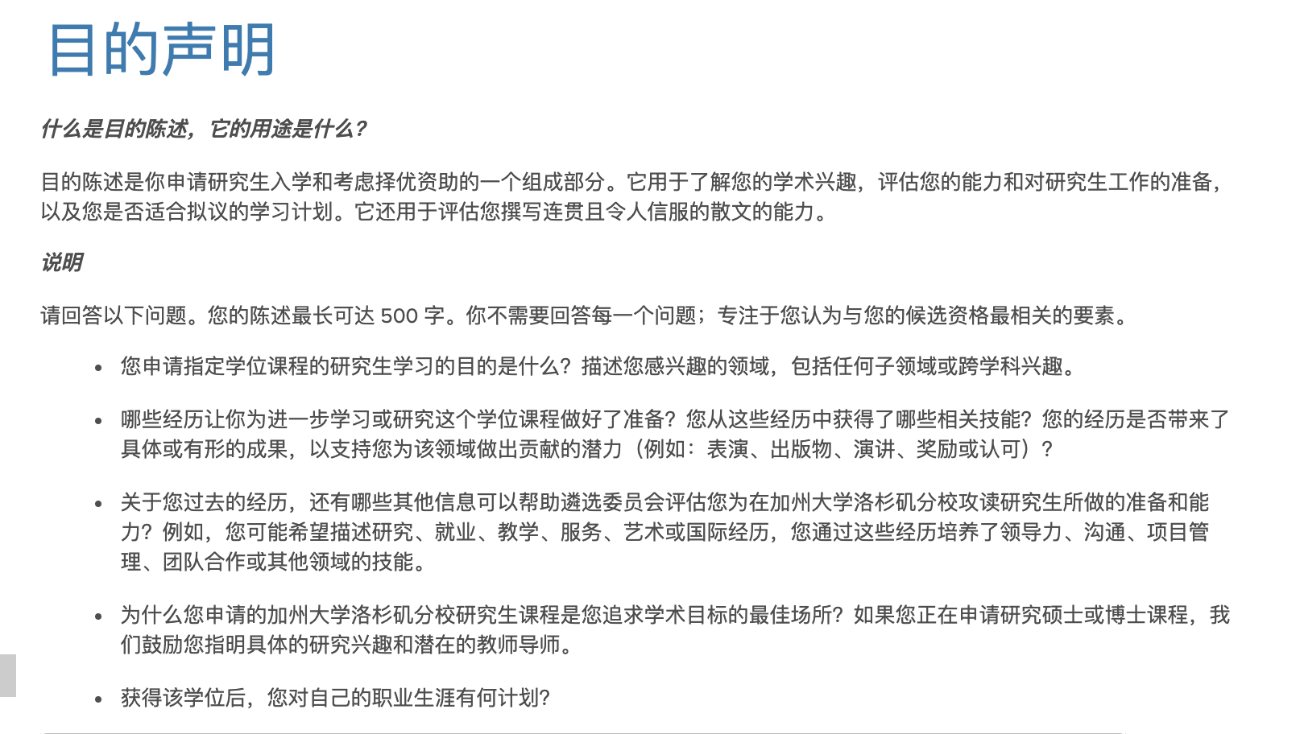

* What is your purpose in applying for graduate study in your specified degree program? Describe your area(s) of interest, including any subfield(s) or interdisciplinary interests.
* What experiences have prepared you for advanced study or research in this degree program? What relevant skills have you gained from these experiences? Have your experiences led to specific or tangible outcomes that would support your potential to contribute to this field (examples: performances, publications, presentations, awards or recognitions)?
* What additional information about your past experience may aid the selection committee in evaluating your preparation and aptitude for graduate study at UCLA? For example, you may wish to describe research, employment, teaching, service, artistic or international experiences through which you have developed skills in leadership, communication, project management, teamwork, or other areas.
* Why is the UCLA graduate program to which you are applying is the best place for you to pursue your academic goals? If you are applying for a research master’s or doctoral program, we encourage you to indicate specific research interests and potential faculty mentors.
* What are your plans for your career after earning this degree

I received my Bachelor's and Master's degrees in computer science, and I am motivated to apply AI algorithms to serve our daily lives better. After I gained years of research and work experience in different areas, including computer vision, recommendation systems, knowledge graphs, and data mining, it shaped my interest in natural language processing (NLP). The rich implicit information and potential bias in the text are critical for understanding our society, such as fighting against toxic online comments, gender bias, and prejudice. There are three major guided research questions: (1) How can we better understand the implication and connection of text? How do we solve the bias or inadequate evidence in the text? (2) How can we efficiently explore and represent text information? (3) How can we collaborate our models with humans or society systems robustly, equivalently, and reasonably?

I joined TAL AI Lab as a research intern within four months. I proposed a deep knowledge tracing (DKT) model to monitor student knowledge state or skill acquisition level based on historical question-answer series, which is critical to the tutoring system. Our proposed research demonstrates the importance of the ''relation'' information and outperforms state-of-the-art baselines significantly. Eventually, we submitted a paper to AIED (top conference in education AI). In 2019, I joined Mobvoi AI Lab as a speech algorithm engineer (now senior). I have mainly focused on text mining of text-to-speech regarding semantics and emotions. For semantic NLP, my work converts non-standard text into representations with accurate pronunciation, prosody, and spoken events based on cross-lingual. The emotional NLP focuses on the intrinsic aspect of language understanding, such as speaking style, stress, and emotion. These two projects are critical for accurate and emotional speech generation, and I covered the establishment and optimization. It has led to 100k+ user applications (www.moyin.com), research results in PRML, ICASSP (top conference in speech), and five patents.

I have built a solid foundation for my future study since I have accumulated research experiences, solid engineering, and soft skills from my school, extracurricular activities, internship, and formal work. With these prior experiences, I am confident that the UCLA program will guide me to develop novel achievements in my interest field and help me become a hot contributor and researcher in the open-source community. (<https://xqfeng-josie.github.io/>)

Deriving inspiration from supervision (semi- or non-), data mining, and linguistic learning, I am interested in extending my experience in unstructured, multi-lingual, or cross-lingual text information extraction and understanding. At UCLA, several professors' projects are especially appealing to me. Professor **Kaiwei Chang's** research about robust learning (bias investigation and reduction) and cross-lingual transfer interests me. Linked to this, I am also interested in Professor **Yizhou Sun's** research on social network analysis (data mining) and Professor **Nanyun Peng's** research on creative language generation and cross-lingual transfer. My willingness to develop real and cutting-edge technology and collaborative mindset make me a clear fit for UCLA. I hope UCLA can be the new launchpad for my research journey.