Stephen Zhu

Srzhu3

ECE 496

In the past few weeks, I created some actuators to determine what parameters I would be interested in testing. It was my first time making CAD files to create molds, so it took some time to model the actual actuators before creating the molds and printing them using our 3D printer. I made 4 different molds, switching between the height of the actuator (15mm and 30mm) and the canal width, defined as the width between the valley and the bottom of the actuator (2.5mm and 7.5mm). Another mold was made with actuator height 25mm and canal width 5mm, but with double the width of the actual actuator. Included are two images, the first one shows one side of the mold for the 15mm 2.5mm actuator, while the second shows one side of the mold for the 30mm 7.5mm actuator. From the images, the canal width can be seen as the distance from the top of the molds to the peaks of the triangles

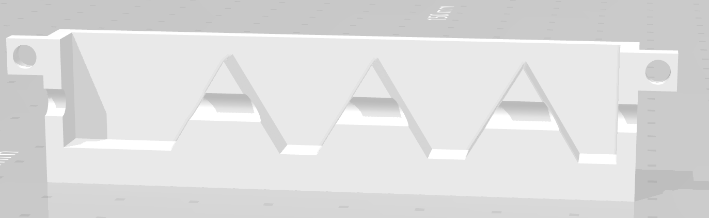

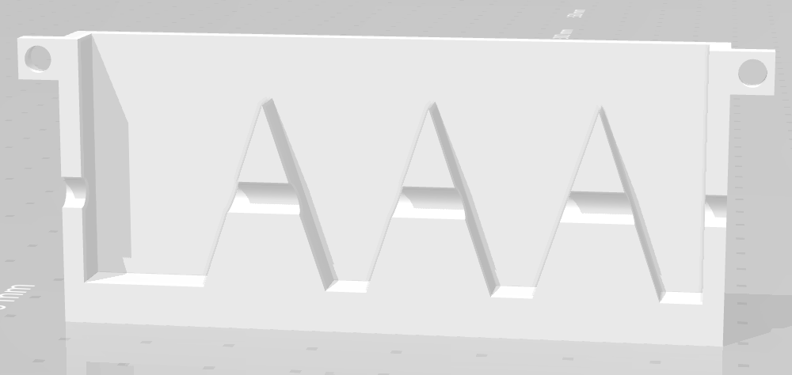

The molds were made such that each mold has two halves that can be connected by screws on both ends. In the middle, a cylindrical cavity is made, so that before each half is pushed together, a piece of tubing can be put inside the cavity. Silicon rubber is then poured into the mold and allowed to harden.

To further process each actuator, when the actuators are taken out, additional bits of rubber are trimmed off, and the parts of the tubing that aren’t within the actual actuator are cut off. Below are the two actuators made from the above molds

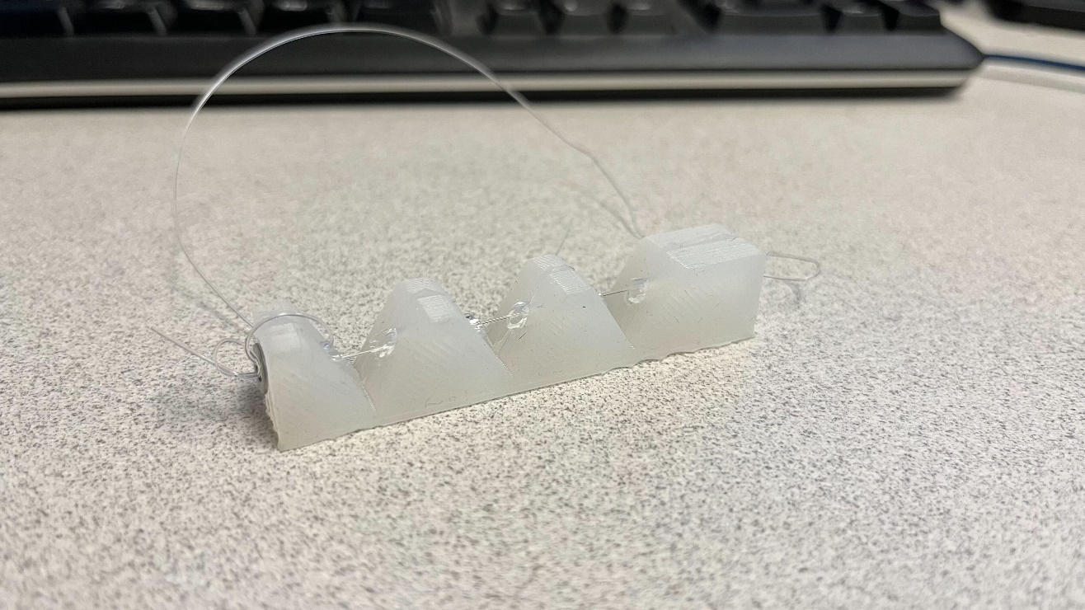

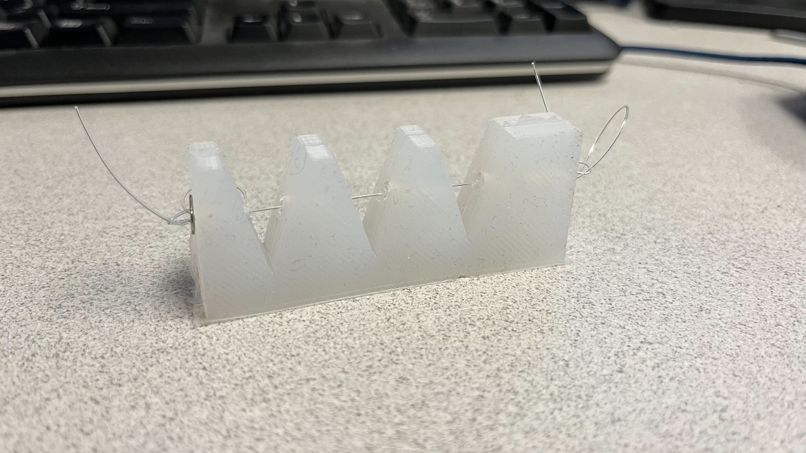

A total of 10 actuators were made, using two different materials (Ecoflex 50 and Dragon Skin 30) and each of the 5 molds. I then tried testing different aspects for each of the actuators and comparing them. Ultimately, the Ecoflex actuators were too soft to have any significant effect, and it only took at most 150 grams of weights to bend them fully. The Dragon Skin actuators were stiffer, and ranged from 110 g to 800 g of weight to bend fully. Below is a picture of the data taken, as well as a verbal description of the testing procedure to determine the weights needed to bend.

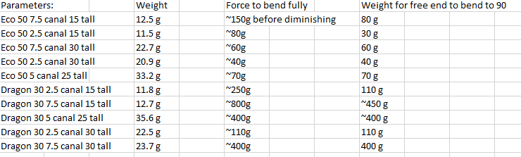

Testing Procedure:

1. Set actuator against side of table with vertical drop (ensure string doesn’t touch edge of table to factor out table friction
2. Add weights on to the hook weight and drop it onto the loop at the end of the actuator
3. Compare bend with bend through finger pulling
4. Change weights and redrop onto the line to ensure there isn’t any retention of shape from the actuator that affects the reading
5. Record amount of weight that is close enough to the full finger bend distance before significant diminishing marginal bend