Stephen Zhu

Srzhu3

ECE 496

In order to test out the previously made actuators, I had to design a prototype body for the robot to attach the actuators to. Below is an image of the first design I made in SolidWorks. These designs were 3D printed, as we have not yet finalized the design for the robot itself, and 3D printing is significantly quicker and easier to make prototypes with.

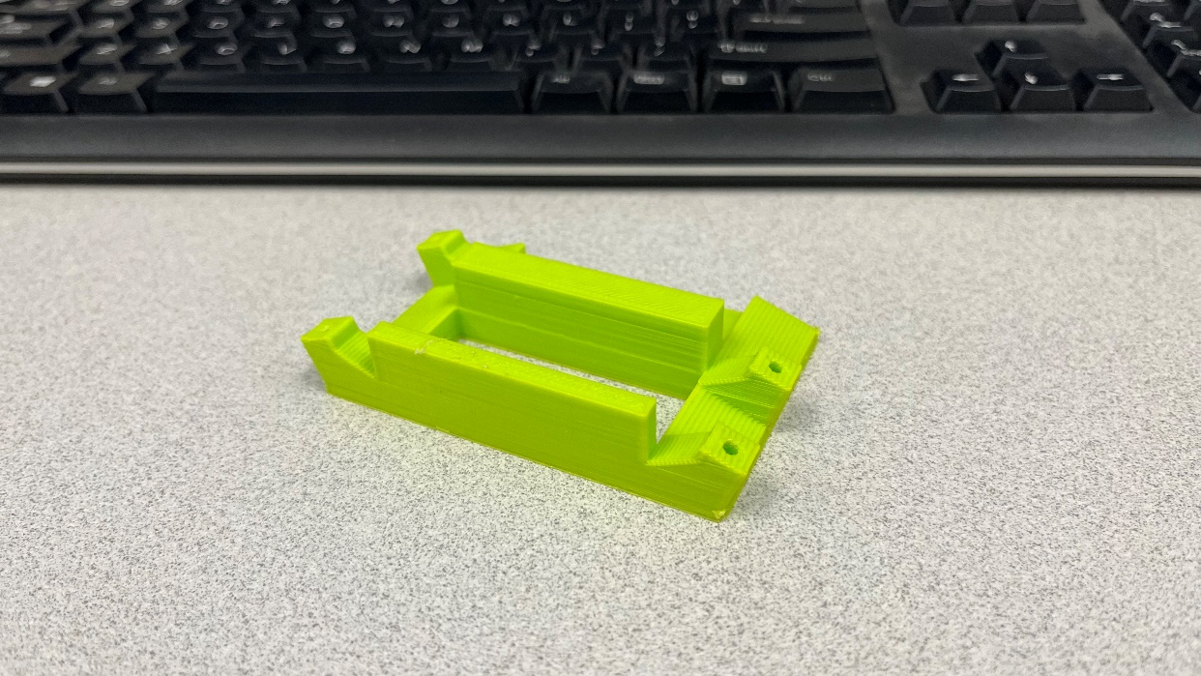

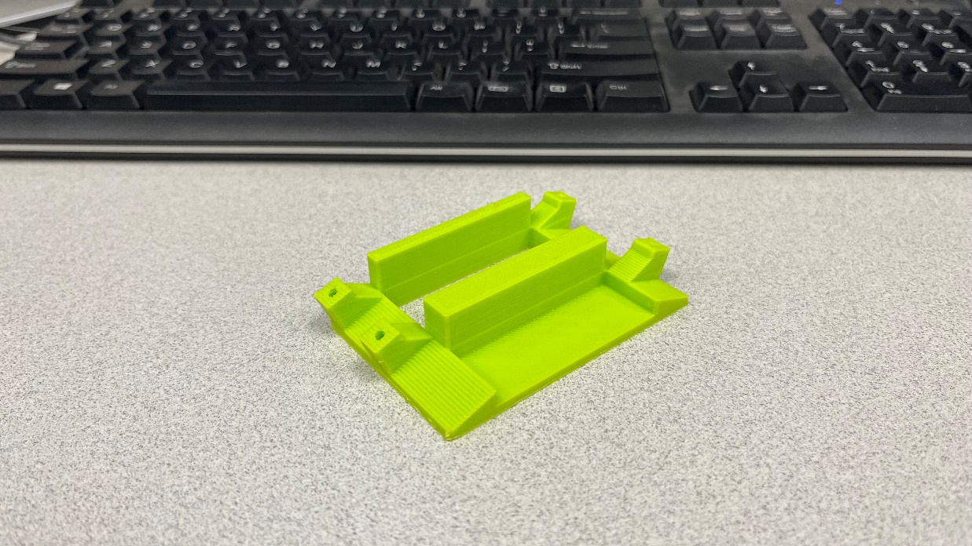

A few problems came with this design. First, the underside of the back half of the robot was too thick, so it added on a lot of time to the print. Second, I wanted to place a servo in the center to actuate the actuators on both sides, but my design failed to account for the fact that one end of the motor had cables exiting it, so the servo couldn’t fit inside the space I allotted it. Lastly, I designed the body in such a way that I could test the 15mm tall actuators on the “left” side and the 30mm tall actuators on the “right” side. This limited me from testing 30mm actuators on both sides, but since I had only 1 of each actuator, and I wanted to test the actuators first, this wasn’t a huge issue.

With the actual tests of the actuators, I quickly realized a trend. In the previous report, I included a table of how much weight it took to bend the actuators and one column detailed the weight needed to fully bend the actuator. Any actuator that had less than 400g as its entry wasn’t able to move the printed body at all. In other words, the Ecoflex 50 actuators were all too soft to have any noticeable effect on movement, and only a select few actuators were actually stiff enough to cause movement. It should be noted that the slopes that the actuators are attached on are at 20 degrees above the horizontal. When the actuators that were actually able to move the body were attached, some of them were stiff enough to raise the body above the ground.

The circuit to move the body was made using an ItsyBitsy 3V development board, attached to a computer though a USB micro cable. The reason it was attached to a computer was to ensure the voltage and current were high enough to run the servo. The program to actually move the servo was made on the Arduino IDE, as the ItsyBitsy board is capable of supporting Arduino IDE. Below is a picture of the circuit on a breadboard.

