Stephen Zhu

Srzhu3

ECE 496

To address the previous problems with the body, I redesigned it to allow space for the servo, reduce the print time, an allow the same actuator to be put on both sides.

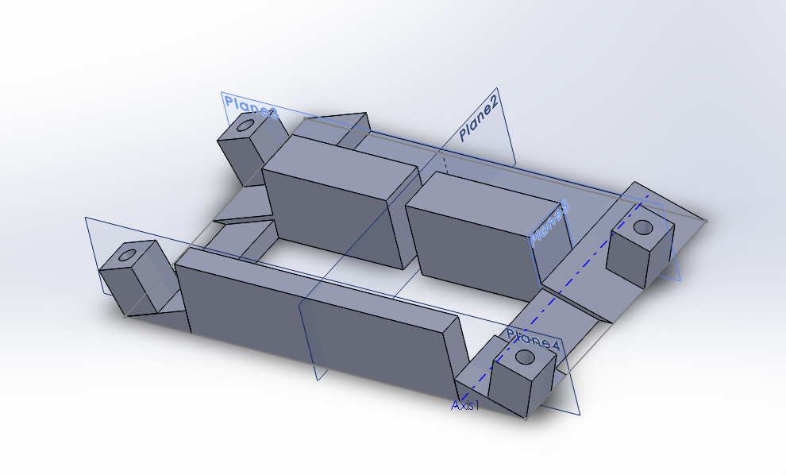

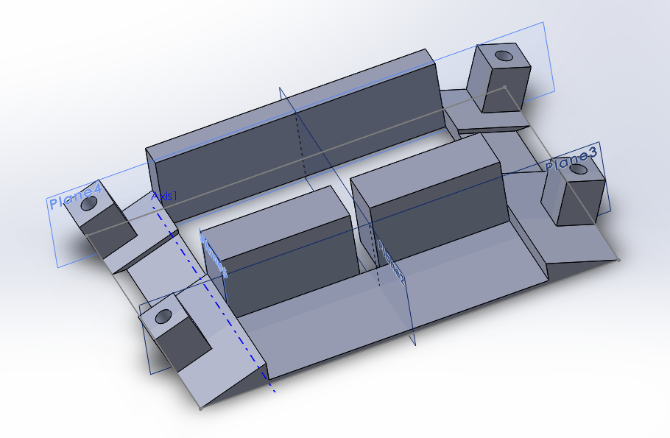

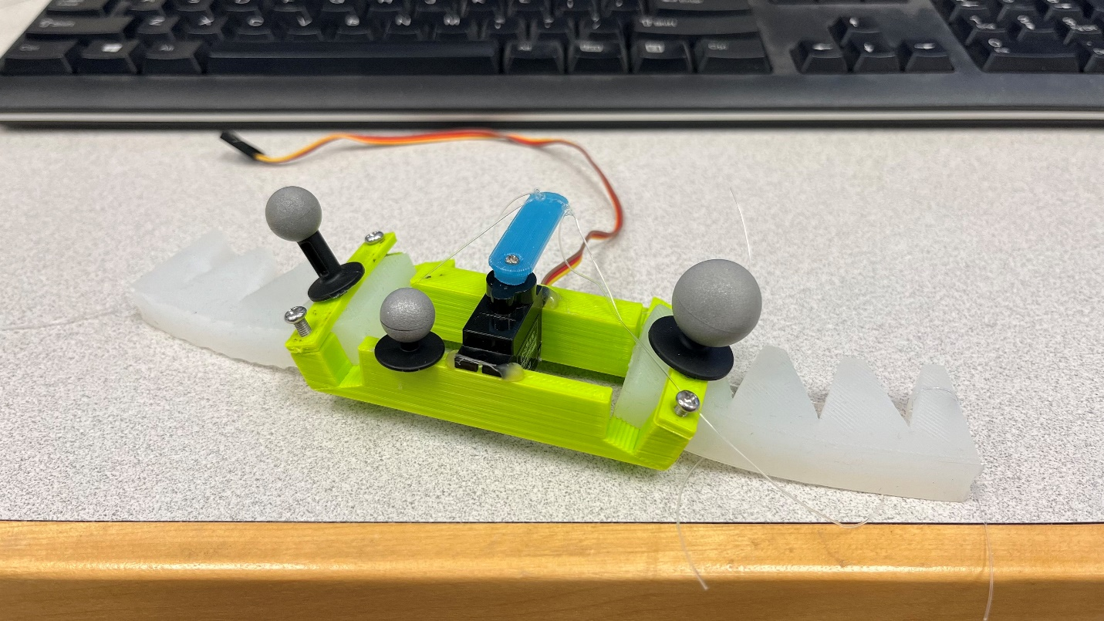

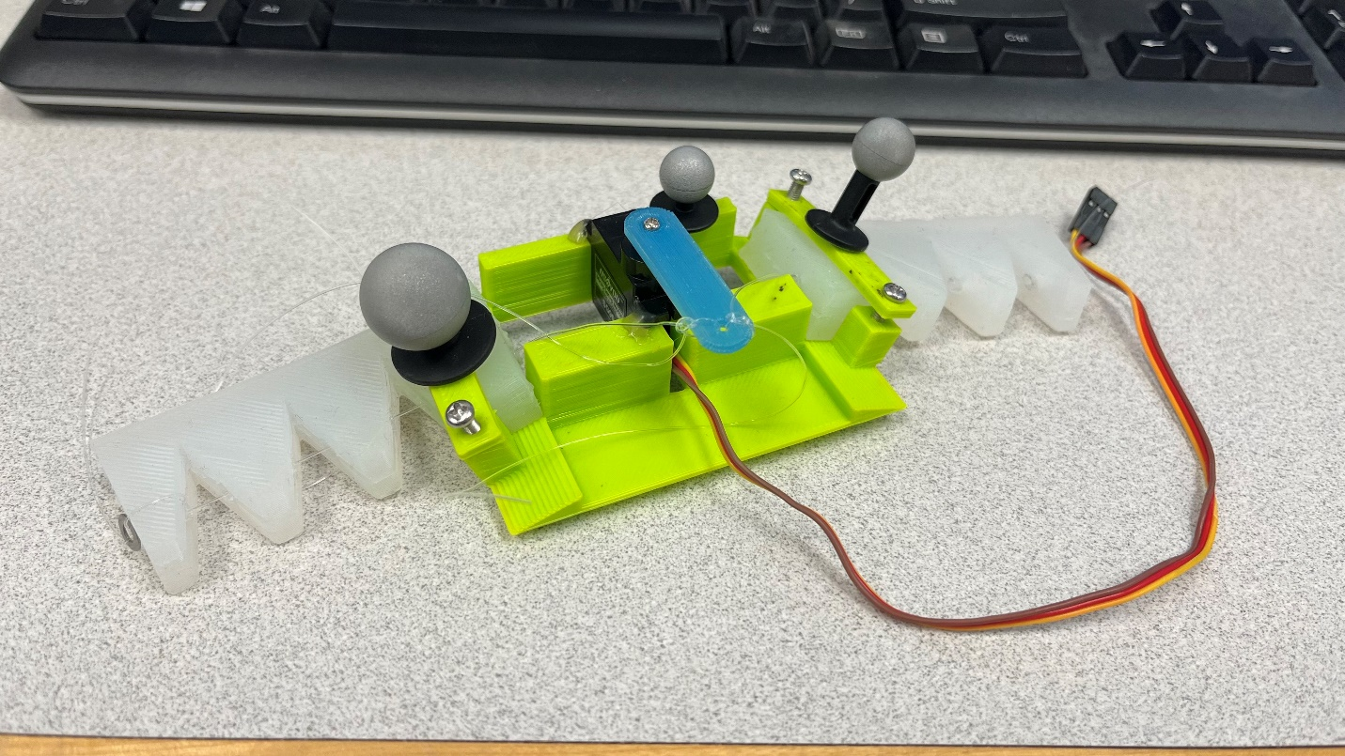

Additionally, grooves were introduced within the actuator attachment points to constrain the 15mm tall actuators so that they won’t wiggle around when put in. Additionally, the actuators that were able to move the body were duplicated (15 tall, 7.5 width canal and 30 tall, 7.5 width canal) and new actuators with 20 degree bends at the end were created.

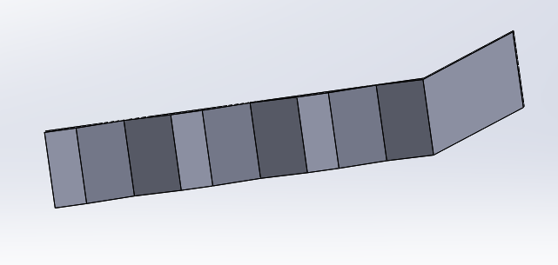

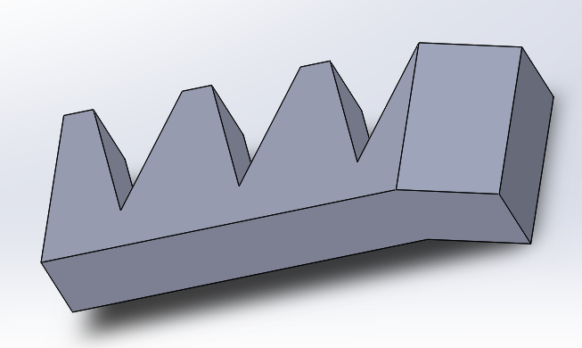

These actuators were made to account for the 20 degree slope that is on the body, and to bring more of the actuator to touch the ground. These were modified from the 30 tall, 7.5 width actuators. Each pair of the actuators were attached to the body and tested for speed (efficiency) though a motion capture system. Since the motion capture system is too far away for the cable to reach, the circuitry was modified to allow for 2 LiPo batteries in series to power the system. Below are graphs made using the data.

15 tall, 7.5 width; velocity: 0.8 mm/s

30 tall, 7.5 width; velocity: 2.1 mm/s

30 tall, 7.5 width, bent actuator; velocity: 0.3 mm/s

From the data, we can see that in terms of overall speed, the 30 tall, 7.5 width actuator performed the best. Additionally, I now believe that what caused the body of the robot to move is due to the edges of the actuators, not the bottom face, which explains why the bent actuators performed worse. It should be noted that the 15 tall, 7.5 actuator was so stiff that the body was completely off the ground, and when the actuators began moving, the robot tipped over slightly due to how unbalanced the system was.

In the future, I want to design some actuators with grooves at the bottom, and see if that can artificially create an “edge” for the actuators to move off of. Additionally, I want to experiment with making actuators with “legs bent in one direction,” which would allow the actuator to return smoothly to its default position, but give a lot of resistance when the actuator is being pulled.