Stephen Zhu

Srzhu3

ECE 499

Progress Report 4

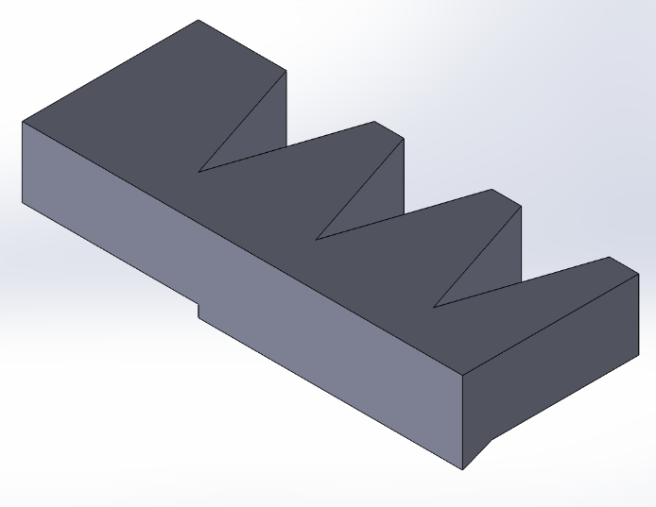 I continued to test out different actuator designs, expanding on the thought of introducing “legs” or other shapes on the bottom of the actuators. My main focus was on improving the “edge” of the actuator, since the net motion of the robot seemed to be driven by how well the edge was able to push off against the ground. As shown in the images below, I tried designs such as adding a more distinct “edge” to the actuator and three “legs” to the edge.



Single-edge isometric view Single-edge side view

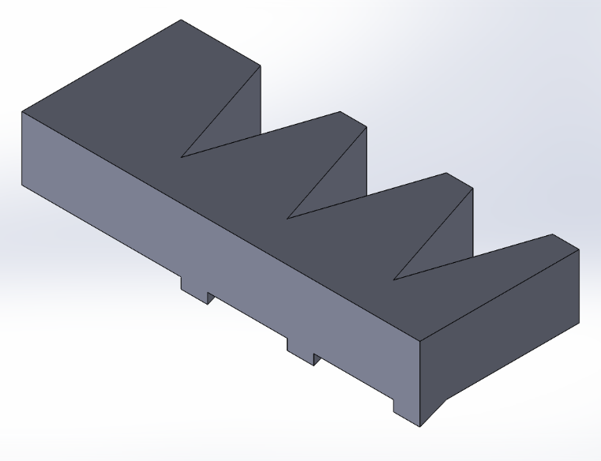

Tri-edge (tri-leg) isometric view

Additionally, I experimented with adding a tilt into the actuator, to see if that would enable better “grip” from the new edges, as well as reversing the direction of the legs to see if that would enable movement in the reverse direction.

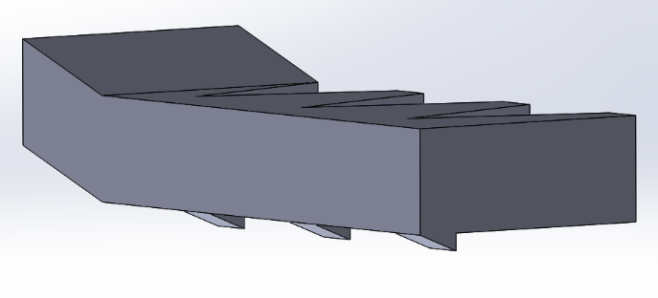

Tilted and reverse-leg isometric view Tilted and reverse-leg side view

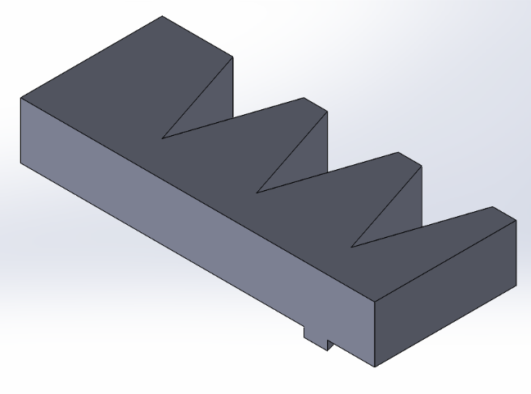 After using the motion capture system to test the efficiency of the actuators, it was clear that introducing a tilt to the actuator was detrimental to its efficiency, since there was less pressure pushing the edge of the actuator into the ground. Reversing the legs also did nothing. Between the single-edge and tri-edge designs, the tri-edge performed better. On further inspection through video footage, it seemed like when the actuators were being pulled, the smooth side of the legs would get pulled back normally. However, when the actuator was being released, the edges of the legs would catch the ground, causing them to greatly increase the friction and create a larger net motion than the other designs. I then tried to create a design with only one leg to further reduce the friction when the actuator was being pulled, but it proved to be less effective than the design with three legs.

Single-leg design

Lastly, I experimented with increasing the speed of the servos. As expected, the faster the servos went, the faster the robot would go through an entire movement cycle, and thus the faster the robot moved.

Below is the graph of the increased speed, tri-edge/leg design.

From the line of best fit, the velocity of the robot was around 9.1 mm/s.