Stephen Zhu

Srzhu3

Progress Report 5

With the actuator design finalized, I turned to working on designing the circuitry on Eagle and making the soft prototype body.

For the circuitry, I used the Adafruit ItsyBitsy board and Arduino to control two servos, one for each actuator. The initial prototype relied on one servo to pull each actuator back and forth, but with the use of two servos, separate control of each actuator can be achieved. I then experimented with using a 3V-5V voltage booster, since the nominal voltage of the battery was on the low side for the servos. I eventually found that just directly linking the servos to the output of the booster without extra resistance was fine and didn’t damage the servos, and I finalized the circuit design, shown below. The rightmost component is the ItsyBitsy board, the top left is the battery-to-board connector, the middle left is the 3V-5V booster, and the bottom two are the servo-to-board connectors.

I then began to prototype a soft body, to verify if my prior experiments would work once I shifted away from the 3D-printed body. Initially, I tried making a mold based off of the previous design, but the screw clamps I used to hold the actuators in place wouldn’t work on a soft body. Also, the lack of material surrounding the servos proved to be detrimental, since the servos would turn in place rather than pull on the actuators’ cables.

To fix this, I surrounded the servos with material, and adjusted the actuator housing so that I would need to use more silicone rubber to glue the actuator to the body. Additional, I added a small compartment to hold the battery, and created a well to be able to glue the circuit board onto the body better. The design is shown below.

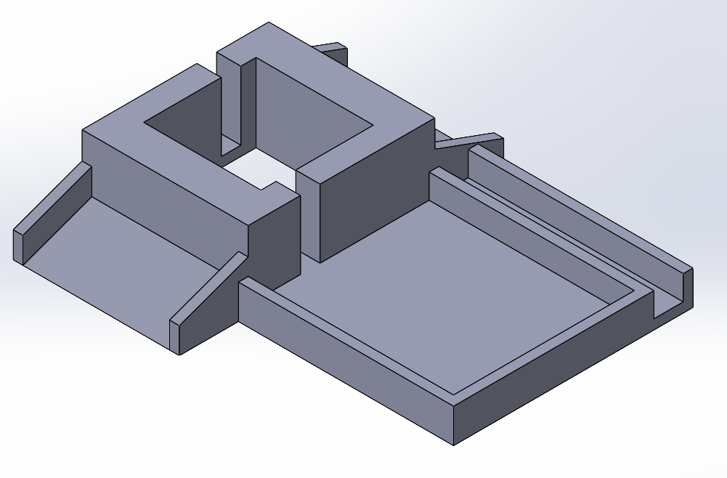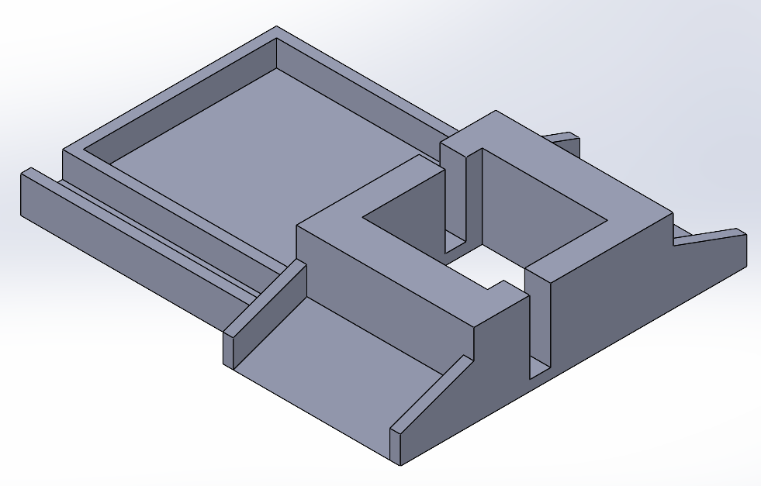

With these two elements, we were finally able to make the robot completely untethered and gather data on it using the motion capture system. The completed prototype is shown below, as well as the data.

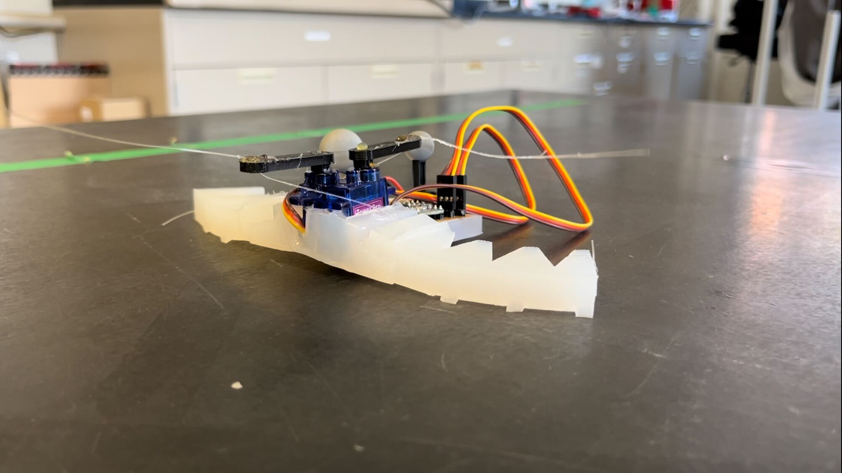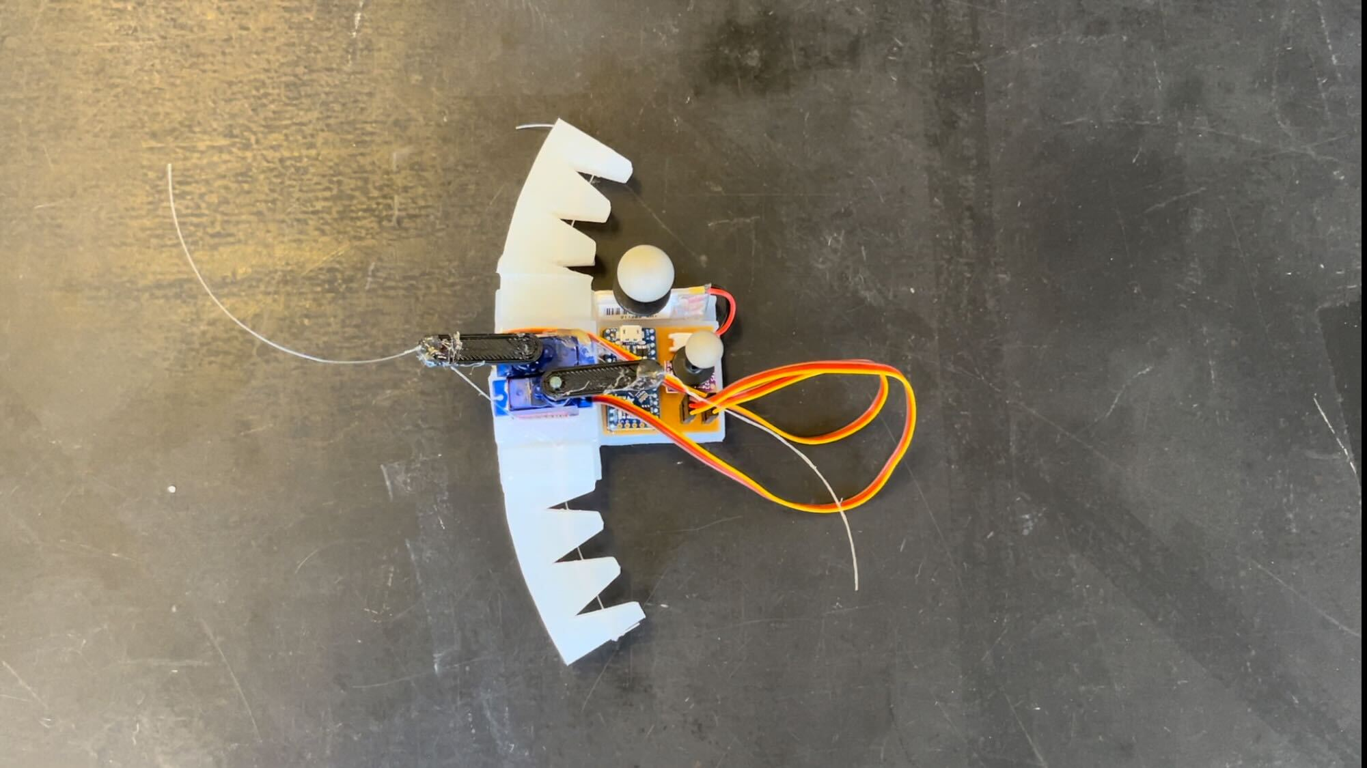

From the data, the net velocity is around 4 mm/s this is a slight decrease in the previous results, though there are several factors that influence this. As expected, having a soft body produces more friction overall in comparison to a 3D printed body, so the performance decreases. Also, the servos used for the soft body were less powerful than the one used in the printed body prototype, so the speed of the servos had to be decreased. Lastly, due to the soft body, the body itself bends a little bit, which in turn bends the actuators less. Thus, there is less pressure against the legs of the actuator, which causes less directional force to be generated.