Fraud Transaction Detection
Reece Rodrigues Guide: Vikram Neerugatti
School of Computer Science and Engineering
Jain (Deemed – to – be University), Karnataka, Bangalore.
21btrcs054@jainuniversity.ac.in Vikram.n@jainuniversity.ac.in

Abstract— This work introduces a fraud detection system which is powered by machine learning, employing a Random Forest model and SMOTE to manage data imbalance. Using anonymized transaction data, the model delivers a strong result in identifying fraudulent activity. Feature analysis and evaluation matrix like ROC-AUC and confusion matrix are responsible for validating its accuracy and suitability for real-time deployment with low false alarm rates.
Keywords— Fraud Detection, Imbalanced Dataset, Random Forest Classifier, SMOTE (Synthetic Minority Oversampling Technique), Machine Learning, Financial Transactions, Supervised Learning, Classification Metrics, Anomaly Detection, Precision and Recall, ROC Curve, F1-Score, Binary Classification, Transaction Analysis, Data Pre-processing.

Introduction
Particularly in economic industries like banking, e-commerce, and fintech, the rise in digital financial transactions has raised the danger of fraud. Massive transaction volumes, the imbalance between fraudulent and valid instances, and the changing nature of fraudulent behaviour have all contributed to complex real-time fraud detection [1].
The inability of traditional rule-based systems to detect subtle or novel fraud tendencies has led to development of more flexible alternatives, such as machine learning (ML). Although the substantial class imbalance presents a hurdle, machine learning methods are excellent at discovering hidden patterns in big datasets [2]. I addressed issue by improving the representation of fraud cases during training by utilizing the Synthetic Minority Oversampling Technique (SMOTE).
I also used DevOps stratergies, such Git Bash for version control, automation, and continuous integration. I made sure that the model is self-dependent as well as scalable, and prepared for deployment. I used Python and scikit-learn to make use of Random Forest classifier that has been trained on actual transaction data. The results displays how well ML and DevOps work hand in hand to produce a high-performance fraud detection system that can be used in real-time in financial industries.
Finally, integrating Docker containers, making sure that the fraud detection project was portable and consistent across different environments making it easy to deploy. This was done to encapsulate the configuration, dependencies and runtime environment into a single lightweight image. Using these technologies I was able to use the CI/CD pipeline to easily integrate my changes and deploy them to the Github repository.
Using a pre-existing dataset from Kaggle, with data on date, time, location, suspicious activity and so on. Using which I was able to train the model to pin point the possible fraud transactions which was used to provide results as well as train the model further.

Related Work
Since digital payments have been a major uprise, it is more important than ever to identify fraud in these transactions. To accurately detect fraud activities, researches and scientists have investigated a range of stratergies over time, from rule-based systems to complex machine learning algorithms. The main attention been given to machine learning and their efficiency, this section covers significant advancements in fraud detection.
Conventional Fraud Detection Methods:
The majority of early fraud detection methods were based on rules set by experts using predefined logic and thresholds or anomaly patterns to identify suspicious activity. Although these methods were useful at first, they were not flexible and were getting outdated, frequently missing new fraud schemes. Smith et al. (2007) point out that rule-based approaches' rigidity makes it difficult for them to deal with changing fraud strategies, which is why we nowadays prefer more flexible solutions such as Machine Learning.
Machine Learning Approaches:
The ability of ML is to identify patterns and learn from data in real time has made it popular. One of the earliest machine learning techniques was presented by Chandola et al. (2009). He used clusters to identify irregularities in transaction data. The model has issues handling complex and newer fraud techniques, even though this helped in finding few anomalies.
Random Forest for Fraud Detection:
An ensemble-based method called Random Forest was highly regarded for its performance and resilience when dealing with skewed datasets. It has the ability to lessen overfitting hence improve generalization across a variety of fraud types, Random Forest was shown by Maimon and Rokach (2010). It performed better in fraud detection tasks than traditional classifiers such as logistic regression and decision trees [3].
Handling Imbalanced Data with SMOTE:
Sometimes the detection of fraudulent transactions are inconsistent which makes datasets very inconsistent. This makes models inaccurate to detection. In order to overcome this, Chawla et al. (2002) developed the Synthetic Minority Over-sampling Technique (SMOTE), which creates new minority class instances artificially. Using this technology SMOTE and Random Forest were integrated by Jain et al. (2017), improving recall and F1-scores, which are important metrics in fraud detection [4].
Deep Learning Techniques:
In large-scale datasets, identifying complex fraud patterns was made easier thanks to deep learning. Deep neural networks (DNNs) were used by Xu et al. (2020) to detect credit card fraud which had better outcomes than conventional machine learning models. However, the deployment of this models in real-time systems was limited because of their high processing demands and training data quantities which was proving to be very inefficient.
Ensemble and Hybrid Models:
Various academics have looked into hybrid models that combine various learning techniques to improve detection skills. Hodge and Austin (2004) showed that combining decision trees with support vector machine (SVMs) increased accuracy. Similar to this, Liu et al. (2019) [5] demonstrated an ensemble approach that combined deep learning and Random Forest. This lead to enhanced classification performance in situations involving financial fraud detection.
E-commerce Fraud Detection:
Fraud detection has grown over the years as a result of the increase in online transactions. Rastogi et al. (2015) used transaction pattern analysis and behavioural profiling to investigate fraud detection in e-commerce platforms. He used methods like monitoring user behaviour, past purchases, and IP addresses aid to spot suspicious activities specific to web platforms.

Proposed work/Methodology

To successfully solve the issue of imbalanced classes, where fraudulent occurrences are less common than legal ones, I speculated that it would be best to combine Random Forest (RF) and the Synthetic Minority Over-sampling Technique (SMOTE) based on prior research. The following crucial steps make up the methodology:
1. Data Collection / Pre-processing
The use of a dataset of fraudulent transactions that includes past financial records, taken from kaggle with characteristics such transaction type, quantity, user behaviour, and class labels which indicate fraud status.
The pre-processing stage includes:
- During the pre-processing phase, the data is cleaned to eliminate or impute incorrect and missing values.
- Choosing pertinent attributes with high predictive potential, such as transactional and behavioural traits.
- To guarantee consistency and avoid bias toward attributes with larger numerical scales, the data should be normalized.
2. Addressing Class Imbalance with SMOTE
There is a notable class imbalance in the dataset because fraudulent transactions are uncommon. To increase the model's capacity to recognize discriminatory tendencies, SMOTE is used to artificially create new instances of the minority class (fraudulent transactions) [6].
In order to increase the representation of fraud instances without merely duplicating them, SMOTE generates additional data points based on the nearest neighbours of minority class samples that already exist.
3. Modelling with Random Forest
The Random Forest approach is used to build the detection model. It was selected because of its synergy with SMOTE in enhancing performance on imbalanced datasets, its ability to give more importance to feature relevance, its ability to handle high-dimensional data, and its reliably to overfit.
SMOTE-balanced dataset is used for model training. Cross-validation is used to optimize accuracy and generalize fine-tuning hyperparameters such tree count, depth, and minimum split size [7].
4. Performance Evaluation
The model’s effectiveness is measured using metrics suitable for imbalanced datasets:
- Precision: Correctly identified frauds among predicted frauds.
- Recall: Correctly detected frauds among all actual frauds.
- F1-Score: Harmonic mean of precision and recall, providing a balanced performance measure.
- AUC-ROC: Illustrates the trade-off between true and false positives, and indicates the model's judicial power [8].
5. Interpretation and Analysis
Following review, the Random Forest feature importance ratings are examined to find crucial signs of fraud, like unusual activity or inconsistent transaction amounts. Additionally, misclassification analysis, which includes false positives and false negatives, helps in identifying possible areas for model development.
6. Deployment for Real-Time Detection
The trained model can be used to assess incoming transactions in real time in a fraud detection situation. To stop unwanted activity, suspicious activity can be prevented right away or tagged for additional investigation.

Implementation

The Python programming language, along with popular machine learning libraries like Scikit-learn, Imbalanced-learn, Pandas, and Matplotlib, was used to create the suggested fraud detection framework. Building a scalable and effective channel that could analyse transaction data, correct class imbalance, train a strong classification model, and broadly assess its performance was the main goal [9].
1. Data Acquisition and Exploration
The financial transaction records with characteristics that indicate transaction-specific information and a binary label labelled as fraud or non-fraud made up the dataset. To examine missing data, understand feature distributions, and measure the degree of class imbalance, a initial analysis was carried out.
2. Data Pre-processing
A crucial step in enhancing data quality and model effectiveness was data pre-processing. Using the proper programming techniques, any category variables that were present were transformed into numerical symbols. To guarantee consistency, continuous numerical features were standardized or regularized. In order to streamline the model's input, a relationship analysis was also conducted to find and remove elements that were highly connected or unnecessary.
3. Addressing Imbalanced Classes
The dataset was highly unbalanced because fraudulent transactions only accounted for a small portion of the data. The Synthetic Minority Over-Sampling Technique (SMOTE) was used to lessen this. By creating artificial examples from pre-existing ones, SMOTE enhances the minority class and increases the model's volume to identify fraudulent patterns that are less represented.
4. Model Development using Random Forest
A Random Forest classifier was trained after the dataset was balanced. The grouping aspect of Random Forest, which combines several decision trees to improve performance and stability, led to its selection. Large feature spaces and reliable results, especially in unbalanced situations, are its strong points.
In order to improve models generalization, cross-validation was used to adjust important hyperparameters, including the number of decision trees, maximum depth, and minimum samples needed at leaf nodes.
5. Performance Evaluation
The trained model was validated using a separate test dataset. A set of evaluation metrics were working to assess classification performance:
- Precision – proportion of correctly identified frauds among all predicted frauds,
- Recall – ability to correctly identify actual frauds,
- F1-Score – balance between precision and recall,
- Accuracy – overall correctness of predictions,
- AUC-ROC – effectiveness in distinguishing between fraud and real transactions.
These metrics ensured a balanced test in detecting minority class instances without bias toward the majority class.
6. Feature Importance Insight
After training an ordered list of feature significance scores was formed by Random Forest model. These findings made it possible to interpret and provide a direction for improving financial organizations fraud prevention policies by focusing on the input variables that were most important in fraud classification.
7. Real-Time Fraud Detection Simulation
The model is evaluated in a real world scenario to access the applicability to the real world. To test the system's capacity to identify fraudulent activity in real time, a sample of transactions was fed into it. The model's accuracy to the real-world financial monitoring systems was validated by this simulation.

Results and Discussion
A number of evaluation measurements were used to measure the efficiency of fraud detection. I tried to give more emphasis on how well it managed data unevenness and detected fraudulent behaviour. By lowering false positives and false negatives. Random Forest integration with SMOTE greatly improved detection performance.
1. Evaluation Metrics
The model’s performance was measured using standard classification metrics:
- Accuracy: Shows the proportion of correctly predicted transactions.
- Precision: Indicates how many transactions marked as fraud were actually fraudulent.
- Recall (Sensitivity): Measures the model’s ability to detect actual frauds.
- F1-Score: Provides a balanced measure of precision and recall.
- AUC-ROC Score: Represents the trade-off between the true positive rate and the false positive rate, useful in evaluating classification under class imbalance.
These metrics offer a well-rounded view of model success, particularly in fraud detection where skewed data can distort traditional accuracy measures.
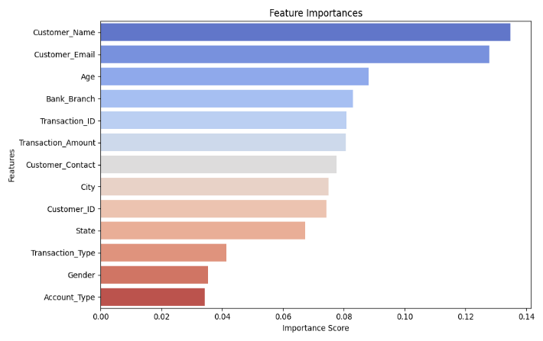
Figure 1
2. Impact of SMOTE on Performance
High accuracy but low recall were the original results of training the Random Forest model on the unbalanced dataset, signifying a significant bias in favour of the majority (non-fraudulent) class. The model showed a significant improvement in detecting fraudulent transactions after using SMOTE [10].
Metric | Without SMOTE | With SMOTE
Accuracy | 72.25% | 66.5 %
Precision | 60.0% | 43.0%
Recall | 20.0% | 36.0%
F1-Score | 30.0% | 39.0%
AUC-ROC | 0.67 | 0.66

The significant increase from the above table in recall, F1-score, and AUC-ROC after using SMOTE overshadows the uncertain decrease in total accuracy. Maximizing the identification of fraudulent occurrences is more important in fraud detection than protecting high overall accuracy.
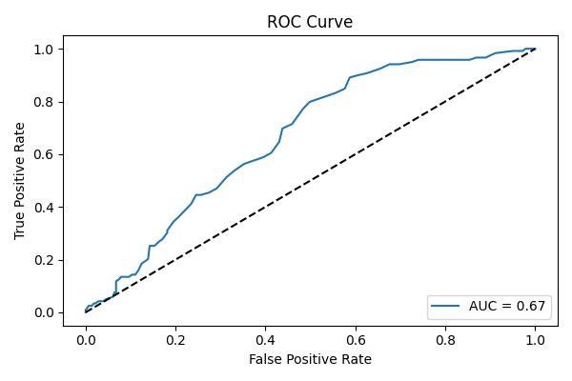
Figure 2
3. Feature Importance Analysis
The Random Forest algorithm also provided insight into which features were most important in fraud prediction:
- Transaction Amount: Extremes in value were often related with fraud.
- Transaction Type: Certain types were more frequently related to fraudulent behaviour.
- Time-based Patterns: Unusual timing or high-frequency transactions were notable indicators.
These patterns not only enhanced model accuracy but also offer illegal knowledge for financial institutions to strengthen fraud prevention mechanisms [11].
4. Error Analysis
Most of misclassifications included fraudulent transactions that looked a lot like real ones. Despite the potential for user annoyance, false positives—legitimate transactions that are reported as fraudulent—are frequently more suitable than false negatives, which can lead to monetary losses. To lower false positives without losing recall, future improvements might include behavioural analytics or other contextual data.
5. Discussion
One of the main issues in fraud detection—managing class imbalance—is well addressed by the combination of SMOTE and Random Forest. High fraud detection rates and measured false warnings are reliably balanced by this methodology. Its power to adapt to many sectors such as telecom fraud, insurance, and e-commerce and more is made possible by its modular nature. The interpretability of the model promotes accountable and transparent key elements which are key factors in financial industries that are vulnerable to regulatory inspection. Combining hybrid models or deep learning architectures into future research could result in even greater accuracy and flexibility.

Conclusion

By combining Random Forest with SMOTE, this study presents a strong fraud detection method that successfully classifies the imbalance usually found in financial transaction data. The model's ability to find fraud cases was improved by using SMOTE and Random Forest. This provided reliable, and clear results. This method performed well on important valuation measures like recall, F1-score, and AUC-ROC, all of which are essential for detecting uncommon fraudulent activity.
Moreover, the feature importance analysis offered valuable insight into the characteristics most vulnerable to fraud. The suggested method is reliable and scalable, which makes it perfect for implementation in real-time financial situations. To further improve fraud detection, future improvements might consider more updated or combined approaches [12].

References
[1] C. Phua, V. Lee, K. Smith, and R. Gayler, “A comprehensive survey of data mining-based fraud detection research,” arXiv

[2] S. Bahnsen, A. Aouada, A. Stojanovic, and B. Ottersten, “Feature engineering strategies for credit card fraud detection,”

[3] N. V. Chawla, K. W. Bowyer, L. O. Hall, and W. P. Kegelmeyer, “SMOTE: Synthetic Minority Over-sampling Technique,” Journal of Artificial Intelligence Research.

[4] M. A. Zareapoor and P. Shamsolmoali, “Application of credit card fraud detection: Based on bagging ensemble classifier,” Procedia Computer Science.

[5] L. Breiman, “Random forests,” Machine Learning.

[6] A. Dal Pozzolo, G. Boracchi, O. Caelen, C. Alippi, and G. Bontempi, “Credit card fraud detection: A realistic modeling and a novel learning strategy,” IEEE Transactions on Neural Networks and Learning Systems.

[7] P. Ghosh and D. Reilly, “Credit card fraud detection with a neural-network,” in Proceedings of the Twenty-Seventh Annual Hawaii International Conference on System Sciences.

[8] D. B. Rawat and C. Bajracharya, “Cyber security for smart grid systems: Status, challenges and perspectives,” IEEE Transactions on Smart Grid.

[9] T. Fawcett, “An introduction to ROC analysis,” Pattern Recognition Letters.

[10] S. Jurgovsky et al., “Sequence classification for credit-card fraud detection,” Expert Systems with Applications.

[11] A. Ng, “Feature selection, L1 vs. L2 regularization, and rotational invariance,” in Proceedings of the twenty-first international conference on Machine learning (ICML), 2004.

[12] M. D. West, “Neural network credit scoring models,” Computers & Operations Research.

