AREA

Briann GERBAUX

David NIKOLIC

Jefferson GUIOT

Maxime SARRES

User Documentation

Welcome to **AREA**, the built-in solution to enable workflows between multiple services.

Firstly, please create your account here. A pop-up will show.

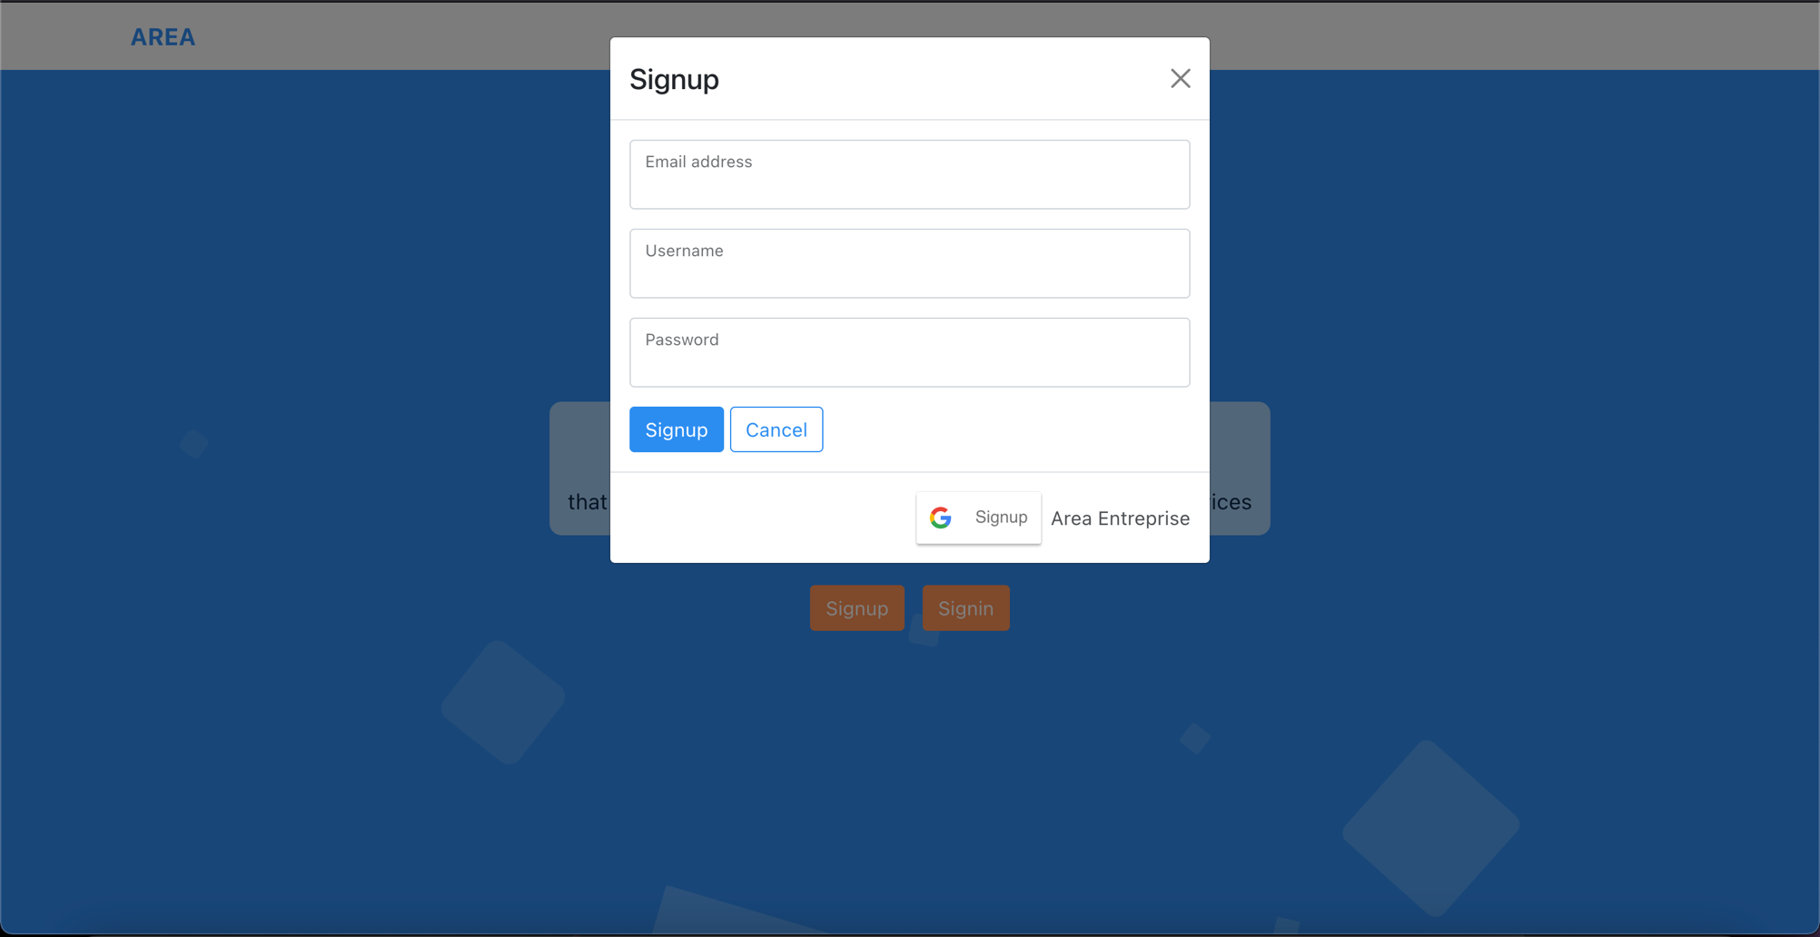

Then, you’ll have to sign into your newly created account.

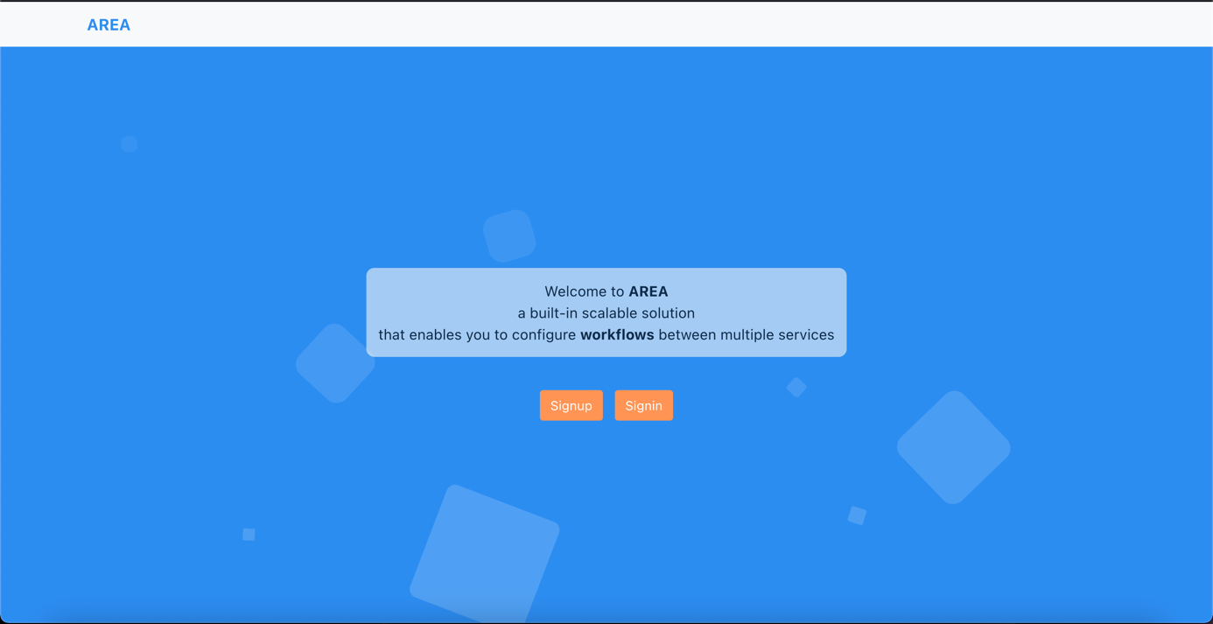

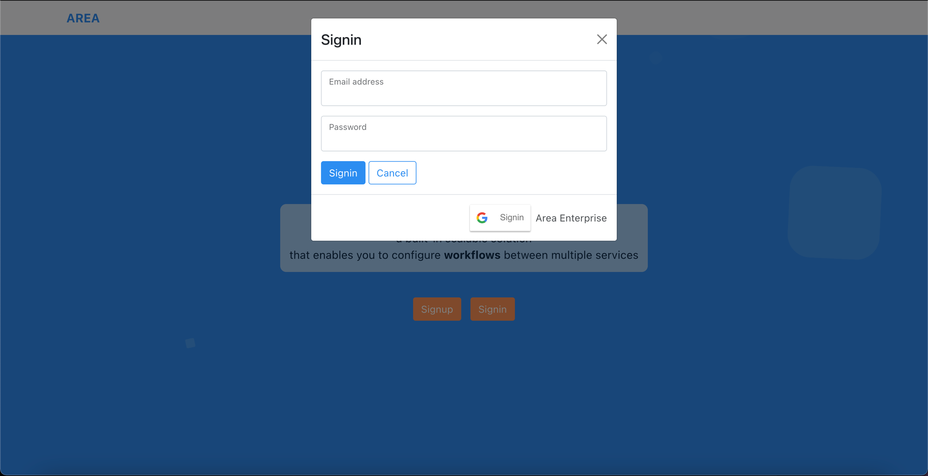

When you are signed into your account, you’ll be redirect to your profile page:

* On the left side there are your personal information.
* On the right side there are all the available service that require you to login to it with your account.

If you plan any of the listed service, please login ASAP to them.

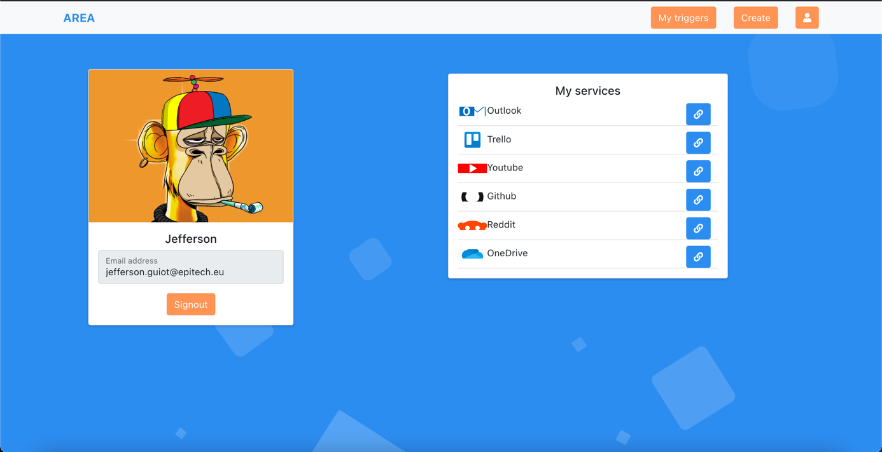

In the navbar you’ll find the **Create** tab and the **My Triggers** tab.

On the **Create** tab, you’ll have to select an **action** and configure it

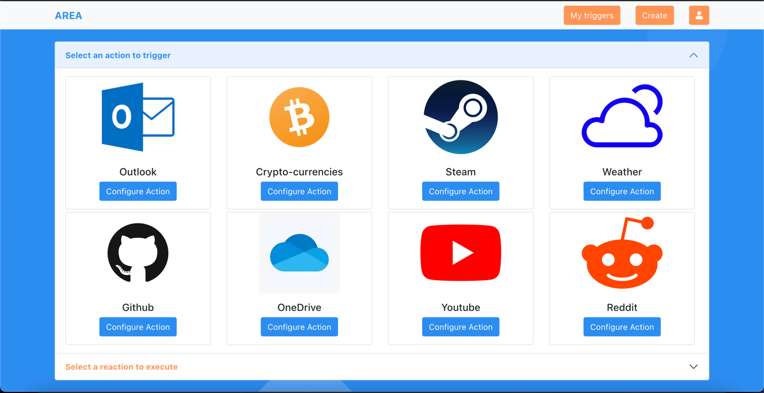

Then go to the **reaction** field, select one and configure it.

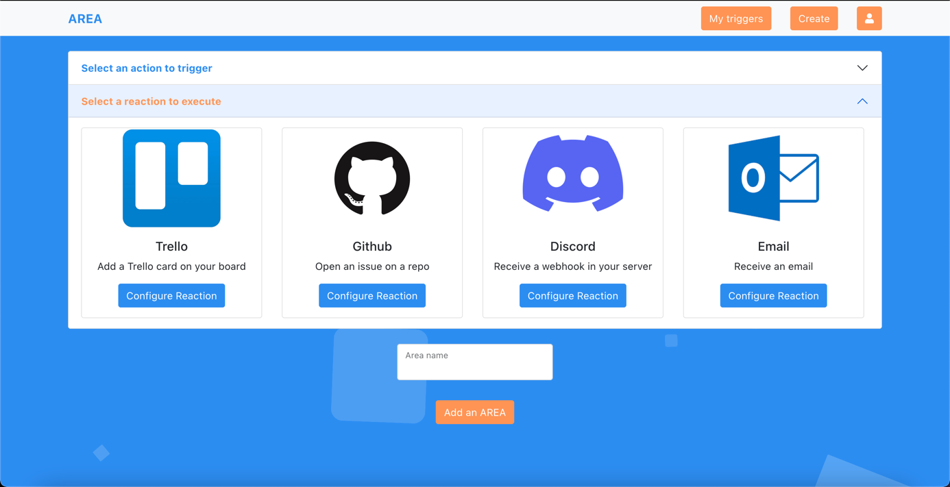

Finally, you’ll find all your configured workflows on the **My triggers** tab.

You can delete any workflow by clicking on this button.