First attempt on fully cnn autoencoder architecture

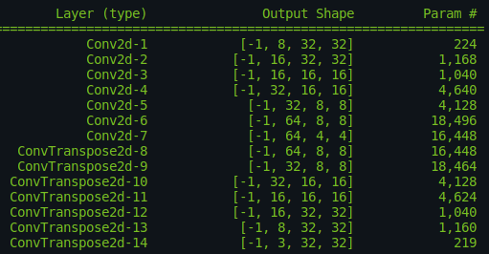
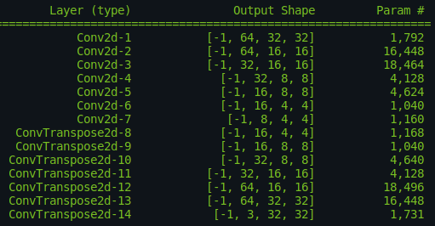
First approach increases depth while the second decreases it. Both seem to be learnable, but the first one gave some better results in the first try. We continue with the second as it highly compresses the image and change if it does not work.

* Scope of this study is to compare architectures and applications of classification, that is we are not concerned of perfectly restoring the image, but on making recognizable by systems such as robots etc. or used as data augmentation.

Remember that PSNR is not a good measure as it compares an initial image with its noisy counterpart, while we actually generate a new image, so even without noise the final image would be quite different from the initial.

I fixed the randomness of noise application but this may be a problem for training tests comparison, at least for the PSNR. So PSNR should only be used as a measure of model learning rather than actual scoring ?

Initially performed tests on the 45,000 train – 5,000 val split. I decided there if the model can learn and proceeded with smaller train split to speed up the training process. Runtimes were big so a quicker approach should be followed. If the model is able to perform well on smaller split it could also perform well on bigger splits too.

This initial train on the big split showed whether the model can learn or not. It showed that indeed the model can learn but a good fine tuning is required. To perform this fine tuning it is unavoidable to reduce the train set and the runtimes.

[Image of the initial split class balance]

[Image of the new split class balance]

Added ViT classifier during training but it highly impacted the runtime.

Also the noise distributions changed reducing the noise but still giving difficult results in their combinations.

[Plot with new noises]
[Plot kdes with new noises]

It remains stuck at .0055 loss. Next step is try some batch normalization layers and if it does not succeed then remove the noise combination.

[screenshot of the new model with the batch norm]

Batch Normalization did not help. Increasing learning rate to 0.005 and it performs better at 100 epochs. From now on test setups on 100 epochs and see which setup converges faster.

Lowered batch size + 0.005 learning rate → it did not help.

Changing architecture with smaller to bigger feature depth (no batch normalization).

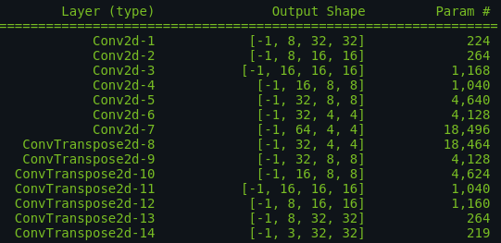

Depth inversion did not seem to work increasing learning rate before batch normalization.
Learning rate did not make make model learn.

Continuing with batch normalization on the reverse depth architecture.

Batch normalization fixes it. General conclusion Batch normalization is mandatory!

Batch normalization and reversed depth works perfectly !!!!

It gets stuck later on at ~0.0045 for the training loss. So, we try a different learning rate and then if not weight decay and at last expand the network.

Bigger learning rate made it more unstable and still gets stuck. Trying smaller learning rate.

Neither the lower learning rate made any difference it got stuck later on at ~ 0.0043 training loss.

Now making the model more deep.

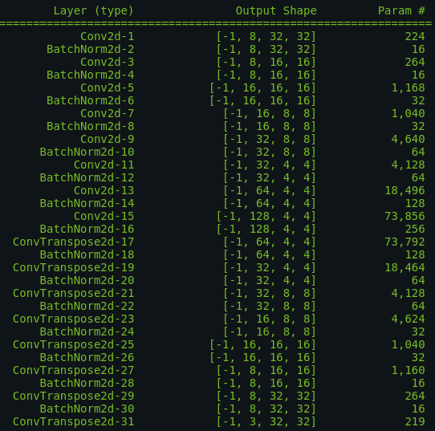

The deeper model did not work as expected so let’s make it shallower.

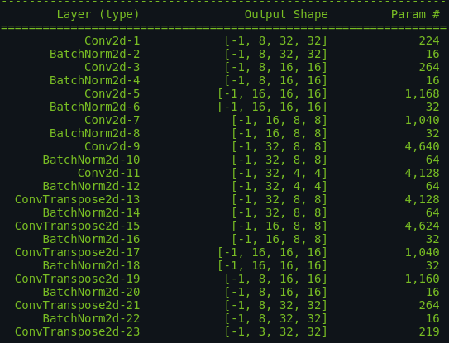

The model converged quicker but it stuck again ~0.0045 training loss. Trying to make it smaller.

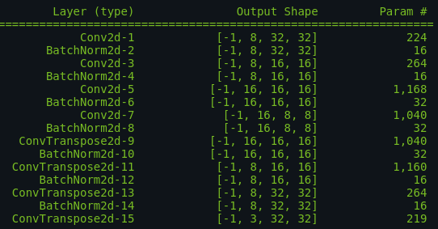
The model converges even faster but does it actually learn ?
YES, IT LEARNS !!!

Perhaps it can be made much simpler, but before proceeding with that let’s try to make the validation (and training in general more smooth). Also try more epochs and at last, if needed, remove more layers.

