ASSIGNMENT 1

Title: ER Modeling and Normalization: Aim: To study how to draw ER diagram

Prerequisites: Basic Knowledge about the Database model. Objective: To Study and Understand the ER diagram and modeling.

Outcome:

- ER Diagram Design using tools like ERD plus or ER Win.

Theory:

Entity Relationship Diagram – ER Diagram in DBMS

An Entity–relationship model (ER model) describes the structure of a database with the help of a diagram, which is known as Entity Relationship Diagram (ER Diagram). An ER model is a design or blueprint of a database that can later be implemented as a database. The main components of E-R model are: entity set and relationship set.

What is an Entity Relationship Diagram (ER Diagram)?

An ER diagram shows the relationship among entity sets. An entity set is a group of similar entities and these entities can have attributes. In terms of DBMS, an entity is a table or attribute of a table in database, so by showing relationship among tables and their attributes, ER diagram shows the complete logical structure of a database.

ER Diagram:

Rectangle: Represents Entity sets. Ellipses: Attributes

Diamonds: Relationship Set

Lines: They link attributes to Entity Sets and Entity sets to Relationship Set Double Ellipses: Multivalued Attributes

Dashed Ellipses: Derived Attributes Double Rectangles: Weak Entity Sets

Double Lines: Total participation of an entity in a relationship set

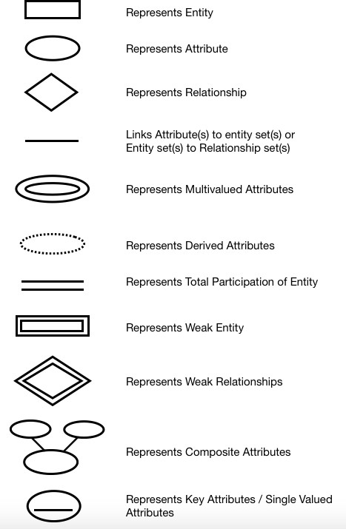

ER diagram has three main components:

1. Entity
2. Attribute
3. Relationship
4. Entity

An entity is an object or component of data. An entity is represented as rectangle in an ER diagram. For example: In the following ER diagram we have two entities Student and College and these two entities have many to one relationship as many students study in a single college. We will read more about relationships later, for now focus on entities.

Weak Entity:

An entity that cannot be uniquely identified by its own attributes and relies on the relationship with other entity is called weak entity. The weak entity is represented by a double rectangle. For example – a bank account cannot be uniquely identified without knowing the bank to which the account belongs, so bank account is a weak entity.

1. Attribute

An attribute describes the property of an entity. An attribute is represented as Oval in an ER diagram. There are four types of attributes:

1. Key attribute
2. Composite attribute
3. Multivalued attribute
4. Derived attribute
5. Key attribute:

A key attribute can uniquely identify an entity from an entity set. For example, student roll number can uniquely identify a student from a set of students. Key attribute is represented by oval same as other attributes however the text of key attribute is underlined.

1. Composite attribute:

An attribute that is a combination of other attributes is known as composite attribute. For example, In student entity, the student address is a composite attribute as an address is composed of other attributes such as pin code, state, country.

1. Multivalued attribute:

An attribute that can hold multiple values is known as multivalued attribute. It is represented with double ovals in an ER Diagram. For example – A person can have more than one phone numbers so the phone number attribute is multivalued.

1. Derived attribute:

A derived attribute is one whose value is dynamic and derived from another attribute. It is represented

by dashed oval in an ER Diagram. For example – Person age is a derived attribute as it changes over time and can be derived from another attribute (Date of birth).

3. Relationship

A relationship is represented by diamond shape in ER diagram, it shows the relationship among entities. There are four types of relationships:

1. One to One
2. One to Many
3. Many to One
4. Many to Many
5. One to One Relationship

When a single instance of an entity is associated with a single instance of another entity then it is called one to one relationship. For example, a person has only one passport and a passport is given to one person.

1. One to Many Relationship

When a single instance of an entity is associated with more than one instances of another entity then it is called one to many relationship. For example – a customer can place many orders but a order cannot be placed by many customers.

1. Many to One Relationship

When more than one instances of an entity is associated with a single instance of another entity then it is called many to one relationship. For example – many students can study in a single college but a student cannot study in many colleges at the same time.

Conclusion: Thus we have studied how to draw ER diagram.