**CHAPTER 1**

**INTRODUCTION**

**1.1 Rationale of the Study**

The Duane and Dwight Enterprise was founded in 2009 by Daniel D. Kaindoy. The main branch is located at Masiwa, Marigondon Lapu-Lapu City and a second branch was established in Soong Mactan, Lapu-Lapu City by his wife Arlene I. Kaindoy. The hardware enterprise was named after the husband and wife’s twin sons Duane and Dwight Kaindoy. It offers a wide variety of construction supplies, like sand and gravel, hollow blocks, plywood, and many more.

The current business process of Duane and Dwight Enterprise is being done manually from ordering down to delivery. So in the current business process, there is no existing system implemented, instead a manual process is being implemented. The current business process is manually done, a log book plays a vital role, it contains all the transaction details, while every clerk-in-charge is tasked to write down these transactions. Since a log book holds all the transaction, the inevitable scenario of losing even just a page of the log book or by simply getting it wet may cause problems in the business.

The current business process of Duane and Dwight Enterprise, is inefficient, inaccurate, unorganized and unmonitored. The current business process has an unorganized business flow because, there is no sequence/order of delivery to follow. It is inaccurate, in a way that when it comes to delivery scheduling there is no proper timestamp recording, details like what time the delivery was done and what time the delivery was received by the customer or was it successfully done. It is also unmonitored because there are no records from time-to-time for the whereabouts of the delivery, like the current location and the current status of the delivery.

The implementation of H.A.T.O.D. (Handling And Tracking Of Deliveries) in Duane and Dwight Enterprise makes it easier for the owner and it helps improve the business process of the enterprise, as it makes it more efficient, secured, organized, and well monitored. It will be more efficient as per some of its business process will be automated. In delivery scheduling everything will be arranged and organized according to the system’s principle of “first come, first serve basis”. According to the study of Biagoni (2013) he found out that using online GPS (Global Positioning System) tracking with low data uplink usage is very useful especially in reporting the current location of the device to a central server, in HATOD (Handling And Tracking Of Deliveries) delivery will be monitored and secured with the use of GPS (Global Positioning System) tracking the current location of the delivery personnel.

**1.2 Statement of the Problem**

**1.2.1 General Objective**

This research aimed to develop a web based delivery tracking system for Duane and Dwight Enterprise.

**1.2.2 Specific Objectives**

1. Analyzed the current business process of Duane and Dwight Enterprise and determine its effectiveness to the employees and business owner.

2. Designed and developed a delivery tracking system with SMS notification.

3. Tested and evaluated the system

**1.3 Significance of the Study**

This study would be beneficial to the following:

**Owner.** The system will help the owner in monitoring the delivery of orders. Deliveries will be tracked using the system, viewing all the necessary information of the customer and the delivery options. Through the system the owner can provide an estimated time of delivery to his customers and set an efficient delivery transaction.

**Customer.** The system will also help the customers of Duane and Dwight Enterprise in giving them the assurance of having their items delivered, they will see the progress of their inquiries and the date of the delivery.

**Other enterprises.** The system provides a convenient procedure in transactions to help improve other companies and their business process that involves delivery transactions.

**Researchers.** The system will help enhance the programming skills of the researchers and improve their analytical thinking in deciphering community problems and finding out possible solutions by developing a system.

**Future Researchers.** The system may provide information on developing a delivery tracking system. Other researchers who would like to design a system related to this may use this as a related literature.

**1.4 Scope and Limitation**

The Delivery Tracking System is capable of managing the ordering transactions and tracking of the delivery whereabouts of the Duane and Dwight Enterprise, however the system will only cater to all walk-in customers of the client. The system is managed by an admin and another module is allocated for the clerk in charge, and delivery personnel.

The system has 4 statuses, first is **“Pending”** this indicates that the transaction is on queue, second is **“Processed”** this indicates that the requested items are being prepared by the clerk, third is **“Delivered”** this indicates that the order is on its way to the customer’s address and lastly, **“Received”** this indicates that the transaction and delivery was done and was received by the customer.

In this system the admin has full capabilities in accessing the system, he can add a new product item, customer, personnel, vehicle and order, view the order’s list page (record of all transactions) and its details (order’s customer name, date and time the transaction was made, customer’s address, items requested, total amount of items, and delivery status), and a tally of all the transactions to be made and was made (record’s section). Only the admin can create a product item, personnel and vehicle. And in addition, only the admin can cancel orders.

The major feature of the H.A.T.O.D. system is tracking of the delivery whereabouts of a vehicle using a mobile phone given to the delivery personnel accessing the mobile application, and eventually sending an SMS notification to a customer. The system is able to generate reports using the filtering function, this function displays all the reports that was done and will be done. In filtering the reports, the admin has the option whether to filter through a specific range of date/s, through a customer’s name, or through the order’s transaction status. And lastly the admin can only create, update, search and delete an item, personnel, customer and vehicle. The second module which will be manage by the clerk, can add a new order and customer. The clerk can also view the order list, view the details of the order, and generate reports using the filtering function. The third module is for the delivery personnel; they will be accessing the mobile application in order to give the system its location thus making the admin able to track the delivery.

The Delivery Tracking System helps the owner of the Duane and Dwight Enterprise in monitoring the flow of their deliveries. The system only covers the delivery and ordering process of Duane and Dwight Enterprise. It does not have an inventory module and payment method, since the client has an existing POS (Point of Sales) machine. The Delivery Tracking System is only capable of tracking, adding a new order, and viewing of delivery schedule. The tracking of the deliveries will be done using the mobile phone of the delivery personnel, given that it is connected to internet.

**CHAPTER 2**

**RELATED SYSTEMS**

This chapter includes the review of systems and articles that are related to our system that helps us understand more about automated tracking systems, its benefits, and the kind of technologies that are used.

IT solutions are the center approaches for dealing with the business processes and the business data. The productiveness and quality of the data managing, is specifically reliant on the executed IT frameworks. Uniting this information, to create a subsystem into a whole, guaranteeing that those subsystems work together, is a practice called system integration. It also solves a part of a business’ processing, redesigning and automation. Therefore, the accomplishment of an organization, is relying upon the level of quality and effectiveness of data processing, and also on the accomplishment of the organizational goals, relying on their implemented IT processes for data gathering, handling and exchanging. The combination of different IT frameworks empowers their brought together usefulness as one single IT platform (Prencipe, Davies, & Hobday, 2005). The general point of the integration is the use of automated processes, for importing of different data types (input data), and their automated data processing towards computerized trading of the particular results (output data) (Scheer, 2000).

Implementing an automated system eliminates the traditional practice of keeping printouts such as receipts, important documents or transaction records on a log book (Julasiri, Hernandez, Uy, & Remedio, 2017) and instead, integrating subsystems into a one single coordinated IT system to enhance an organization’s core business allowing a huge and drastic improvement and change on the business procedure, straightforwardly relying upon the utilized and actualized data advances, arrangements and solutions. This shows that automation and technology potentially enhances any business, and perhaps on a bigger scale the market. (Petrevski, Josimovski, & Kiselicki, 2017).

Duane and Dwight Enterprise offers a delivery service for its customers, and with the help of a delivery tracking system it can assist in auditing merchandise that are under travel and movement, between its origin to its target location. A study of Villareal et. al, (2013) pointed out the problems of commercial cargoes and deliveries including the troubles on the business management side, thus conducting a study that uses the world wide web as a tool in data location to track a location with the aid of the GPS (global positioning system) and the internet technology. The study has a server application that uses hypertext preprocessor to create a web application and MySQL as database that keeps all-important information, they also used an API (application programming interface) to communicate to the server. A proposed vehicle tracking system of Dhumal (2015) suggested that a user has to login through a phone that uses GPS and GSM (global system for mobile) to track delivery vehicles, it displays the location through a web client that uses Google maps. The study proved to be reliable to an organization. Prasad (2013) suggested a web development project that uses GPS and database implementation declines the paper work by a user drastically, this is because a database securely keeps the valuable data and a user-friendly system efficiently improves data storing, while the GPS aids in tracking a cargo. Another study of Bhatia and Verma (2013)suggested a tracking system that informs the user a vehicle’s location and the routes it travelled from any remote location. The system they suggested includes a web application (HTML based) in Google map that provides an exact location of the target vehicle through the GPS and GSM technologies.

GPS authorizes a user to know a location by consulting a radio receiver. The exactness encompasses 15 meters max to a minimum of just a few millimeters, but it is still based on the hardware utilized and systems connected to the procedure of data gathering. There are additionally further developed GPS collectors that can tell not only areas but as well as areas a user has been to. Any place on Earth, well anyplace yet not inside structures, underground, amid overwhelming precipitation, around radio transmissions, close to powerful radio transmitter reception apparatuses or any place else not having an immediate perspective of a considerable segment of the sky (Kennedy, 2010). But to what extent are these GPS technologies trustworthy? In study of Horecny (2015) tried to prove that GPS on mobile phone are accurate or aren’t. Their experiment was held in 2014 wherein two phones were used to test their location on urban, rural, and indoor areas. The older phone had more difference in location from the real location than the newer phone. So their research concluded that, as time passes, technology is getting more reliable and the accuracy of GPS technology on smartphones are trusted.

GPS was designed to easily give positioning information, but implementing GPS with GSM (global system for mobile) provide new solutions for wireless networks to associate the benefit of telecommunication and location positioning. Providing the network operator, service provider and end user the benefits of position-enabled communication capabilities. Wireless communication has been used anytime and anywhere these days allowing location-dependent system enhancement, services or applications to rapidly spread its usage globally (Figueiras & Frattasi, 2010). Cellular is one of the most stunning developing and most demanding telecommunication applications (Hooft & Brown-Martin, 2009), according to Sasikiran (2015) “the concept of cellular service is the use of low-power transmitters where frequencies can be reused within a geographic area”. It is easier now than ever to access people or content using one of the many available wireless mobile devices. The evolution from mainframes to wired desktops and now wireless mobile devices has caused fundamental changes in the ways in which we communicate with others or access, process, create, and share information. Fourth generation mobile networks will be an innovational-entrepreneurial and user-centric system, integrating the financial and technological advances of various transmissions to give a context-aware and versatile access anywhere at any time (Hecker & Badra, 2008).

The Short Message Service (SMS) in the GSM framework is intended to give a vehicle to conveying length-constrained information messages between mobile users. In a study of Tang (2001) and others, it described a prototype system that is able to give a Short Message Command Interface (SMCI) for mobile users integrating it with GSM-enabled terminals on devices to connect remote PCs or workstations by executing DOS or UNIX commands, it was successfully tested and furthermore a framework of the Home Network Service Centre was made by expanding the prototype system for mobile users to access emerging information appliances connected by Home Networks in a reliable and cost-efficient way. “By taking advantage of this prototype system and the proposed framework, mobile users can login remote machines and can access value-added services as well as Home Network services provided on those machines or information appliances.”

Another study suggested a new approach in communication that connects billions of sensor objects to actuators, the concept can be used in various domains such as logistics, smart environments, energy and asset tracking, this approach is called Machine-to-Machine (M2M) communication. This monitoring process uses a vehicle’s position data to a server through a GSM modem, its results showed a high accuracy level in transmitting the position of the vehicle and can be accessed in many devices (Abdurohman, Herutomo, Suryani , Elmangoush, & Magedanz, 2013). There is a pattern that SMS is winding up increasingly famous on the grounds that it encourages more expanded methods of communication. Utilizing innovation acknowledgment display, it is inevitable that the mentality of SMS would be affected by its apparent viability for interchanges, saw conveniences, and subjective standards (Cho & Hung, 2011). For mobile communication systems a standardization is necessary to reach the needed functioning: SIM cards must perform perfectly in every terminal, every terminal should also function in every network, and that internetworking of all networks for call/message routing and support of roaming must be possible. It is sufficient to choose among mostly used solutions but the end result must be usable to users, operators and manufacturers (Hillebrand, Trosby, Holley, & Harris, 2010).

Overall reducing the cost of making a tracking system based on GPS service is the objective without sacrificing the reliability of knowing real-time location anywhere on the surface of the earth (Chaudhari, Bohra, Karma, & Dhupadale, 2015) and enhancing the proficiency of operations is one of the greatest challenge nowadays particularly in mobile environment such as transportation administrations, which is why integrating the installation of a mobile device in a vehicle with a designed web application to know the vehicle’s location is the main objective of this study (Sumit & Ajila, 2015).

Table 1

*Summary of Related Systems*

|  |  |
| --- | --- |
| Studies about: |  |
| GPS (Global Positioning System) | Villareal (2013), Dhumal (2015), Prasad (2013), Verma & Bhatia (2015), Kennedy (2010), Horecny (2015), Abdurohman (2013), Figueiras (2010), Prasad (2013) |
| GSM (Global System for Mobile) | Chaudhari (2015), Hooft (2009), Sasikiran (2015), Sumit (2015), Tang (2001) |
| SMS implementation (Short Message Service) | Cho (2011), Hecker (2008), Hillebrand (2010), |
| Others (Business process, additional citations) | Prencipe (2005), Scheer (2000), Julasiri (2017), Petrevski (2017) |

**CHAPTER 3**

**TECHNICAL BACKGROUND**

This chapter contains the significant tools, applications, theorems and definitions that are important to this study.

**Android Studio**

The mobile application of the system was made through the use of the Android Studio. In order to track the location of the vehicle, the delivery personnel used the mobile application. Android Studio’s extensive testing tools, frameworks, and code templates allowed the researchers to build the mobile. Its unified domain makes it suitable for any Android device.

**iTexMo SMS Services**

Through iTexMo’s simple POST Request SMS services, the system was able to send the messages. Their ready to made functions and script provided easy integration to the system.

**Global Positioning System (GPS)**

Global Positioning System (GPS) is a system that gives users information about a location along with time data whether it’s on land, sea, air or space. It’s a satellite that works as a clock in an extremely accurate orbit. It broadcasts coded signals representing time. A receiver determines its distance from a satellite by measuring the lapsed time between transmission and reception. The receiver then takes similar measurements relative to at least three other satellites and uses this family of measurements to calculate its latitude, longitude, altitude, and often other parameters, such as velocity, direction, and orientation, as well. Its positioning services allowed the system to locate the delivery trucks deployed, and thus giving an approximate distance from site to customer’s house.

**Google Maps API**

Google Maps API gave the developers several ways of embedding Google Maps into web pages or retrieving data from Google Maps, and allowed for either simple use or extensive customization.

**HTML/CSS/Bootstrap** **(frontend)**

Bootstrap is one of the most popular frameworks used for building fast and reliable responsive websites. The predefined CSS elements and JavaScript components make it easier to have consistency across different browsers and devices. It is customizable and overrides with CSS styles, together with HTML standard language, it was used in creating the web pages.

**Laravel PHP Framework (backend)**

Laravel’s extendable, fast and manageable core allows a clean and easy routing that is an effective ORM and database layer which gives an easy integration with other PHP framework libraries.

**MySQL Database**

With MySQL database management system’s user friendly platform, it provided an organized presentation of the database. It is stable, secure, reliable and powerful suited for low and mid-level organizations. Its efficiency provides anyone a database that can handle large data without compromising its processing speed and flexibility.

**CHAPTER 4**

**DESIGN AND METHODOLOGY**

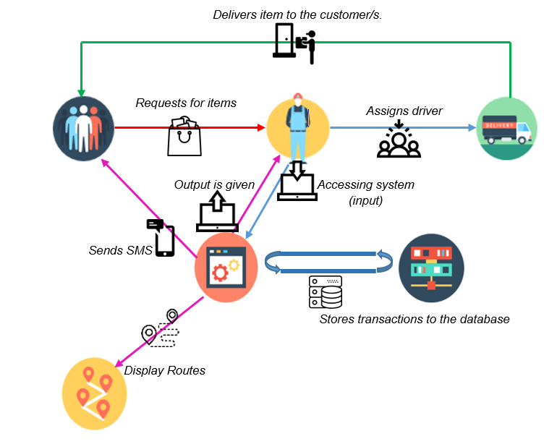**4.1 Conceptual Framework**

*Figure 1.* New business process with the system implementation

This is the new business process through the implementation of the HATOD system. The customer makes a transaction with the clerk-in-charge to order and the clerk-in-charge registers the customer’s information and orders to the system and the delivery personnel delivers the item ordered back to the customer, in the process an SMS message will be sent to the customer once the delivery is on its way. All important information is recorded in the system and stored in the database.

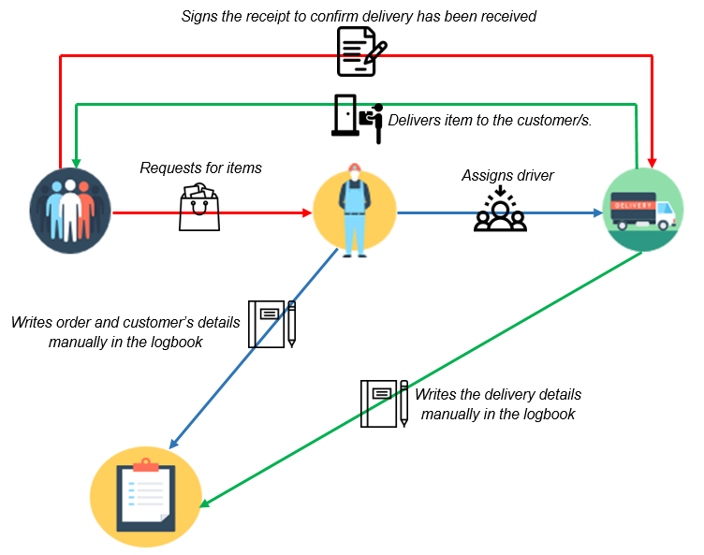

*Figure 2. Old Business Process*

The old business process may look as simple as it is, but the efficiency of this business process is very low. Every transaction done by the customer, clerk-in charge and delivery personnel has to be written on a log book.

**4.2 Analysis and Design**

*Figure* *3.* Entity-Relationship Diagram

The customer has an account made by the administrator after ordering. After which the sales personnel gets the orders that the customers ordered with the status of pending then the items are prepared for delivery the status is changed to processed then items are ready for delivery assigned to delivery personnel after it was delivered status changed as delivered then when the delivery personnel arrive back in the hardware after the ordered items are delivered the status is changed to received.

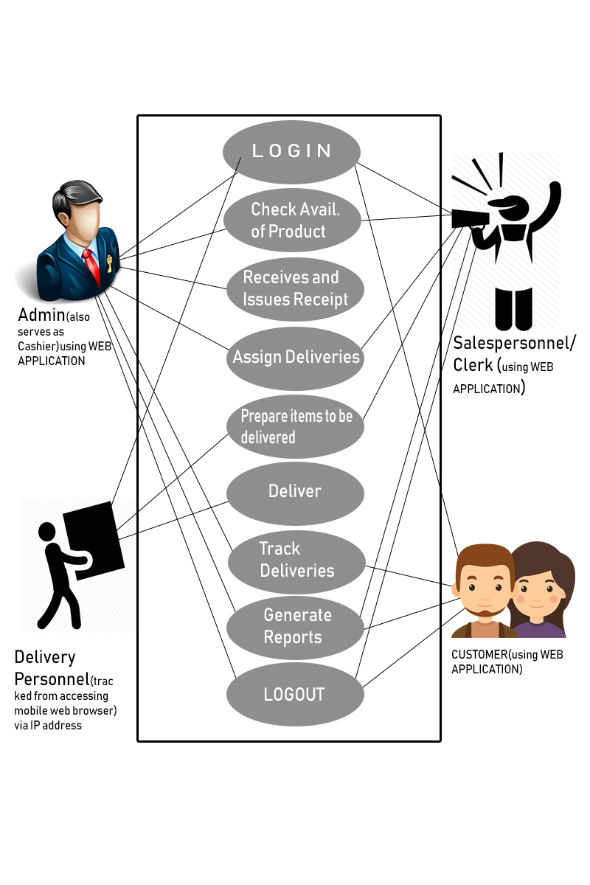

*Figure 4. Use-Case Diagram*

The admin handles major operations using the system by creating and tracking of order, create account for customers (updating customer details/password) and can view previous transactions made. The customer can log in to his/her account, update account details and can view transaction history. The delivery personnel accept the delivery assigned to him/her and confirms delivery status.

Table 2

*Use-Case Diagram overall scenarios*

|  |  |  |  |  |  |
| --- | --- | --- | --- | --- | --- |
| CASE | DESCRIPTION | ACTOR | | | |
|  |  | Admin | Customer | Clerk | Delivery Personnel |
| Login | Logging in the system | ✓ | ✓ | ✓ | ✓ |
| Check Availability of Product | Checking of Product if Available to be sold | ✓ |  | ✓ |  |
| Receives and Issues Receipt | Receiving Money and Issuing Receipt | ✓ |  |  |  |
| Assign Deliveries | Assigning Delivery to Delivery Personnel | ✓ |  | ✓ |  |
| Prepare items to be delivered | Item Preparation for delivery |  |  | ✓ | ✓ |
| Deliver | Delivering items ordered to the customer |  |  |  | ✓ |
| Track Deliveries | Tracking the delivery | ✓ | ✓ |  |  |
| Generate Reports | List of transaction orders | ✓ | ✓ | ✓ | ✓ |
| Logout | Signing out in the system | ✓ | ✓ | ✓ | ✓ |

**4.3 Development Method**

The researchers developed the system through the Rapid Application Development (RAD) methodology. This model uses the essential planning methods in order to amplify the effectiveness of fast prototyping. A prototype is a functional module (subsystem) of the whole system. The researchers have developed prototypes in parallel and have integrated them producing a faster application deployment. Because there is no strict planning, it makes it easier to incorporate changes within the development process. The most important aspect for this model to be successful is to make sure that the developed prototypes are reusable.

Prototyping Process

*Figure 5.* Rapid Application Development Model

Implementation

Testing

Planning/Analysis

**Planning and Analysis.** The researchers gathered data and information during this phase. Site visits were done in order to observe the enterprise’s business process and for further understanding, current delivery tracking systems were analyzed to enhance the system’s functionalities and general objectives.

**Prototyping Process.** This is a 3-step cycle that involved incorporating individual modules by using the data and information gathered. The researchers developed prototypes and selected the best prototype to be used and to further develop. This step was repeated as often as necessary as the project evolved.

**Building and designing.** The user interface was given great emphasis and focus to determine the system architecture through the data and information gathered. The researchers designed and built modules using code compiling softwares like Sublime and Bootstrap templates.

**Refining.** The prototype was further enhanced enabling the developers to have a stable system architecture. The Laravel computer framework was used to establish the frontend and backend of the module.

**Demonstrating.** This process evaluated the module. It was evaluated by its functionality and user friendliness. Modules were executed and compiled to uncovered the bugs and errors. Lapses, bugs and problems were managed and solved.

**Testing.** The selected prototype/s and its module/s with less to no errors and bugs were compiled. The selected prototype was deployed on a blackbox tester software to further find errors and to upgrade some functionalities. This process is critical in order to ensure the system's performance.

**Implementing.** Provided an “accepted” user acceptance test by the black box tester, the system was installed on site and further upgrades and maintenance was provided by the researchers. The beta version of the system was also deployed.

**4.4 Development Approach**

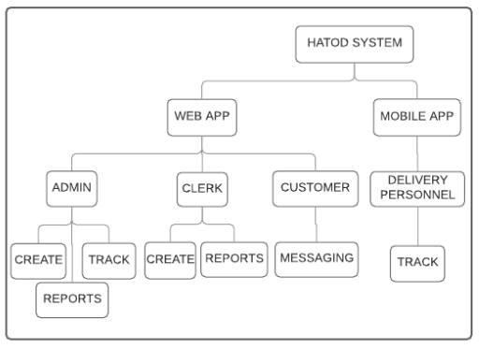

*Figure 6.* Top-Down Development Approach

The researchers used the top-down approach, envisioning from a wider perspective for future development. The researchers started by determining the advantages and disadvantages of the current business process of Duane and Dwight Enterprise, additionally a research was done about existing delivery tracking systems in order to gather data and information, after which it was determined as to how these existing systems could be enhanced. Furthermore, modifications were made, this was done to aid the researchers in creating a customizable and flexible delivery tracking system for Duane and Dwight Enterprise, thus implementing HATOD to aid the business process of the enterprise.

**Admin module**. In this module, the administrator (owner) has the full capabilities to manage, access and regulate the system by creating, updating, searching and deleting an item, personnel, customer vehicle and cancel orders. The admin can also track the location on the on-going delivery transactions.

**Clerk module**. The clerk can add new customer and order, view order list and track order status of the transaction made by the customer. The clerk can also generate reports on the past transactions by the customers using the filtering function and view details on the selected orders of the customer.

**Delivery** **personnel module**. The delivery personnel used the tracking mobile application for location tracking. The system sends a SMS message to the customer that the delivery is already coming and will update to the customer on the current location of the ongoing delivery.

**Customer module**. The customer can view the order transaction details made and status of the delivery transaction given an account made by the admin. The customer receives a message

**4.5 Software Development tools**

This is the complete list of applications, tools used in the research study. The version, tool number, description and the origin as the time it was written are included in this section.

Table 3

*Software Development Tools*

|  |  |  |  |
| --- | --- | --- | --- |
| Sublime Text | Code editor in building up the system. | Build 3126 | https://www.sublimetext.com/ |
| Visual Studio  Code | Source code editor in the process of constructing the system. | Version 1.4 | https://code.visualstudio.com |
| Github | For hosting and graphical interface, access control. | Not Available | https://about.gitlab.com/ |
| MySQL | Management operations, applying database and to all objects. | Version 5.7 | https://www.mysql.com/ |
| iTexMo SMS | Instant messaging for sms notifcation | Version: 4.0.2.6 | https://www.itexmo.com |
| Android Application | Android mobile operating system | Android Lollipop version 5.1 | https://developer.android.com |

**4.6 Project Management**

**4.6.1 Schedule and Timeline**

This is the scheduled list of the time for the development of the system. This is the representation of the time needed to work on a certain objective and achieve the goal of the research.

Table 4

*Scheduling Table for the first half of deployment of the system*

|  |  |  |  |  |  |  |  |  |  |  |  |  |  |  |  |  |  |  |  |  |
| --- | --- | --- | --- | --- | --- | --- | --- | --- | --- | --- | --- | --- | --- | --- | --- | --- | --- | --- | --- | --- |
|  | November (weeks) | | | | December (weeks) | | | | January (weeks) | | | | February (weeks) | | | | March (weeks) | | | |
|  | 1 | 2 | 3 | 4 | 1 | 2 | 3 | 4 | 1 | 2 | 3 | 4 | 1 | 2 | 3 | 4 | 1 | 2 | 3 | 4 |
| **Planning** |  |  |  |  |  |  |  |  |  |  |  |  |  |  |  |  |  |  |  |  |
| *Prototype building (frontend)* |  |  |  |  |  |  |  |  |  |  |  |  |  |  |  |  |  |  |  |  |
| **Admin’s functionalities** |  |  |  |  |  |  |  |  |  |  |  |  |  |  |  |  |  |  |  |  |
| Building |  |  |  |  |  |  |  |  |  |  |  |  |  |  |  |  |  |  |  |  |
| Refining |  |  |  |  |  |  |  |  |  |  |  |  |  |  |  |  |  |  |  |  |
| Demonstration |  |  |  |  |  |  |  |  |  |  |  |  |  |  |  |  |  |  |  |  |
| **Clerk’s functionalities** |  |  |  |  |  |  |  |  |  |  |  |  |  |  |  |  |  |  |  |  |
| Building |  |  |  |  |  |  |  |  |  |  |  |  |  |  |  |  |  |  |  |  |
| Refining |  |  |  |  |  |  |  |  |  |  |  |  |  |  |  |  |  |  |  |  |
| Demonstration |  |  |  |  |  |  |  |  |  |  |  |  |  |  |  |  |  |  |  |  |
| **Customer’s functionalities** |  |  |  |  |  |  |  |  |  |  |  |  |  |  |  |  |  |  |  |  |
| Building |  |  |  |  |  |  |  |  |  |  |  |  |  |  |  |  |  |  |  |  |
| Refining |  |  |  |  |  |  |  |  |  |  |  |  |  |  |  |  |  |  |  |  |
| Demonstration |  |  |  |  |  |  |  |  |  |  |  |  |  |  |  |  |  |  |  |  |
| *Implementation of system (frontend)* |  |  |  |  |  |  |  |  |  |  |  |  |  |  |  |  |  |  |  |  |

Table 4.1

*Scheduling Table for the final half deployment of the system*

|  |  |  |  |  |  |  |  |  |  |  |  |  |  |  |  |  |
| --- | --- | --- | --- | --- | --- | --- | --- | --- | --- | --- | --- | --- | --- | --- | --- | --- |
|  | April  (weeks) | | | | May  (weeks) | | | | June  (weeks) | | | | July  (weeks) | | | |
|  | 1 | 2 | 3 | 4 | 1 | 2 | 3 | 4 | 1 | 2 | 3 | 4 | 1 | 2 | 3 | 4 |
| *Prototype building (backend)* |  |  |  |  |  |  |  |  |  |  |  |  |  |  |  |  |
| **Admin’s functionalities** |  |  |  |  |  |  |  |  |  |  |  |  |  |  |  |  |
| Building |  |  |  |  |  |  |  |  |  |  |  |  |  |  |  |  |
| Refining |  |  |  |  |  |  |  |  |  |  |  |  |  |  |  |  |
| Demonstration |  |  |  |  |  |  |  |  |  |  |  |  |  |  |  |  |
| **Clerk’s functionalities** |  |  |  |  |  |  |  |  |  |  |  |  |  |  |  |  |
| Building |  |  |  |  |  |  |  |  |  |  |  |  |  |  |  |  |
| Refining |  |  |  |  |  |  |  |  |  |  |  |  |  |  |  |  |
| Demonstration |  |  |  |  |  |  |  |  |  |  |  |  |  |  |  |  |
| **Customer’s functionalities** |  |  |  |  |  |  |  |  |  |  |  |  |  |  |  |  |
| Building |  |  |  |  |  |  |  |  |  |  |  |  |  |  |  |  |
| Refining |  |  |  |  |  |  |  |  |  |  |  |  |  |  |  |  |
| Demonstration |  |  |  |  |  |  |  |  |  |  |  |  |  |  |  |  |
| *Implementation of system (backend)* |  |  |  |  |  |  |  |  |  |  |  |  |  |  |  |  |
| **Black-box testing** |  |  |  |  |  |  |  |  |  |  |  |  |  |  |  |  |
| **Implementation** |  |  |  |  |  |  |  |  |  |  |  |  |  |  |  |  |

**4.6.2 Responsibilities**

The presentation of the tasks divided unto the assigned researcher(s). By assigning the tasks, it helped the researchers follow the scheduled list thoroughly.

Back-end: Kaindoy and Galicinao

Front-End: Pepino and Manos

Table 5

*Division of Tasks*

|  |  |
| --- | --- |
| **Task** | **Assigned Researcher** |
| Proposal and Documentation | Galicinao, Kaindoy, Manos, Pepino |
| Mockup Design for Web App | Kaindoy |
| Determining Data Models | Manos, Pepino |
| Backend Implementation | Galicinao, Kaindoy |
| Maps API for Web | Galicinao, Kaindoy |
| SMS API module | Galicinao, Kaindoy |
| **Web Application Development** |  |
| Admin Module (frontend) & (backend) | Manos, Pepino & Galicinao, Kaindoy |
| Clerk Module (frontend) & (backend) | Manos, Pepino & Galicinao, Kaindoy |
| Driver Module (frontend) & (backend) | Manos, Kaindoy & Galicinao, Kaindoy |
| Testing and Debugging | Galicinao, Kaindoy, Manos, Pepino |
| Implementation and Deployment | Galicinao, Kaindoy, Manos, Pepino |

**4.6.3 Budget and Cost Management**

The presentation of the budget and cost allocated by the researchers for the cost management of the research.

Table 6

*Budgeting and Costing*

|  |  |
| --- | --- |
| **Activity** | **Cost** |
| ***Documentation:***  A. Lenovo ideapad 310 laptop  B. Printing of System documentations, reports, forms and final thesis document.  C. Printer Inks and bond papers  D. Monthly prepaid internet connection | = P 30,000.00  = P 10,000.00  = P 3,000.00  = P 300.00 |
| ***System Implementation:***  A. (1) Administrator PC  B. (3) Clerk-in-charge PC  C. Monthly broadband internet connection  D. (5) Mobile Cellphones  E. Monthly prepaid internet connection  F. Web domain | = P 20,000.00  = P 60,000.00 (P 20,000.00 * 3)  = P 2,500.00  = P 17, 500.00 (P 3,500.00 * 5)  = P 1,500 (P 300 * 5)  = P 300.00 |
| **Overall Total:** | **P 145, 100.00** |

**4.7. Verification, Validation and Testing**

The researchers of the system authenticated each functionality through black-box testing. 5 programmers conducted the Black Box Testing, while 5 clerk-in charge, 4 delivery personnel and Mr. Kaindoy conducted the User Acceptance Testing.

The system’s functionalities and specifications were tested and examined through the black box testing (verification) and user acceptance testing (validation). The Black Box Testing will have 25 test cases that will be tested individually by 5 programmers. Each test cases will be defined as “Accepted” or “Not Accepted” if they meet the expected results. The User Acceptance Testing will be done by the employees and Mr. Kaindoy, the system will be rated according to its functionality, reliability, usability, efficiency, maintainability and support and manuals. The average scores in the UAT will be totaled and will be interpreted as Very Acceptable, Acceptable, Moderately Acceptable and Not Acceptable.

**CHAPTER 5**

**RESULTS AND ANALYSIS**

**Survey Results**

During the early dates of this research, we had a site visit and observed the business process of Duane and Dwight Enterprise. We then conducted a survey about how the respondents find the business process of the enterprise effective. We asked 5 clerk-in-charge and 5 delivery personnel. The survey consisted with 6 survey questions for the clerk-in charge and 5 survey questions for the delivery personnel.

*Figure 7.* Survey Results for the Clerk-In Charge.

The clerk’s survey results showed that, most clerks have at least 20 transactions to cater every day while some may have at least 16 transactions in a day. The result also showed that the clerk has to write these transactions down on a log book taking them a lot of time in doing so and they have to keep these transactions on a logbook. This shows that efficiency is at risk when a clerk has to manually write down these transactions, it also manifests that by keeping the transactions on a logbook would become a dilemma if they were misplaced and/or improperly kept. However, it also showed that the clerks in Duane and Dwight Enterprise highly agree that implementing an automated system would be a great help to them.

*Figure 8.* Survey Results for the Delivery Personnel

The delivery personnel’s survey results showed that they receive at least 11 transactions that has a request for delivery. And most of the time they find it hard to locate a customer’s address and often ask some people about the customer’s address just to locate it, that as a result they sometimes arrive late to the location. The delivery personnel in Duane and Dwight Enterprise also highly agree that implementing an automated system would be a great help to them especially in locating a customer’s address.

**System’s Capabilities**

* The system is capable of adding an admin user account that can add personnel, products, vehicles, and customers.
* The system is capable of adding orders and generating daily, weekly, monthly and yearly reports.
* The system is capable of tracking orders through the tracking app provided.
* The system is capable of sending SMS notifications of the delivery’s status to the customers.

See Appendix E for detailed Software Requirements Specifications**.**

**Major Modules**

The system has these following major modules:

* Admin –has the following modules
* Create – a module that can add (as well as delete) personnel, products, vehicles, customers and orders.
* Reports – a module that can generate a summary of all the transactions that was made daily, weekly, monthly and yearly.
* Track – a module that can track a vehicle in-real time.
* SMS Notification – a module that sends an SMS notification to a customer about his/her delivery status.
* Profile – organizes the information of the admin
* Clerk – has the following modules:
* Create – a module that can add customers and orders.
* Reports – a module that can generate a summary of all the transactions that was made daily, weekly, monthly and yearly.
* Profile – organizes the information of the clerk.
* Delivery personnel –has the following modules:
* Track – a module that can track the delivery personnel’s vehicle in-real time.
* Profile – organizes the information of the delivery personnel
* Customer –has the following modules:
* SMS Notification – a module that sends an SMS notification to a customer about his/her delivery status.
* Profile – organizes the information of the customer.

See Appendix F for detailed Functional Requirements

**Verification (Black Box Testing)**

The HATOD delivery tracking system was tested on May 21, 2018 by the following testers:

* Karen Gabaca
* Bebie Mae Montalban
* Miguel Sarmiento
* Romei Agapoy
* Kevin Styx Kapunan

After executing a test, the decision is defined according to the following rules:

* Acceptable – the test sheet is set to “Acceptable” status if the actual result meets the expected result.
* Not Acceptable – the test sheet is set to “Not Acceptable” status if the actual result does not meet the expected result.

There are 25 test cases being tested by the testers.

Table 7

*Black Box Testing Results*

|  |  |  |  |  |  |
| --- | --- | --- | --- | --- | --- |
| Test Case # | Tester #1 | Tester #2 | Tester #3 | Tester #4 | Tester #5 |
| 1 |  |  |  |  |  |
| 2 |  |  |  |  |  |
| 3 |  |  |  |  |  |
| 4 |  |  |  |  |  |
| 5 |  |  |  |  |  |
| 6 |  |  |  |  |  |
| 7 | O | O | O |  |  |
| 8 |  |  |  |  |  |
| 9 |  |  |  |  |  |
| 10 | O | O | O | O |  |
| 11 | O |  |  |  |  |
| 12 | O |  | O | O |  |
| 13 |  |  |  |  |  |
| 14 |  |  |  |  |  |
| 15 |  |  |  |  |  |
| 16 | O | O | O | O |  |
| 17 |  |  |  |  |  |
| 18 | O |  |  | O |  |
| 19 |  |  |  |  |  |
| 20 |  |  |  |  |  |
| 21 |  |  |  |  |  |
| 22 |  |  |  |  |  |
| 23 |  |  |  |  |  |
| 24 |  |  |  |  |  |
| 25 |  |  |  |  |  |

See Appendix G for Detailed and Sample Test Cases (Black Box Testing)

The table showed the testers’ decision after executing the test cases whether its “Accepted” or “Not Accepted”. The testing was done by our fellow programmer colleagues, and debugging was done after the black box testing was done. Some of the bugs was caused by software failures.

*Figure 9.* Pie Chart of the total percentage of "Accepted" and "Not Accepted" Test Cases

The pie chart represents the calculated total percentage of the test cases that were accepted and not accepted. The summarized result reflects the overview of bugs and errors that needs to be debugged.

**Validation (User Acceptance Testing)**

The HATOD System was tested from May 21-23, 2018 by the following users of the system: (1) Mr. Daniel Kaindoy – considered as the admin user, (5) clerk-in-charge, (4) delivery personnel. The system was tested based on functionality, reliability, usability, efficiency, maintainability, support and manuals.

Table 8

*User Acceptance Average Rating Summary*

|  |  |
| --- | --- |
| Criteria | Total Score |
| 1. Functionality | Total score / no. of sub questions = 4.8 |
| 2. Reliability | Total score / no. of sub questions = 4.4 |
| 3. Usability | Total score / no. of sub questions = 4..8 |
| 4. Efficiency | Total score / no. of sub questions = 4.8 |
| 5. Maintainability | Total score / no. of sub questions = 4.0 |
| 6. Support and Manuals | Total score / no. of sub questions = 4.0 |

See Appendix H for detailed User Acceptance Testing.

*Figure 10.* User Acceptance Rating Average Graph

Average Score Interpretation

4.1 – 5.0 – Very Acceptable

3.1 – 4.0 – Acceptable

2.1 – 3.0 – Moderately Acceptable

1.0 – 2.0 – Not Acceptable

There were 10 respondents during the User Acceptance Testing. The 10 respondents were all employees at the Duane and Dwight Enterprise. Figure 7 shows that the average score for the functionality criteria is at 4.8, in which it interprets that the respondents find it as Very Acceptable in terms of the system’s objectives of accuracy and security. The Reliability criteria was also rated as Very Acceptable having a 4.4 average score in terms of data validity and recoverability. While both Usability and Efficiency had a 4.8 average score interpreting to Very Acceptable in terms of understandability, learnability, operability, attractiveness for Usability and ease of strap-up, resource utilization and time behavior for Efficiency. Also, both Maintainability and Support Manuals criteria had an average of 4.0 interpreting to Acceptable in terms of installability, testability, undestandability and visual references. Overall, the User Acceptance Testing the system had an average score of 4.4 interpreting as Very Acceptable.

**CHAPTER 6**

**CONCLUSION AND RECOMMENDATION**

In conclusion, the development of this research preceded to the implementation of a web based delivery tracking system for the Duane and Dwight Enterprise.

The survey conducted to the clerks-in charge and delivery personnel showed, that they were in need of assistance in boosting the efficiency of catering the orders, transactions and delivery requests from the customers. Furthermore, the analysis of the current business process of the Duane and Dwight Enterprise provided a better understanding and methodology to enhance its own business process effectively. Developing the H.A.T.O.D delivery tracking system provided them an efficient aid in making the orders, transactions and delivery requests, most especially it boosted the enterprise’s capabilities in receiving orders, transactions and delivery requests as a result also. The design and development of the delivery tracking system was made easily and proficiently through the Laravel PHP framework together with the creative Bootstrap and custom CSS lay outing.

An evaluation of the system was made in Duane and Dwight Enterprise’s main branch in Masiwa, Soong, Lapu-lapu City by the clerk-in charge and delivery personnel. A verified Black Box Testing with 25 test cases was also conducted by 5 programmers with a result of 80% acceptable rating and a validated User Acceptance Testing conducted by 10 testers gave the system an overall 4.4 average score interprets a Very Acceptable result. The overall results of this research may opt to guide researchers in developing a delivery tracking system for small or starting businesses. In today’s innovative and rapidly upgrading technology, it is important to adapt and upgrade to these innovations.

To further improve the system, the researchers recommend to add a customer module that allows them to order online and access the system’s ordering module without having to personally visit the site, future researchers may also include a customer’s profile account and provide membership incentives. Having its own “POS” (Point of Sales) accounting module and inventory module will also significantly improve the system, instead of statically selecting the mode of payment whether the customer paid through cash or credit card.

**GLOSSARY**

**Admin** – owner of the enterprise.

**Customer** – a person who buys goods from the client’s enterprise.

**Clerk-in-charge** – a person who works on the sales counter.

**Delivery** – to transport on the proper place or recipient.

**Delivery Personnel** – a person who delivers a specific ordered items to the customer.

**Order** – a request made by a customer.

**Route** – a way taken in getting from a starting point to the destination.

**SMS (Short Message Service)** – text messaging service on mobile phones.

**Track** – to follow the course in order to find the location of a delivery vehicle.

# **BIBLIOGRAPHY**

**Book**

Figueiras , J., & Frattasi, S. (2010). *Mobile Positioning and Tracking.* United Kingdom: John Wiley and Sons Publication.

Hillebrand, F., Trosby, F., Holley, K., & Harris, I. (2010). *Short Message Service (SMS) The creation of Personal Global Text Messaging.* United Kingdom: John Wiley and Sons.

Hooft, M., & Brown-Martin, G. (2009). *Anywhere anytime learning with wireless mobile devices.* IGI Global.

Kennedy, M. (2010). *The Global Positioning System and ArcGIS.* Boca Raton Florida: Taylor and Francis Group.

Prencipe, A., Davies, A., & Hobday, M. (2005). *The business of systems integration.* New York: Oxford University Press Inc.

Scheer, A. (2000). *ARIS (Architecture of Integrated Information Systems) -business process modeling.* Heidelberg: Springer Berlin Heidelberg.

**Journal Article**

Chaudhari, A., Bohra, S., Karma, H., & Dhupadale, A. (2015). GPS/GSM Enabled Person Tracking System. *International Journal of Innovative Research in Science, Engineering and Technology*.

Cho, V., & Hung, H. (2011). The Effectiveness of Short Message Service for Communication with Concerns of Privacy Protection and Conflict Avoidance. *Journal of Computer-Mediated Communication*, 250-270.

Dhumal, A. (2015). Vehicle Tracking System using GPS and Android OS. *International Journal of Advanced Research in Computer Engineering and Technology*.

Julasiri, A.-R., Hernandez, K. J., Uy, I. C., & Remedio, E. J. (2017). CARGO TRACKING SYSTEM.

Petrevski, V., Josimovski, S., & Kiselicki, M. (2017). BUSINESS PROCESS IMPROVEMENT OF THE SYSTEM INTEGRATOR COMPANIES THROUGH A CASE STUDY ANALYSIS. *Journal of Sustainable Development*.

Sasikiran, N., GovindaRao, N., GovindaRao, N., Jeswanth Krishna Kumar, S., & Murari, G. (2015). Global System For Mobile Communication. *International Journal of scientific research and management (IJSRM)*, 2545-2549.

Sumit, R., & Ajila, P. (2015). Transport Tracking System using GPS and GSM module. *International Journal of Innovative Research in Science, Engineering and Technology*.

Tang, M., Chou, C., Tang, C., Pan, D., & Shih, W. (2001). Exploiting GSM short message service for ubiquitous accessing. *Journal of Network and Computer Applications*, 249-267.

**Web Article**

Abdurohman, M., Herutomo, A., Suryani , V., Elmangoush, A., & Magedanz, T. (2013). Mobile Tracking System Using OpenMTC Platform based on event driven method.

Bhatia, J., & Verma, P. (2013). Retrieved from Design and Development of GPS-GSM based tracking System with Google Map based monitoring: http://airccse.org/journal/ijcsea/papers/3313ijcsea04.pdf

Hecker, A., & Badra, M. (2008). *Security in 4G.* IGI Global.

Horecny, V. (2015). *Can we trust a GPS technology to deliver accurate location on a smatphone device?* Retrieved from computing.derby.ac.uk: https://computing.derby.ac.uk/c/wp- content/uploads/2015/10/Horecny-Dissertation.pdf

Prasad, S. (2013). Retrieved from Cargo Management System: http://www.freestudentprojects.com/phpscript/cargo-managementsystem/

Villareal, D., Guzman, B., Jose, K., & Macapagal, P. (2013). *Delivery Van Tracking System.* Retrieved from http://pages.upd.edu.ph/dvillareal/publications/delivery-van-tracking-system-0