Relaciones de Varios a Varios
One to Many
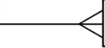

One album to many tracks.
JOIN Album.id ON Track.album_id
Here one Album.id is a one to many Track.album_id
Track.album_id is a many to one Album.id

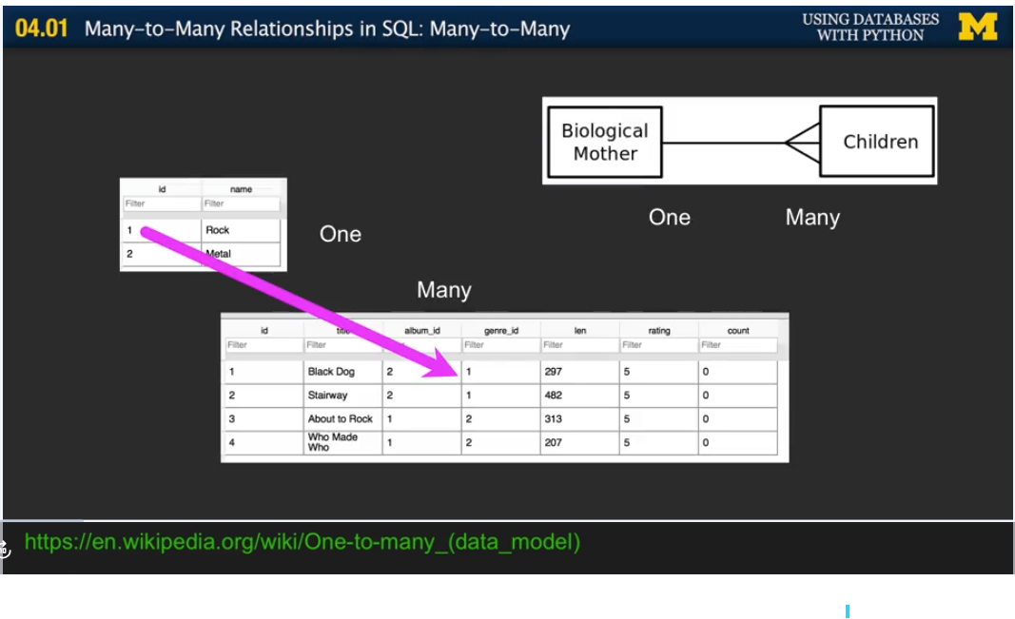

Maybe genetics database could be a good example of how dabases could work.
Make a database of a hedgefund.
TV catalogue data.
Commodities

Many to many
Books and Authors: many authors to many books and many books to many authors. Here we need to add a “connection” table with two foreign keys. There is usually no separate primary key.
- What we can model is a many to one to the “Junction table” afrom both sides.
- The junction table will have two foreign keys and no primary key.
- CREATE TABLE BooksandAuthors(books_id VARCHAR(128), authors_id VARCHAR(128));
- CREATE TABLE Books(id INTEGER PRIMARY KEY AUTOINCREMENT UNIQUE, books VARCHAR(128))
- CREATE TABLE Authors(id INTEGER PRIMARY KEY AUTOINCREMENT UNIQUE, authors VARCHAR(128))

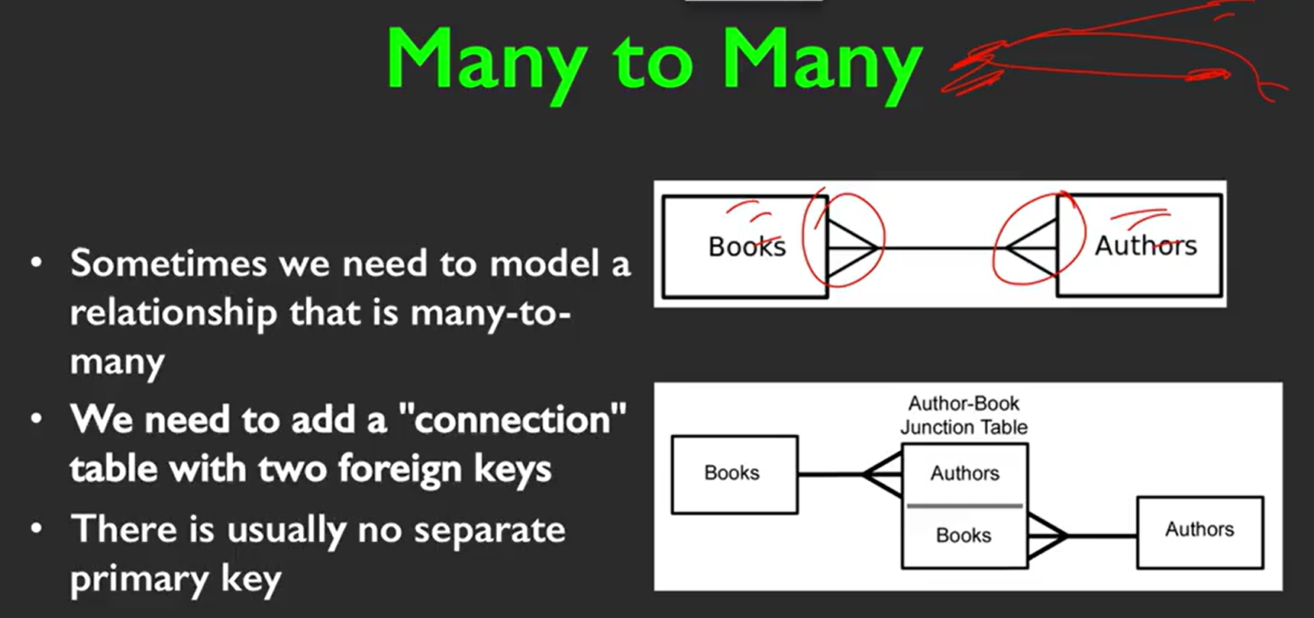

Another example:

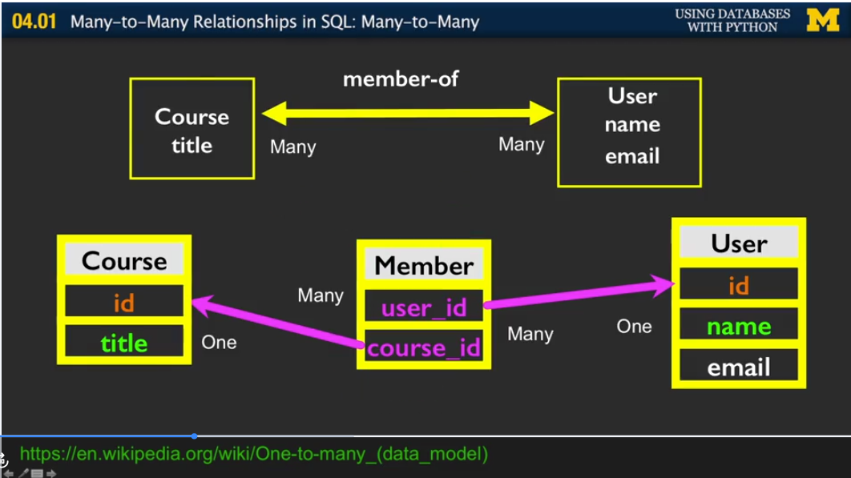

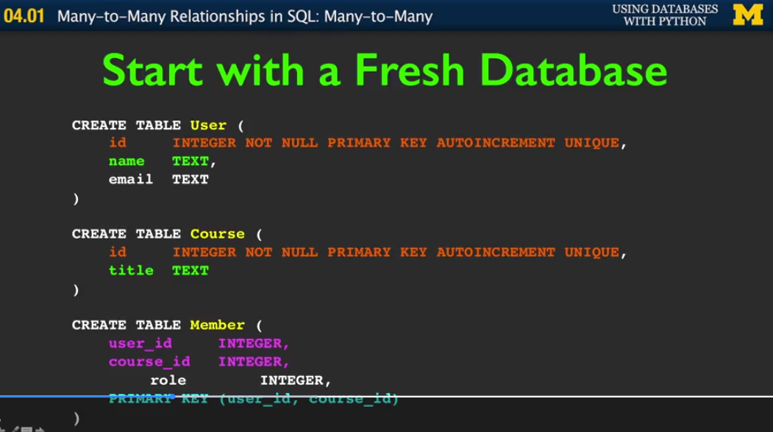

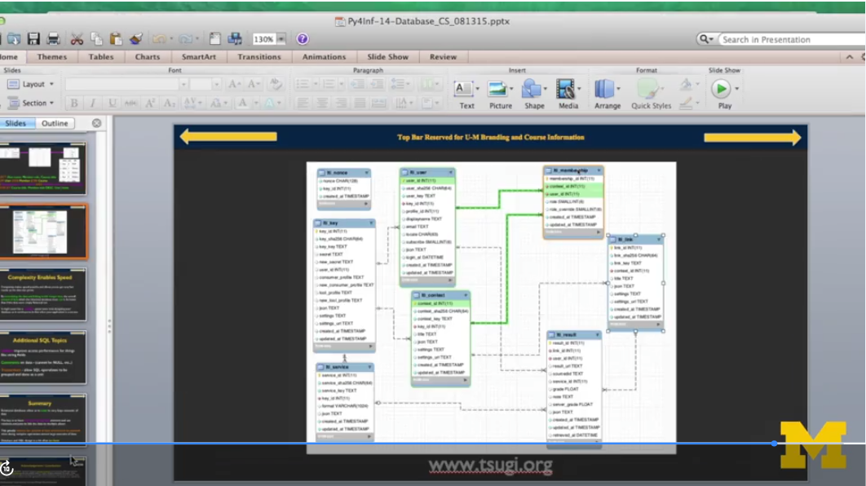

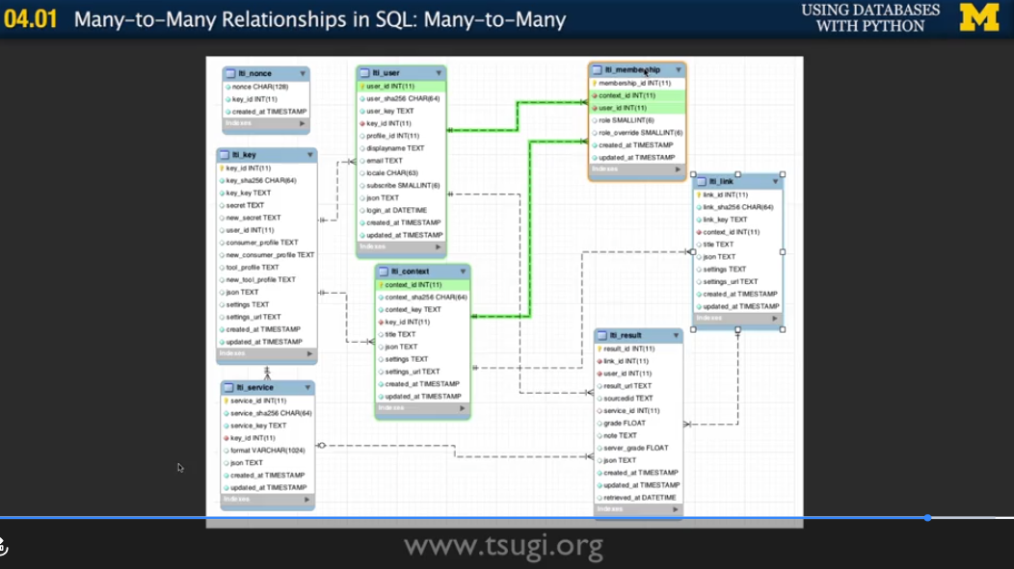

- All relations are meaningful when information is dynamic or even gargantuan.
- We should pay attention to indexes, like logical keys and lookups for strings.
- We should elaborate on constrains (NOT NULL).
- Also, it is important to hold a mental map of all transactions that a dialect of SQL may offer. This is meaningful since it allows to group operations that may impose restriction on data retrieval or even broden the spectrum that data can relate to each other.

