Geocodificación
- Multisteps programs.
- Multi-step Data Analysis

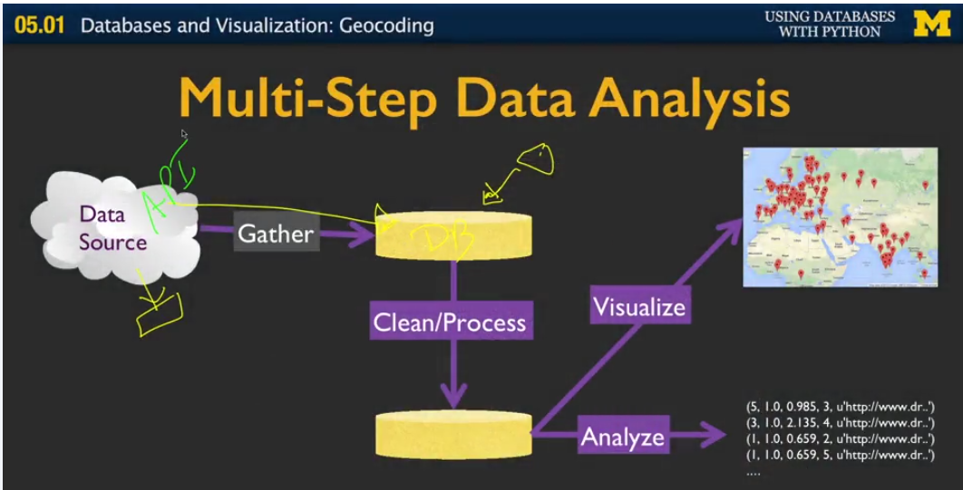

The following step can represent a lot of problems, therefore has to be on it’s own team. This means the process is restartable without compromising the rest of the application.
- Data Source (API) → Gather → Raw

- Raw data → Clean/Process → Organized Data

- Organized Data → → (Visualize, Analyze)

For more indepth tools you should take a look at:
- hadoop
- apache spark
- Amazon redshift
- pentaho

Personal Data Mining:

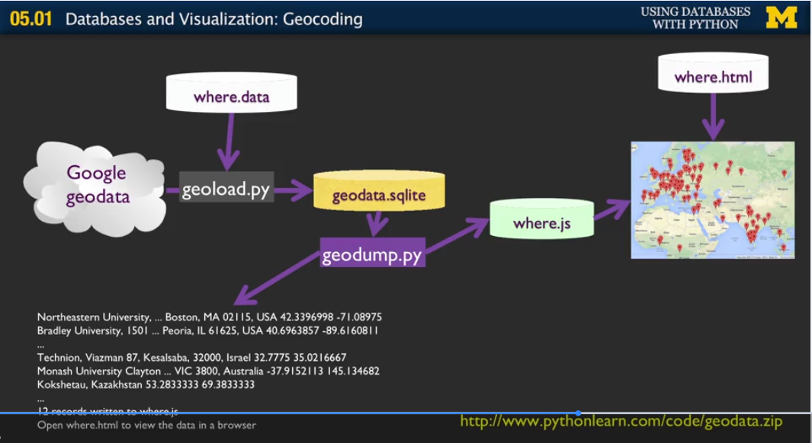
Data cache: is a local copy of something that is elsewhere.

