International Merchandise Trade Statistics Highlights

*A simple report*

Christophe Bontemps (SIAP)[1]

# Loading the data

Mydata <- read.csv("Data/TradeData.csv")

# Statistics

## Main Exports over the whole period

### As a table

# Calculate total value by principle export type  
CommodityByType <- Mydata %>%  
 group_by(Principle_Exports) %>%  
 summarise(total = sum(Stat_Value)) %>%  
 arrange(desc(total))

# Table display  
# To reduce the homogenization efforts and the number of functions to be called,   
# it is recommended to define formatting properties once and for all  
  
set_flextable_defaults(  
 font.size = 10, table.layout = "autofit")  
  
# Printing the table  
flextable(CommodityByType)

| Principle_Exports | total |
| --- | --- |
| Alcoholic Drinks | 14,908.72 |
| Wood | 4,765.27 |
| Kava | 2,699.67 |
| Coffee | 1,340.77 |
| Coconut Oil | 1,051.49 |
| Cocoa | 957.56 |
| Beef | 409.04 |
| Cowhides | 247.46 |
| Vanilla | 167.25 |
| Copra | 148.90 |

Or as a graphic:

# Plot the exports  
CommodityByType %>%  
 ggplot(aes(x = reorder(Principle_Exports, total), y = (total))) +  
 geom_bar(stat = "identity",   
 fill= "lightsteelblue1") +  
 labs(title ="Exports from Vanuatu [ 2000-2010] ",   
 subtitle = "Vanuatu National Statistical Office",   
 x= "Exports categories",  
 y = "Vatu") +  
 coord_flip() +  
 theme_minimal()

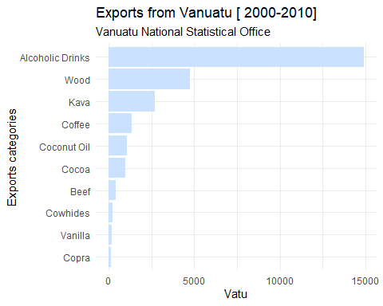

knitr::knit_exit()

1. Based on data and information from Vanuatu National Statistical Office (VNSO)