Final summary

As expected the simulation done with one doctor and one nurse faired the worst. After we added in the functionality of patients dying after they sit at severity 20 for a set about of time, the average wait time dropped quite dramatically to about 170 minutes of wait time per person. Though just under 450 people died in the simulation where a new patient arrived once every three minutes. At one person every four minutes the wait time dropped to only 17 minutes per person and no deaths. When there was only one person every 15 minutes, the wait time dropped to an average of 1.7 minutes each.

When there was one doctor and two nurses, at one person every three minutes the average wait time was 35 minutes and there was about 120 deaths. When it was one patient every four minutes, the wait dropped to 8.5 minutes with no deaths. Its smallest wait time was also when there was one patient every 15 minutes at 0.95 minutes each.

With two doctors and one nurse, the worst wait time was only 7.9 minutes each with no deaths. The next slowest was 2.5 minutes. It maxed out at 0.3 seconds of wait time per person. 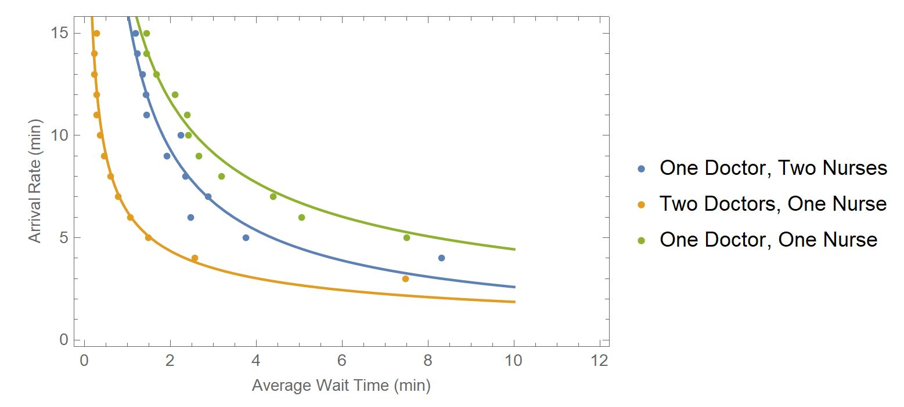

We didn’t change a ton from our original design but we added a few features that were not on the prompt. Patients tick upward on severity over time if they are not treated. We also went one step farther from that and added that if a patient is sitting at severity 20 for too long then they die and are removed entirely from the list of possible names.