Versions:

Date | Version | Authors | Comment
21.11.2017 | 0.1 | Coporiie Andreea  Stanciu Alexander | The first version of Saboteur project

Analisys&Design for Saboteur

Content:

- General Presentation

- Theoretical Fundamentals

- IT Technology

- Functionalities

- Actors and related access rights

- Use Case Diagrams

- System Architecture

- Design (UML Diagrams)

- Operation Mode (Operation Guide, including screen-shots)

- Portability

- Competing softwares

1. General Presentation

.
The main objective of this project is recreating the existent board game called Saboteur in a digital environment.
Saboteur is a board game for 3 to 10 players divided into 2 teams: the gold-diggers and the saboteurs. The game is turned based and it ends either if the gold piece is reached or there are no more cards that can be played by any of the players. In the original game, the deck has 44 path cards and 27 action cards. The road cards are rectangular and should be placed so that the road that they form makes sense (you can`t place them perpendicular or in a way that an open road on one card goes into the side with no road on the other).
The game setup starts with placing the start card on the board and under it, at a distance of 7 card widths` space (small side) the face down goals out of each one of them is the gold and the other 2 are coals.
On his turn, a player must play a card:

-on the path, if it is a path card

-in front of a player if it is an action card

-pass by putting a card face down in the discard pile

The player’s turn ends by drawing a card, if any left, or by playing the cards in hand until none are left.
The special cards are of 4 types: blocking, unblocking, rock-fall and vision:
- blocking cards: they prevent the player that has this type of card in front of them from playing a path cards on their turn, but they can play other cards. There are 3 symbols and one player can`t be blocked by the same symbol more than once
-unblocking cards: it is played on a blocked player which has the same symbol, they negate the effect of that blocking card and both cards
-rock-fall: destroys one of the path cards from the game board game
-vision cards: allows only the player who plays this type of card to look in secret at one of the 3 face down goal cards and then return it
When the uninterrupted road reaches one of the face down goal cards, the card is revealed and if it is the gold card, the game ends in the gold diggers victory. If the card was a coal card, the game continues until the gold card is revealed (gold diggers’ victory) or until the players can no longer play any cards (saboteurs’ victory).

- Theoretical Fundamentals

-dfs for the path
-matrix like board

- IT Technology

The project is developped on Windows 7 Operating System. The code is written in Python programming language with the help of PyCharm IDE (JetBeans PyCharm Community Edition 2017.2.4 x64). Several different modules are used to make the project possible, such as numpy and pygame libraries.
As this is a group project, effective communication and work were possible with the help of GitHub by creating a public repository and uploading the progress step by step and using version control to ensure the integrity of the project. The ability to rollback the project has proved extremely useful in various situations.
Other tools that have been used to successfully design the diagrams of the system are draw.io, and for the presentation, Microsoft Office and Microsoft PowerPoint.

- Functionalities

- Actors and related access rights

There are only two actors present in this project: the user, and the player.
The user is the actor that interacts with the main interface of the game. Right after opening the game, the user is requested to log in with valid data. If the log in is successful, he may choose between reading the game regulations, checking the highscores, connecting to an existing game server or creating and hosting a game by himself. The user is also able to log out fo the game and close it in case he does not want to play.
The player is the actor that represents the client part of the game. The players aim is trying to win the game by being a part of a team (diggers or saboteurs). To do this, at his turn, he must choose to play a path card, play an action card, or discard a card of his choice from his hand.
There are no particular access rights that must be specified regarding these actors. At most, we could say that by entering a game, the user becomes a player of the particular match.

- Use Case Diagrams

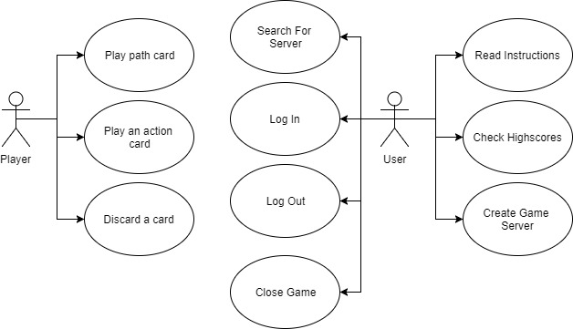

- System Architecture

- Design (aprox 12 UML Diagrams!!!)

- Operation Mode (Interactivity presentation) + screen shots (UI design)

….
By running the game one would get, at first, a small window to fill in with the correct username and password, in order to lo gin to the game. After a successful authentication another window becomes available with multiple options to choose from, represented in form of buttons and corresponding to the user’s use case diagram. These are:
Read Instructions: the user can read the game rules
----insert picture ----
Check highscores: the user can verify the ranking of the players
----insert picture----
Log Out: the user may let another user log in
Close Game: terminates the program
Create Game Server: the user decides to host the match and wait for other users to connect in order to start the game match
---insert picture----
Search for Game Server: the user searches for a created server to connect to and be able to play

After all the desired players are connected, the game starts.
The first look of the game looks like a huge board full of flipped cards which represent the ‘empty’ spaces, three goal cards (two coals, one gold) and only one unflipped starting card. The players are randomly split into the diggers and saboteurs teams, and are only aware of their own team and available cards.
--insert picture----

As this is a turn-based game, each player takes his turn to do an action and try to get as close as possible to his aim: dig for the gold, or try and stop the diggers from achieving their aim. This means playing a path card, action card, or simply discarding something, followed by drawing a new card as long as there are any available.
--inset picture with random moment in the middle of the game—

The game has 2 possible endings:
First, the diggers win by reaching the correct goal card, which is the golden one.
--insert picture----

The other one, the saboteurs win when the common stack of cards is empty and there are no more cards the players can use to get to the gold card.
--insert yet another picture---

At the end screen the players can see the score they obtained in the match and their overall score.
--woopty freaking doo possibly last screenshot-----

- Portability

By choosing Python as programming language it makes it possible for the developed system to be portable on any other operating system, including Linux and iOS.

- Competing software

Considering Saboteur is a game the competing software can be quite numerous.
The aim of the project is simulating an already existing board game, and so it could be said that there are other software which try to simulate already existing board games, however, none doing the exact same thing.
It can be said that Saboteur is a turn-based card game, so any game of this sort could be considered competition.

