Version overview

Date | Version | Authors | Comment
21.11.2017 | 0.1 | Coporiie Andreea  Stanciu Alexander | The first version of Saboteur project
16.01.2018 | 0.2 | Coporiie Andreea  Stanciu Alexander | No changes have been brought to the system requirements.

System requirements for Saboteur

1 Introduction 2
2 General view of actors and use cases 2
3 Detailed description of actors and use cases 3
3.1 Actors 3
3.1.1 User……………...…………………………………………………………………… ..3
3.1.2 Player……………….…………………………………………………………………..4
3.2 Use cases 4
3.2.1 Use Case for User………...……………………………………………………… ….4
3.2.2 Use case for Player……………………………………………………………..……..5
4 Glossary – used terms…………………………………………………………………………...6

Introduction
The main objective of this project is recreating the existent board game called Saboteur in a digital environment.
Saboteur is a board game for 3 to 10 players divided into 2 teams: the gold-diggers and the saboteurs. The game is turned based and it ends either if the gold piece is reached or there are no more cards that can be played by any of the players. In the original game, the deck has 44 path cards and 27 action cards. The road cards are rectangular and should be placed so that the road that they form makes sense (you can`t place them perpendicular or in a way that an open road on one card goes into the side with no road on the other).
The game setup starts with placing the start card on the board and under it, at a distance of 7 card widths` space (small side) the face down goals out of each one of them is the gold and the other 2 are coals.
On his turn, a player must play a card:

-on the path, if it is a path card

-in front of a player if it is an action card

-pass by putting a card face down in the discard pile

The player’s turn ends by drawing a card, if any left, or by playing the cards in hand until none are left.
The special cards are of 4 types: blocking, unblocking, rock-fall and vision:
- blocking cards: they prevent the player that has this type of card in front of them from playing a path cards on their turn, but they can play other cards. There are 3 symbols and one player can`t be blocked by the same symbol more than once

-unblocking cards: it is played on a blocked player which has the same symbol, they negate the effect of that blocking card and both cards

-rock-fall: destroys one of the path cards from the game board game

-vision cards: allows only the player who plays this type of card to look in secret at one of the 3 face down goal cards and then return it

When the uninterrupted road reaches one of the face down goal cards, the card is revealed and if it is the gold card, the game ends in the gold diggers victory. If the card was a coal card, the game continues until the gold card is revealed (gold diggers’ victory) or until the players can no longer play any cards (saboteurs’ victory).

General view of actors and use cases

Actor | Type | Description
User | Human | The person who wants to play a game; needs to log-in and search or create a game server.
Player | Human | The person who is already in a game; can be gold-digger or saboteur.

Use case | Actor | General description
Log In | User | The User fills in his log in information
Log Out | User | The User logs out of his profile
Search for Game Server | User | The User tries to connect to an existing game server
Create Game Server | User | The User creates a new game, hosting it on his computer
Read Instructions | User | The User is provided a list of game rules
Check Highscores | User | The User is provided a list of players with the highest scores
Close game | User | The User exits the game.
Play path card | Player | The Player selects a card from his hand to place on the board
Play action card | Player | The Player selects an action card to use against other players
Discard card | Player | The Player discards one of the cards in his hand.

Detailed description of actors and use cases

Actors

User

Type: human
Detailed description:
This actor is the person who decides to play the game and opens it. The user is supposed to log in with his information once the game is opened and has several choices to choose as actions. He is able to read the instructions of the game, to check highscores, and to actually start a game server or connect to an already existing one. Once logged in, the user may log out and/or quit the game at will.

Where is used:
This actor is used in the: “Log In” use case
. “Log Out “use case
“Search for Game Server” use case
“Create Game Server” use case
“Read Instructions” use case
“Check Highscores” use case
“Close Game” use case

Player

Type: human
Detailed description:
This actor represents the person that is already in a game match together with several other actors of the same kind. The role of the player is to play the game in a match. On his turn, the player may play a path card or an action card, or, if none are possible, just discard a card from his hand.

Where is used:
This actor is used in the: “Play path card” use case
. “Play action card” use case
“Discard card” use case

Use cases

Use Case for User
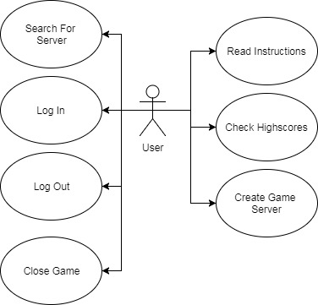

Description:
Actor: User
Precondition: Game is opened
Postcondition: Match starter or game is closed
Behavior: Please see Analysis & Design for Saboteur – 8. Design – Activity Diagram and State Diagram

Use Case for Player
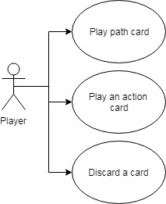

Description:
Actor: Player
Precondition: Be in a started match
Postcondition: Match is over
Behavior: Please see Analysis & Design for Saboteur – 8. Design – Activity Diagram and State Diagram

Glossary – used terms

Term | Use cases | Description
User account  authentication | User Log-in use case | Contains all the information needed by the administrator that wants to authenticate itself in the system using a user password schema
Path card | Player Play path card use case | Represents a type of card that can be played to get closer to achieving the final goal
Action card | Player Play action card use case | Represents a special card of different types that interacts with players or
Highscore | User Check Highscores use case | Provides a list of users with their respective scores accumulated in their games, in a decreasing order, representing a ranking.
Game server | Search for Game Server, Create Game Server | The platform that hosts the game for all the players, created by one of the users

Term Groups | Included terms and term groups | Description
Cards | Path cards, Action cards | Defines the items the players can use during their turns to get closer to victory

