Федеральное государственное автономное

образовательное учреждение

высшего образования

«СИБИРСКИЙ ФЕДЕРАЛЬНЫЙ УНИВЕРСИТЕТ»

Институт космических и информационных технологий

институт

Кафедра «Информатика»

кафедра

**ОТЧЕТ О ПРАКТИЧЕСКОЙ РАБОТЕ № 5**

Spring Security

тема

|  |  |  |
| --- | --- | --- |
| Преподаватель | ______________ | А.С. Кузнецов |
|  | подпись, дата | инициалы, фамилия |
| Студент КИ20-16/1б, 031945012 | __________ | Ф.В. Пироженко |
| номер группы, зачетной книжки | подпись, дата | инициалы, фамилия |

Красноярск 2022

**СОДЕРЖАНИЕ**

1 Цель 3

2 Задание 3

3 Ход выполнения 3

3.1 Реализация программы 3

3.2 Демонстрация работы программы 21

Вывод 24

# Цель

Ознакомиться с настройкой безопасности в Spring.

# Задание

Изменить практическую работу №4, добавив следующий функционал:

1. Добавить простейшую страницу регистрации. Пользователь вводит свои логин и пароль, и данная информация вносится в базу данных, пользователю присваивается роль пользователя (*User*) приложения.
2. Добавить простейшую форму аутентификации. Форма создается программно, а не автоматически генерируется *Spring*.
3. В приложении должен быть предусмотрен пользователь — администратор (*Admin*) с ролью отличной, от *User*.
4. Разграничить уровни доступа к страницам приложения. Пользователь (*User*) имеет доступ только к страницам просмотра всех записей и запросов. Администратор (*Admin*) имеет возможность добавлять, редактировать и удалять записи.
5. Информация о пользователях и их ролях должна храниться в базе данных. Способ хранения — на усмотрение студента.
6. Предусмотреть возможность выхода из приложения (*logout*).
7. Продемонстрировать умение настраивать безопасность на уровне представлений. Для этого реализуется приветствие пользователя после его входа и отображение элемента на основе его роли.

Помимо всего должны быть осуществлены проверки (не менее двух) входных данных, сопровождающиеся соответствующими сообщениями об ошибках.

Вариант 20. Настольная игра

# Ход выполнения

## Реализация программы

Решение задания, представлено в листингах 1-15.

Листинг 1 – конфигурационный файл pom (pom.xml)

<?xml version="1.0" encoding="UTF-8"?>  
  
<project xmlns="http://maven.apache.org/POM/4.0.0" xmlns:xsi="http://www.w3.org/2001/XMLSchema-instance"  
 xsi:schemaLocation="http://maven.apache.org/POM/4.0.0 http://maven.apache.org/xsd/maven-4.0.0.xsd">  
 <modelVersion>4.0.0</modelVersion>  
  
 <groupId>ru.sfu</groupId>  
 <artifactId>Lab5_hib_and_sec</artifactId>  
 <version>1.0-SNAPSHOT</version>  
 <packaging>war</packaging>  
  
 <name>Lab5_hib_and_sec Maven Webapp</name>  
 <!-- FIXME change it to the project's website -->  
 <url>http://www.example.com</url>  
  
 <properties>  
 <project.build.sourceEncoding>UTF-8</project.build.sourceEncoding>  
 <maven.compiler.source>1.7</maven.compiler.source>  
 <maven.compiler.target>1.7</maven.compiler.target>  
 <spring.version>5.3.10</spring.version>  
 </properties>  
  
 <dependencies>  
 <dependency>  
 <groupId>junit</groupId>  
 <artifactId>junit</artifactId>  
 <version>4.11</version>  
 <scope>test</scope>  
 </dependency>  
  
 <!-- https://mvnrepository.com/artifact/org.springframework/spring-core -->  
 <dependency>  
 <groupId>org.springframework</groupId>

Продолжение листинга 1  
 <artifactId>spring-core</artifactId>  
 <version>${spring.version}</version>  
 </dependency>  
  
 <!-- https://mvnrepository.com/artifact/org.springframework/spring-beans -->  
 <dependency>  
 <groupId>org.springframework</groupId>  
 <artifactId>spring-beans</artifactId>  
 <version>${spring.version}</version>  
 </dependency>  
  
 <!-- https://mvnrepository.com/artifact/org.springframework/spring-context -->  
 <dependency>  
 <groupId>org.springframework</groupId>  
 <artifactId>spring-context</artifactId>  
 <version>${spring.version}</version>  
 </dependency>  
  
 <!-- https://mvnrepository.com/artifact/org.springframework/spring-web -->  
 <dependency>  
 <groupId>org.springframework</groupId>  
 <artifactId>spring-web</artifactId>  
 <version>${spring.version}</version>  
 </dependency>  
  
 <!-- https://mvnrepository.com/artifact/org.springframework/spring-webmvc -->  
 <dependency>  
 <groupId>org.springframework</groupId>  
 <artifactId>spring-webmvc</artifactId>  
 <version>${spring.version}</version>  
 </dependency>  
  
 <!-- https://mvnrepository.com/artifact/org.thymeleaf/thymeleaf-spring5 -->  
 <dependency>  
 <groupId>org.thymeleaf</groupId>  
 <artifactId>thymeleaf-spring5</artifactId>  
 <version>3.0.11.RELEASE</version>  
 </dependency>

Продолжение листинга 1  
 <!-- https://mvnrepository.com/artifact/org.hibernate.validator/hibernate-validator -->  
 <dependency>  
 <groupId>org.hibernate.validator</groupId>  
 <artifactId>hibernate-validator</artifactId>  
 <version>6.1.7.Final</version>  
 </dependency>  
  
 <!-- https://mvnrepository.com/artifact/javax.servlet/javax.servlet-api -->  
 <dependency>  
 <groupId>javax.servlet</groupId>  
 <artifactId>javax.servlet-api</artifactId>  
 <version>4.0.1</version>  
 <scope>provided</scope>  
 </dependency>  
  
 <!-- https://mvnrepository.com/artifact/org.hibernate/hibernate-entitymanager -->  
 <dependency>  
 <groupId>org.hibernate</groupId>  
 <artifactId>hibernate-entitymanager</artifactId>  
 <version>5.5.7.Final</version>  
 </dependency>  
  
 <dependency>  
 <groupId>org.springframework</groupId>  
 <artifactId>spring-jdbc</artifactId>  
 <version>5.2.8.RELEASE</version>  
 </dependency>  
  
 <dependency>  
 <groupId>org.springframework.data</groupId>  
 <artifactId>spring-data-jpa</artifactId>  
 <version>2.3.3.RELEASE</version>  
 </dependency>  
  
 <dependency>  
 <groupId>org.postgresql</groupId>  
 <artifactId>postgresql</artifactId>  
 <version>42.2.15</version>

Продолжение листинга 1  
 </dependency>  
  
 <dependency>  
 <groupId>org.jetbrains</groupId>  
 <artifactId>annotations</artifactId>  
 <version>RELEASE</version>  
 <scope>compile</scope>  
 </dependency>  
  
 <dependency>  
 <groupId>org.springframework</groupId>  
 <artifactId>spring-context-support</artifactId>  
 <version>5.3.10</version>  
 </dependency>  
 <dependency>  
 <groupId>org.springframework.security</groupId>  
 <artifactId>spring-security-web</artifactId>  
 <version>5.3.11.RELEASE</version>  
 </dependency>  
 <dependency>  
 <groupId>org.springframework.security</groupId>  
 <artifactId>spring-security-config</artifactId>  
 <version>5.3.10.RELEASE</version>  
 </dependency>  
 <dependency>  
 <groupId>org.springframework.security</groupId>  
 <artifactId>spring-security-core</artifactId>  
 <version>5.3.10.RELEASE</version>  
 </dependency>  
 <dependency>  
 <groupId>org.springframework.security</groupId>  
 <artifactId>spring-security-crypto</artifactId>  
 <version>5.3.10.RELEASE</version>  
 </dependency>  
 <dependency>  
 <groupId>org.springframework.security.oauth</groupId>  
 <artifactId>spring-security-oauth2</artifactId>  
 <version>2.5.1.RELEASE</version>  
 </dependency>  
 <!-- https://mvnrepository.com/artifact/org.hibernate/hibernate-core -->

Продолжение листинга 1  
 <dependency>  
 <groupId>org.hibernate</groupId>  
 <artifactId>hibernate-core</artifactId>  
 <version>5.6.1.Final</version>  
 </dependency>  
  
 <dependency>  
 <groupId>org.thymeleaf.extras</groupId>  
 <artifactId>thymeleaf-extras-springsecurity5</artifactId>  
 <version>3.0.4.RELEASE</version>  
 </dependency>  
 </dependencies>  
  
 <build>  
 <finalName>Lab5_hib_and_sec</finalName>  
 <pluginManagement><!-- lock down plugins versions to avoid using Maven defaults (may be moved to parent pom) -->  
 <plugins>  
 <plugin>  
 <artifactId>maven-clean-plugin</artifactId>  
 <version>3.1.0</version>  
 </plugin>  
 <!-- see http://maven.apache.org/ref/current/maven-core/default-bindings.html#Plugin_bindings_for_war_packaging -->  
 <plugin>  
 <artifactId>maven-resources-plugin</artifactId>  
 <version>3.0.2</version>  
 </plugin>  
 <plugin>  
 <artifactId>maven-compiler-plugin</artifactId>  
 <version>3.8.0</version>  
 </plugin>  
 <plugin>  
 <artifactId>maven-surefire-plugin</artifactId>  
 <version>2.22.1</version>  
 </plugin>  
 <plugin>  
 <artifactId>maven-war-plugin</artifactId>  
 <version>3.2.2</version>  
 </plugin>

Окончание листинга 1  
 <plugin>  
 <artifactId>maven-install-plugin</artifactId>  
 <version>2.5.2</version>  
 </plugin>  
 <plugin>  
 <artifactId>maven-deploy-plugin</artifactId>  
 <version>2.8.2</version>  
 </plugin>  
 </plugins>  
 </pluginManagement>  
 <plugins>  
 <plugin>  
 <groupId>org.apache.maven.plugins</groupId>  
 <artifactId>maven-compiler-plugin</artifactId>  
 <configuration>  
 <source>8</source>  
 <target>8</target>  
 </configuration>  
 </plugin>  
 </plugins>  
 </build>  
</project>

Листинг 2 – Файл index (index.jsp)

<html>  
<body>  
<h2>Hello!</h2>  
<a href="/table_games">Begin to work</a>  
</body>  
</html>

Листинг 3 – Файл web (web.xml)

<!DOCTYPE web-app PUBLIC  
 "-//Sun Microsystems, Inc.//DTD Web Application 2.3//EN"  
 "http://java.sun.com/dtd/web-app_2_3.dtd" >  
  
<web-app>  
 <display-name>Archetype Created Web Application</display-name>  
</web-app>

Листинг 4 – Файл add (add.html)

<!DOCTYPE html>  
<html lang="en" xmlns:th="http://thymeleaf.org">  
<head>  
 <meta charset="UTF-8">  
 <title>Add New Game</title>  
</head>  
<body>  
<a href="/table_games">Back</a>  
<form th:method="POST" th:action="@{/table_games/add}" th:object="${game}">  
 <label for="gameName">Enter name: </label>  
 <input type="text" th:field="*{gameName}" id="gameName"/>  
 <div th:if="${#fields.hasErrors('gameName')}" th:errors="*{gameName}">ERROR</div>  
 <br/>  
  
 <label for="price">Price </label>  
 <input name="price" type="number" id="price"/>  
 <div th:if="${#fields.hasErrors('price')}" th:errors="*{price}">ERROR</div>  
 <br/>  
  
 <label for="genre">Genre </label>  
 <input type="text" th:field="*{genre}" id="genre"/>  
 <div th:if="${#fields.hasErrors('genre')}" th:errors="*{genre}">ERROR</div>  
 <br/>  
  
 <label for="playerAmount">Player amount </label>  
 <input name="playerAmount" type="number" id="playerAmount"/>  
 <div th:if="${#fields.hasErrors('playerAmount')}" th:errors="*{playerAmount}">ERROR</div>  
 <br/>  
  
 <input type="submit" value="Add game"/>  
</form>  
</body>  
</html>

Листинг 5 – Файл edit (edit.html)

<!DOCTYPE html>  
<html lang="en" xmlns:th="http://thymeleaf.org">  
<head>  
 <meta charset="UTF-8">

Продолжение листинга 5  
 <title>Edit Game</title>  
</head>  
<body>  
<a href="/table_games">Back</a>  
<form th:method="POST" th:action="@{/table_games/{id}/edit(id=${game.getId()})}" th:object="${game}">  
 <label for="idx">ID</label>  
 <input th:field="*{id}" type="number" id="idx" disabled/>  
 <br/>  
 <label for="gameName">Enter name: </label>  
 <input type="text" th:field="*{gameName}" id="gameName"/>  
 <div th:if="${#fields.hasErrors('gameName')}" th:errors="*{gameName}">ERROR</div>  
 <br/>  
 <label for="price">Price </label>  
 <input th:field="*{price}" type="number" id="price"/>  
 <div th:if="${#fields.hasErrors('price')}" th:errors="*{price}">ERROR</div>  
 <br/>  
 <label for="genre">Genre </label>  
 <input type="text" th:field="*{genre}" id="genre"/>  
 <div th:if="${#fields.hasErrors('genre')}" th:errors="*{genre}">ERROR</div>  
 <br/>  
 <label for="playerAmount">Player amount </label>  
 <input th:field="*{playerAmount}" type="number" id="playerAmount"/>  
 <div th:if="${#fields.hasErrors('playerAmount')}" th:errors="*{playerAmount}">ERROR</div>  
 <br/>  
 <input type="submit" value="Edit game"/>  
</form>  
<form th:method="POST" th:action="@{/table_games/delete/{id}(id=${game.getId()})}" th:object="${game}">  
 <input type="submit" value="Delete Game"/>  
</form>  
</body>  
</html>

Листинг 6 – Файл find (find.html)

<!DOCTYPE html>  
<html lang="en" xmlns:th="http://www.thymeleaf.org">  
<head>  
 <meta charset="UTF-8">

Окончание листинга 6  
 <title>Find</title>  
</head>  
<body>  
<a href="/table_games">Back</a>  
<form th:method="GET" th:action="@{/table_games/search}">  
 <label for="price">Max price</label>  
 <input type="number" id="price" name="price"/>  
 <br/>  
 <input type="submit" value="Find"/>  
</form>  
</body>  
</html>

Листинг 7 – Файл menu (menu.html)

<!DOCTYPE html>  
<html xmlns="http://www.w3.org/1999/xhtml"  
 xmlns:sec="http://www.thymeleaf.org/extras/spring-security"  
 lang="en">  
<head>  
 <meta charset="UTF-8">  
 <title>Menu</title>  
</head>  
<body>  
<p>Welcome <span sec:authentication="name">username</span>!</p>  
<p sec:authorize="hasAuthority('ADMIN')"><a href="/table_games/add">Add new games</a></p>  
<a href="/table_games/show">Show all games</a><br/>  
<a href="/table_games/find">Find games</a><br/>  
<form action="/logout" method="POST">  
 <button type="submit">Logout</button>  
</form>  
</body>  
</html>

Листинг 8 – Файл show (show.html)

<!DOCTYPE html>  
<html lang="en" xmlns:th="http://www.thymeleaf.org">  
<head>  
 <meta charset="UTF-8">  
 <title>Show</title>  
</head>  
<body>

Окончание листинга 8  
 <a href="/table_games">Back</a>  
 <div th:each="game : ${games}">  
 <a th:href="@{{id}/edit(id=${game.getId()})}" th:text="${game.toString()}">game</a>  
 </div>  
</body>  
</html>

Листинг 9 – Файл showGame (showGame.html)

<!DOCTYPE html>  
<html lang="en" xmlns:th="http://www.thymeleaf.org">  
<head>  
 <meta charset="UTF-8">  
 <title>th:text="${game.getGameName()}"</title>  
</head>  
<body>  
<a href="/table_games">Back</a>  
<p th:text="${game.toString()} ">game</p>  
</body>  
</html>

Листинг 10 – Файл login (login.html)

<html xmlns:th="http://www.thymeleaf.org" lang="en">  
<head>  
 <meta charset="utf-8">  
 <title>Login Customer</title>  
</head>  
<body>  
<div>  
 <form method="post" action="/login">  
 <h2 >Login</h2>  
 <p>  
 <label for="username">Username</label>  
 <input type="text" id="username" name="username" class="form-control" placeholder="Username" required>  
 </p>  
 <p>  
 <label for="password">Password</label>  
 <input type="password" id="password" name="password" placeholder="Password" required>  
 </p>  
 <button type="submit">Sign in</button>

Окончание листинга 10  
 </form>  
 <a th:href="@{/registration}">Sign up</a>  
</div>  
</body>  
</html>

Листинг 11 – Файл registration (registration.html)

<!DOCTYPE html>  
<html lang="en" xmlns:th="http://www.thymeleaf.org">  
<head>  
 <meta charset="UTF-8">  
 <title>Registration</title>  
</head>  
<body>  
<form th:method="POST" th:action="@{/registration}" th:object="${user}">  
 <h2>Registration</h2>  
 <p>  
 <label for="username">Username</label>  
 <br/>  
 <input type="text" id="username" name="username" th:field="*{username}" required>  
 <div style="color: red" th:if="${#fields.hasErrors('username')}" th:errors="*{username}">Username error</div>  
 <div style="color: red" th:text="${usernameOccupiedError}"></div>  
 </p>  
 <p>  
 <label for="password">Password</label>  
 <br/>  
 <input type="password" id="password" name="password" th:field="*{password}" required>  
 <div style="color: red" th:if="${#fields.hasErrors('password')}" th:errors="*{password}">Password error</div>  
 </p>  
 <input type="submit" value="Sign up">  
</form>  
<p>  
 <a th:href="@{/login}">Sign in</a>  
</p>

</body>  
</html>

Листинг 12 – Файл application (application.properties)

#--- Postgres ---  
dataSource.driverClassName =org.postgresql.Driver  
jpa.database=POSTGRESQL  
dataSource.url=jdbc:postgresql://localhost:5432/lab3_db  
dataSource.username=postgres  
dataSource.password=qwerty

Листинг 13 – Класс DataConfig(DataConfig.java)

package ru.sfu.config;  
  
import org.springframework.context.annotation.Bean;  
import org.springframework.context.annotation.ComponentScan;  
import org.springframework.context.annotation.Configuration;  
import org.springframework.context.annotation.PropertySource;  
import org.springframework.core.env.Environment;  
import org.springframework.data.jpa.repository.config.EnableJpaRepositories;  
import org.springframework.jdbc.datasource.DriverManagerDataSource;  
import org.springframework.orm.jpa.JpaTransactionManager;  
import org.springframework.orm.jpa.LocalContainerEntityManagerFactoryBean;  
import org.springframework.orm.jpa.vendor.HibernateJpaVendorAdapter;  
import org.springframework.transaction.PlatformTransactionManager;  
import org.springframework.transaction.annotation.EnableTransactionManagement;  
  
import javax.persistence.EntityManagerFactory;  
import javax.sql.DataSource;  
  
@Configuration  
@EnableTransactionManagement  
@ComponentScan("ru.sfu.repository")  
@EnableJpaRepositories("ru.sfu.repository")  
@PropertySource("classpath:application.properties")  
public class DataConfig {  
  
 private final Environment env;  
  
 public DataConfig(Environment env) {  
 this.env = env;  
 }  
  
 @Bean  
 DataSource dataSource() {

Окончание листинга 13  
 DriverManagerDataSource dataSource = new DriverManagerDataSource();  
  
 dataSource.setDriverClassName(env.getProperty("dataSource.driverClassName"));  
 dataSource.setUrl(env.getProperty("dataSource.url"));  
 dataSource.setUsername(env.getProperty("dataSource.username"));  
 dataSource.setPassword(env.getProperty("dataSource.password"));  
 return dataSource;  
 }  
  
 @Bean  
 public EntityManagerFactory entityManagerFactory() {  
 HibernateJpaVendorAdapter vendorAdapter = new HibernateJpaVendorAdapter();  
 vendorAdapter.setGenerateDdl(true);  
 LocalContainerEntityManagerFactoryBean factory = new  
 LocalContainerEntityManagerFactoryBean();  
 factory.setJpaVendorAdapter(vendorAdapter);  
 factory.setPackagesToScan("ru.sfu");  
 factory.setDataSource(dataSource());  
 factory.afterPropertiesSet();  
 return factory.getObject();  
 }  
  
 @Bean  
 public PlatformTransactionManager transactionManager() {  
 JpaTransactionManager txManager = new JpaTransactionManager();  
 txManager.setEntityManagerFactory(entityManagerFactory());  
 return txManager;  
 }  
}

Листинг 14 – Класс DispServletInit(DispServInit.java)

package ru.sfu.config;  
  
import org.springframework.web.servlet.support.AbstractAnnotationConfigDispatcherServletInitializer;  
  
public class DispServletInit extends AbstractAnnotationConfigDispatcherServletInitializer {

Окончание листинга 14  
  
 @Override  
 protected Class<?>[] getRootConfigClasses() {  
 return new Class[]{DataConfig.class, SecurityConfig.class};  
 }  
  
 @Override  
 protected Class<?>[] getServletConfigClasses() {  
 return new Class[]{SpringConfig.class};  
 }  
  
 @Override  
 protected String[] getServletMappings() {  
 return new String[]{"/"};  
 }  
}

Листинг 15 – Класс SecurityConfig(SecurityConfig.java)

package ru.sfu.config;  
  
import org.springframework.beans.factory.annotation.Autowired;  
import org.springframework.context.annotation.Bean;  
import org.springframework.context.annotation.ComponentScan;  
import org.springframework.context.annotation.Configuration;  
import org.springframework.security.config.annotation.authentication.builders.AuthenticationManagerBuilder;  
import org.springframework.security.config.annotation.web.builders.HttpSecurity;  
import org.springframework.security.config.annotation.web.configuration.EnableWebSecurity;  
import org.springframework.security.config.annotation.web.configuration.WebSecurityConfigurerAdapter;  
import org.springframework.security.core.userdetails.UserDetailsService;  
import org.springframework.security.crypto.bcrypt.BCryptPasswordEncoder;  
import org.springframework.security.crypto.password.PasswordEncoder;  
import org.springframework.security.web.util.matcher.AntPathRequestMatcher;  
  
  
@Configuration  
@EnableWebSecurity  
@ComponentScan("ru.sfu.service")  
public class SecurityConfig extends WebSecurityConfigurerAdapter {

Продолжение листинга 15  
  
 @Autowired  
 UserDetailsService userDetailsService;  
  
 @Override  
 protected void configure(final AuthenticationManagerBuilder auth) throws Exception {  
 auth.userDetailsService(userDetailsService).passwordEncoder(passwordEncoder());  
 }  
  
 @Bean  
 public PasswordEncoder passwordEncoder() {  
 return new BCryptPasswordEncoder();  
 }  
  
 /*@Override  
 protected void configure(final AuthenticationManagerBuilder auth)  
 throws Exception {  
 auth.inMemoryAuthentication()  
 .withUser("admin").password(passwordEncoder()  
 .encode("qwerty")).roles("ADMIN");  
  
 auth.inMemoryAuthentication()  
 .withUser("user").password(passwordEncoder()  
 .encode("user")).roles("USER");  
 }*/  
 @Override  
 protected void configure(final HttpSecurity http) throws Exception {  
 http  
 .csrf().disable()  
 .authorizeRequests()  
 .antMatchers("/registration").not().fullyAuthenticated()  
 .antMatchers("/").permitAll()  
 .anyRequest().authenticated()  
 .and()  
 .formLogin()  
 .loginPage("/login").permitAll()  
 .defaultSuccessUrl("/table_games")  
 .and()

Окончание листинга 15  
 .logout()  
 .logoutRequestMatcher(new AntPathRequestMatcher("/logout", "POST"))  
 .invalidateHttpSession(true)  
 .clearAuthentication(true)  
 .deleteCookies("JSESSIONID")  
 .logoutSuccessUrl("/login");  
 }  
}

Листинг 16 – Класс SecurityWebApplicationInitializer (SecurityWebApplicationInitializer.java)

package ru.sfu.config;  
  
import org.springframework.security.web.context.AbstractSecurityWebApplicationInitializer;  
  
public class SecurityWebApplicationInitializer extends AbstractSecurityWebApplicationInitializer {  
}

Листинг 17 – Класс SpringConfig (SpringConfig.java)

package ru.sfu.config;  
  
import org.springframework.beans.factory.annotation.Autowired;  
import org.springframework.context.ApplicationContext;  
import org.springframework.context.annotation.Bean;  
import org.springframework.context.annotation.ComponentScan;  
import org.springframework.context.annotation.Configuration;  
import org.springframework.security.config.annotation.method.configuration.EnableGlobalMethodSecurity;  
import org.springframework.web.servlet.config.annotation.EnableWebMvc;  
import org.springframework.web.servlet.config.annotation.ViewResolverRegistry;  
import org.springframework.web.servlet.config.annotation.WebMvcConfigurer;  
import org.thymeleaf.extras.springsecurity5.dialect.SpringSecurityDialect;  
import org.thymeleaf.spring5.SpringTemplateEngine;  
import org.thymeleaf.spring5.templateresolver.SpringResourceTemplateResolver;  
import org.thymeleaf.spring5.view.ThymeleafViewResolver;  
  
@Configuration  
@ComponentScan({"ru.sfu.controller", "ru.sfu.repository"})

Окончание листинга 17  
@EnableWebMvc  
@EnableGlobalMethodSecurity(prePostEnabled = true)  
public class SpringConfig implements WebMvcConfigurer {  
 private final ApplicationContext applicationContext;  
  
 @Autowired  
 public SpringConfig(ApplicationContext applicationContext) {  
 this.applicationContext = applicationContext;  
 }  
  
 @Bean  
 public SpringResourceTemplateResolver templateResolver() {  
 SpringResourceTemplateResolver templateResolver = new SpringResourceTemplateResolver();  
 templateResolver.setApplicationContext(applicationContext);  
 templateResolver.setPrefix("/WEB-INF/views/");  
 templateResolver.setSuffix(".html");  
 return templateResolver;  
 }  
  
 @Bean  
 public SpringTemplateEngine templateEngine() {  
 SpringTemplateEngine templateEngine = new SpringTemplateEngine();  
 templateEngine.setTemplateResolver(templateResolver());  
 templateEngine.addDialect(new SpringSecurityDialect());  
 templateEngine.setEnableSpringELCompiler(true);  
 return templateEngine;  
 }  
  
 @Override  
 public void configureViewResolvers(ViewResolverRegistry registry) {  
 ThymeleafViewResolver resolver = new ThymeleafViewResolver();  
 resolver.setTemplateEngine(templateEngine());  
 registry.viewResolver(resolver);  
 }  
}

Листинг 18 – AuthController ( AuthController.java)

package ru.sfu.controller;  
  
import org.springframework.beans.factory.annotation.Autowired;

Окончание листинга 18  
import org.springframework.stereotype.Controller;  
import org.springframework.ui.Model;  
import org.springframework.validation.BindingResult;  
import org.springframework.web.bind.annotation.GetMapping;  
import org.springframework.web.bind.annotation.ModelAttribute;  
import org.springframework.web.bind.annotation.PostMapping;  
import org.springframework.web.bind.annotation.RequestMapping;  
import ru.sfu.model.User;  
import ru.sfu.service.UserDetailsServiceImpl;  
import javax.validation.Valid;  
@Controller  
public class AuthController {  
 @Autowired  
 private UserDetailsServiceImpl userDetailsService;  
 @GetMapping("/login")  
 public String getLoginPage() {  
 return "login";  
 }  
  
 @GetMapping("/registration")  
 public String registration(@ModelAttribute("user") User user) {  
 return "registration";  
 }  
  
 @PostMapping("/registration")  
 public String addUser(@ModelAttribute("user") @Valid User userForm, BindingResult bindingResult, Model model) {  
 if (bindingResult.hasErrors()) {  
 return "registration";  
 }  
  
 if (!userDetailsService.saveUser(userForm)) {  
 model.addAttribute("usernameOccupiedError", "User with this username already exists");  
 return "registration";  
 }  
 return "redirect:/login";  
 }  
  
}

Листинг 19 – Класс TableGamesController (TableGamesController.java)

package ru.sfu.controller;  
  
import org.springframework.security.access.prepost.PreAuthorize;  
import org.springframework.stereotype.Controller;  
import org.springframework.ui.Model;  
import org.springframework.validation.BindingResult;  
import org.springframework.web.bind.annotation.*;  
import ru.sfu.model.TableGame;  
import ru.sfu.repository.TableGameRepository;  
  
import javax.validation.Valid;  
import java.util.Optional;  
  
  
@Controller  
@RequestMapping("/table_games")  
public class TableGameController {  
 private final TableGameRepository repo;  
  
 public TableGameController(TableGameRepository repo) {  
 this.repo = repo;  
 }  
  
 @GetMapping()  
 public String menu(){  
 return "table_games/menu";  
 }  
  
 @GetMapping("/{id}")  
 public String showGame(@PathVariable("id") int id, Model model){  
 Optional<TableGame> tg = repo.findById(id);  
 if (tg.isPresent()) {  
 model.addAttribute("game", tg.get());  
 return "table_games/showGame";  
 }  
  
 return "redirect:/table_games";  
 }

Продолжение листинга 19  
 @GetMapping("/show")  
 public String showGames(Model model){  
 model.addAttribute("games", repo.findAll());  
 return "table_games/show";  
 }  
  
 @GetMapping("/add")  
 @PreAuthorize("hasAuthority('ADMIN')")  
 public String newGame(Model model){  
 model.addAttribute("game", new TableGame());  
 return "table_games/add";  
 }  
  
 @PostMapping("/add")  
 @PreAuthorize("hasAuthority('ADMIN')")  
 public String addGame(@ModelAttribute("game") @Valid TableGame game,  
 BindingResult bindingResult){  
 if (bindingResult.hasErrors()){  
 return "table_games/add";  
 }  
  
 repo.save(game);  
 return "redirect:/table_games";  
 }  
  
  
  
 @GetMapping("/{id}/edit")  
 @PreAuthorize("hasAuthority('ADMIN')")  
 public String editGame(@PathVariable("id") int id, Model model){  
 Optional<TableGame> tg = repo.findById(id);  
 if (tg.isPresent()){  
 model.addAttribute("game", tg.get());  
 return "table_games/edit";  
 }  
  
  
 return "redirect:/table_games";  
 }

Окончание листинга 19  
 @PostMapping("/{id}/edit")  
 @PreAuthorize("hasAuthority('ADMIN')")  
 public String updateGame(@PathVariable("id") int id,  
 @ModelAttribute("game") @Valid TableGame game,  
 BindingResult bindingResult){  
 if (bindingResult.hasErrors()){  
 return "table_games/edit";  
 }  
 repo.save(game);  
 return "redirect:/table_games";  
 }  
  
 @PostMapping("delete/{id}")  
 @PreAuthorize("hasAuthority('ADMIN')")  
 public String deleteGame(@PathVariable("id") int id){  
 if (repo.existsById(id)) {  
 repo.deleteById(id);  
 }  
 return "redirect:/table_games";  
 }  
  
 @GetMapping("search")  
 public String findGame(@RequestParam("price") int maxPrice, Model model)  
 {  
 model.addAttribute("games", repo.findAllByPriceIsLessThanEqual(maxPrice));  
  
 return "/table_games/show";  
 }  
  
 @GetMapping("find")  
 public String showFoundedGames(){  
 return "table_games/find";  
 }  
}

Листинг 20 – TableGame (TableGame.java)

package ru.sfu.model;  
  
import javax.persistence.*;  
import javax.validation.constraints.Max;

Продолжение листинга 20  
import javax.validation.constraints.Min;  
import javax.validation.constraints.NotEmpty;  
import javax.validation.constraints.Size;  
  
  
@Entity  
@Table(name = "table_games")  
public class TableGame {  
  
 @Id  
 @GeneratedValue  
 int id;  
  
 @Column(name = "gamename")  
 @NotEmpty(message = "Name should not be empty")  
 @Size(min = 3, max = 30, message="Name should be between 3 and 30")  
 String gameName;  
  
 @Column(name = "price")  
 @Min(value = 1, message = "price should be greater than 0")  
 @Max(value = 9000, message = "price should be less than 9000")  
 int price;  
  
 @Column (name = "playeramount")  
 @Min(value = 1, message = "player amount should be greater than 0")  
 @Max(value = 20, message = "player amount should be less than 20")  
 int playerAmount;  
  
 @Column (name = "genre")  
 @NotEmpty(message = "Genre should not be empty")  
 @Size(min = 3, max = 30, message="Genre should be between 3 and 30")  
 String genre;  
  
 public TableGame(){}  
  
 public TableGame(int id, String gamename, int price, int playerAmount, String genre) {  
 this.id = id;  
 this.gameName = gamename;  
 this.price = price;

Продолжение листинга 20  
 this.playerAmount = playerAmount;  
 this.genre = genre;  
 }  
  
 public int getId() {  
 return id;  
 }  
  
 public void setId(int id) {  
 this.id = id;  
 }  
  
 public String getGameName() {  
 return gameName;  
 }  
  
 public void setGameName(String gameName) {  
 this.gameName = gameName;  
 }  
  
 public int getPrice() {  
 return price;  
 }  
  
 public void setPrice(int price) {  
 this.price = price;  
 }  
  
 public int getPlayerAmount() {  
 return playerAmount;  
 }  
  
 public void setPlayerAmount(int playerAmount) {  
 this.playerAmount = playerAmount;  
 }  
  
 public String getGenre() {  
 return genre;  
 }

Окончание листинга 20  
  
 public void setGenre(String genre) {  
 this.genre = genre;  
 }  
  
 @Override  
 public String toString(){  
 return "id: " + id + ", name: " + gameName + ", price: " + price + ", playersAmount: " + playerAmount + ", genre: " + genre;  
 }  
}

Листинг 21 – User (User.java)

package ru.sfu.model;  
  
import javax.persistence.*;  
import javax.validation.constraints.NotEmpty;  
  
@Entity  
@Table(name = "users")  
public class User {  
 @Id  
 @GeneratedValue  
 int id;  
  
 @Column (name = "username")  
 @NotEmpty  
 String username;  
  
 @Column (name = "password")  
 @NotEmpty  
 String password;  
  
 @Column (name = "role")  
 String role;  
  
 public int getId() {  
 return id;  
 }  
  
 public void setId(int id) {

Окончание листинга 21  
 this.id = id;  
 }  
  
 public String getUsername() {  
 return username;  
 }  
  
 public void setUsername(String username) {  
 this.username = username;  
 }  
  
 public String getPassword() {  
 return password;  
 }  
  
 public void setPassword(String password) {  
 this.password = password;  
 }  
  
 public String getRole() {  
 return role;  
 }  
  
 public void setRole(String role) {  
 this.role = role;  
 }  
}

Листинг 22 – TableGameRepository (TableGameRepository.java)

package ru.sfu.repository;  
  
import org.springframework.data.repository.CrudRepository;  
import org.springframework.stereotype.Repository;  
import ru.sfu.model.TableGame;  
  
@Repository  
public interface TableGameRepository extends CrudRepository<TableGame, Integer> {  
 Iterable<TableGame> findAllByPriceIsLessThanEqual(int value);  
  
}

Листинг 23 – UserRepository (UserRepository.java)

package ru.sfu.repository;  
  
import org.springframework.data.repository.CrudRepository;  
import org.springframework.stereotype.Repository;  
import ru.sfu.model.User;  
  
import java.util.Optional;  
  
@Repository  
public interface UserRepository extends CrudRepository<User, Integer> {  
 Optional<User> findByUsername(String username);  
}

Листинг 24 – MyUserDetails (MyUserDetails.java)

package ru.sfu.security;  
  
import org.springframework.security.core.GrantedAuthority;  
import org.springframework.security.core.authority.SimpleGrantedAuthority;  
import org.springframework.security.core.userdetails.UserDetails;  
import ru.sfu.model.User;  
  
import java.util.*;  
import java.util.stream.Collectors;  
  
public class MyUserDetails implements UserDetails {  
 private String username;  
 private String password;  
 private List<GrantedAuthority> authorities;  
  
 @Override  
 public Collection<? extends GrantedAuthority> getAuthorities() {  
 return authorities;  
 }  
  
 @Override  
 public String getPassword() {  
 return password;  
 }  
  
 @Override  
 public String getUsername() {

Окончание листинга 24  
 return username;  
 }  
  
 @Override  
 public boolean isAccountNonExpired() {  
 return true;  
 }  
  
 @Override  
 public boolean isAccountNonLocked() {  
 return true;  
 }  
  
 @Override  
 public boolean isCredentialsNonExpired() {  
 return true;  
 }  
  
 @Override  
 public boolean isEnabled() {  
 return true;  
 }  
  
 public static UserDetails fromUser(User user) {  
 return new org.springframework.security.core.userdetails.User(  
 user.getUsername(), user.getPassword(),  
 true,  
 true,  
 true,  
 true,  
 Arrays.stream(user.getRole().split(","))  
 .map(SimpleGrantedAuthority::new)  
 .collect(Collectors.toList())  
 );  
 }  
}

Листинг 25 – UserDetailsServicelmpl (UserDetailsServicelmpl.java)

package ru.sfu.service;  
  
import org.springframework.beans.factory.annotation.Autowired;

Окончание листинга 25  
import org.springframework.security.core.userdetails.UserDetails;  
import org.springframework.security.core.userdetails.UserDetailsService;  
import org.springframework.security.core.userdetails.UsernameNotFoundException;  
import org.springframework.security.crypto.bcrypt.BCryptPasswordEncoder;  
import org.springframework.security.crypto.password.PasswordEncoder;  
import org.springframework.stereotype.Service;  
import ru.sfu.model.User;  
import ru.sfu.repository.UserRepository;  
import ru.sfu.security.MyUserDetails;  
import java.util.Optional;  
@Service  
public class UserDetailsServiceImpl implements UserDetailsService {  
 @Autowired  
 UserRepository userRepository;  
  
 @Autowired  
 PasswordEncoder passwordEncoder;// = new BCryptPasswordEncoder();  
  
 @Override  
 public UserDetails loadUserByUsername(String username) throws UsernameNotFoundException {  
 Optional<User> user = userRepository.findByUsername(username);  
 user.orElseThrow(() -> new UsernameNotFoundException("Not found: " + username));  
 return MyUserDetails.fromUser(user.get());  
 }  
  
 public boolean saveUser(User user) {  
 Optional<User> userDB = userRepository.findByUsername(user.getUsername());  
 if (userDB.isPresent()) {  
 return false;  
 }  
 user.setRole("USER");  
 user.setPassword(passwordEncoder.encode(user.getPassword()));  
 userRepository.save(user);  
 return true;  
 }  
}

# Демонстрация работы программы

Демонстрация проделанной работы представлена на рисунках 1-7.

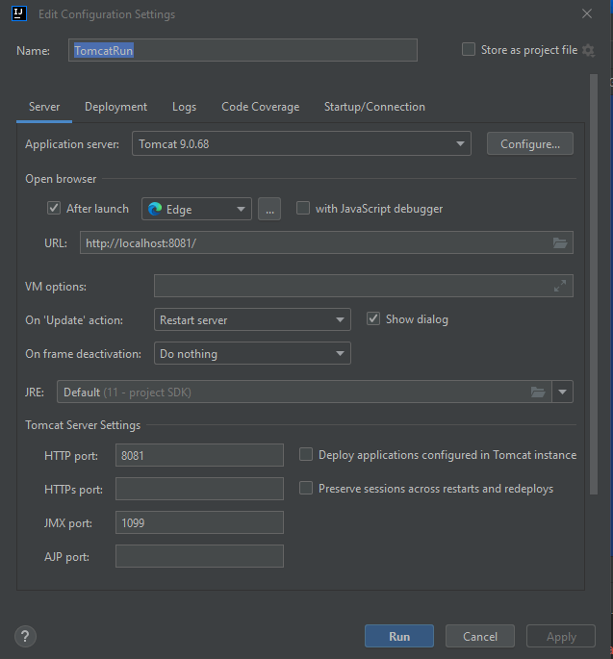

Рисунок 1 – Настройка Tomcat

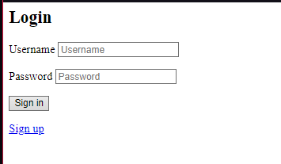

Рисунок 2 – Авторизация

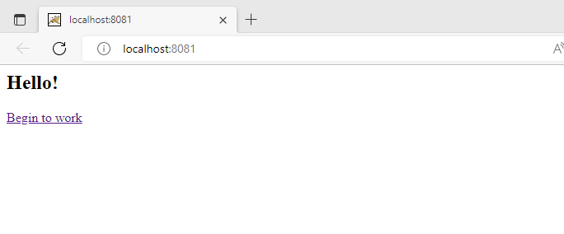

Рисунок 3 – Главная страница

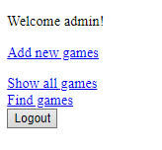

Рисунок 4 – Страница меню

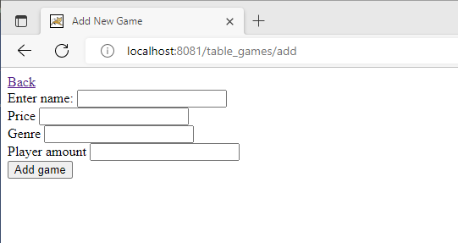

Рисунок 5 – Страница добавления новой записи

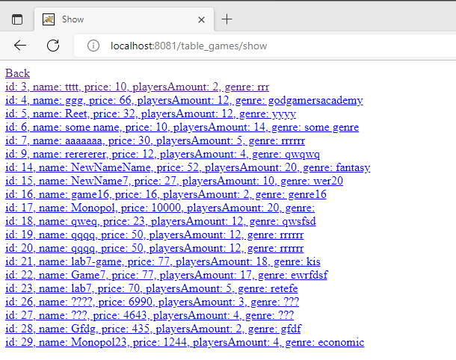

Рисунок 6 – Страница просмотра записей

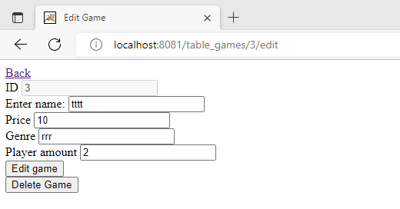

Рисунок 7 – Страница редактирования и удаления записи

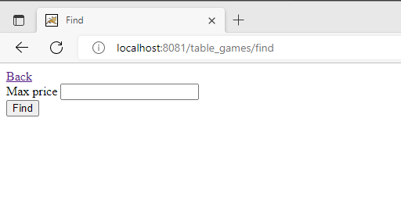

Рисунок 8 – Страница поиска записи по критерию максимальной цены

# Вывод

В результате проделанной практической работы была выполнена следующая задача:

- были ознакомлены c настройкой безопасности в Spring и тем, как он используется при создании web-приложений.