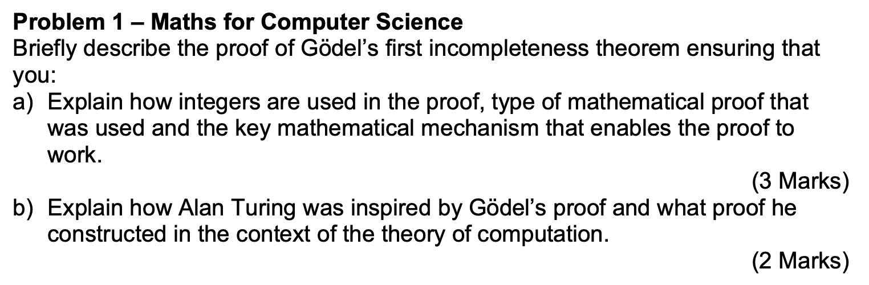

(a)
Godel’s first incompleteness theorem states that for any consistent formal system, there will be statement which cannot be proven.
Integers are used in the proof by using prime numbers for each statement/number/etc., and putting them to the power of an integer that is the representation of that particular statement/number/etc. For example, 0=0 would be 2^6 * 3^5 * 5^6, which is called the Godel number. Essentially, the point of doing this is that you can represent a meta-mathematical concept using mathematical notation. Each Godel number is unique to that specific statement, so it allows you to comment using Godel numbers, about the system itself, specifically, its completeness and consistency.
For this proof, we use a contradiction. Making a consistent formal system M, Godel was able to then make a statement called G which states “G cannot be proven”. Now, if G is true, that means G cannot be proven, so there will be statements within M that cannot be proven, and therefore, the formal system is incomplete.
If G is false, that means G can be proven. A proven statement must be true, which means G is true (G cannot be proven). Cannot have both G and ~G being true, so we get a contradiction. Therefore, formal system cannot be complete and also consistent.
(b)
Alan Turing was inspired by Godel’s proof, and wanted to see if a computer would be capable of knowing if a program could be proved (in which it would halt), or would go on forever (loop). As a result, using his idea of a Turing machine, which is the simplest form of a computer, he made the Halting problem, and decided that no machine could decide whether a program would halt or not.

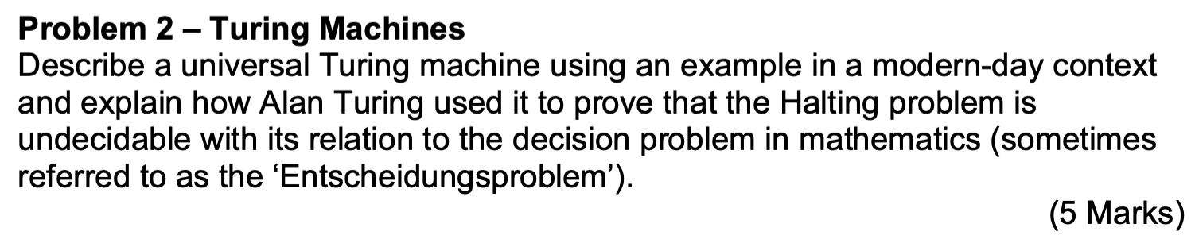
A universal Turing machine (UTM) is a Turing machine that can simulate any other Turing machine. A Turing machine is a machine that has an infinitely long tape, a read and write head, transitions, along with start and reject states. An example of a UTM could be a CPU. CPU’s simulates other programs, and so is a modern-day example of a Universal Turing machine.
For the halting problem, he came up with the idea of a UTM which can tell if a given any program with an input will halt or not. If a program will finish, UTM will halt, if not, it will loop.

So, make a UTM (called machine H) that takes program P and input I and determines if P will halt (i.e., it will give us an answer) on input I or not.

Yes
Does P halt on input I?

No
H

Now, we make a new machine H+ that, if H gives a ‘Yes’ then H+ will loop forever and if H gives a ‘No’ then H+ will halt.

Loop
Yes
Does P halt on input I?

Halt
H
No

H+

If we give H+ to itself, H+ feed it into the H inside itself, so H asks, “Does H+ halt on input H+?”.
If H says that H+ does halt, we get a Yes output from H, but then H+ loops (doesn’t halt).
If H says that H+ doesn’t halt, we get a No output from H, but then H+ halts.
So if H+ does halt, then it doesn’t halt, and if it doesn’t halt, then it halts. Either way, we have a contradiction.
So, we started off by assuming we could solve the problem, we found a contradiction, so we must reject our assumption. Therefore, there is no algorithm that solves the halting problem.

A decision problem is a problem that can be phrased as a yes-or-no question, and we ask whether there exists an algorithm that can correctly determine the answer for all possible inputs. The Halting Problem is a decision problem where the input consists of a program (or Turing Machine) and an input value for that program. The question it poses is: Will the program halt when given that input, or will it run forever? Alan Turing proved that the Halting Problem is undecidable, meaning there is no algorithm that can always determine the answer for every possible program and input. This result has significant implications, including for the decision problem for first-order logic. Using the concept of reduction, the Halting Problem can be reduced to the first-order logic decision problem, meaning that if the first-order logic decision problem were decidable, then the Halting Problem would also be decidable. However, since the Halting Problem is provably undecidable, this forces the first-order logic decision problem to also be undecidable.

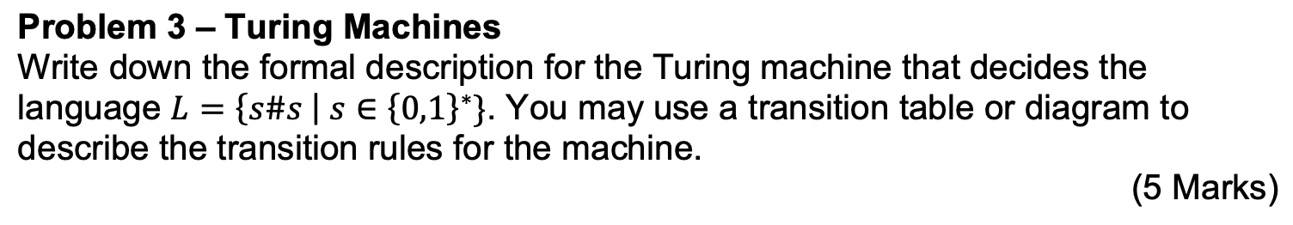
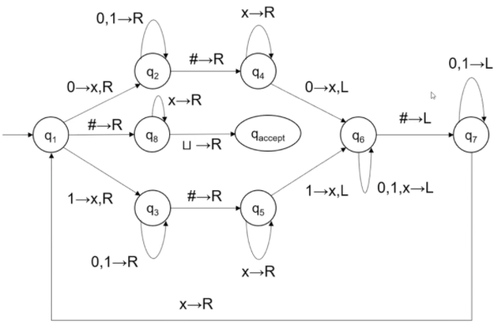
L = {s#s | s $∈$ {0,1}*}
Turing machine formal description is: (S, A_i, A_t, M, S_i, S_a, S_r)
Where S is the set of all of the states.
A_i is the input alphabet {0,1,#}
A_t is the tape alphabet, including u {0,1,#,ux,u}
M is the transition rules (diagram). Any other transitions move to reject.
S_i is the start state {q1}
S_a is the accept state {qa}
S_r is the reject state.

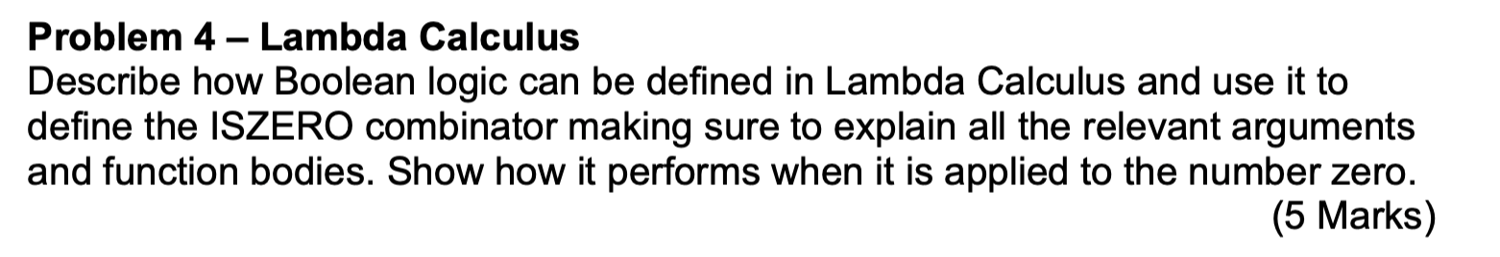
True = \p.\q. p
False = \p.\q.q
Where True takes the first argument, and false takes the second argument.
0 is \f.\z. z in lambda calc

What should the missing values be? Well, ZERO is the function that returns its second argument, and we want ISZERO applied to ZERO to evaluate to TRUE, so the second argument better be TRUE. The numbers other than ZERO are functions that apply their first argument to the second argument some number of times, and for all of those numbers we want the final result to be FALSE. So the first argument needs to be a lambda term g such that g applied to TRUE is FALSE; a constant false. So, make g be the function that ignores its argument and returns FALSE:
g == λx.FALSE

Is0 = (λn.n (λx. false) true) 0
0 (\x. false) true)
(\f.\x.x) (\x. false) true)
True
is0 2
(λn.n (λx. false) true) 2
(2 (λx. false) true)
(\f.\x. f (f x)) (λx. False) true
((\x. (λx. False) ((λx. False) x)) true
(λx. False) ((λx. False) true)
False

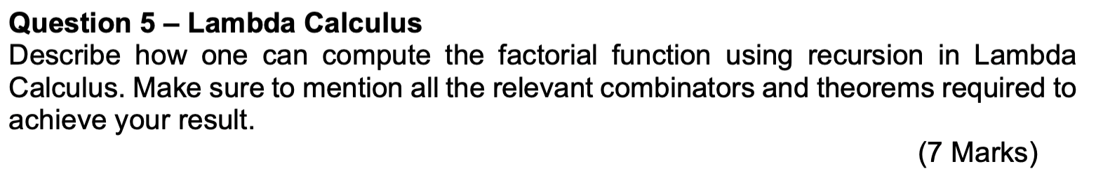

For lambda calc, it uses pure functions so you cannot give the functions a name which can be called within itself. We can however still do recursion by using the Y combinator.
The Y combinator is: (\f. ((\x. f (x x)) (\x. f (x x)))
For how the Y combinator works:
Y G <- G is a function
(\f. ((\x. f (x x)) (\x. f (x x))) G
((\x. g (x x)) (\x. g (x x)))
G (Y G)
Etc.

Doing this with a function such as G gives:
G (G (G ….(G (Y G)))) etc. So we can use recursion.
So the factorial function would be:
Factorial = Y (\f.\n. iszero (1) (mult n (f(pred (n)))))
Where is zero return true if the value is 0, and false otherwise.
Mult is multiplication, and it will multiple two values together, n and (n-1)!
1 here uses Church encoding where numbers are as follows:
0 = \f.\x. x
1 = \f.\x. f(x)
Etc.
What is going on is basically in code:
F(n):
If n == 0:
Return 1;
Else:
Return n * f(n-1)

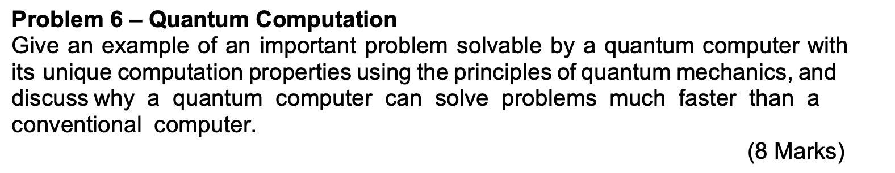

An important problem solvable by a quantum computer would be the Deutsch oracle problem. This is where we have a black box (BB) containing either set 0, set 1, identity, or negation. The first two are constant, and the last two are balanced. We want to be able to know if what is in the BB is constant or balanced. With classical bits, we must have 2^{n-1}+1 queries to the BB. For quantum bit (qubits) however, we only need one call to the BB.

The Deutsch-Jozsa algorithm uses superposition to evaluate a function on all possible inputs simultaneously. However, its power comes from quantum interference, which amplifies or cancels certain states based on their phases. This interference reveals whether the function is constant or balanced with just one query. Classical bits lack superposition and interference, so they must check many inputs to decide. Thus, quantum computing leverages superposition and interference to solve the problem more efficiently.

For a two-qubit system, we have this setup:
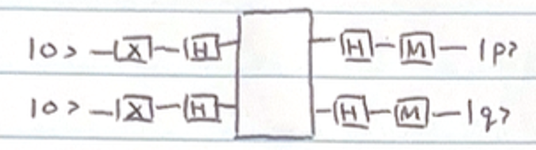

Due to the superposition and quantum interference as discussed above, we are able to get an output of |11> if the BB function is constant, and |01> if the BB function is balanced, thereby distinguishing between the two in just one query.

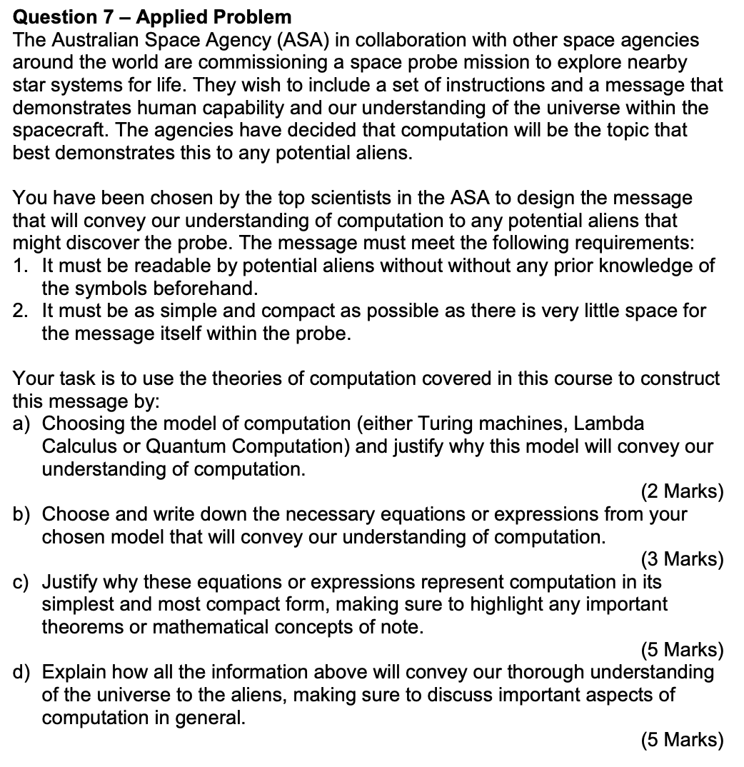

**note: might not be 100% ‘correct’ look at with scrutiny.

- Choosing model, justify.
I choose lambda calculus. Lambda calculus allows us to only use pure functions, without the use of the normal arithmetic and symbols we know such as “+*-“ etc. The aliens can have no preconceived ideas about what symbols we have such as “1” “2” “3”, because we will make this symbolisation within lambda calculus itself. It can convey our understanding of computation, because lambda calculus is Turing complete, and so can allow for computation to the same extent that Turing machines can. Turing machine require knowledge of symbols unknown to the aliens such as ‘->’ and our number system. They could probably guess but it is not necessarily intuitive to know what symbols mean what. In lambda calculus, the numbers are essentially just counting the number of (for example, if using \f.\x) f’s in the equation. Example: 2 = \f.\x. f(f x)). This can be understood by the aliens.

Additionally, lambda calculus is very compact, so this would be good for the message within the probe.

- Necessary equations or expressions from chosen model
For our understanding of computation, it all boils down to the simplest computer, and what that simplest computer can do. We need to have the basic level to compute such as numbers, arithmetic, Boolean, loops. Although Turing machine can do all of those things, as said above, it could be difficult for aliens to understand. So, we can use lambda calculus.
We need numbers, firstly. We can use the normal way to express them in lambda calc:
0 = \f.\x. x
1 = \f.\x. f x
2 = \f.\x. f(f x)
Etc.

True = \f.\x. f
False = \f.\x. x <- note that this also is the same as the value for 0

The ability to do recursion is important. Therefore, we must have the Y combinator:
Y = (\f. ((\x. f (x x)) (\x. f (x x)))

We also need the B combinator:
B = (\f.\g.\x. f (g x))

With these, the aliens can come up with the other arithmetic such as plus, multiplication, including the successor function.

- Why are these computation in its simplest form?
The ability to use numbers (counting) is very important for computation. These allow you to do basic arithmetic such as add, multiply, minus, along with others. This is the foundation of any computation to occur.
Essential for logic and computation is Boolean. This is extremely important, because basic logic required this, and it is necessary component of the state transitions allowable for Turing machines. The computation must “decide” between choices, and so the logic or true or false is imperative.
Additionally, recursion is very important because this allow us to do for and while loops, which allow for more complex solving of problems in computation.
B combinator is important because it allows you to do composition in lambda calculus, which is imperative for have functions and applying other functions to it. This is analogous to the state transitions of Turing machines, and allows lambda calculus to be Turing complete.
These allow us to do everything else required for computation.

Church-Turing thesis states that all computation can be boiled down to what can be done using a Turing machine, and also using lambda calculus. For that reason, these equations represent computation in its simplest and most compact form. This is what we want for the probe.

- Convey our understanding of the universe?

In terms of the universe, it conveys our understanding by recognising the basic requirements of computation. This is very important. While it could be said that Quantum computation could give the aliens a better understanding of our understanding of the universe since it, by its very nature, uses the knowledge of quanta particles which the aliens would possibly know about, we as humans are still in our dormant stages of understanding quantum computation, and what ramifications it may bring in the future. Therefore, I think it is more important to focus on the basic level of computation, which is imperative to computation; this is being Turing complete. As said in the Church-Turing thesis, any computation can be boiled down to a Turing machine, and obviously, also Lambda calc. This will let the aliens know that we understand what computation is in its’ simplest form, and therefore, our understanding of logic. Computation is everywhere, and the aliens will understand that we understand what it is. As said previously, Boolean, arithmetic, numbers, some sort of recursion including loops, are the necessary requirements for computation of any solvable problem.
Keep in mind, the universe includes our Earth, and the computation on it is important in the same way that quantum computation is important; it still conveys our understanding of the universe.

