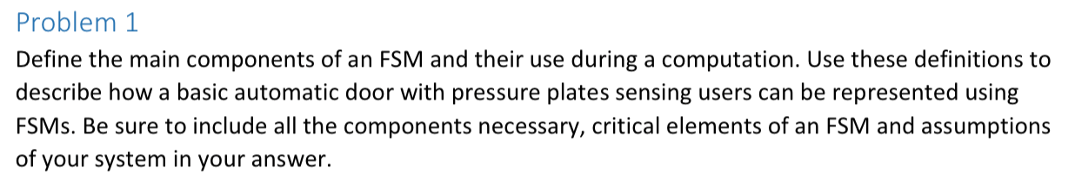

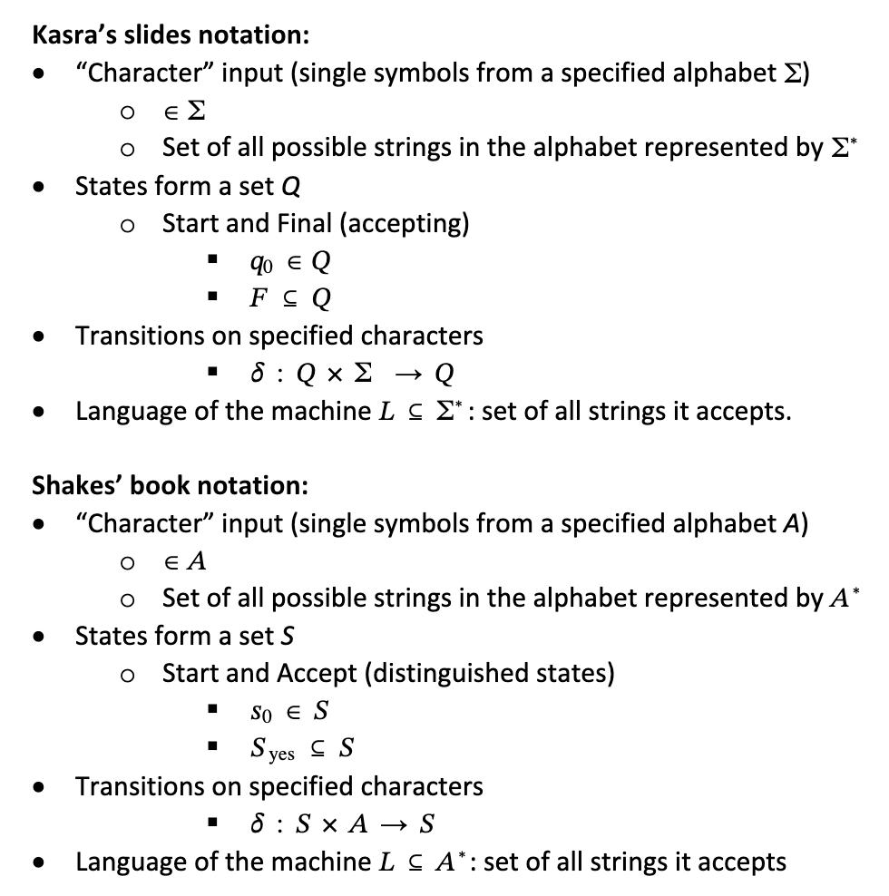

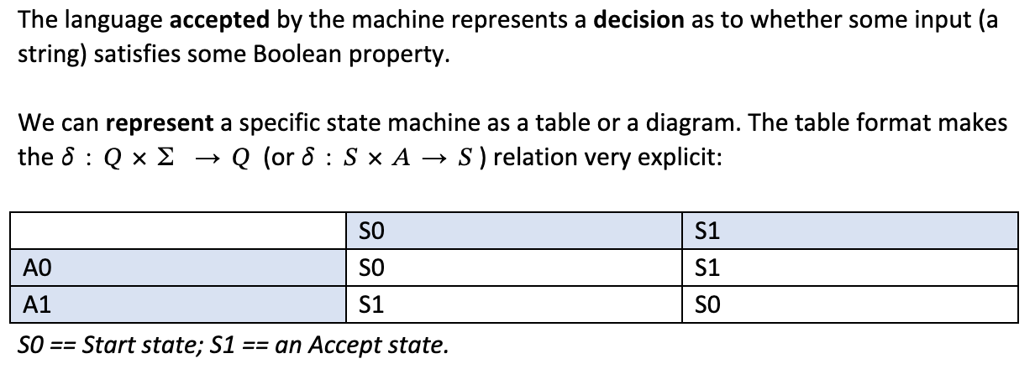

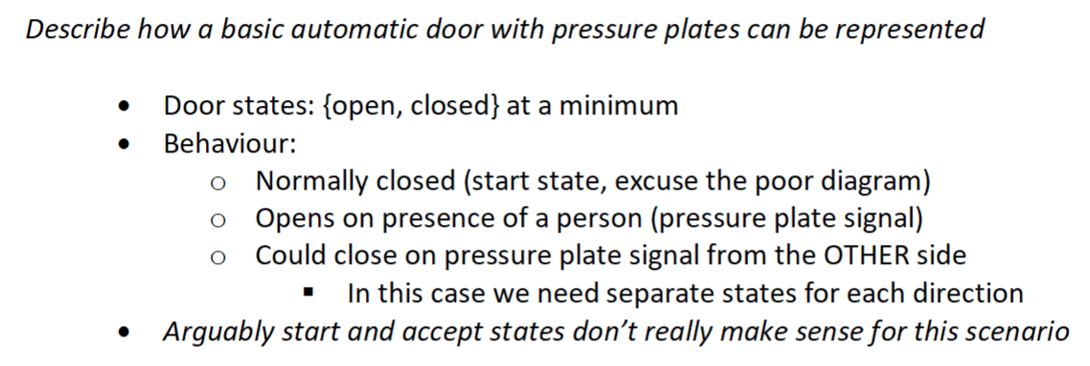
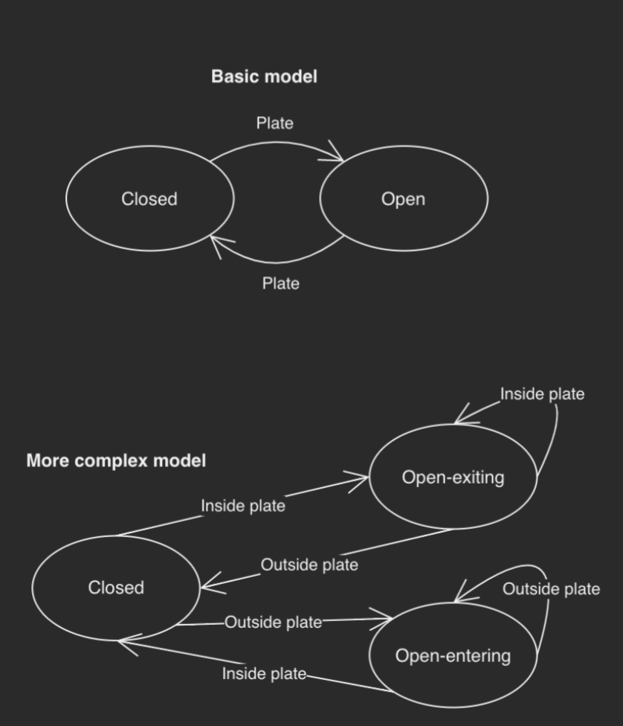

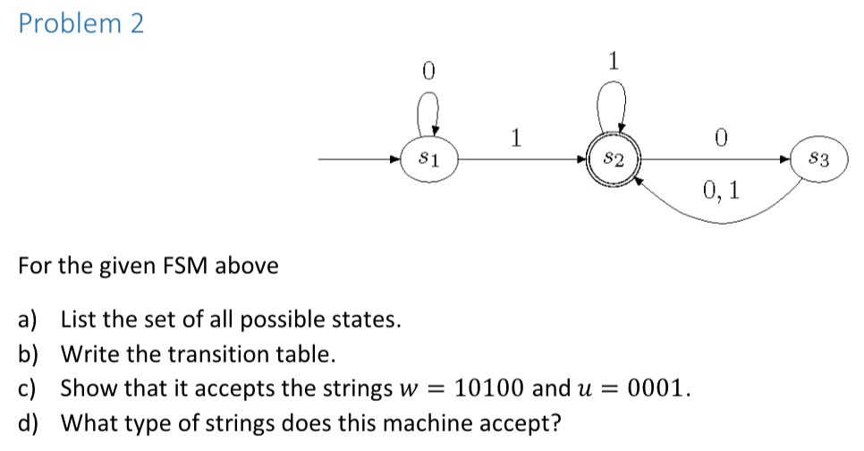

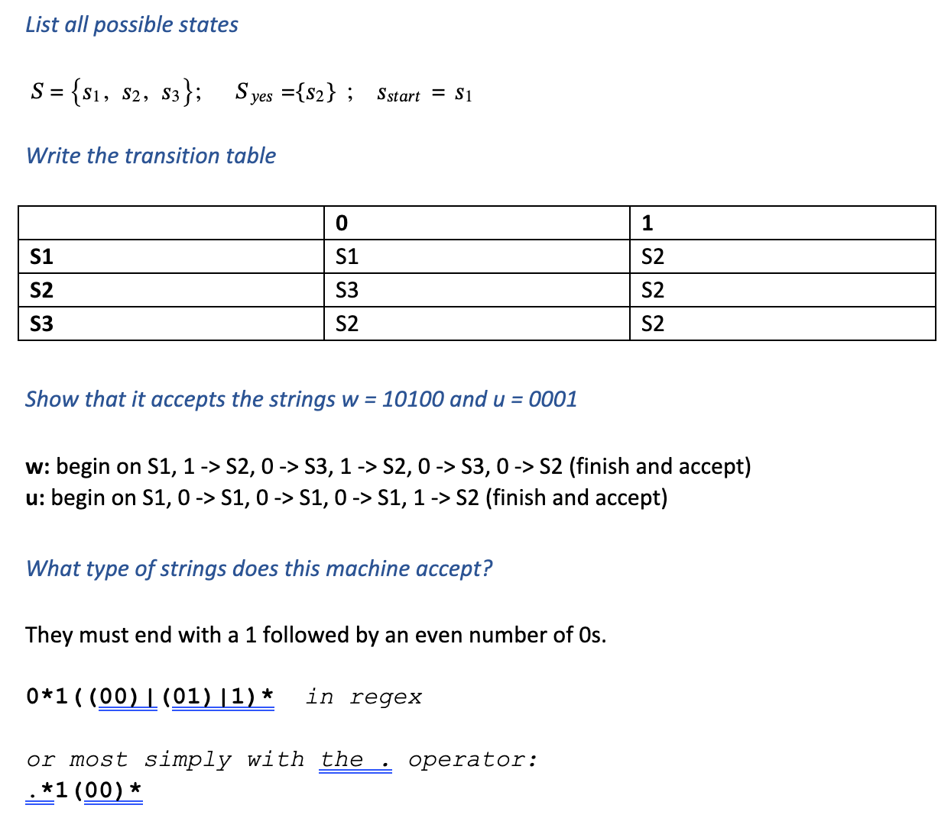

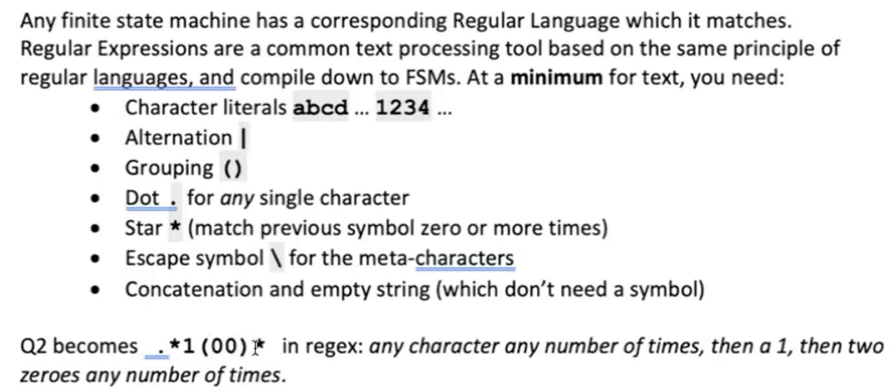
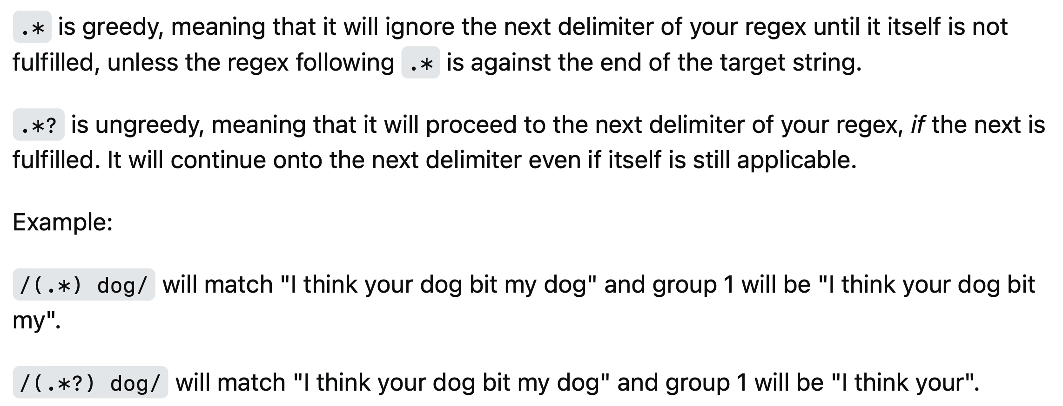

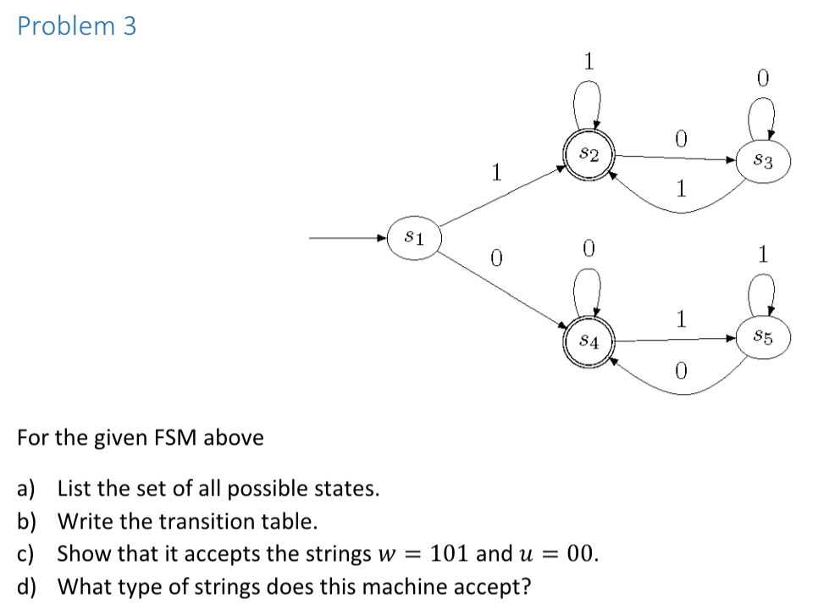

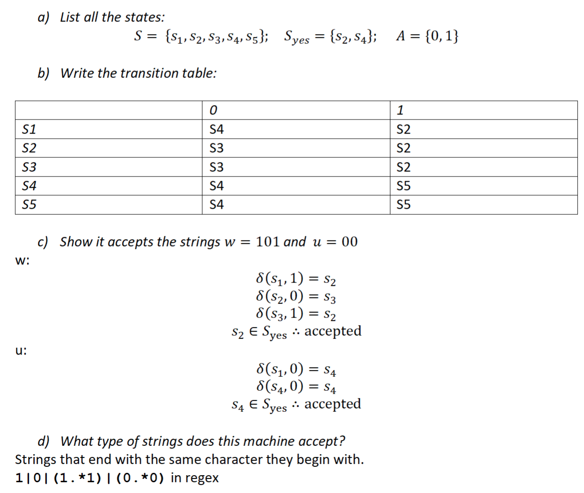
Alternatively, (1(.*1)*) | (0(.*0)*)
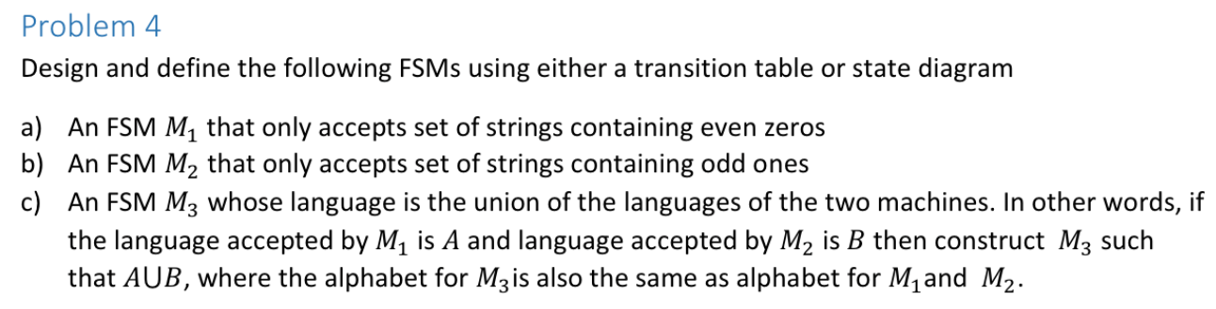
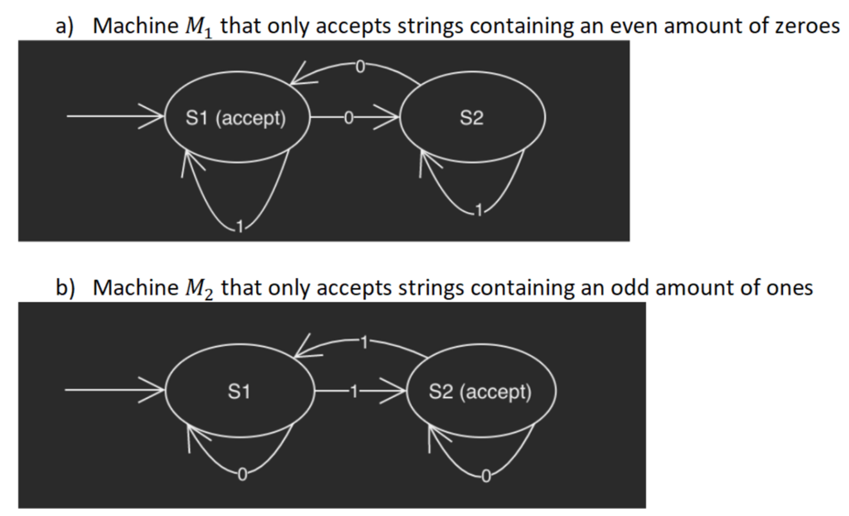

c)

even zeros + even 1s, even zeros + odd 1s, odd zeros + even 1s, odd zeros + odd 1s
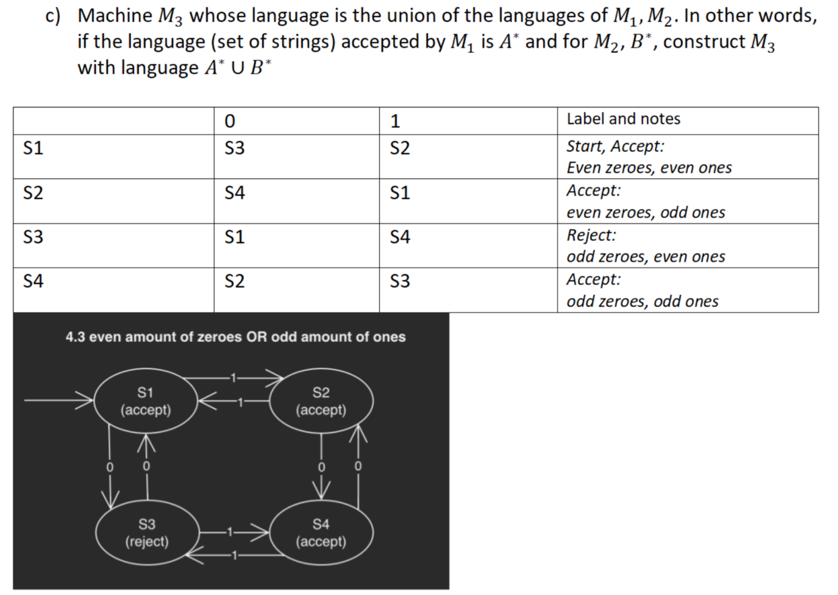

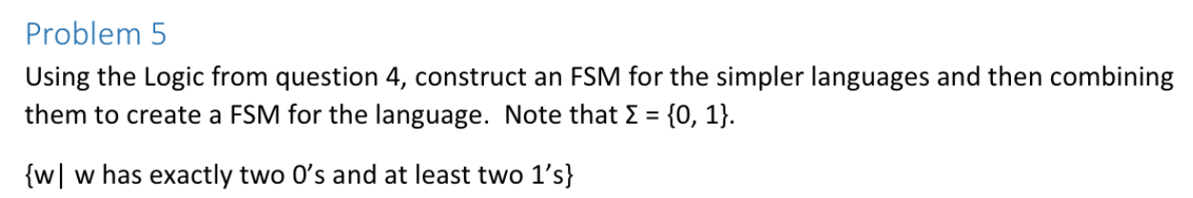

Need a machine Mp for {p | p has exactly two 0s} and another machine Mq for {q | q has at least two 1s}. Then we can take their intersection using a Cartesian-product approach. Let machine M be the FSM that recognises the intersection of M_{p} and M_{q}.

We will need a four-state machine for p – no 0, one 0, two 0 (accept), three+ 0.
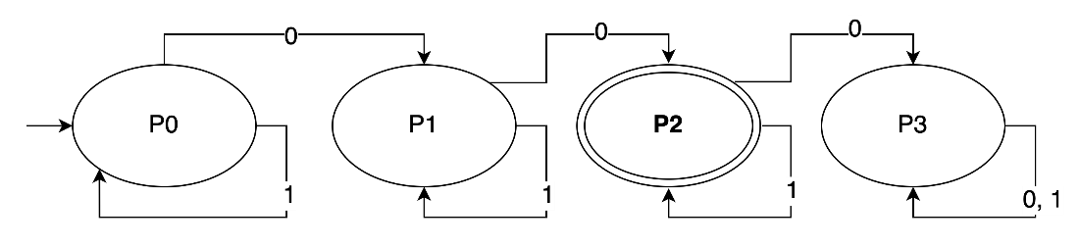

We will need a three-state machine for q – no 1, one 1, two+ 1 (accept)
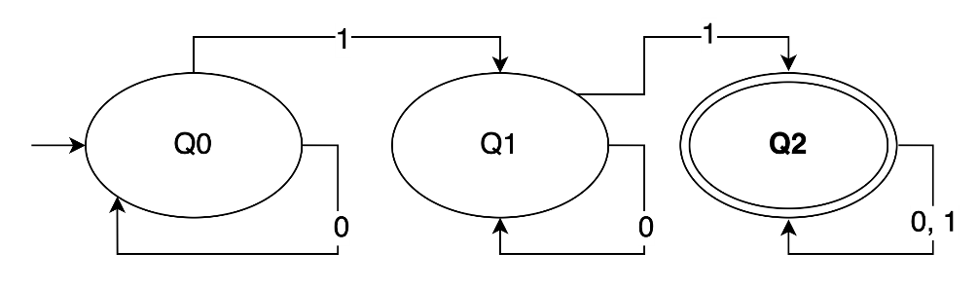

12-state grid layout for the combined machine: if you get a 0 you move right, if you get a 1 you move down.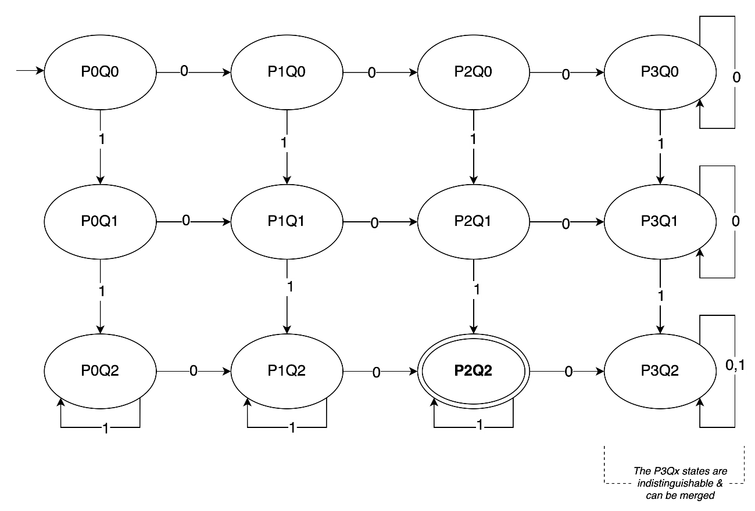 0011
00011
01101

What’s a regex for this machine? 1*(0011|0101|0110|1001|1010|1100)1*

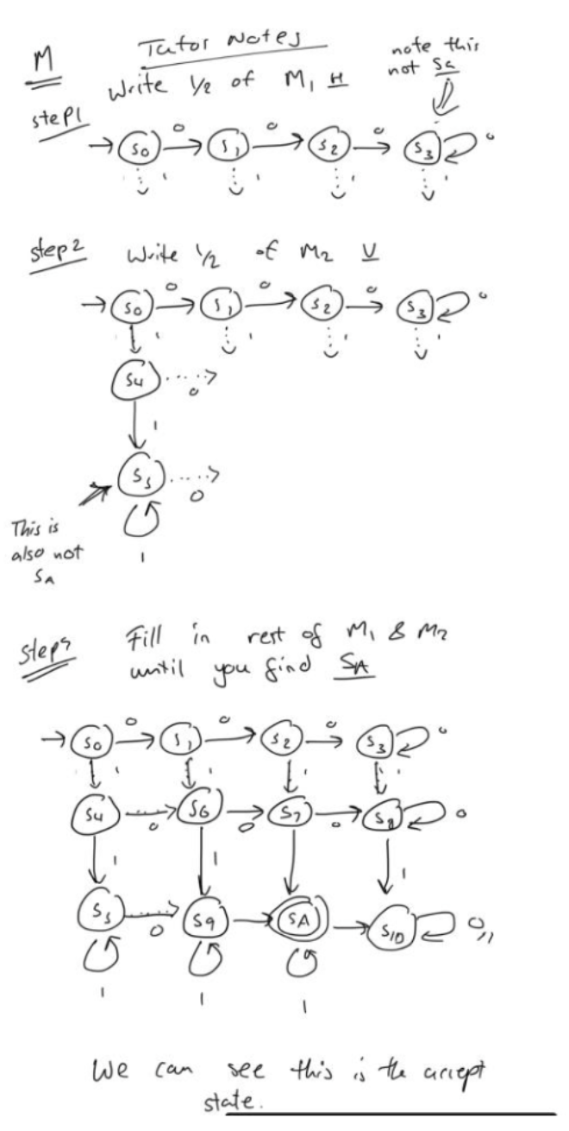
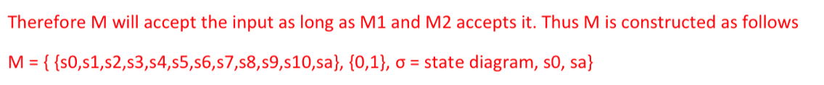

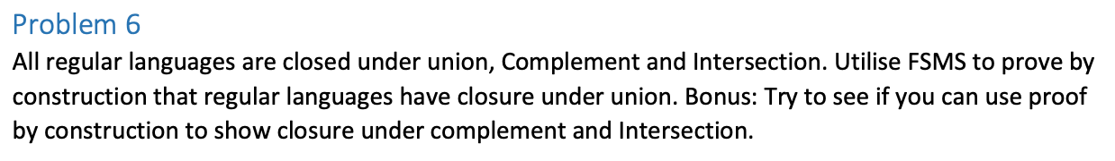

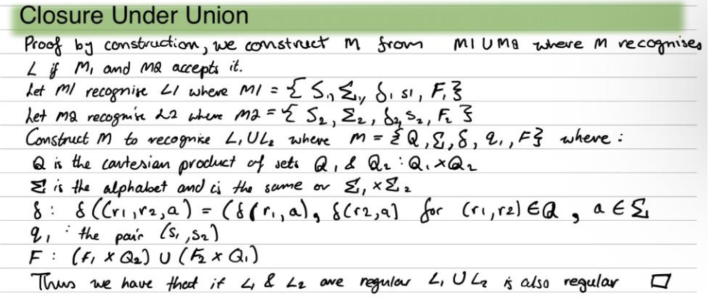

Note:
Q₁ = S₁
Q₂ = S₂
r₁ ∈ Q₁ and
r₂ ∈ Q₂
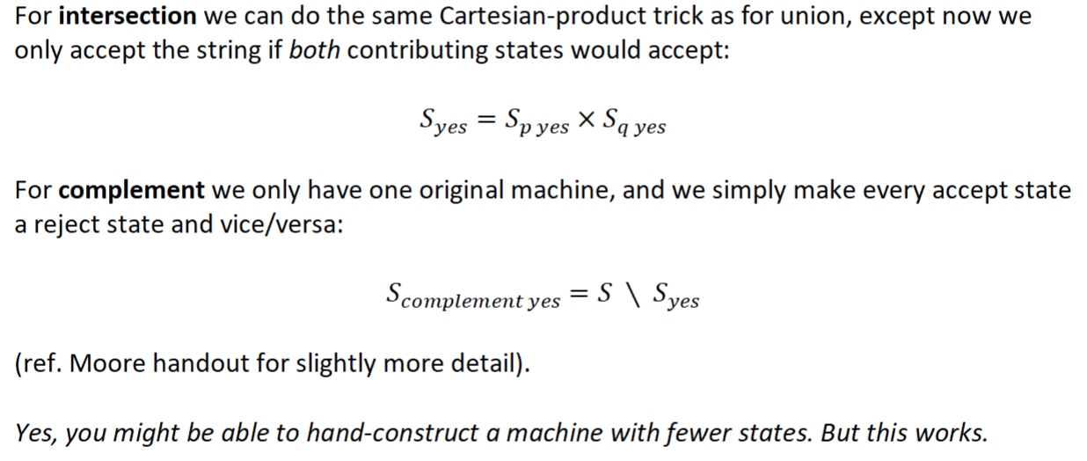

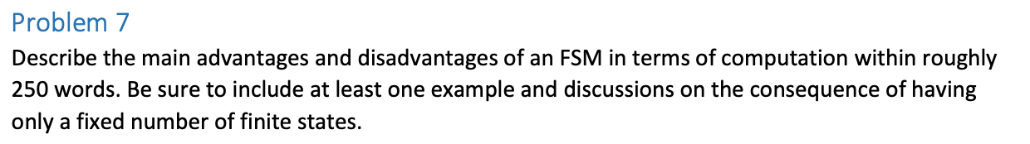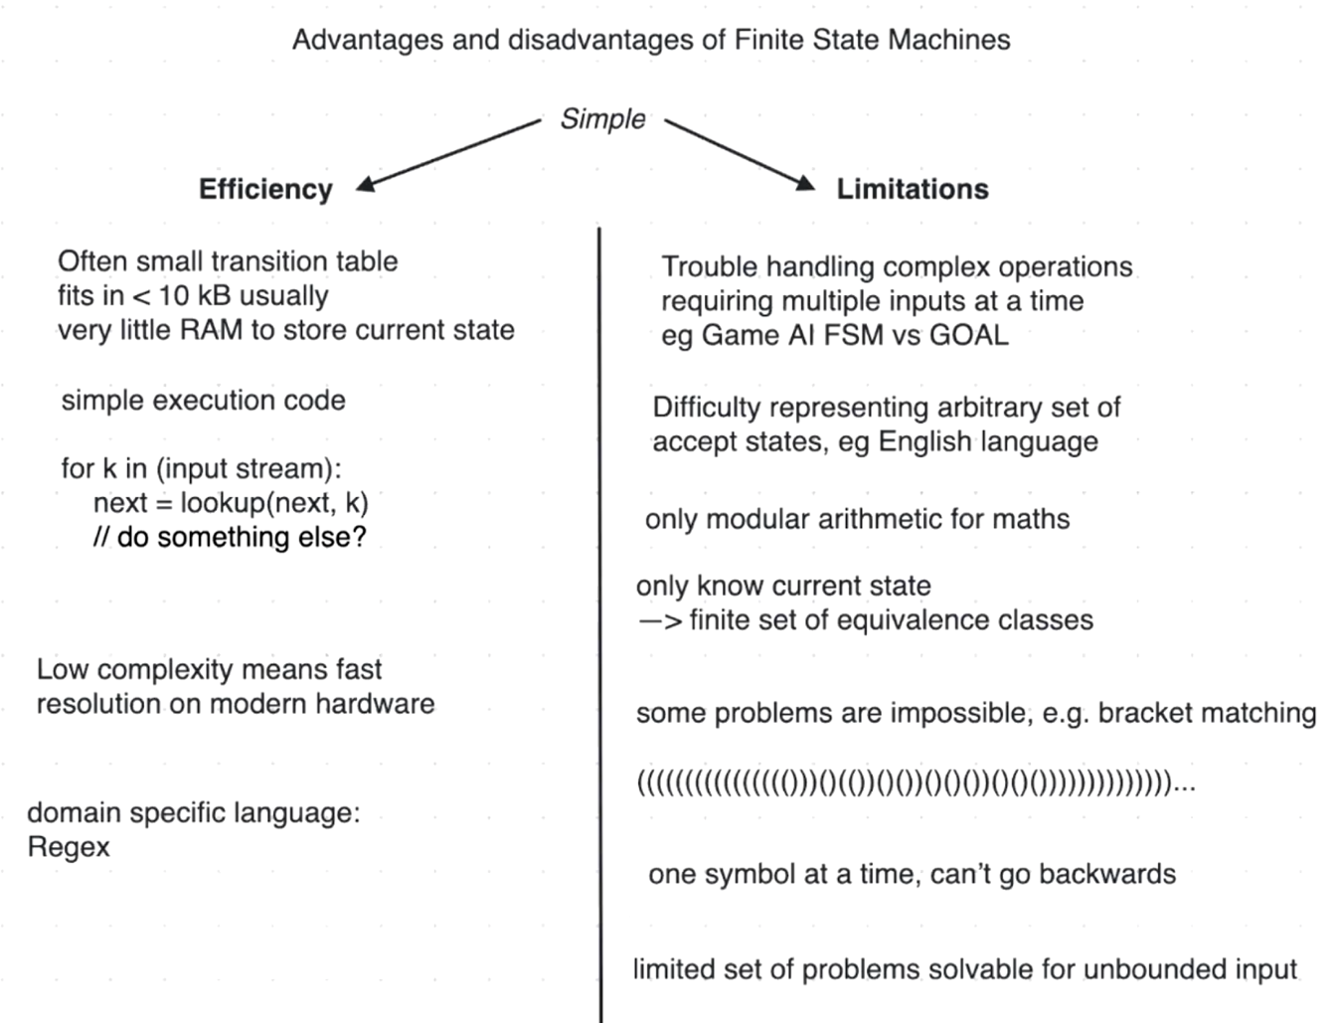

FSM can only count up to <= n

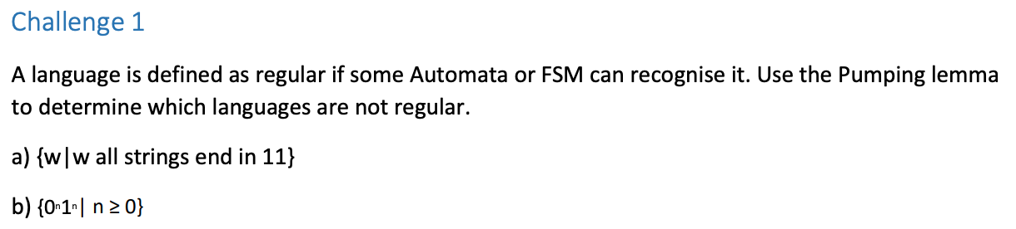

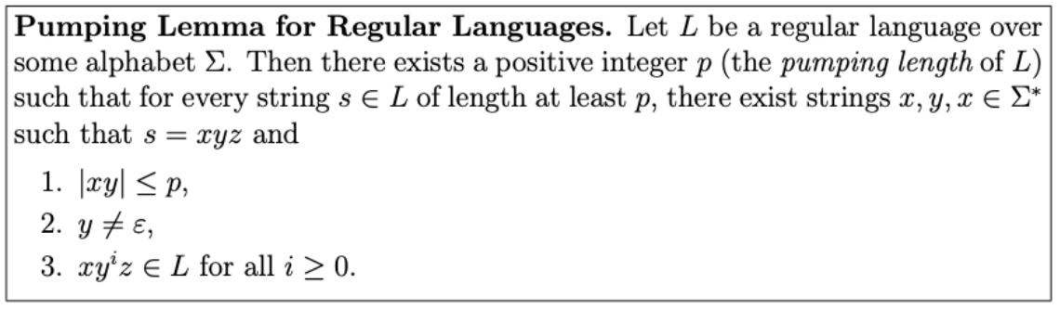
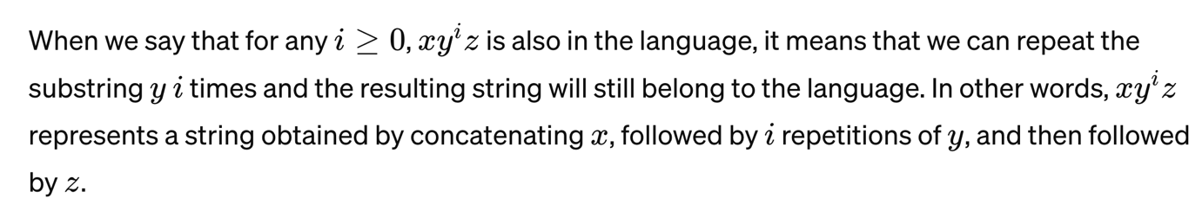

Also note: The Pumping Lemma is used to prove a language is not regular, not to prove it is regular. It works by assuming a language is regular, then demonstrating that a specific string within that language cannot be "pumped" (repeated) without resulting in a string outside the language, thus contradicting the assumption that the language is regular.
p is a threshold length beyond which all strings in the language must obey the pumping property.
- Any string of length at least p must be pumpable.
- There may be shorter strings in the language, but they are not required to satisfy the pumping property.
Assume A = {0,1}

- 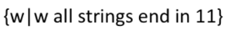
We could set an arbitrary x, arbitrary y, and z = 11.

Step 1: Assume L is regular
s=xyz with the conditions (1-3) above.

Step 2: Choose a string s in L
S = 0 010 11

X = 0, Y = 010, Z = 11
Step 3: Pump y (example 3 times)
S’ = 0 (010)³ 11
S’ ends with 11 still so is a word in the language L.

Since the Pumping Lemma does not lead to a contradiction, we cannot use it to prove Language L is not regular.
- 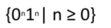

Assume that this language (denoted B) is regular and P be some pumping length. Let s = 0^{p}1^{p}. As s is a string accepted by the language and has length greater than p, we can split this into x = before the pump, y = the substring to be pumped and z = the accepted state. Consider three cases:
- The string where y consists only of 0’s. Here xyyz has more 0’s than 1’s and is not accepted by B.
- The string y consists only of 1’s. This results in xyyz where it has more 1’s than 0’s and is not accepted by B.
- The string y consists of both 0’s and 1’s. Here xyyz might have the same number of 0’s and 1’s but will be out of order with some 1’s before 0’s.
Another way to think of this problem is to imagine a FSM that would accept B. The machine seems to need to remember how many 0’s have been seen so far as it reads the input. Because the number of 0’s isn’t limited, the machine will have to keep track of an unlimited number of possibilities. But it cannot do so with any finite number of states.
Y has only zeros:
000111
Y = 00
X = 0
Z = 111
00 00 00 00 111 (i=positive integer) => too many zeros -> not in language

Y has only ones:
X = something
Y = all ones
Z = something
X (fixed number of zeros) Y^{i} (a potentially massive number of ones) Z => too many ones -> not in language

Y has both zeros and ones:
000111
Y = 0001
X = empty
Z = 11
0001 0001 0001 0001 11=> out of order zero and ones -> not in language

