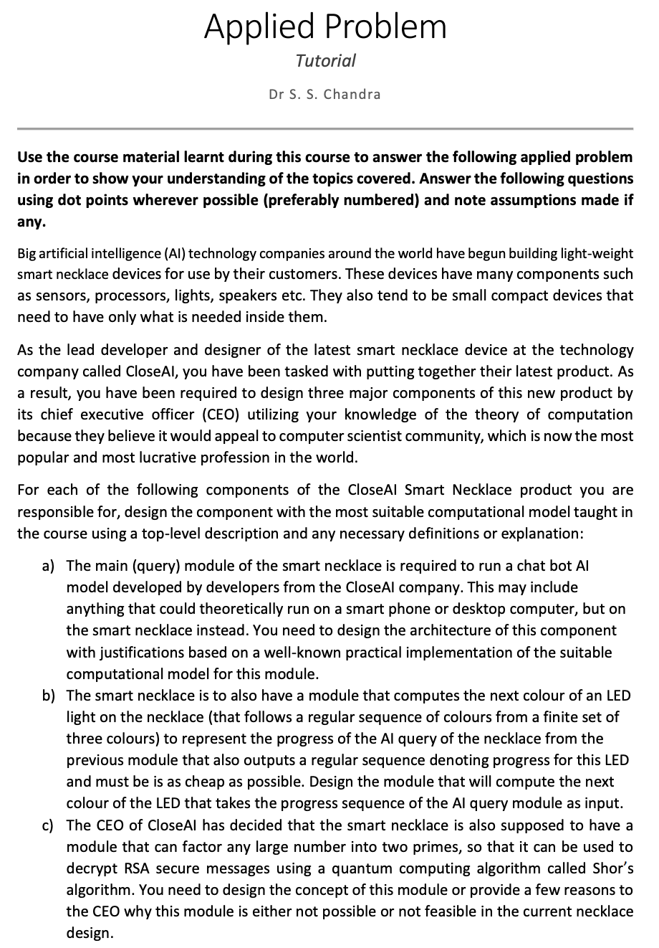

a) Define a Turing machine and then the von Neumann architecture
We can make a UTM implement this with VNA. TM = (Q, Σ, Γ, δ, q₀, qaccept, qreject), where Q is the set of states, Σ is the input alphabet (natural language characters and symbols (punctuation etc.), Γ is the tape alphabet (includes the blank symbol), δ is the transition function, and the last three are the start, accept, and reject states respectively.
The input can be any input such as time of day (if the necklace needs to give prompts such as ‘good morning’ to the user) or a query that the user has etc. The transition function handles all computations that a, for example, neural network would do, considering it is possible to simulate NNs with a TM (Church-Turing hypothesis).
To implement the TM, since it is a theoretical computation rather than a fully realisable one (infinite tape is not possible in reality), we can use the VNA to implement it. We have a CPU which contains the ALU, CU and registers. ALU will handle neural network computations and logic, CU will be the instruction decoder, and registers are for temporary storage of data. We also have a memory (instead of a ‘tape’), containing both the program and data memory. Input will be the same as for TM, so things such as microphone, or a sensor (e.g., if the user double taps the device, prompting something to happen (e.g., music to be played)), and the output can be visual, voice, or data output depending on the input and computations done. Additionally, rather than L/R movement from a read head of TMs, we use the program counter to maintain instruction order.
b) Should be an FSM
FSM = (Q, Σ, δ, q₀, qaccept), where Q is the set of states, Σ is the alphabet, δ is the transition function, q₀ is the start state, qaccept is the accept state. Considering we have a finite number of LED colours (3) and not that many, we can use a FSM which cycles through the three LED colours to indicate AI query progress. It needs to be as cheap as possible and is a simple problem, which is why we can use a simple solution (FSM) to solve it. Additionally, this is a deterministic problem which FSMs can handle well with minimal computational effort.
The states would be {Colour 1, Colour 2, Colour 3}, and the input would be the signal from the AI module indicating computation progress. The transition function would effectively just have to look at the input (progress), and if progress has been made, move to another state (colour) accordingly. Otherwise, stay in the same state. I assume that the colours have no semantic meaning besides that when there is a change in the colour, this corresponds to indicating that there is progress being made (much like a Moore machine). As such, there is no ‘accept state’ for this FSM.
c)
This is not realistic. This is because of decoherence, which is the phenomenon where the quantum system loses its quantum properties (superposition and entanglement) due to interacting with the environment (collapsing). It would be very difficult to maintain coherence in the environment of just being on someone’s person, which would cause multiple errors and limit the duration of computations. It would also be difficult to store effectively the number of qubits required for factoring large RSA numbers, let alone the fact that most quantum computing approaches require temperatures near absolute zero which require a lot of energy to maintain. This would be impossible in a small device such as a wearable necklace. Additionally, to account for error, often times many additional qubits are used for quantum error correction, which we can’t do realistically in a necklace.

