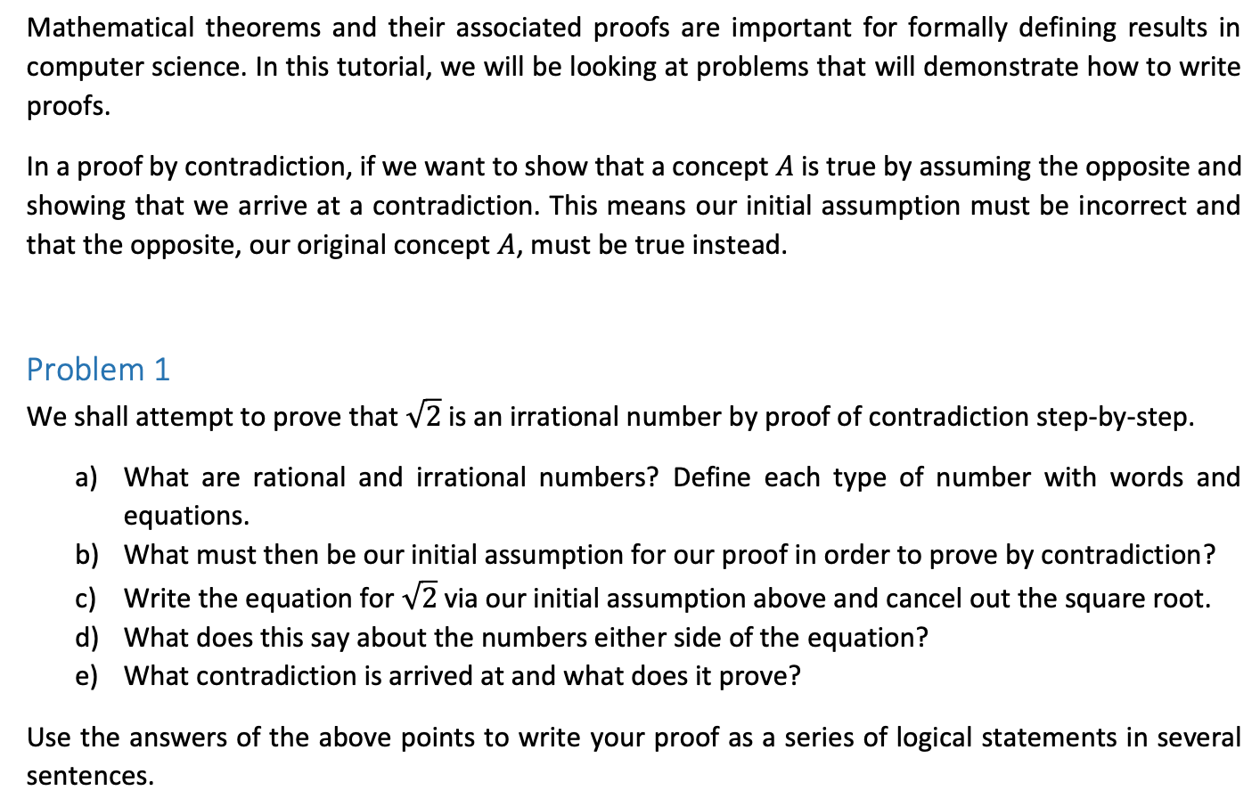
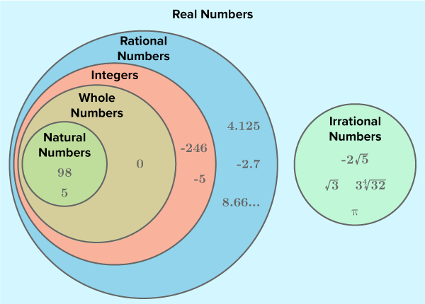
a)

Rational number: $Any number s.t. \frac{a}{b} , a,b ϵ Z$
Irrational number: $R \backslash Q:Any real number that is not rational$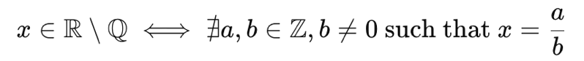

We wish to proceed by contradiction, so we assume that:
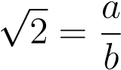
Where a,b ∈ $Z$ and gcd(a,b) = 1 (i.e., fraction is in lowest terms). Now we can rearrange to get:
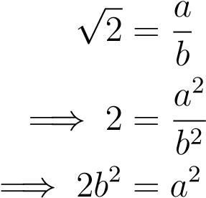
So a² is even, which implies a is even, so we can write a = 2k for some integer k. So:
2b² = (2k)²
2b² = 4k²
=⇒ b² = 2k²
So b² is even, which implies b is even. As a and b are both even, they have a common factor of 2 which contradicts our initial assumption. Therefore, root(2) cannot be a rational number.
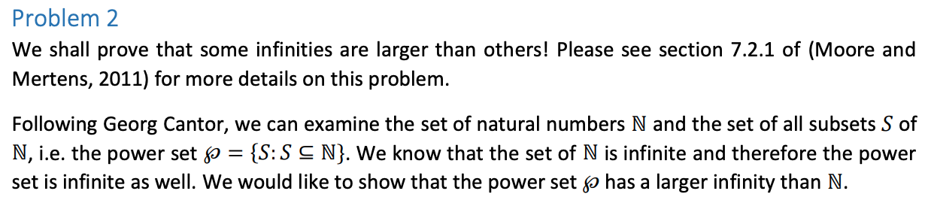

Example of a powerset:
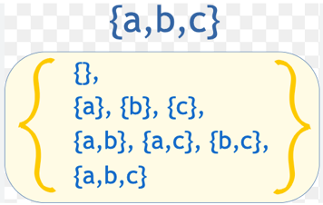

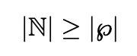

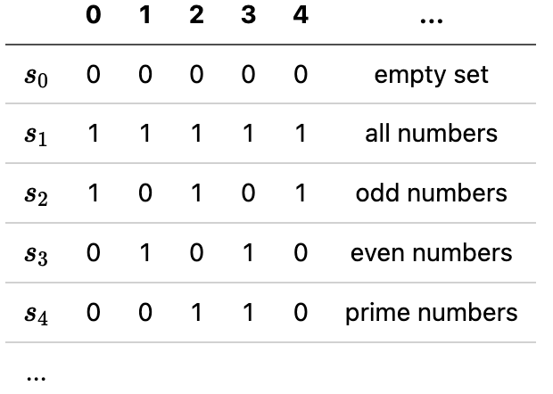

We can define two sets as having the same size (or cardinality) if there exists some way to create a bijective mapping between them. In this case, we’re looking at the natural numbers N and the powerset of the natural numbers $℘(N)$. We assume that some bijective mapping between these two sets exists, so:

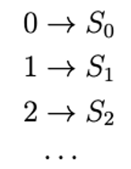

This mapping maps every natural number to a subset of the natural numbers, and every subset has a number which maps to it. Consider the representation of these subsets (below is another (arbitrary example) of the representation like we did with 2c), where a 1 bit denotes that the natural number is included in the subset, and a 0 bit denotes that it is excluded (Note that we are assuming the rows of the table continue infinitely, and that every subset of the naturals exists in the table thanks to our bijective mapping).

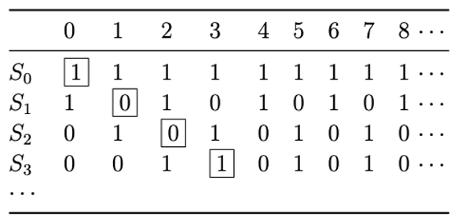

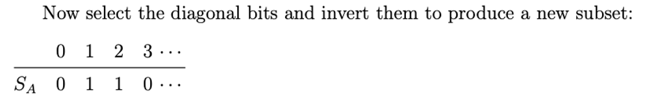

This subset cannot exist in our original table, as it is different to every row in at least one spot (as the subset is constructed from inverting diagonal bits).

2e implies that our mapping does not have a number which maps to this subset, a contradiction, so no such mapping exists. Therefore, the powerset of the naturals is larger than the naturals themselves.

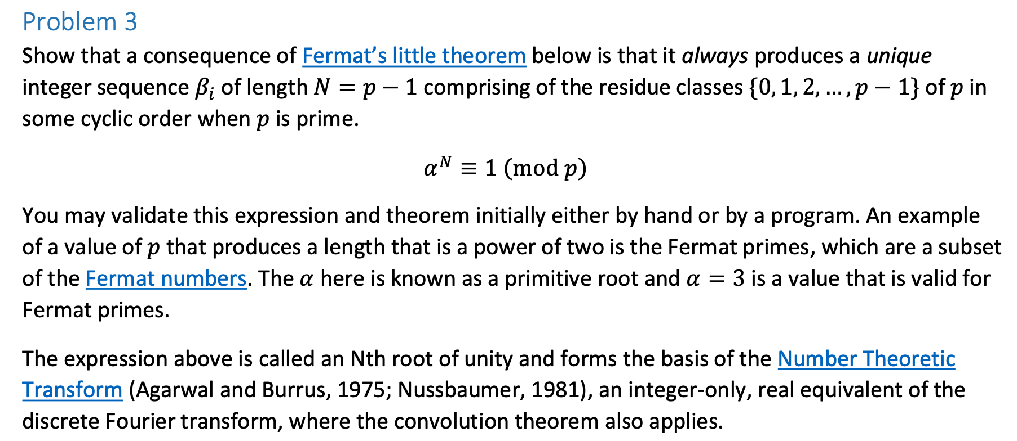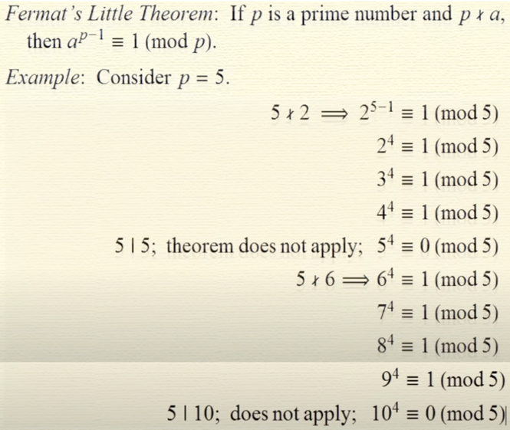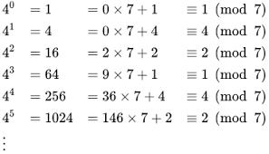256/7 = 36
36 * 7 + R =256 -> 256 mod 7 = R = 4

What does the question actually mean?

Example: Let’s say $α=3$, prime p = 5
3 mod 5:
3⁰ | 3¹ | 3² | 3³ | 3⁴ | 3⁵
↓ | ↓ | ↓ | ↓ | ↓ | ↓
1 | 3 | 9 | 27 | 81 | 243
1 | 3 | 4 | 2 | 1 | 3

So, we have a cyclic order for $α^{k}$ that repeats for length N=p-1.
In this example where $α=3$ and $p=5$, it is $\{1,3,4,2\} (N=5-1=4)$

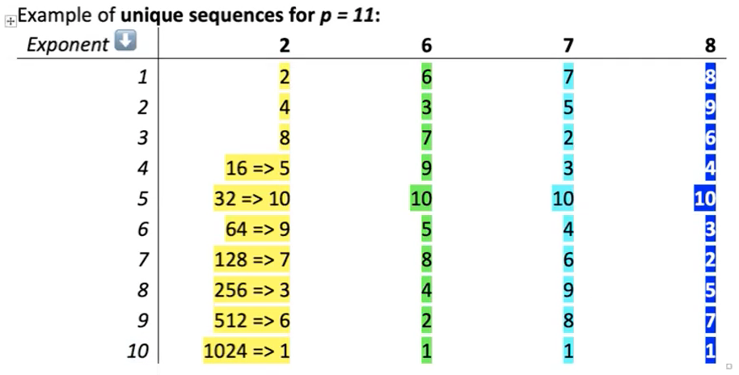
Significance of ^: that these sequences are unique to each a. If ever there’s two numbers in the same order in these sequences, then they must be from the same a (mod p).

We use Fermat’s little theorem to show that every cyclic group has a multiplicative inverse.

$$a^{p-1}≡1 (mod p)$$
$$a^{p-1}-k*p≡1 (mod p), k∈Z$$
(conventionally, 1 ≤ a ≤ p)
$$a* a^{p-2}≡1$$
$→$ conclusion: elements have a multiplicative inverse (i.e., which means $a^{p-2}$ is the multiplicative inverse of $a$ modulo $p$), and we can do algebra.
e.g., $2^{4}≡1 \left(mod 5\right);2^{3}*2 ≡1 (mod 5);8*2 ≡1 (mod 5)$

The modular inverse of a number refers to the modular multiplicative inverse. For any integer a such that (a, p) = 1 there exists another integer $a^{-1}$ such that ${a∙a}^{-1}≡1$

Actually solving the question:

Assume we have two integer sequences $A= \left\{a, a^{2}, a^{3}, …\right\}$, $B= \left\{b, b^2, b^{3}, …\right\}$, such that $a≠b$ and $a^{k}=b$ for some $k$ (i.e., the sets have the same elements, but with a different cyclic order). We know from Fermat’s little theorem that every element has an inverse.

Since $a$ generates all numbers from 1 to p-1, this means there must be some index $i∈\{0,1,…,p-1\}$ such that:
$$a^{k}≡b (mod p)$$
What comes next in the sequence:
$$a^{k}*a≡b*b$$
As we know, the sets have the same elements with some cyclic shift.
$${(a^{k})}^{-1}* a^{k}*a ≡b^{-1}* b*b$$
$$a≡b$$
Therefore, if two sequences have the same numbers in succession, their primitive roots are not unique –they’re congruent. So, it’s actually the same sequence.

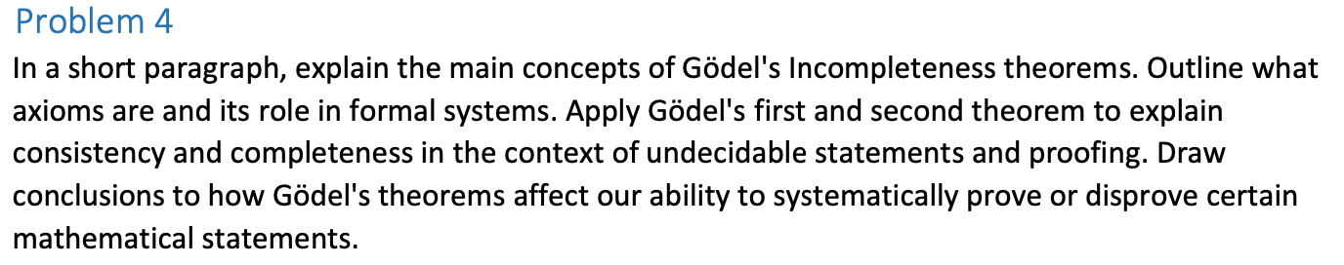

How does mathematics actually work? We have axioms, which are “a statement or proposition which is regarded as being established, accepted, or self-evidently true.” E.g., a + b = b + a, things that are equal to the same thing are equal to each other, if A=B, B=A. Axioms are statements that are assumed to be true without requiring proof within the system. They serve as the starting point for deriving new results through logical deduction. In essence, axioms provide the basic building blocks upon which the entire structure of the formal system is constructed. The goal was to have a set of axioms from which we can deduce all true statements. People also thought that we should be able to prove that mathematics is consistent (the mathematics won’t give rise to contradictions).

A formal system is complete if every statement (that can be formulated in the system) is either provable or its negation is provable; A system is complete if the axioms govern all of the possible theorems. It is consistent if no two theorems contradict each other (if there is no statement such that both the statement and its negation are provable from the axioms, and inconsistent otherwise).
Godel developed a way to encode all theorems, results, formula, variables, etc., by assigning a unique natural number to each. E.g., 0=0 is 2⁶ x 3⁵ x 5⁶. Each expression has a unique Godel number. By doing this, we are now able to talk about mathematics, using mathematics.

Godel’s incompleteness theorem I: There are statements of consistent formal system which can neither by proved nor disproved.

So now, using Godel numbering, we make a statement g saying “there is no proof for statement g”/”this statement cannot be proved from the axioms”.

Proof:
Assume we have a consistent formal system.

Case 1: Let’s say that G is true
- That means what G says — “G is not provable” — is actually true.
- So G is true, but unprovable within the system.
- Therefore, the system is incomplete — there exists a true statement the system cannot prove.

Case 2: Let’s say that G is false
- That means that we negate G
- ∴G is provable
- In a consistent formal system, a provable statement must be true. So if G is provable, then G is true.
- G says, “G has no proof”
- ∴G is unprovable
- =><= Contradiction; G cannot be both provable and unprovable in the consistent system.

So therefore, if we want to keep our system consistent, we must accept Case 1, where the system is consistent. So we cannot have a system that is both consistent and complete; if the system is consistent, it is incomplete, and if the system is complete, it must be inconsistent.

(Contrast with Liar Paradox: “this sentence is false” cannot be shown to be either true nor false using logic. This is a linguistic paradox, which doesn’t have a truth value.)

(SIDENOTE: Why in a consistent system, must a provable statement be true? In a consistent system, a provable statement must be true because proving something false would create a contradiction. For example, suppose we have a simple arithmetic system, and someone proves "2 + 2 = 5." But we know from the rules of arithmetic that "2 + 2 = 4," so proving "2 + 2 = 5" would mean the system allows falsehoods to be proven—which would make it inconsistent. On the other hand, if someone claims a false statement like "2 + 2 = 5," we can disprove it by showing a contradiction arises from assuming it's true. But if a system is consistent, that kind of contradiction can't happen when a statement is provable—so only true statements can be proven. That’s why in a consistent system, provability implies truth.)

Godel’s incompleteness theorem II: Any consistent formal system of math cannot prove its own consistency.

Assume formal system S is consistent. If we can prove our system is consistent, we can make a Godel number for that proof. To be consistent, “this system is consistent”. By the 1st theorem, this system would have to be incomplete. Therefore, “the system is incomplete” => “there is a true formula that cannot be proved” = g. We know the axioms cannot prove g, therefore, No set of axioms can prove its own consistency.

= “there is a true formula that cannot be proved” = g = “this system is consistent”

