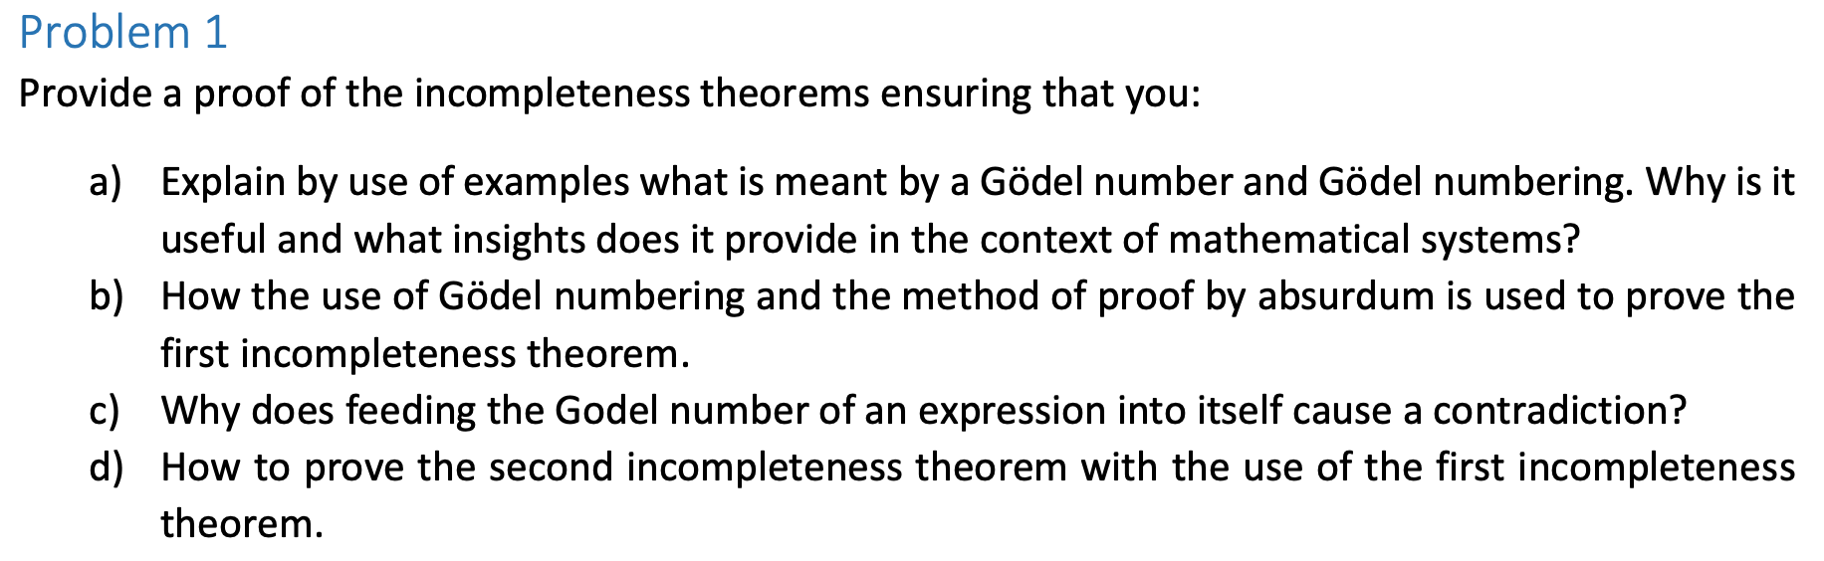

- Gödel numbering is a method of encoding mathematical expressions, statements, and even proofs as unique natural numbers. Each symbol (like "+", "=", "x", etc.) is assigned a unique number, and sequences of symbols (i.e., entire formulas or proofs) are encoded using a method like prime factorization. This encoding allows us to treat statements about mathematics as mathematical objects themselves. That is, we can now talk within mathematics about statements, proofs, and even the process of proving things.
It allows meta-mathematical reasoning within a formal system. We can now ask: “Can this statement be proved in the system?” as a mathematical question. It provides insight into the limits of formal systems, which is key for Gödel’s incompleteness theorems.

- (This is a shortened version of what was said last week as to not repeat content:) Gödel used numbering to create a special statement, G, which essentially says: “This statement G is not provable in this system.” This self-referential statement is created by encoding it numerically using Gödel numbering.

Proof by contradiction (reductio ad absurdum):
- Assume G is provable (G is false).
- Then the system proves a statement which says it is not provable. Contradiction.
- Assume G is unprovable (G is true)
- Then G is unprovable but true, so system is consistent but incomplete.

Conclusion: The only consistent outcome is: G is true, but unprovable, showing that the system is incomplete — it has true statements it cannot prove. The system cannot be both consistent and complete.

- When a statement refers to its own Gödel number, it becomes self-referential. This causes the contradiction, because in the case where you accept G as false, G is provable but also unprovable, which is not possible in a consistent formal system. The contradiction forces us to accept incompleteness in order to maintain consistency.

(Copied from the W2 answer: Assume formal system S is consistent. If we can prove our system is consistent, we can make a Godel number for that proof. To be consistent, “this system is consistent”. By the 1st theorem, this system would have to be incomplete. Therefore, “the system is incomplete” => “there is a true formula that cannot be proved” = g. We know the axioms cannot prove g, therefore, No set of axioms can prove its own consistency.)

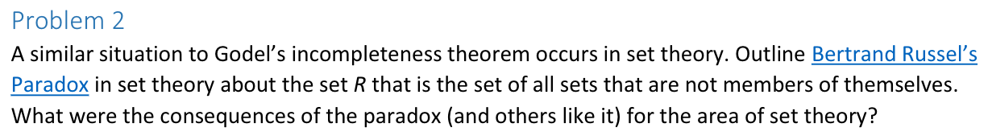

R = set of all sets that don’t contain themselves.
R = {S | S ∉ S}

If R doesn’t contain itself, then it must contain itself. If it does, then it must not contain itself.
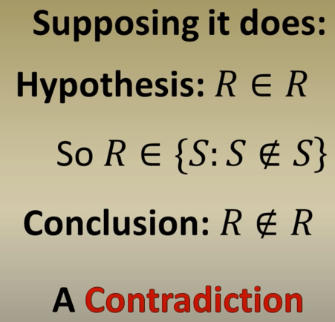
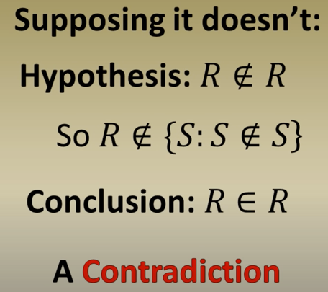

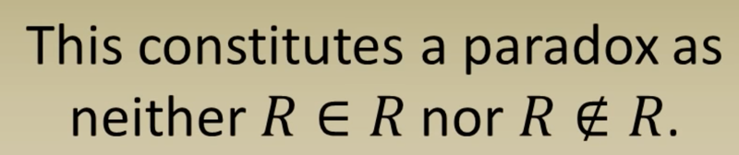

What’s the point? Russell’s paradox is a standard way to show naïve set theory is flawed. Naïve set theory uses the comprehension principle. This states that ‘given any property there exists a set containing all objects that have that property’. But we know that not every set is valid (because paradox). So we have to be careful with how we define and construct a set.

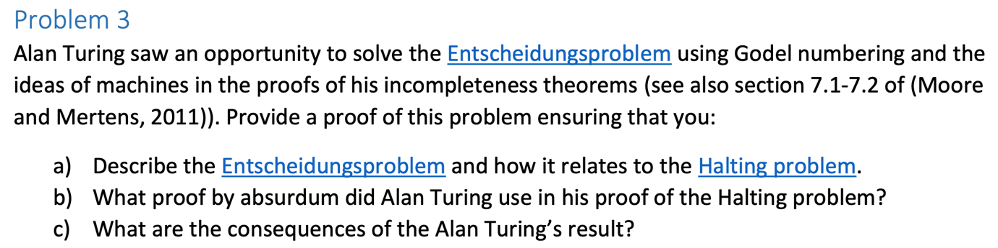

Entscheidungsproblem = ‘Decision problem’ in German

- Decision problem: Can we determine using an algorithm if any given statement is provable or non-provable?
Halting problem: Can we determine if any given program given any input will halt or not? (Decidable or undecidable)

  - These are the same problem. A program is a sequence of 1s and 0s. Any sequence of operation on numbers is a mathematical statement. Decision problem is a more general question about the existence of a decision algorithm for mathematical statements, and halting problem is more specific version of the decision problem related to the behaviour of computer programs.
  - Example: Take a computer program P and input I. You can construct a corresponding mathematical statement S that says, ‘Program P halts on input I’. The Decision problem is, “is this mathematical statement (S) true or false?”

- What did Turing do with regard to the halting problem? The problem was proved to be undecidable by Alan Turing in 1936, meaning that there is no algorithm that can solve it for all possible inputs.

Let’s assume that we have some machine that solves the halting problem. So Turing started by making a machine (UTM) (Called machine H) that takes program P and input I and determines if P will halt (i.e., it will give us an answer) on input I or not.
Yes
Does P halt on input I?

No
H

So H takes input P and I and says ‘Yes’ it will halt, or ‘No’ it will not halt.
So now, we want to make a new machine H+ that, if H gives a ‘Yes’ then H+ will loop forever and if H gives a ‘No’ then H+ will halt.

Loop
Yes
Does P halt on input I?

Halt
H
No

H+

What happens if we feed H+ into itself? So we give H+ to itself, H+ feed it into the H inside itself, so H asks, “Does H+ halt on input H+?”.
If H says that H+ does halt, we get a Yes output from H, but then H+ loops (doesn’t halt).
If H says that H+ doesn’t halt, we get a No output from H, but then H+ halts.
So if H+ does halt, then it doesn’t halt, and if it doesn’t halt, then it halts. Either way, we have a contradiction.
So, we started off by assuming we could solve the problem, we found a contradiction, so we must reject our assumption. Therefore, there is no algorithm that solves the halting problem.

- The significance is that, your computer might be running something that will never halt, but your computer cannot say for certain that it won’t halt. So you need to use some sort of time-out mechanism (e.g., after too many loops). There are many problems that computers can’t solve.

Robot(program, input)
While x != i
Turn right
X += 1

I = -1

