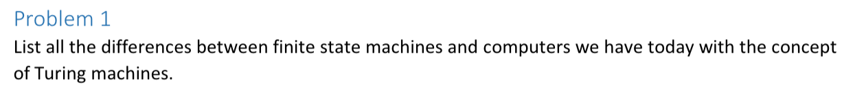

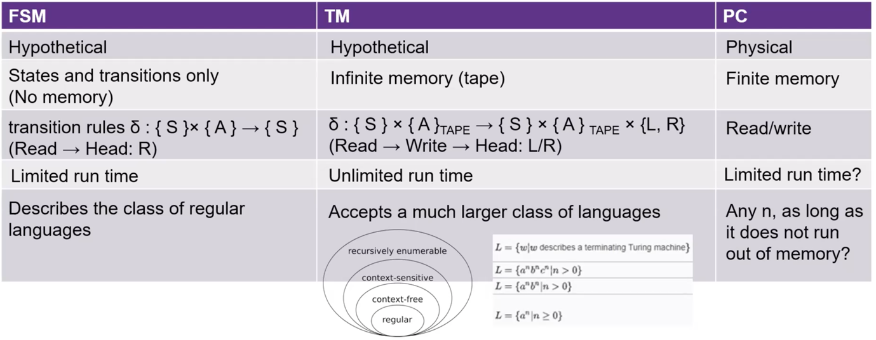

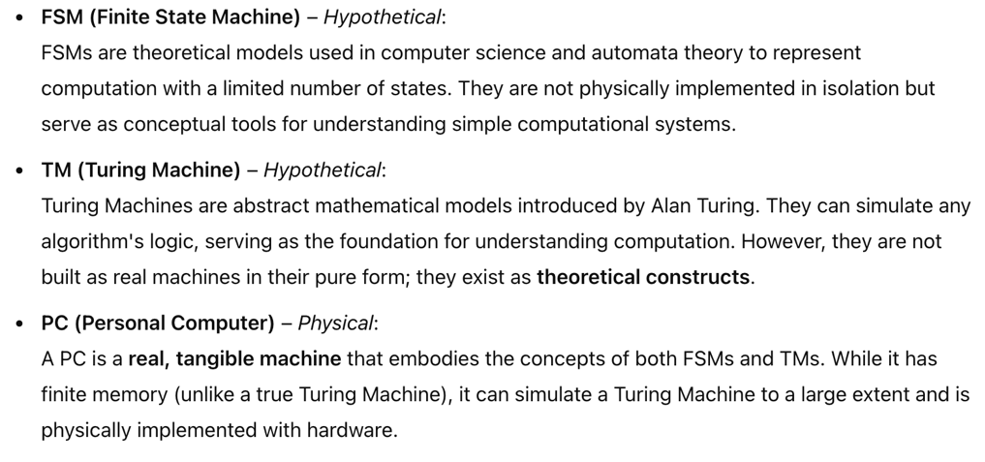

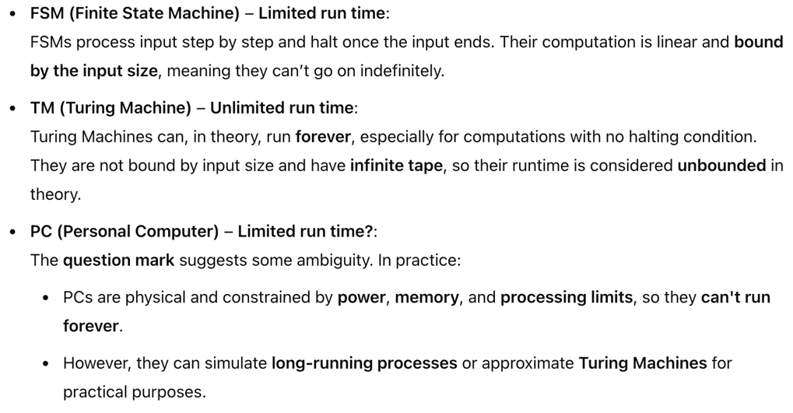

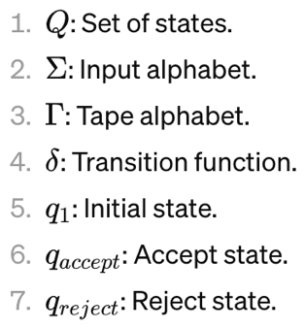
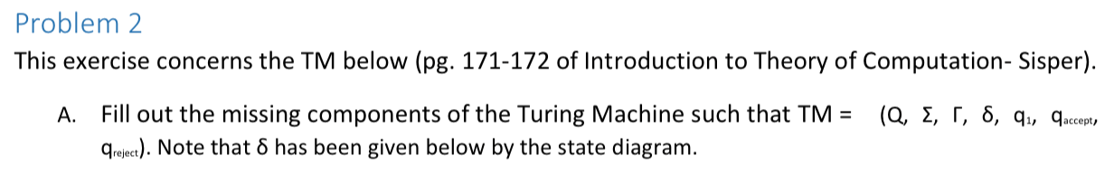

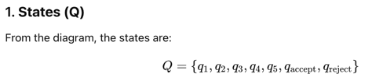
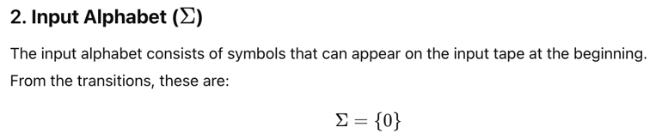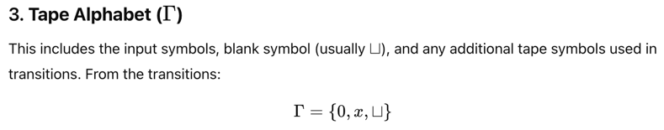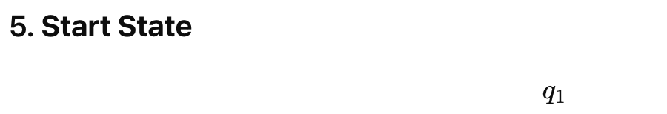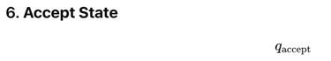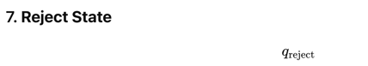

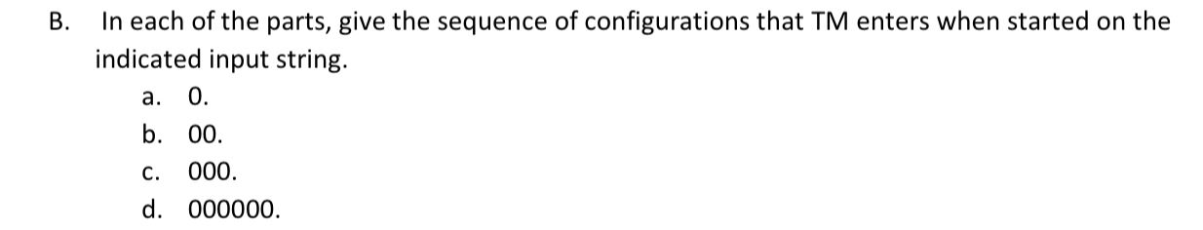

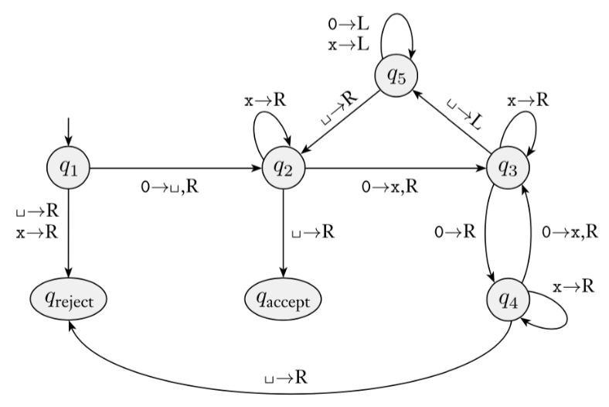

- 0: q₁0, uq₂u, uuq_{accept}
- 00: q₁00, uq₂0, uxq₃u, uq₅xu, q₅uxu, uq₂xu, uxq₂u, uxuq_{accept}
- 000: q₁000, uq₂00, uxq₃0, ux0q₄u, ux0uq_{reject}
- 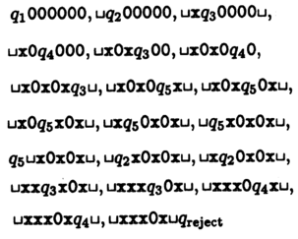

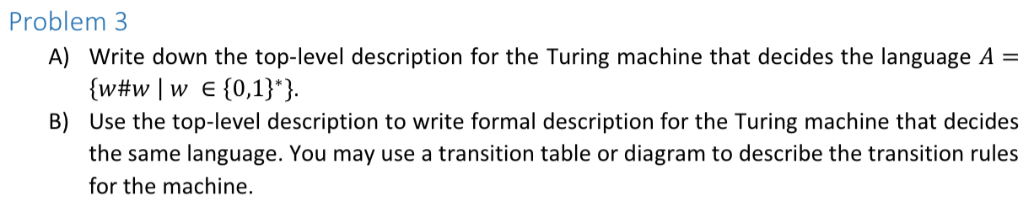

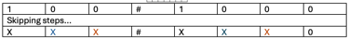
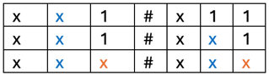
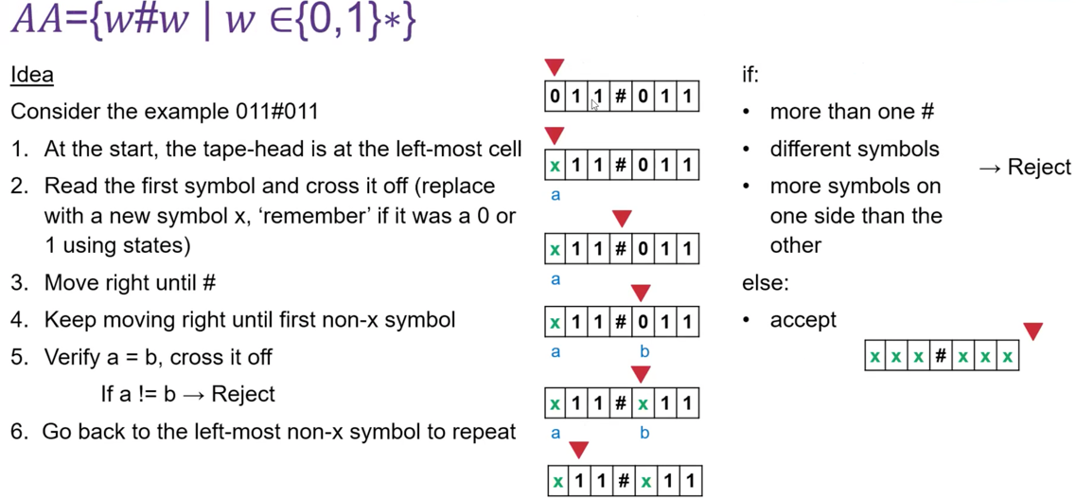

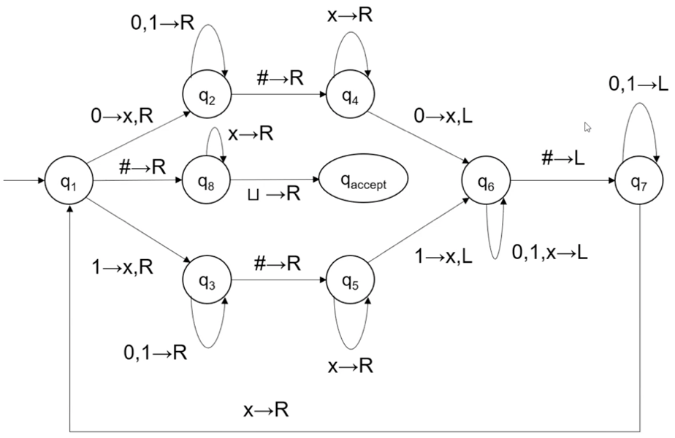

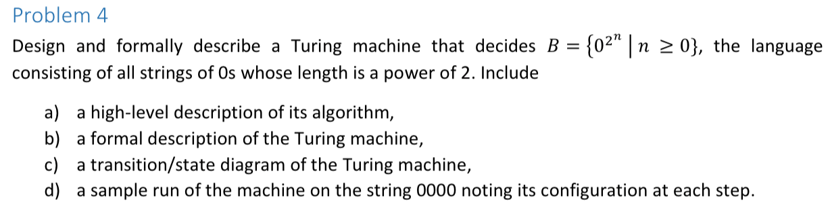
16
16/2 = 8
8/2 = 4
4/2 = 2
2/2 = 1

12/2 = 6
6/2 = 3

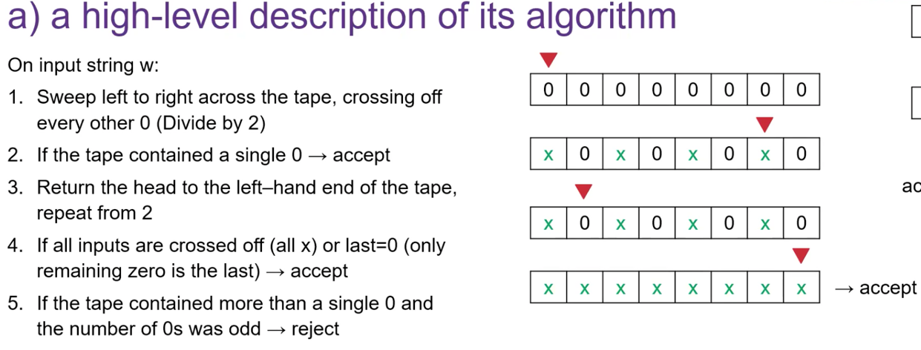

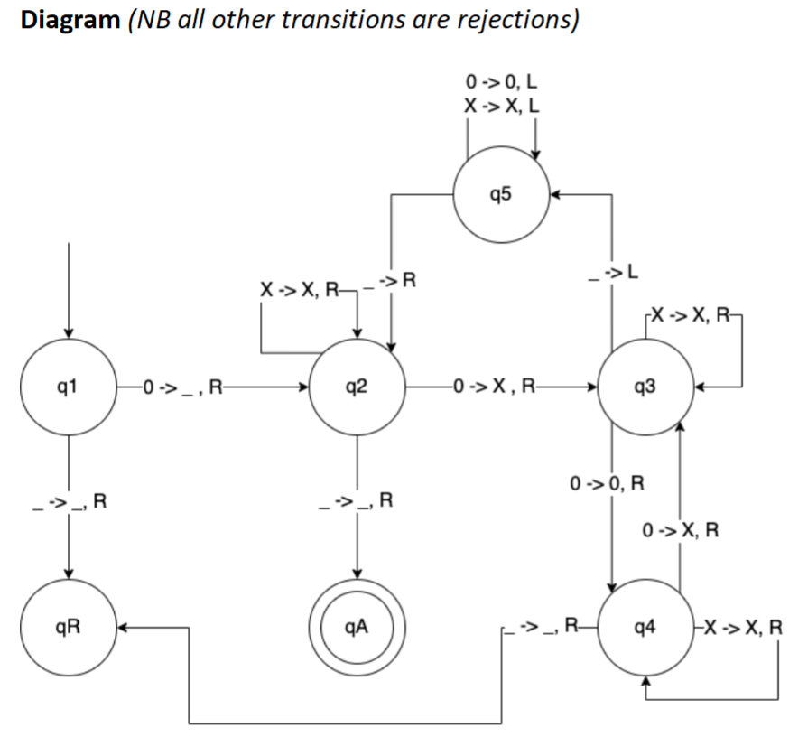
1 | 2 | 3 | 4 | 5 | 6 | 7 | 8 | 9 | 10 | 11 | 12 | 13 | 14 | 15 | 16
0 | 0 | 0 | 0 | 0 | 0 | 0 | 0 | 0 | 0 | 0 | 0 | 0 | 0 | 0 | 0
_ | X | 0 | X | 0 | X | 0 | X | 0 | X | 0 | X | 0 | X | 0 | X
_ | X | X | X | 0 | X | X | X | 0 | X | X | X | 0 | X | X | X
_ | X | X | X | X | X | X | X | 0 | X | X | X | X | X | X | X
_ | X | X | X | X | X | X | X | X | X | X | X | X | X | X | X

d) 0000:
q₁0000, _q₂000, _xq₃00, _x0q₄0, _x0xq₃_, _x0q₅x, _xq₅0x, _q₅x0x, q₅_x0x, _q₂x0x
_xq₂0x, _xxq₃x, _xxxq₃_, _xxq₅x, _xq₅xx, _q₅xxx, q₅_xxx, _q₂xxx, _xq₂xx, _xxq₂x,
_xxxq₂_, _xxx_q_{a}

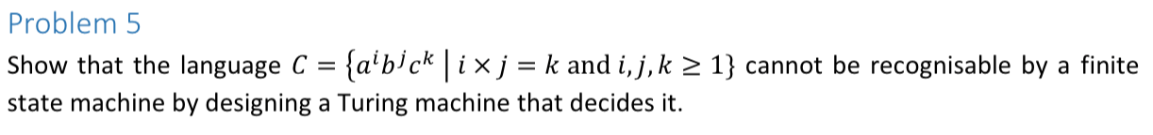

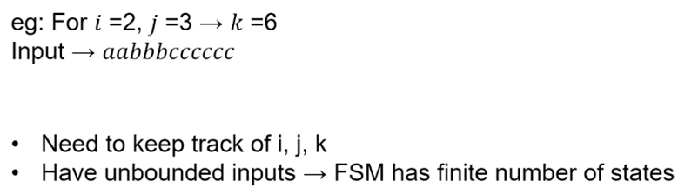

aabbbcccccc
xxyyyzzzzzz

we are basically making c’s into z, j times, for each i.

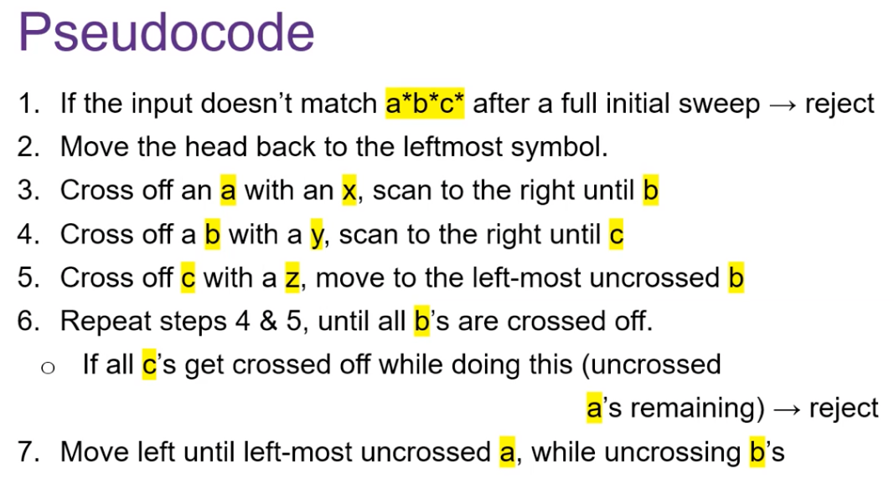

Q0 a | a | b | b | b | c | c | c | c | c | c
x | Q1 a | b | b | b | c | c | c | c | c | c
Keep going right until reach b
x | a | Q1 b | b | b | c | c | c | c | c | c
x | a | y | Q2 b | b | c | c | c | c | c | C
Keep going right until reach c
x | a | y | b | b | Q2 c | c | c | c | c | c
x | a | y | b | Q3 b | z | c | c | c | c | c
Keep going left until reach y
x | a | Q3 y | b | b | z | c | c | c | c | c
x | a | y | Q1 b | b | z | c | c | c | c | c
x | a | y | y | Q2 b | z | c | c | c | c | c
Keep going right until reach c
x | a | y | y | b | z | Q2 c | c | c | c | c
x | a | y | y | b | Q3 z | z | c | c | c | c
Keep going left until reach y
x | a | y | Q3 y | b | z | z | c | c | c | c
x | a | y | y | Q1 b | z | z | c | c | c | c
x | a | y | y | y | Q2 z | z | c | c | c | c
*skip some steps*
x | a | y | y | y | Q1 z | z | z | c | c | c
x | a | y | y | Q4 y | z | z | z | c | c | c
Go left, replacing all the y’s back to b’s
x | Q4 a | b | b | b | z | z | z | c | c | c
Q5 x | a | b | b | b | z | z | z | c | c | c
x | Q0 a | b | b | b | z | z | z | c | c | c
Repeat the same steps done for the 1st a for the 2nd a.
x | x | y | y | y | z | z | z | z | Q3 z | z
Keep going left until reach y
x | x | y | y | Q3 y | z | z | z | z | z | z
x | x | y | y | y | Q1 z | z | z | z | z | z
x | x | y | y | Q4 y | z | z | z | z | z | z
Go left, replacing all the y’s back to b’s
x | Q4 x | b | b | b | z | z | z | z | z | z
x | x | Q6 b | b | b | z | z | z | z | z | z
Keep going right through all the b’s and z’s.
x | x | b | b | b | z | z | z | z | z | Z qa _

aabbbcccc
xaybbzccc
xayybzzcc
xayyyzzzc
xabbbzzzc
xxybbzzzz
xxyyb; stuck on q2, no c’s left.

abba

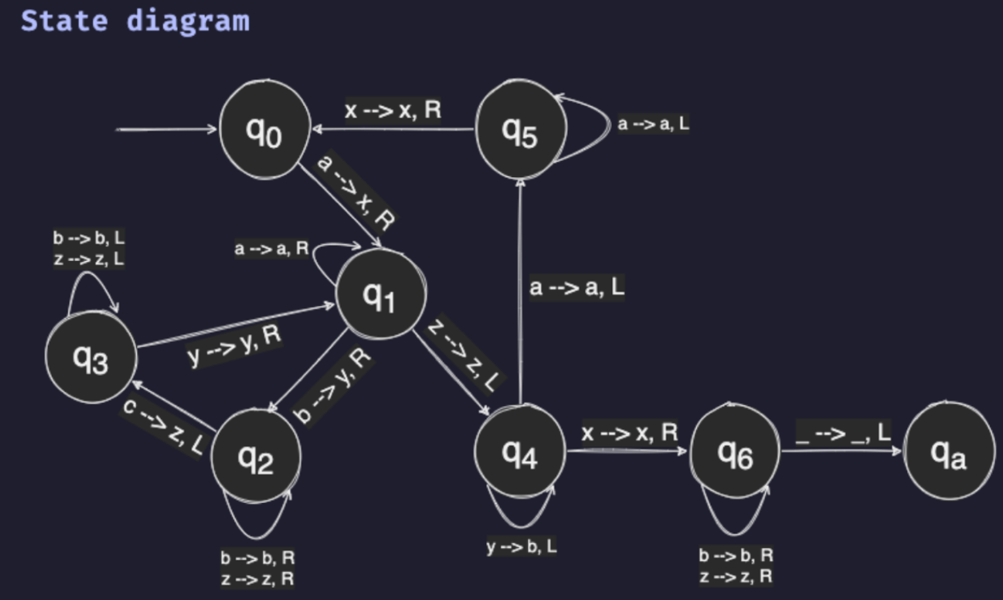

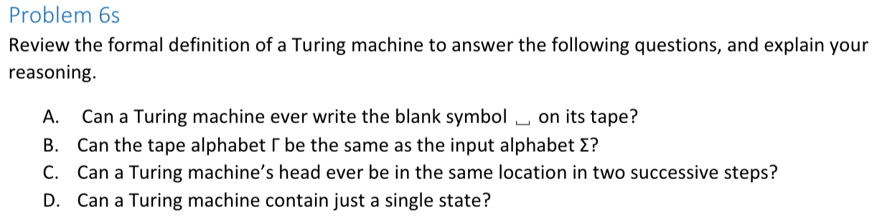

- Yes. 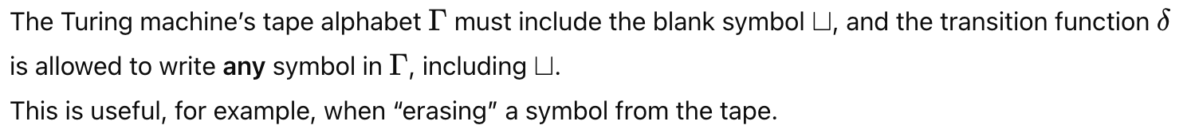
- No.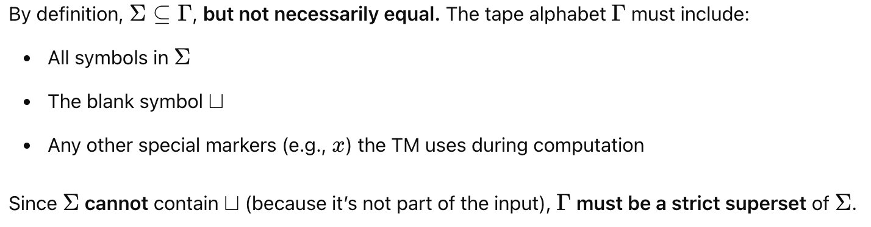
- Yes, a Turing machine's head can remain in the same location for two successive steps, but only if the machine is on the leftmost tape cell and attempts to move left, as moving off the left edge of the tape is not allowed.
- No, since accept and reject states cannot be the same.

