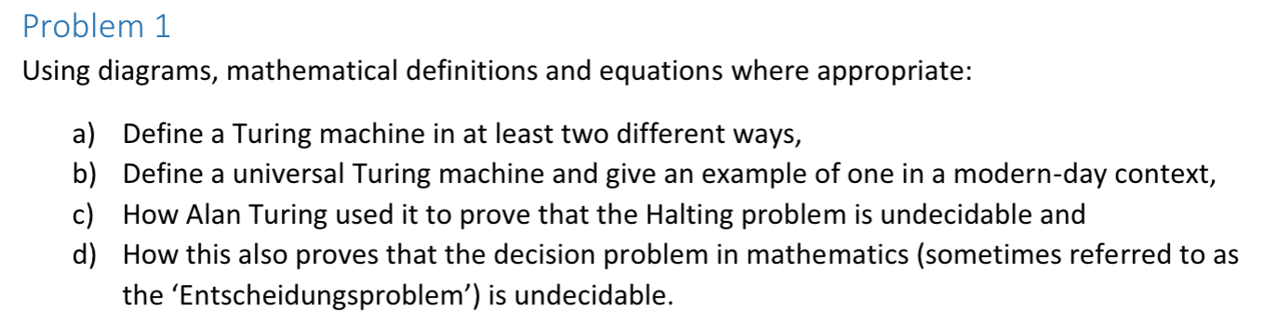

- Formal definition: (the seven-tuple definition, using a table or diagram for the transitions). Conceptual definition: a theoretical computational model that operates by manipulating symbols on an infinite tape according to a set of rules. It has a tape head that can read and write symbols and move left or right, and process continues until it reaches an accept or reject state. (etc.etc.)
- TM that runs other TMs. How does it take input? The TM must be on the tape. Examples of programs that run other programs?
- OS,
- Emulator - An emulator is a software program or hardware device that replicates the functions of one computer system (the guest system) on another computer system (the host system).
- CPU - ability to execute Turing complete instruction sets
- Revision from W3_tut:
The idea is that we create a machine (Turing machine) that computes whether or not a given program on input i is guaranteed to halt or not. This machine takes any program (machine), and so because its input is other TMs, it is a UTM; In our notation from the w3 tute, this means that our machine ‘H’ is a UTM. Our H+ is constructed using this H (a UTM) so must be a UTM as well.
- The Halting Problem is a decision problem where the input consists of a program (or Turing Machine) and an input value for that program. The question it poses is: Will the program halt when given that input, or will it run forever? Alan Turing proved that the Halting Problem is undecidable, meaning no algorithm can universally determine the halting behaviour for all possible inputs. Now, suppose you make another machine that can solve a different problem: deciding whether any first-order logic statement is true or false (this is called the decision problem for first-order logic). If such a machine existed, we could cleverly use it to also solve the Halting Problem—which we already know is impossible. This leads us to an unavoidable conclusion: the decision problem for first-order logic must also be undecidable, because if it were solvable, the Halting Problem would be too, which contradicts Turing’s proof. In other words, proving the Halting Problem is undecidable lets us transfer that insolvability to other problems by reducing them to it.

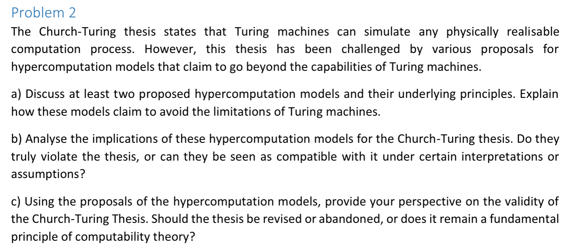

Church-Turing thesis: any real-world computation can be translated into an equivalent computation involving a Turing machine (or represented using lambda calc). There are conflicting points of view about the Church-Turing thesis. One says that it can be proven, and other says that it serves as a definition for computation. There has never been a proof, but the evidence for its validity comes from the fact that every realistic model of computation, yet discovered, has been shown to be equivalent. If there were a device which could answer questions beyond those that a Turing machine can answer, then it would be called an oracle.

- Oracle machines: An oracle machine is a Turing machine augmented with an "oracle"—a black-box that can solve decision problems that are undecidable for ordinary Turing machines, such as the Halting Problem. How it avoids Turing limits: Oracle machines bypass the limits of Turing machines by offloading undecidable tasks to the oracle, allowing them to compute problems beyond the Turing limit.
Don't necessarily violate thesis directly, as thesis applies to "physically realizable" computations.
But expand the notion of what's considered "physically realizable" beyond classical digital Turing model.
- Neural networks: Can learn and approximate complex functions by adjusting weights/biases, potentially computing non-computable functions. Weights of the connections between the nodes determines how much influence each input has on the output. Rely on training data to improve accuracy.
While Artificial neural networks don’t directly violate the CT-thesis, they challenge traditional interpretations of computability by demonstrating that effective computation can occur through mechanisms that diverge from the strict sequential symbol manipulation of Turing machines:
- Parallel and distributed processing: ANNs perform computation through parallel and distributed processing, with interconnected neurons processing information simultaneously. This contrasts with the sequential execution of instruction in Turing machines.
- Some research areas explore how neural networks, especially those with features like chaotic dynamics or unbounded precision (e.g., recurrent neural networks (RNNs)), may be capable of hypercomputation. However, the formal proof of hypercomputation by neural networks remains a challenge and is not yet widely accepted. At the end of the day, ANNs do not directly violate the thesis because their computations are ultimately representable and able to be simulated by a TM.

- Provide your perspective on the validity and significance of the Church-Turing thesis:

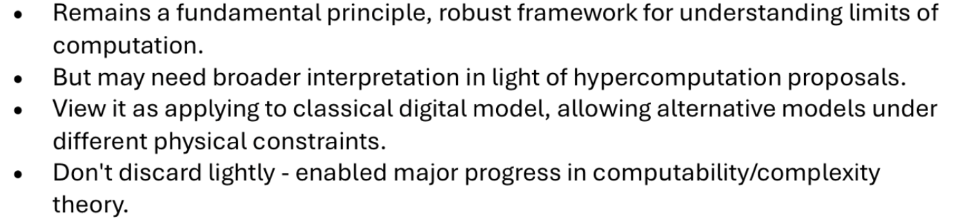
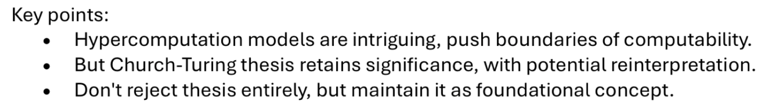

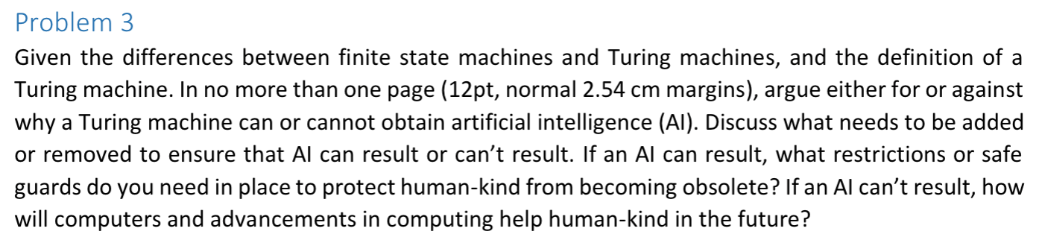

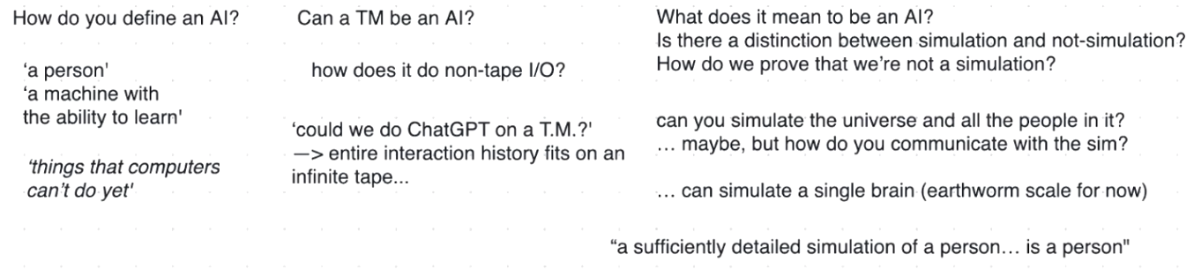

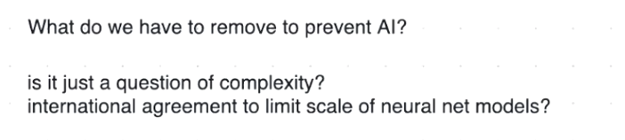

Paperclip maximiser theory.
