1. 基础验证模块 (Authentication)
这两个模块是系统的入口，负责安全校验。

1.1 身份验证 (Identity Verification)
功能: 验证当前操作者的身份令牌（Token）或 Session 是否合法。
MODULE Identity_Verification (user_token)
BEGIN
IF user_token IS EMPTY THEN
RETURN "错误: 未提供身份令牌"
END IF
// 验证令牌有效性
decoded_token = CALL Verify_Token_Algorithm(user_token)
IF decoded_token IS VALID AND NOT Expired THEN
current_user = Get_User_Info(decoded_token.user_id)
RETURN current_user
ELSE
RETURN "错误: 身份验证失败或已过期"
END IF
END
NS图
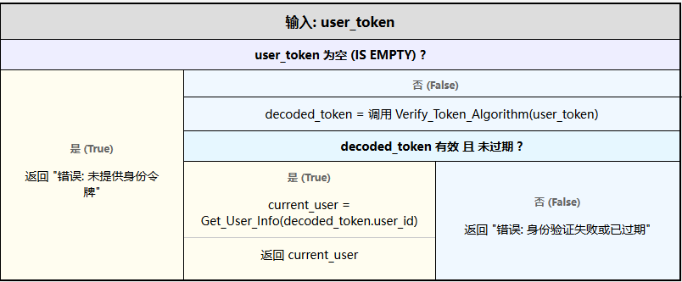

1.2 登录验证 (Login Verification)
功能: 处理用户登录请求，发放凭证。
MODULE Login_Verification (username, password, captcha)
BEGIN
IF captcha IS INVALID THEN
RETURN "错误: 验证码错误"
END IF
// 查询数据库
user_record = DB_SELECT User FROM Users WHERE LoginName = username
IF user_record EXISTS THEN
hashed_password = Hash_Function(password)
IF user_record.password == hashed_password THEN
// 生成会话令牌
token = Generate_Token(user_record.id, user_record.role)
Update_Last_Login_Time(user_record.id)
RETURN "成功: 登录通过", token
ELSE
RETURN "错误: 密码错误"
END IF
ELSE
RETURN "错误: 用户不存在"
END IF
END
PAD图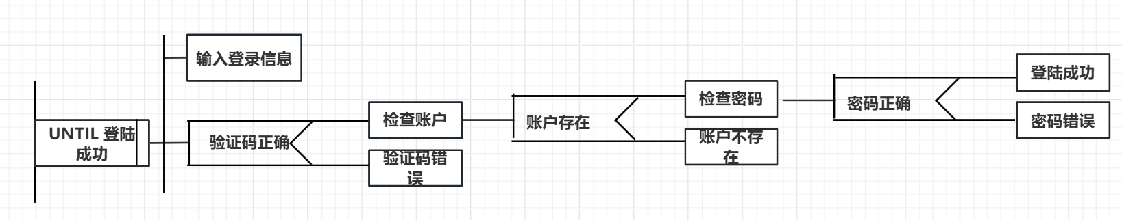

2. 系统管理模块 (System Management)
核心管理模块，包含权限、用户及数据维护。

2.1 权限管理 (Permission Management)
功能: 作为调度模块，管理用户与角色的入口。
MODULE Permission_Management (action, target, data)
BEGIN
SWITCH action
CASE "MANAGE_USER":
CALL User_Management(target, data)
CASE "SET_ROLE":
CALL Role_Settings(target, data)
DEFAULT:
RETURN "错误: 无效的操作类型"
END SWITCH
END

2.2 用户管理 (User Management)
功能: 处理用户信息的增删改查及向下级模块分发任务。
MODULE User_Management (operation_type, user_data)
BEGIN
IF Current_User.Has_Permission("USER_EDIT") IS FALSE THEN
RETURN "拒绝: 权限不足"
END IF
SWITCH operation_type
CASE "DATA_MAINTENANCE":
CALL Data_Maintenance(user_data)
CASE "AUDIT_MERCHANT":
CALL Audit_Merchant_Qualifications(user_data)
DEFAULT:
// 常规用户增删改逻辑
DB_UPDATE Users SET info = user_data
END SWITCH
END

2.2.1 数据维护 (Data Maintenance)
功能: 执行数据备份与日志管理。
MODULE Data_Maintenance (maintenance_config)
BEGIN
// 子功能：数据备份
IF maintenance_config.action == "BACKUP" THEN
backup_file = Create_Snapshot(Database)
Save_To_Storage(backup_file)
RETURN "备份完成"
END IF
// 子功能：日志管理
IF maintenance_config.action == "LOG_MANAGE" THEN
CALL Log_Management()
END IF
END
MODULE Log_Management ()
BEGIN
// 归档旧日志，删除过期日志
Archive_Logs(Older_Than = 6_Months)
Delete_Logs(Older_Than = 2_Years)
END

2.2.2 审核商家资质 (Audit Merchant Qualifications)
功能: 审核商家入驻资质，并处理相关投诉和行为查看。
MODULE Audit_Merchant_Qualifications (merchant_id, docs)
BEGIN
validation_result = Check_Legal_Documents(docs)
IF validation_result IS PASS THEN
DB_UPDATE Merchants SET status = "VERIFIED" WHERE id = merchant_id
ELSE
DB_UPDATE Merchants SET status = "REJECTED" WHERE id = merchant_id
END IF
// 关联操作
CALL Handle_User_Complaint(merchant_id)
CALL View_User_Behavior(merchant_id)
END
MODULE Handle_User_Complaint (merchant_id)
BEGIN
complaints = DB_SELECT * FROM Complaints WHERE target_id = merchant_id AND status = "PENDING"
FOR EACH item IN complaints DO
Process_Complaint(item) // 客服介入或自动处理
END FOR
END
MODULE View_User_Behavior (user_id)
BEGIN
behavior_logs = Fetch_Activity_Logs(user_id)
Display_Timeline(behavior_logs)
END

2.3 角色设置 (Role Settings)
功能: 定义角色及其对应的权限集。
MODULE Role_Settings (role_id, permission_list)
BEGIN
// 分配/撤销权限
CALL Assign_Revoke_Permissions(role_id, permission_list)
END
MODULE Assign_Revoke_Permissions (role_id, new_permissions)
BEGIN
current_permissions = DB_SELECT perms FROM Roles WHERE id = role_id
// 计算差异
to_add = new_permissions - current_permissions
to_remove = current_permissions - new_permissions
DB_INSERT into Role_Permissions VALUES (role_id, to_add)
DB_DELETE from Role_Permissions WHERE role_id = role_id AND perm_id IN to_remove
Refresh_System_Cache() // 刷新缓存使权限即时生效
END

3. 运营监控模块 (Operational Monitoring)

3.1 系统监控 (System Monitoring)
功能: 监控系统的业务指标和技术性能。
MODULE System_Monitoring (monitor_type)
BEGIN
IF monitor_type == "BUSINESS" THEN
CALL Order_Monitoring()
ELSE IF monitor_type == "TECHNICAL" THEN
CALL Performance_Monitoring()
END IF
END

3.1.1 订单监控 (Order Monitoring)
功能: 实时监控订单流转，生成业务报表。
MODULE Order_Monitoring ()
BEGIN
real_time_orders = Fetch_Live_Stream("Orders")
IF real_time_orders.failed_count > Threshold THEN
Trigger_Alert("订单异常激增")
END IF
// 业务统计/生成运营报表
CALL Generate_Operations_Report(Daily_Data)
END
MODULE Generate_Operations_Report (data)
BEGIN
kpi_metrics = Calculate_GMV_DAU(data)
Format_Report_PDF(kpi_metrics)
Send_Report_To_Management()
END

3.1.2 监控系统性能 (Monitor System Performance)
功能: 监控服务器负载，处理告警。
MODULE Performance_Monitoring ()
BEGIN
cpu_usage = Get_CPU_Usage()
mem_usage = Get_Memory_Usage()
IF cpu_usage > 90% OR mem_usage > 85% THEN
// 处理系统告警
CALL Handle_System_Alert("CRITICAL", "服务器负载过高")
END IF
END
MODULE Handle_System_Alert (level, message)
BEGIN
Log_Error(level, message)
Notify_DevOps_Team(message)
IF level == "CRITICAL" THEN
Auto_Scale_Servers() // 尝试自动扩容
END IF
END

4. 财务管理模块 (Financial Management)

4.1 财务报表 (Financial Reports)
功能: 财务数据的汇总与展示中心。
MODULE Financial_Reports (report_period)
BEGIN
settlement_data = CALL Settlement_Management(report_period)
income_data = CALL Income_Statistics(report_period)
report = Merge_Data(settlement_data, income_data)
Display_Dashboard(report)
END

4.1.1 结算管理 (Settlement Management)
功能: 处理商家或合作伙伴的资金结算。
MODULE Settlement_Management (period)
BEGIN
pending_bills = DB_SELECT * FROM Bills WHERE status = "UNPAID" AND date IN period
FOR EACH bill IN pending_bills DO
fee = Calculate_Platform_Fee(bill.amount)
payable = bill.amount - fee
Initiate_Bank_Transfer(bill.merchant_account, payable)
DB_UPDATE Bills SET status = "PAID"
END FOR
END

4.1.2 收入统计 (Income Statistics)
功能: 统计平台收入并进行成本分析。
MODULE Income_Statistics (period)
BEGIN
total_revenue = SUM(Order_Amounts) WHERE date IN period
// 成本分析
CALL Cost_Analysis(period, total_revenue)
RETURN total_revenue
END
MODULE Cost_Analysis (period, revenue)
BEGIN
server_costs = Get_Infrastructure_Cost(period)
labor_costs = Get_Labor_Cost(period)
marketing_costs = Get_Marketing_Cost(period)
net_profit = revenue - (server_costs + labor_costs + marketing_costs)
Generate_Chart("Revenue_vs_Cost", period)
END

5. 内容管理模块 (Content Management)

5.1 活动审核 (Activity Audit)
功能: 管理前台公告及商家提交的促销活动。
MODULE Activity_Audit (audit_task)
BEGIN
SWITCH audit_task.type
CASE "PLATFORM_NOTICE":
CALL Notice_Management(audit_task.data)
CASE "MERCHANT_PROMOTION":
CALL Audit_Merchant_Activity(audit_task.data)
END SWITCH
END

5.1.1 公告管理 (Notice Management)
功能: 发布、编辑或撤回系统公告。
MODULE Notice_Management (notice_content)
BEGIN
IF notice_content.action == "PUBLISH" THEN
Validate_Sensitive_Words(notice_content.text)
Push_To_App_Home(notice_content)
ELSE IF notice_content.action == "DELETE" THEN
Remove_From_Database(notice_content.id)
END IF
END

5.1.2 审核商家活动 (Audit Merchant Activity)
功能: 人工或自动审核商家发起的营销活动。
MODULE Audit_Merchant_Activity (activity_proposal)
BEGIN
// 自动规则检查 (时间冲突、折扣力度等)
auto_check = Check_Rules(activity_proposal)
IF auto_check IS FALSE THEN
// 审核结果：自动驳回
CALL Audit_Result(activity_proposal.id, "REJECTED", "规则校验失败")
RETURN
END IF
// 人工复核流程
admin_decision = Wait_For_Admin_Input(activity_proposal)
// 审核结果
CALL Audit_Result(activity_proposal.id, admin_decision.status, admin_decision.comment)
END
MODULE Audit_Result (activity_id, status, comment)
BEGIN
DB_UPDATE Activities SET status = status, audit_comment = comment WHERE id = activity_id
Notify_Merchant(activity_id, status)
END

