Tutorial 8

Problem: 12.8
Produce a data and requirements specifications for the xref program
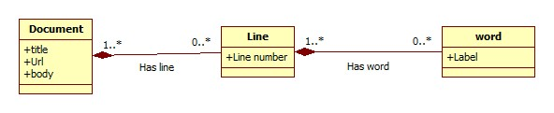
Document: title, url, content
Line: line number
Word: label
HasLine(Document, 1, Line, *)
Hasword(Line,1,Word,*)

Problem: 12.9
Produce a data and requirements specifications for the spelling checker program
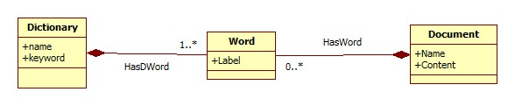
Document: name, content
Word: Label.
Dictionary: name, keyword
HasWord(Document,1,Word,*)
HasDword(Dictionary,1,Word,1..*).

