1

FROM ubuntu:20.04

RUN apt update && apt install -y sbcl

WORKDIR /usr/src

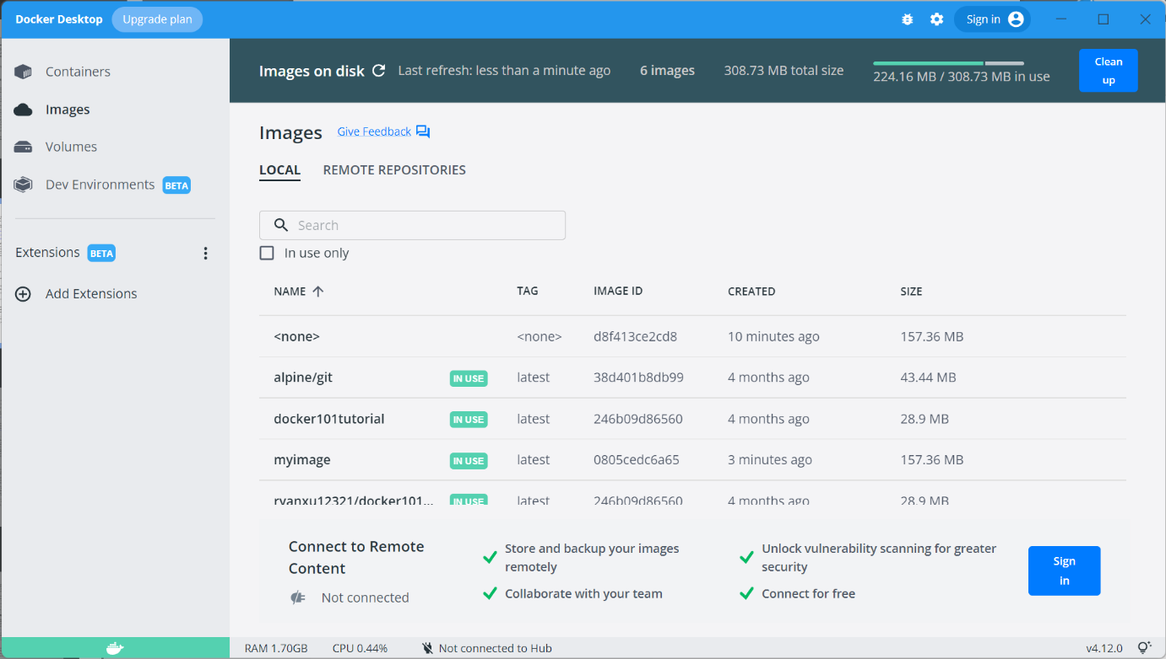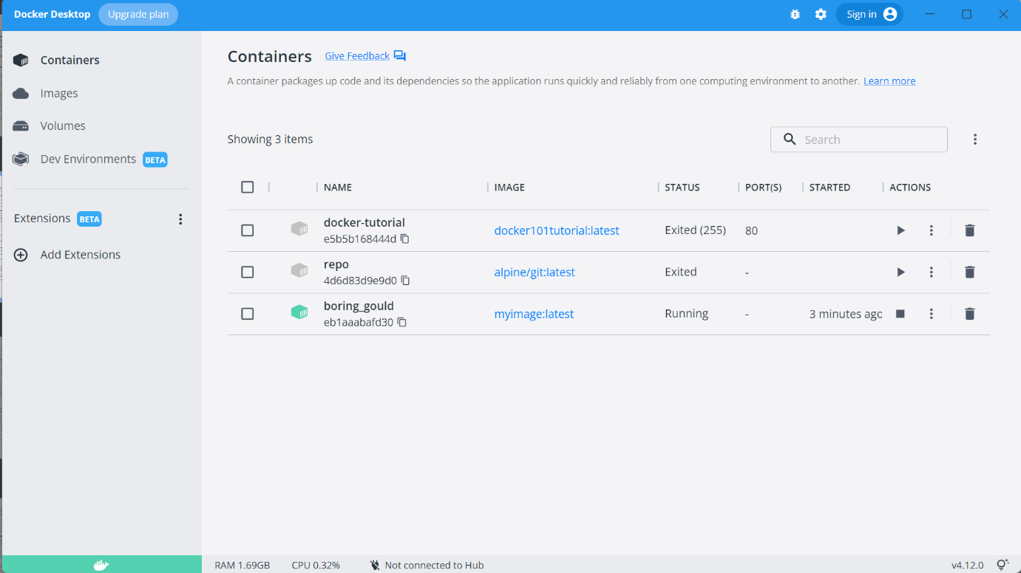

2．1

import pandas as pd

def cardinality_items(file):

    df = pd.read_csv(file)

    ret = df.reset_index().nunique()

    print(ret)

    return ret;

cardinality_items("example.csv")

2.2

number of unique subset is 2 ^ N (including an empty set)

2.3

import pandas as pd

def all_itemsets(file):

    df = pd.read_csv(file)

    uniqueList = df.reset_index().drop_duplicates().toList()

    ret = subsets(uniqueList)

    print(ret)

    return ret;

def subsets(self, nums):

    ans = []

    path = []

    n = len(nums)

    def dfs(i):

        if i == n:

            ans.append(path.copy())

            return

        dfs(i + 1)

        path.append(nums[i])

        dfs(i + 1)

        path.pop()

    dfs(0)

    return ans

all_itemsets("example.csv")

2.4

def prob_S(S, D):

    ret = []

    counter = defaultdict(int)

    for d in D:

        counter[d] += 1

    tot = len(D)

    for s in S:

        prob = counter[s] / tot

        ret.append(prob)

    return ret