Project 2 of CSE 473/573

Shaoming Xu UB# 50247057

# Task 1

Question 1: (images have been resized, the original images in task1_img folder)

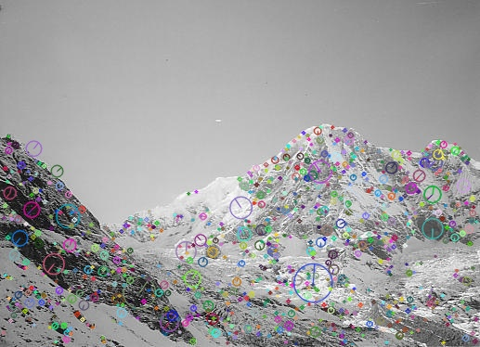

fig1.1 task1_sift1.jpg

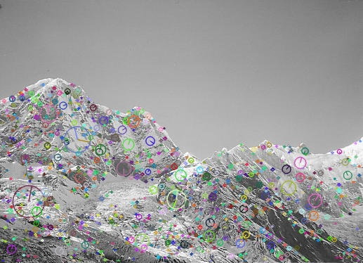

fig1.2 task1_sift2.jpg

Question 2: (images have been resized, the original images in task1_img folder)

Choose matches between 10 and 20.

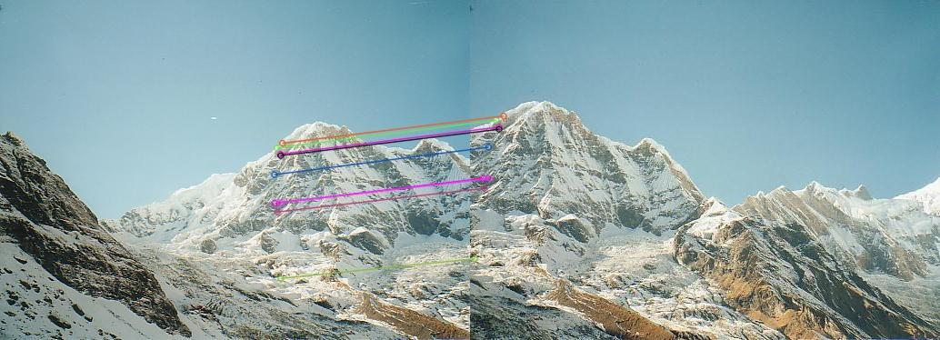

task1_matches_knn.jpg

Question 3:

homography matrix:

[[ 1.58799966e+00 -2.91541838e-01 -3.95539425e+02]

[ 4.48199617e-01 1.43139761e+00 -1.90370131e+02]

[ 1.20864262e-03 -5.94920214e-05 1.00000000e+00]]

Question 4: (images have been resized, the original images in task1_img folder)

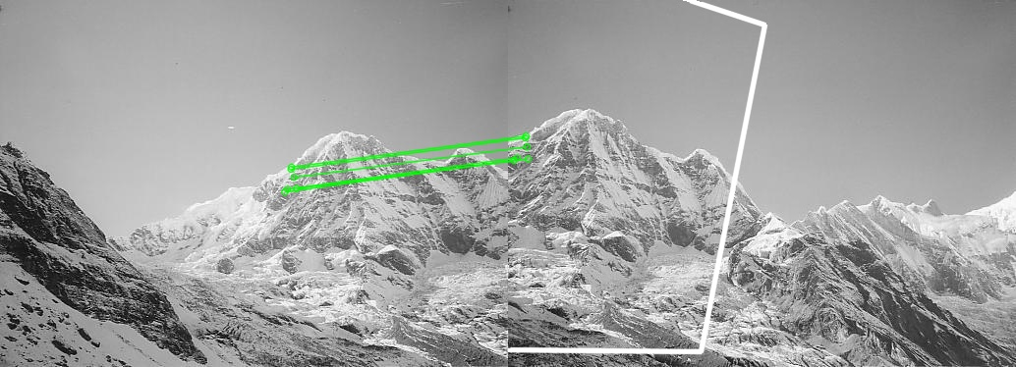

task1_matches.jpg

Question 5: (images have been resized, the original images in task1_img folder)

# Task2

Question 1: (images have been resized, the original images in task2_img folder)

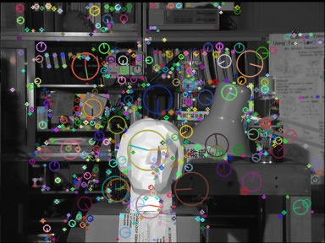

task2_sift1.jpg

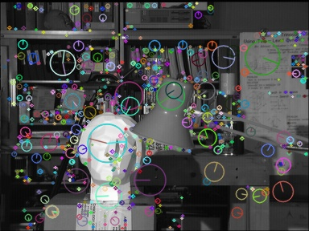

task2_sift2.jpg

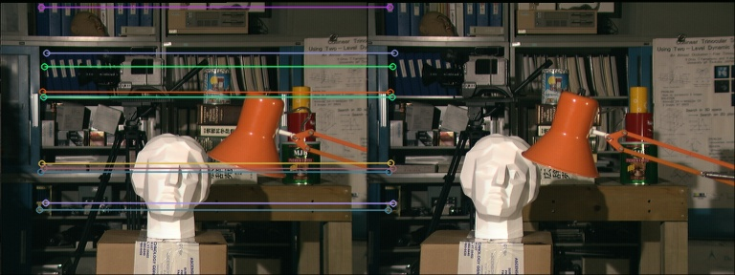

task2_matches_knn.jpg

Question 2:

fundamental matrix:

[[-1.19209290e-07 -1.39236450e-04 4.51660156e-02]

[ 1.48773193e-04 -3.83853912e-05 -1.04858103e+14]

[-4.28466797e-02 1.04858103e+14 1.00000000e+00]]

Question 3: (images have been resized, the original images in task2_img folder)

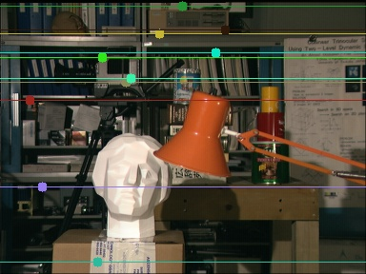

task2_epi_right.jpg

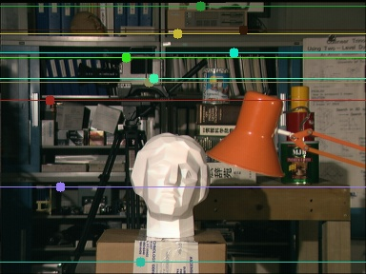

task2_epi_left.jpg

Question 4: (images have been resized, the original images in task2_img folder)

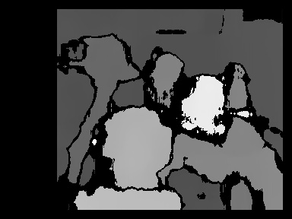

task2_disparity.jpg

# Task3

### Part a: K-means Clustering

There are total two iterations for the given data as shows below. The triangle represents data, the circle represents the cluster center. I show the center and data in same image. Report format is: cluster: mean vector: classification vector (value is the index of data. For example, the index of (5.9,3.2) in data matrix is 0).

**Iteration 0:**

This shows the clusters’ center location which represents the mu in report.

cluster: [6.2 3.2]: [0 1 3 5 6 8 9]

cluster: [6.6 3.7]: [4]

cluster: [6.5 3. ]: [2 7]

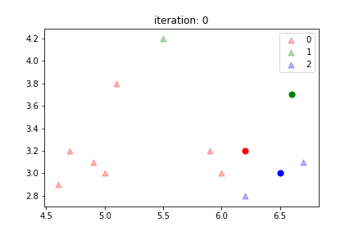

**Iteration 1:**

cluster: [5.17142857 3.17142857]: [1 3 5 6]

cluster: [5.5 4.2]: [4 8]

cluster: [6.45 2.95]: [0 2 7 9]

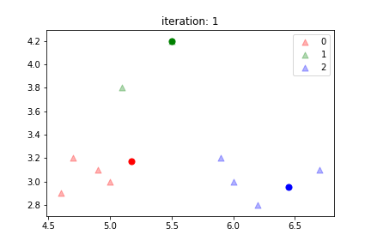

**Iteration 2:**

cluster: [4.8 3.05]: [1 3 5 6]

cluster: [5.3 4. ]: [4 8]

cluster: [6.2 3.025]: [0 2 7 9]

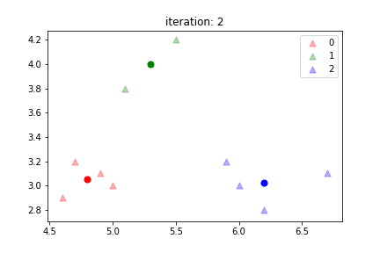

**Color Quantization(code saved in k_mean_img.py):**

For the purpose to save paper, I have resized the image in report. If you want to see the original image, please go to task3_img folder. Thank you

**K = 3:**

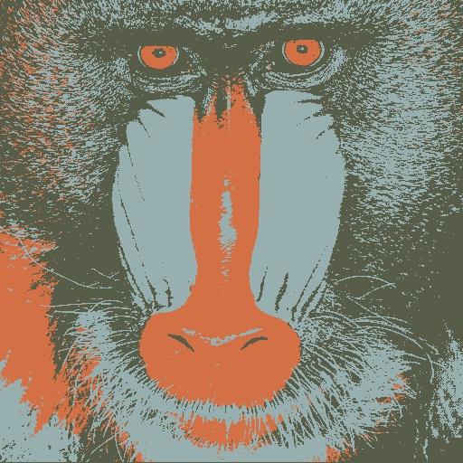

**k = 5**

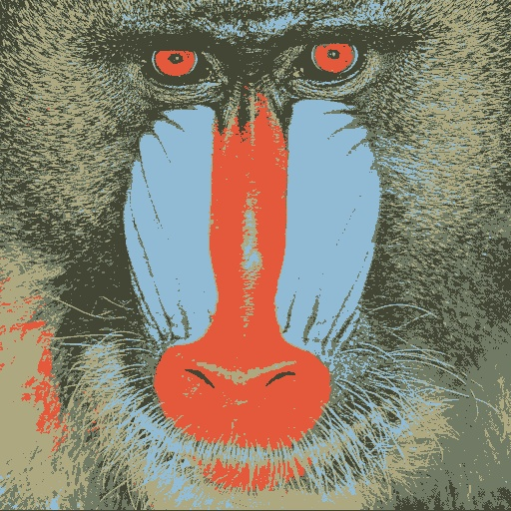

**k = 10**

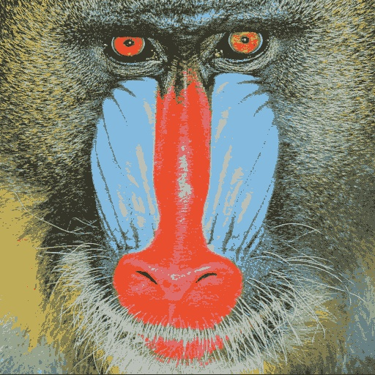

**k=20**

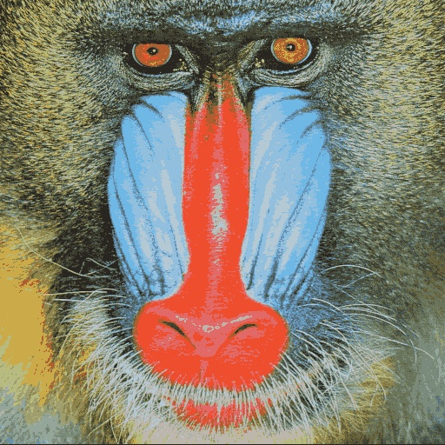

### Part b: Gaussian Mixture Model

**Question a: what is the u_i after the first iteration?**

[5.3165079 3.21527292]

[5.61129795 3.38505311]

[5.60443565 3.14420061]

**Question b: Include first five plots for faithful data.**

