**Homework3**

**Shulei Xu**

**CSE 381**

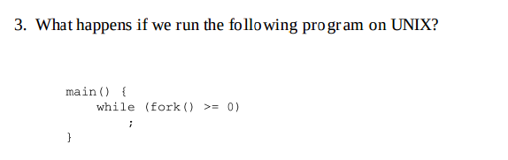

Answer:

This program would go into infinite loop and keep making new child process, because when it makes a child process and then executes it, fork() would return 0 to distinguish the child process, so this while loop will continue to create a new child process.

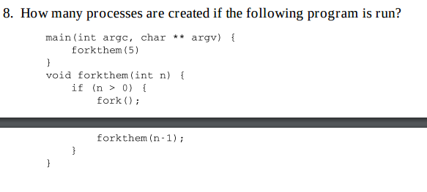

Answer:

Since this recursive program recursively call forkthem method, which would create a child process each time, so by induction, we finally get 2^5 = 32 processes

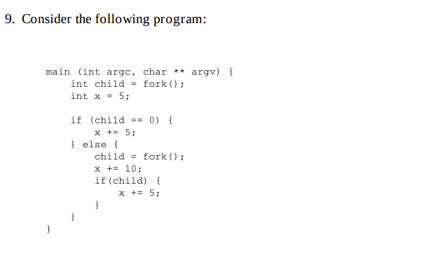

How many different copies of the variable x are there? What are their values when their process finishes?

Answer:

There are 3 different copies of x there, x of first child is 10, x of second child is 20, x of parent is 15

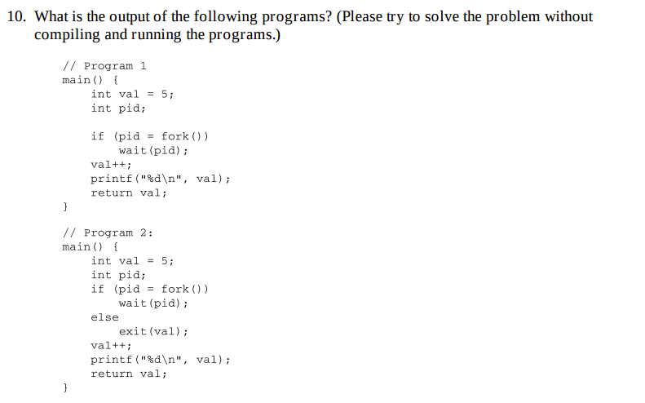

Answer:

Program1: output would be: 6

6

Because the parent and child process have their own variables, so child process would not affect parent process.

Program2: output would be: 6

Because when it creates a child process, the child process will directly exit(val), so the child process will not print anything or modify val.