**CSE381 Lab 4**

1. **Objective**

* Understand the synchronization problems
* Practice using C language
* Practice using lock to solve synchronization problems

1. **C programming language (10 points)**

In the C, there is no string data type. C uses an array of character to represent a string and the last element of the array is NULL. The NULL is the terminator of a string.

Exercise 1

Implement the following string functions and write test cases for them.

1. int string_len( char str[ ] )

return the number of characters in the str.

1. int string_copy( char src[], char dst[ ])

Copy string src to the string dst. Return the number chars have been copied.

1. char *string_append( char str1[ ], char str[ ])

Append str to str1 and return the resulted string

Excurse 2 Implement the following a matrix addition functions and write a test case for it.

void matrix_add( int mtx1[4][4], int mtx2[4][4], int mtx_sum[4][4])

mxt_sum = mtx1 + mtx2

**3 Multiple thread programming (10 points)**

Implement a two-thread program. In the first thread, make an infinite loop that does:

printf(“Hello from thread 1 - A\n”);

printf(“Hello from thread 1 - B\n”);

In the second thread, do an infinite loop that does:

printf(“Hello from thread 2 - A\n”);

printf(“Hello from thread 2 - B\n”);

Run the program, and eventually stop it with CTRL+C. The time between thread switches is called a quantum.

1)Download the file lab4.tar from Canvas.

2)Extract files from the archive lab4.tar using the following command:

tar xvf lab4.tar

3) Name your code to be Exe3.c. Issue the following command to compile your code.

Make Exe3

4) Does the quantum seem long or short?

5) What happens if you insert a pthread_yield() into each loop between the two printf calls?

1. **Multiple Threads Printing (10 points)**

1) Compile the threadPrint.cc using the following command:

make threadPrint

2) Run threadPrint and you will find 24 threads printings are interleaved. For example, thread TH-16 prints its message before thread TH-9 finishes its last message.

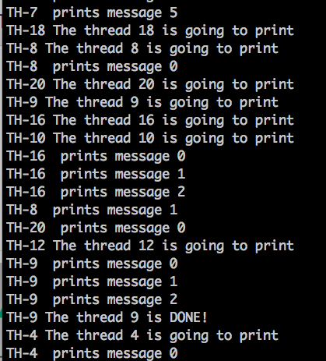

This interleaving is caused by race condition.

3) Please use lock and modify the threadPrint.cc to ensure that there is no interleaving for these 24 threads output.

4) Before using the lock, you need to include the header file

lock.h, by adding the following statement to your file:

#include “lock.h”

(submit your modified threadPrint.cc)