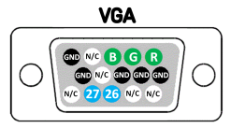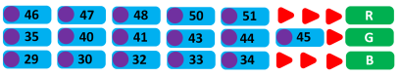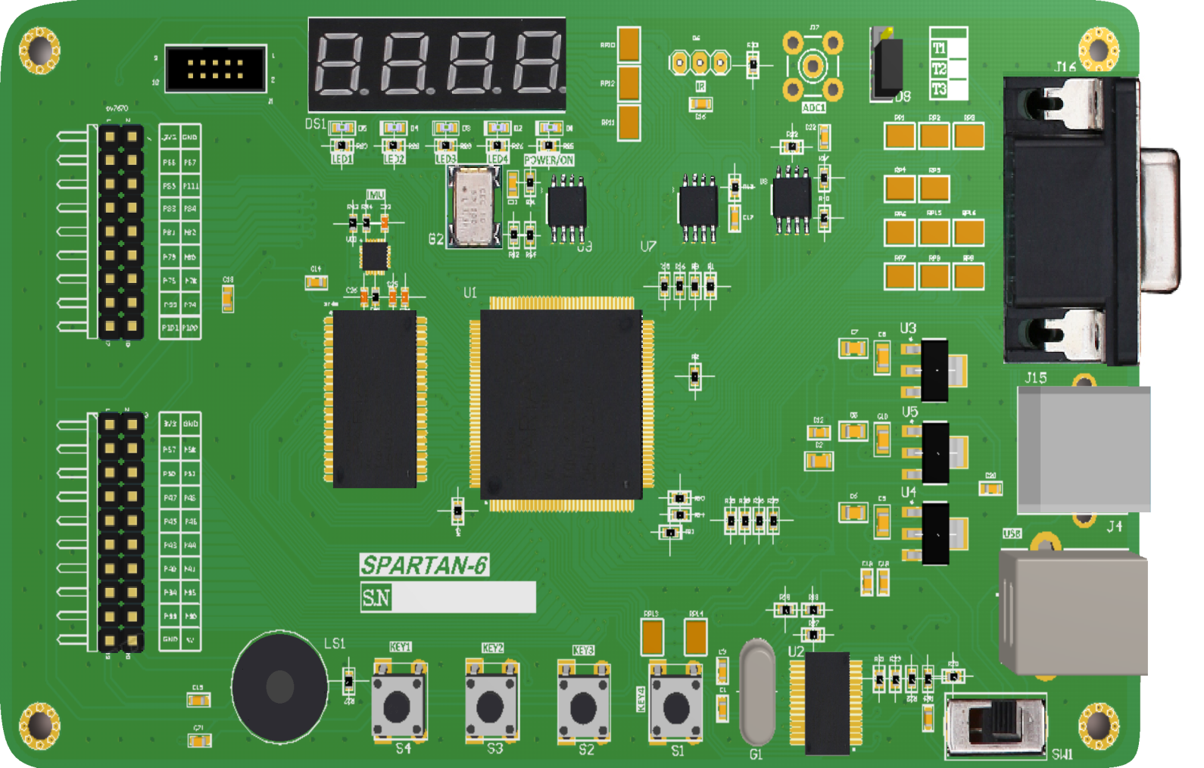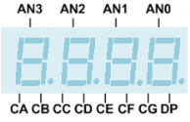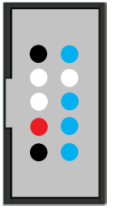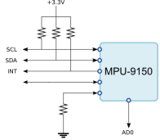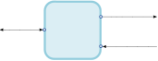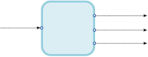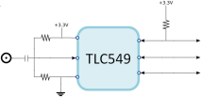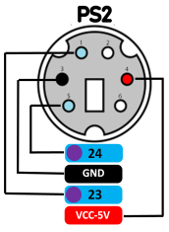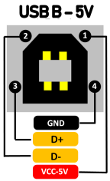

**HDLab - FPGA Development Board**

**123**

VGA

**1**

**8**

**124**

**126**

**131**

**127**

**6**

**2**

**5**

**7**

**118**

**121**

**120**

**143**

**142**

**132**

**133**

**119**

**134**

**137**

**138**

**139**

**140**

**141**

**9**

**10**

**105**

**104**

**102**

**12**

**14**

**21**

**21**

**17**

**16**

**15**

**97**

**98**

**95**

**94**

**11**

**56**

**62**

**116**

**117**

**115**

**112**

**114**

**59**

**55**

**61**

**SMA**

**67**

**75**

**66**

**74**

**85**

**84**

**78**

**81**

**82**

**83**

**79**

**80**

**84**

**100**

**101**

**74**

**99**

**78**

**75**

**80**

**79**

**82**

**81**

**83**

**85**

**111**

**67**

**66**

**33**

**30**

**40**

**34**

**35**

**41**

**43**

**44**

**45**

**46**

**47**

**48**

**50**

**51**

**57**

**58**

**GND**

**VCC-3.3V**

**VCC-5V**

**GND**

**VCC-3.3V**

**GND**

**TMS**

**3.3V**

**TCK**

**BUZZER**

**TDO**

**TDI**

**N/C**

**N/C**

**N/C**

**GND**

**GND**

**CS**

**A-IN**

**CLK**

**DOUT**

**G-VGA**

**GND**

**A-IN**

**IR**

**AN3**

**AN2**

**AN1**

**AN0**

**DP**

**CG**

**CE**

146\

**CF**

**CD**

**CC**

**CB**

**CA**

**50M-CLK**

146\

**LED 4**

**LED 3**

**LED 2**

**LED 1**

**BUTTON 4**

**BUTTON 3**

**BUTTON 2**

**BUTTON 1**

**RESET BUT**

**RX**

**TX**

**AD0**

**CLKOUT**

**INT**

**SDA**

**SCL**

**OE**

**WE**

**CS**

**D7**

**D6**

**D5**

**D4**

**D3**

**D2**

**D1**

**D0**

**A18**

**A17**

**A16**

**A15**

**A0**

**A1**

**A2**

**A3**

**A4**

**A5**

**A7**

**A6**

**A8**

**A9**

**A14**

**A13**

**A12**

**A11**

**A10**

SRAM

Power

GND

Control

Physical Pin

Digital Pin

Analog Pin

Pin Name

146\

146\

146\

146\

146\

146\

146\

146\

146\

146\

146\

146\

146\

146\

146\

146\

146\

146\

146\

146\

146\

146\

146\

146\

146\

146\

146\

146\

146\

146\

146\

146\

146\

146\

146\

146\

146\

146\

CLK

Buzzer

146\

LEDs

146\

146\

146\

146\

146\

146\

146\

146\

146\

Buttons

Reset B

146\

146\

146\

146\

146\

146\

146\

146\

146\

146\

146\

146\

146\

146\

146\

146\

146\

146\

146\

146\

146\

**109**

**108**

**107**

**GND**

**N/C**

**3.3V**

**110**

**N/C**

**GND**

**N/C**

CLKOUT

RX

TX

USB-B

PL2303

UART

2.5V

1.2V

3.3V

USB – 5V

AMS1117

POWER ON/OFF

146\

146\

146\

Jumper

IR

ADC

A-IN

REF+

REF-

DOUT

CLK

CS

146\

146\

146\

146\

146\

146\

146\

146\

146\

146\

146\

146\

146\

146\

146\

146\

146\

146\

146\

146\

146\

146\

146\

146\

146\

146\

146\

146\

146\

146\

146\

146\

146\

146\

146\

146\

146\

146\

146\

PS2

USB

JTAG PORT

7 Segment

IMU

**GND**

**GND**

**GND**