**Group Members**

Zifeng Xu NUID: 001045590

Yutong Zhen NUID: 001557715

Jiajia Liu NUID: 001568540

**Project Purpose**

Solutions to enable universities to measure the quality of the education they deliver to their students

**Outline**

1. Quantitatively demonstrate student information from multiple perspectives.
2. Visualize data for students and schools' reference.
3. The definition of ranking system of educational institutions especially for the developing world and how to apply it.

**Business Model**

1.College

2.Company

3.Course

4.Student

5.Teacher

6.University

7.relationshipGpaSalary

**Model Relationship**

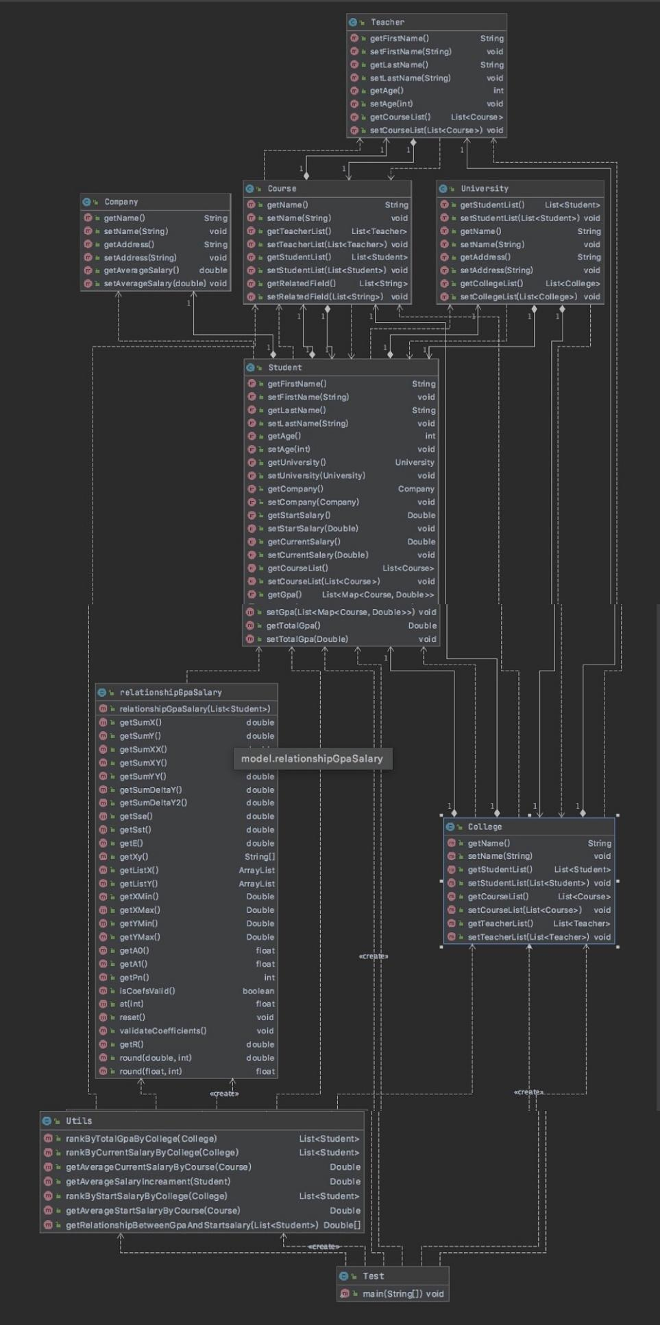

**Sequence diagram**

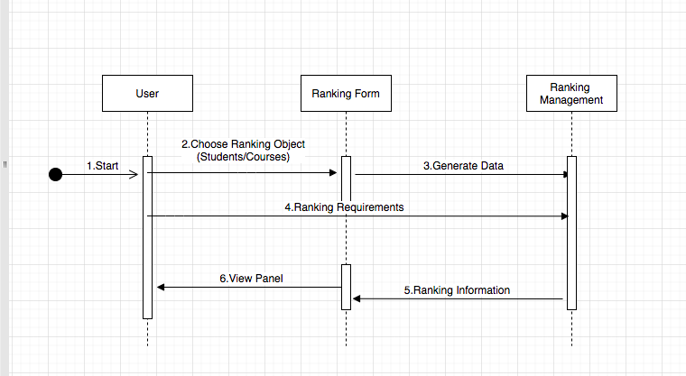

**Ranking View Process**

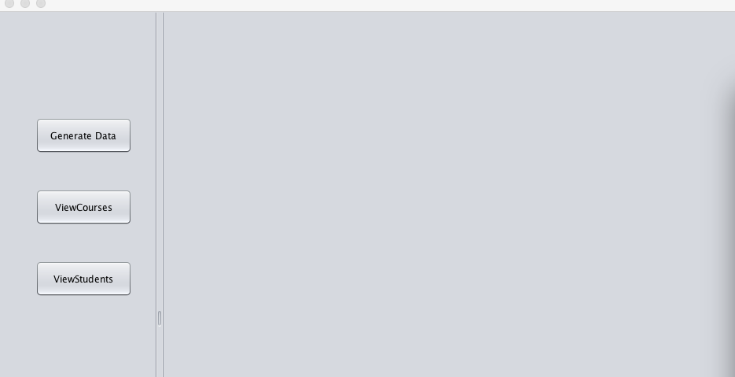

This is our main interface, 3 buttons on the left.

1. **“Generate Data ” : making use of Faker Package to generate realistic data .**

**2 “ View Students ” : including Student Name, Start Salary(USD) ,Current Salary(USD)and GPA(Total score : 4.0 )**

1) if you press the button “ View Detail ” ,you can see these details(The following picture (1) show)

2)Button “ Rank By Salary ” is about all students sorted in descending order with Current Salary (The following picture (2) show)

3) And the button “ Rank By GPA ” : shows all students sorted in descending order with total GPA(The following picture(3) show)

**3.“ View Courses ” : including Course Name, College , Related Field, Average Current Salary**

1)if you press the button “ View Detail ” ,you can see these details and also the Salary Increase(%)(The following picture(4) show)

And “Regression Equation” means the relationship between GPA and starting salary. The first number means that every increase in GPA by 1 means the starting salary increases by the same amount yuan “Regression Deviation ”means r squared, which indicates confidence, and the closer it is to 1, the more accurate the regression equation will be.

1. the button “ Rank By Salary ” is about Courses ranked according to Current Salary(The following picture(4) show)
2. On the top right of this interface, you can choose College such as Engineer College, Medical College...and to select the college course lists you want to view.

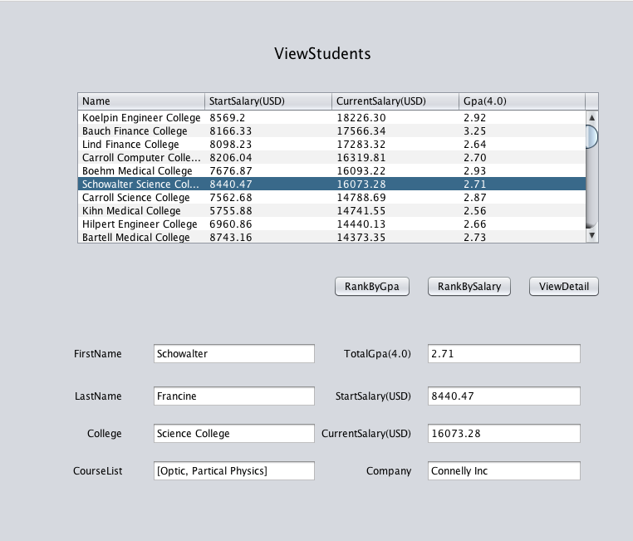

**(1)**

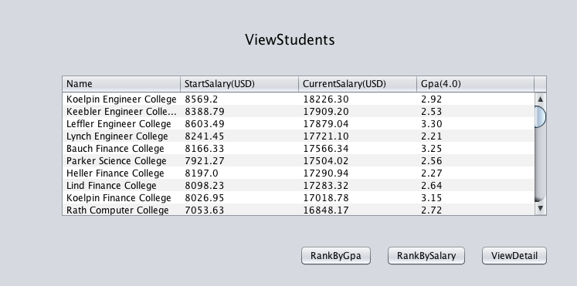

**(2)**

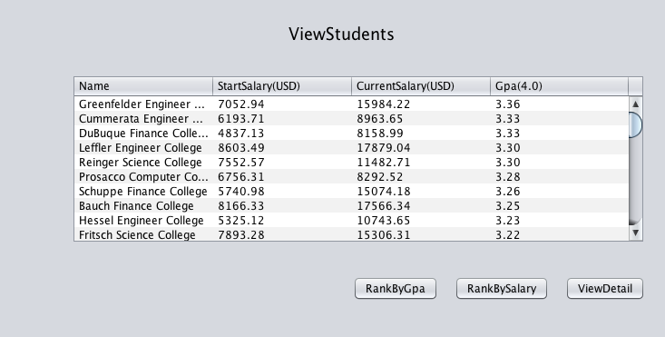

(3)

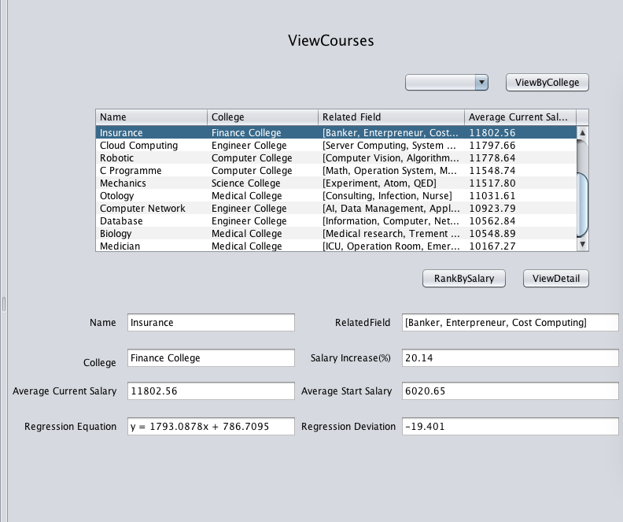

(4)

**Data Generate**

In our project , we import Faker Package to generate data. Faker mainly be used to create pseudo data. With the Faker package, there is no need to generate random numbers manually or handwritten to generate data. We only need to call the methods provided by Faker to complete the data generation for example Students Name, Courses,GPA and so on.

**Assumption of university as an intermediary between students and employers**

In order to achieve this assumption, We achieve this by exploring the relationship between GPA and salary,.University courses will act as a link between students and employers, ensuring that the knowledge they learn at university will contribute to their performance at work.

**Graduates ’Job and promotion**

In our project, by comparing the difference between start salary and current salary to track the jobs and promotions graduates get over time and assign rankings accordingly. And if the salary gap is large ,we believe that the jobs and promotions graduates get better.

**Connection of courses and their relevance to graduates growth**

In our project, by comparing the Salary Increase(%) and Related Field (by press “View Detail ” button to see these detail information )to figure out the connection level.And if the Salary Increase is large ,we believe that Courses are closely related to job growth.

**Relationship between GPAs and industrial success**

In our project ,The correlation between GPA and salary is quantified. By aiming to increase relevance, it would be possible to ensure that the courses they take in college will provide security for their job performance and their industrial success. In most case showed in our project, the people who have higher GPA,they may have the big probability of higher salary. However, because of random generated data, we can't guarantee a positive correlation between GPA and individual success. There will be a high correlation when it is really used.

**How to apply this project to developing countries.**

In developing countries , not all children could be guaranteed the same education at the basic level.Due to the development problems in different regions, the allocation of educational resources, the investment of funds and the development of different regions are different. As the development time is getting longer and longer, the differences in education among different regions are great

So in order to solve this kind of problems , our project mainly studies the connections among GPA , course ,salary .And learned that if the courses are closely related to the job, work will become easier and salaries will be higher,too. Similarly, if they have a high GPA, it shows that they have a good grasp of the course and they could much more easier achieve their own individual success.

With the development of Internet technology, we can provide targeted courses according to the correlation between jobs and major, which is conducive to accurately grasp the learning dynamics of students, make up for gaps and omissions, accurately match the teaching content, and timely generate personalized learning reports which could help them study better to get higher GPA