**人工智能基础第二次编程**

自 02 彭程 2020011075

注：本次选择的是第1题数独游戏

1. 数据维护

使用了一个Sudoku类，实现功能有：从文件中读取初始状态，格式化打印状态，给出每个空格的可能状态，给出可能状态数最少的空格和可能状态，填充数字到某一格，判断是否结束。

使用了一个Node类，维护搜索树，功能包括生成子节点，返回搜索到某节点的路径。

还使用若干基础类例如Stack，Queue等。

一、深度优先搜索

根据我的观察，游戏的复杂度应该并不高，因此我首先尝试使用DFS寻找一种可行解，主要逻辑部分的代码如下：

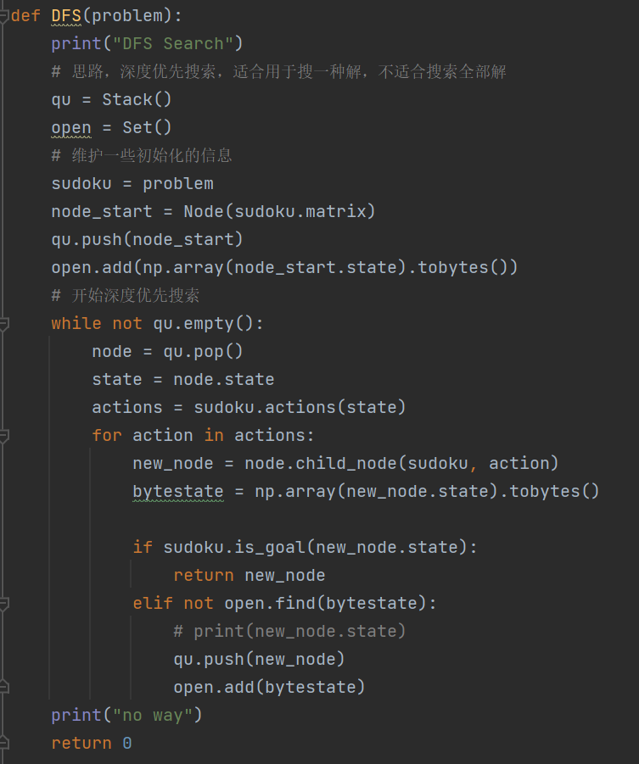

对于需要求解的六种情况，程序都可快速给出一种可行解：

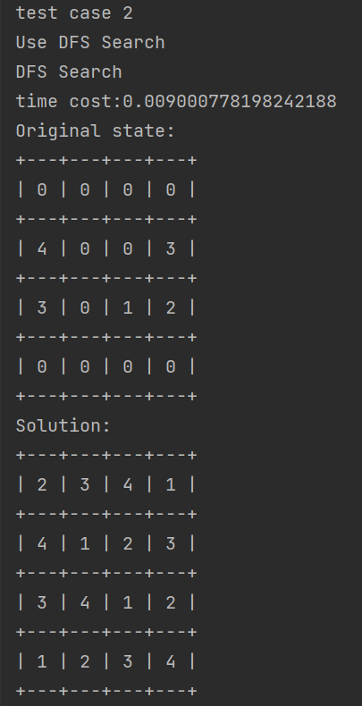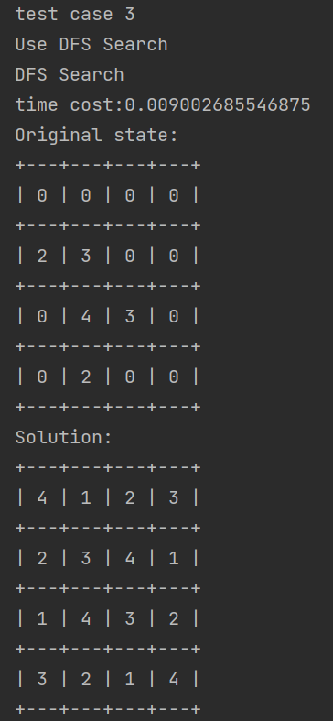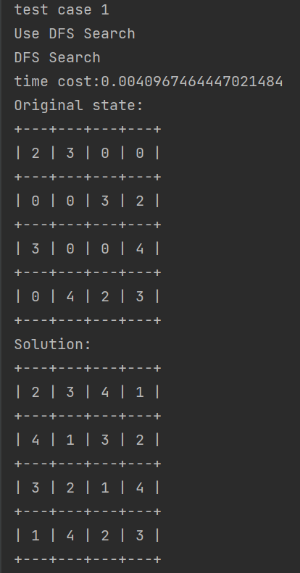

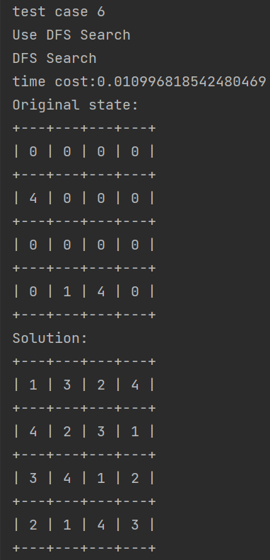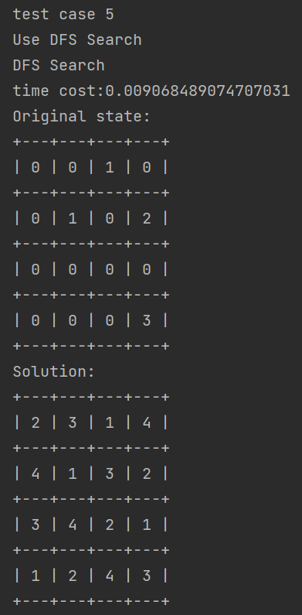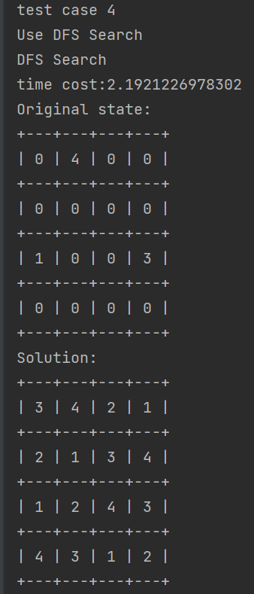

二、回溯搜索

对于此类问题，我们知道回溯搜索是一种高效的解决办法，于是对于本题我还实现了回溯搜索算法，与DFS不同，回溯搜索可以高效得求得所有可能解，主要逻辑部分代码如下：

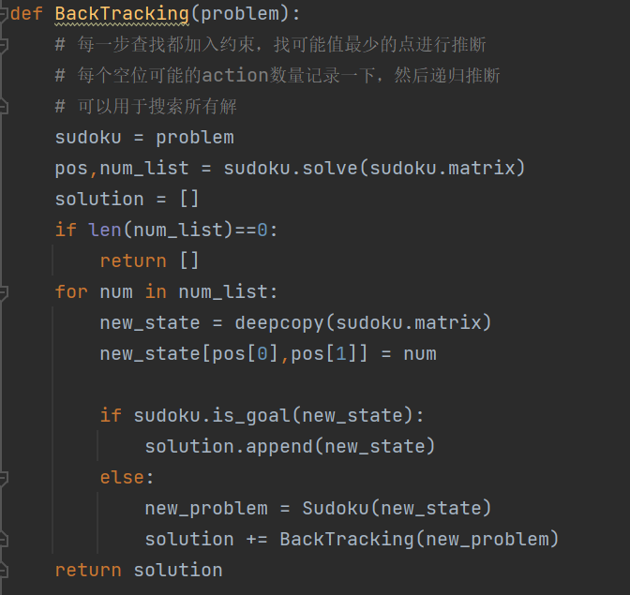

在回溯搜索算法中，每一步我都选择可能取值最少的点进行递归搜索，搜索结果如下图展示，由于解情况较多，此处我仅展示时间和可行解数量，依次有1、1、2、3、3、6种解。

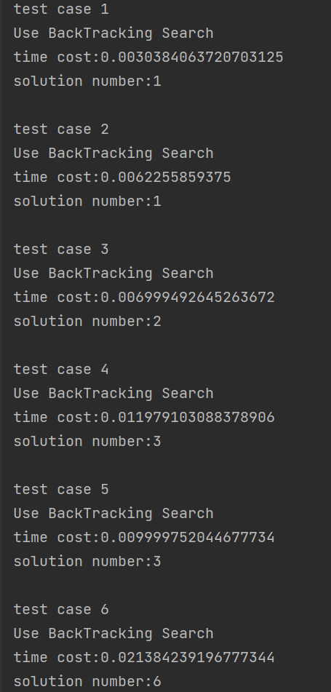

由于要求展示搜索结果，故之后均为使用回溯搜索打印出的所有可行结果：

**test case 1**

Use BackTracking Search

Original state:

+---+---+---+---+

| 2 | 3 | 0 | 0 |

+---+---+---+---+

| 0 | 0 | 3 | 2 |

+---+---+---+---+

| 3 | 0 | 0 | 4 |

+---+---+---+---+

| 0 | 4 | 2 | 3 |

+---+---+---+---+

time cost:0.0040051937103271484

solution number:1

solution 1:

+---+---+---+---+

| 2 | 3 | 4 | 1 |

+---+---+---+---+

| 4 | 1 | 3 | 2 |

+---+---+---+---+

| 3 | 2 | 1 | 4 |

+---+---+---+---+

| 1 | 4 | 2 | 3 |

+---+---+---+---+

**test case 2**

Use BackTracking Search

Original state:

+---+---+---+---+

| 0 | 0 | 0 | 0 |

+---+---+---+---+

| 4 | 0 | 0 | 3 |

+---+---+---+---+

| 3 | 0 | 1 | 2 |

+---+---+---+---+

| 0 | 0 | 0 | 0 |

+---+---+---+---+

time cost:0.008991479873657227

solution number:1

solution 1:

+---+---+---+---+

| 2 | 3 | 4 | 1 |

+---+---+---+---+

| 4 | 1 | 2 | 3 |

+---+---+---+---+

| 3 | 4 | 1 | 2 |

+---+---+---+---+

| 1 | 2 | 3 | 4 |

+---+---+---+---+

**test case 3**

Use BackTracking Search

Original state:

+---+---+---+---+

| 0 | 0 | 0 | 0 |

+---+---+---+---+

| 2 | 3 | 0 | 0 |

+---+---+---+---+

| 0 | 4 | 3 | 0 |

+---+---+---+---+

| 0 | 2 | 0 | 0 |

+---+---+---+---+

time cost:0.011000871658325195

solution number:2

solution 1:

+---+---+---+---+

| 4 | 1 | 2 | 3 |

+---+---+---+---+

| 2 | 3 | 1 | 4 |

+---+---+---+---+

| 1 | 4 | 3 | 2 |

+---+---+---+---+

| 3 | 2 | 4 | 1 |

+---+---+---+---+

solution 2:

+---+---+---+---+

| 4 | 1 | 2 | 3 |

+---+---+---+---+

| 2 | 3 | 4 | 1 |

+---+---+---+---+

| 1 | 4 | 3 | 2 |

+---+---+---+---+

| 3 | 2 | 1 | 4 |

+---+---+---+---+

test case 4

Use BackTracking Search

Original state:

+---+---+---+---+

| 0 | 4 | 0 | 0 |

+---+---+---+---+

| 0 | 0 | 0 | 0 |

+---+---+---+---+

| 1 | 0 | 0 | 3 |

+---+---+---+---+

| 0 | 0 | 0 | 0 |

+---+---+---+---+

time cost:0.016988039016723633

solution number:3

solution 1:

+---+---+---+---+

| 2 | 4 | 3 | 1 |

+---+---+---+---+

| 3 | 1 | 2 | 4 |

+---+---+---+---+

| 1 | 2 | 4 | 3 |

+---+---+---+---+

| 4 | 3 | 1 | 2 |

+---+---+---+---+

solution 2:

+---+---+---+---+

| 3 | 4 | 1 | 2 |

+---+---+---+---+

| 2 | 1 | 3 | 4 |

+---+---+---+---+

| 1 | 2 | 4 | 3 |

+---+---+---+---+

| 4 | 3 | 2 | 1 |

+---+---+---+---+

solution 3:

+---+---+---+---+

| 3 | 4 | 2 | 1 |

+---+---+---+---+

| 2 | 1 | 3 | 4 |

+---+---+---+---+

| 1 | 2 | 4 | 3 |

+---+---+---+---+

| 4 | 3 | 1 | 2 |

+---+---+---+---+

**test case 5**

Use BackTracking Search

Original state:

+---+---+---+---+

| 0 | 0 | 1 | 0 |

+---+---+---+---+

| 0 | 1 | 0 | 2 |

+---+---+---+---+

| 0 | 0 | 0 | 0 |

+---+---+---+---+

| 0 | 0 | 0 | 3 |

+---+---+---+---+

time cost:0.01729607582092285

solution number:3

solution 1:

+---+---+---+---+

| 2 | 3 | 1 | 4 |

+---+---+---+---+

| 4 | 1 | 3 | 2 |

+---+---+---+---+

| 3 | 2 | 4 | 1 |

+---+---+---+---+

| 1 | 4 | 2 | 3 |

+---+---+---+---+

solution 2:

+---+---+---+---+

| 2 | 3 | 1 | 4 |

+---+---+---+---+

| 4 | 1 | 3 | 2 |

+---+---+---+---+

| 3 | 4 | 2 | 1 |

+---+---+---+---+

| 1 | 2 | 4 | 3 |

+---+---+---+---+

solution 3:

+---+---+---+---+

| 3 | 2 | 1 | 4 |

+---+---+---+---+

| 4 | 1 | 3 | 2 |

+---+---+---+---+

| 2 | 3 | 4 | 1 |

+---+---+---+---+

| 1 | 4 | 2 | 3 |

+---+---+---+---+

**test case 6**

Use BackTracking Search

Original state:

+---+---+---+---+

| 0 | 0 | 0 | 0 |

+---+---+---+---+

| 4 | 0 | 0 | 0 |

+---+---+---+---+

| 0 | 0 | 0 | 0 |

+---+---+---+---+

| 0 | 1 | 4 | 0 |

+---+---+---+---+

time cost:0.03113555908203125

solution number:6

solution 1:

+---+---+---+---+

| 1 | 2 | 3 | 4 |

+---+---+---+---+

| 4 | 3 | 1 | 2 |

+---+---+---+---+

| 3 | 4 | 2 | 1 |

+---+---+---+---+

| 2 | 1 | 4 | 3 |

+---+---+---+---+

solution 2:

+---+---+---+---+

| 1 | 2 | 3 | 4 |

+---+---+---+---+

| 4 | 3 | 2 | 1 |

+---+---+---+---+

| 2 | 4 | 1 | 3 |

+---+---+---+---+

| 3 | 1 | 4 | 2 |

+---+---+---+---+

solution 3:

+---+---+---+---+

| 1 | 2 | 3 | 4 |

+---+---+---+---+

| 4 | 3 | 2 | 1 |

+---+---+---+---+

| 3 | 4 | 1 | 2 |

+---+---+---+---+

| 2 | 1 | 4 | 3 |

+---+---+---+---+

solution 4:

+---+---+---+---+

| 1 | 3 | 2 | 4 |

+---+---+---+---+

| 4 | 2 | 1 | 3 |

+---+---+---+---+

| 2 | 4 | 3 | 1 |

+---+---+---+---+

| 3 | 1 | 4 | 2 |

+---+---+---+---+

solution 5:

+---+---+---+---+

| 1 | 3 | 2 | 4 |

+---+---+---+---+

| 4 | 2 | 3 | 1 |

+---+---+---+---+

| 2 | 4 | 1 | 3 |

+---+---+---+---+

| 3 | 1 | 4 | 2 |

+---+---+---+---+

solution 6:

+---+---+---+---+

| 1 | 3 | 2 | 4 |

+---+---+---+---+

| 4 | 2 | 3 | 1 |

+---+---+---+---+

| 3 | 4 | 1 | 2 |

+---+---+---+---+

| 2 | 1 | 4 | 3 |

+---+---+---+---+

Process finished with exit code 0