1. Code của chương trình
2. #include <LiquidCrystal_I2C.h>
3. #include "DHTesp.h";
4. #include <WiFi.h>
5. #include <HTTPClient.h>
6. const char* ssid = "Wokwi-GUEST";
7. const char* password = "";
8. String serverName = "https://postman-echo.com/get";
9. // Define sensor pin
10. const int LED_PIN = 25;
11. const int DHT_PIN = 14;
12. const int PIR_PIN = 2;
13. const int LCD_SDA_PIN = 19;
14. const int LCD_SCL_PIN = 18;
15. // Define sensor object
16. LiquidCrystal_I2C lcd(0x27, 20, 4);
17. DHTesp dhtSensor;
18. void setup() {
19. **Serial**.begin(115200);
20. **Serial**.println("IoT Homework: Esp with sensor !!");
21. // Setup pin
22. pinMode(LED_PIN, OUTPUT);
23. pinMode(PIR_PIN, INPUT);
24. dhtSensor.setup(DHT_PIN, DHTesp::DHT22);
25. // setup lcd
26. **Wire**.begin(LCD_SDA_PIN, LCD_SCL_PIN);
27. lcd.init();
28. lcd.backlight();
29. lcd.setCursor(1, 0);
30. delay(500);
31. lcd.clear();
32. delay(500);
33. }
34. void loop() {
35. // Read data from dht sensor
36. TempAndHumidity  data = dhtSensor.getTempAndHumidity();
37. int temp = data.temperature;
38. int humid = data.humidity;
39. // Get string
40. String stemp = "Temp: " + String(temp) + "C";
41. String shumid = "Humid: " + String(humid) + "%";
42. // Display temp and humid in LCD
43. lcd.setCursor(1, 0);
44. lcd.println(stemp);
45. lcd.setCursor(1, 1);
46. lcd.println(shumid);
47. // Read digital from PIR sensor
48. int pirValue = digitalRead(PIR_PIN);
49. if (pirValue == HIGH) {
50. // If motion then turn on led
51. digitalWrite(LED_PIN, HIGH);
52. **Serial**.println("Motion Detect");
53. }
54. else {
55. // If not motion then turn off led
56. digitalWrite(LED_PIN, LOW);
57. **Serial**.println("Motion End");
58. }
59. delay(2000);
60. }

2. Ảnh kết quả

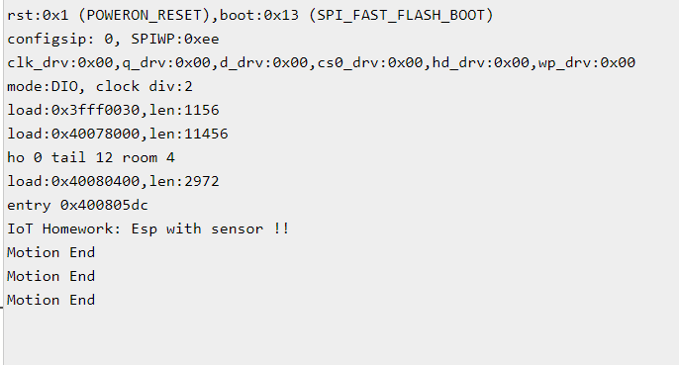

3.Link bài mô phỏng

https://wokwi.com/projects/381886329078642689