ĐỀ 2

PHẦN 1: NGHE HIỂU
Thời gian: Khoảng 20 phút (30 pts)
Số câu hỏi: 15
Directions: There are three parts in this section with special directions for each part. Answer all the questions on the basic of what is stated or implied by the speaker in the recording.
Time allowance: about 20 minutes, including 05 minutes to transfer your answers to your answer sheet.
PART 1 - Questions 1-5
You will hear five short conversations. You will hear each conversation twice. There is one question for each conversation. For questions 1-5, put a tick () under the right answer.
Example:
- How many people were at the meeting?
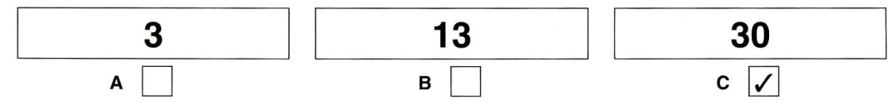

- What’s Steve doing now?
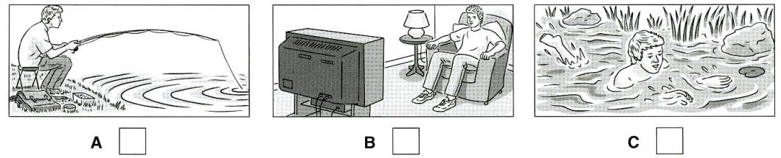
- How are they going to get to the countryside?
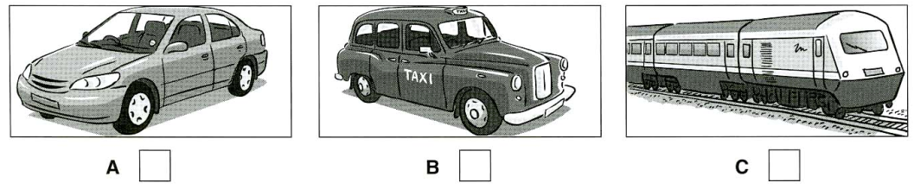
- What will the woman do tonight?
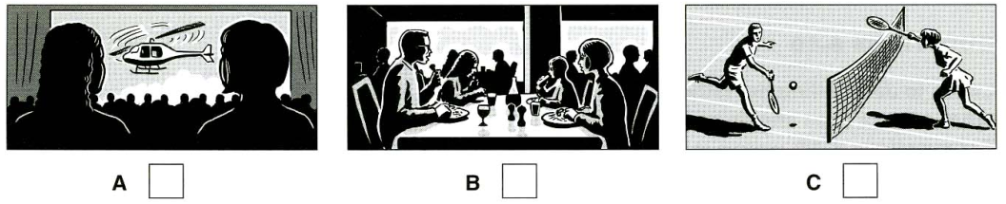
- Where is the cat now?
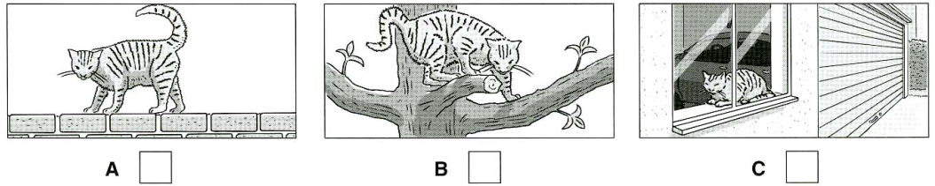
- What job does Mary’s brother do?
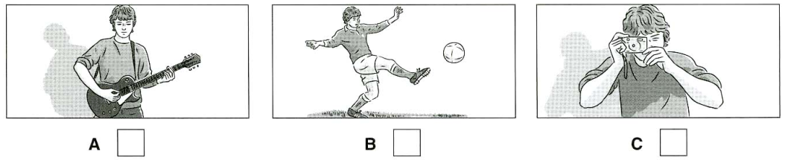
PART 2-Questions 6-10
You will hear a telephone conversation about a show at a theater.
Listen and complete questions 6-10. You will hear the conversation twice.
THEATER VISIT
Play: Cinderella
There are tickets for: | 6 | …………………April

A child’s ticket costs: | 7 | £………………………..

Name of main actor: | 8 | Sophie..………………..

Show begins at: | 9 | ……………………..pm

For information about  Children’s club, phone | 10

PART 3- Questions 11-15
You will hear a man leaving a message. Listen and complete questions 11-15. You will hear the information twice.
Phone message
From: Bike shop
Color of bike: | 11

Bike costs: | 12 | £……………………….

Shop has also got: | 13 | Bicycle………………

Come tonight before: | 14 | …………………..p.m

Address to go to: | 15 | ……………King Street

PHẦN 2: ĐỌC VÀ VIẾT
Thời gian: Khoảng 60 phút
Đọc: 4 phần/25 (50 pts); Viết: 2 phần (30 pts)
PART A-Reading (50 pts)
Part 1- Questions 1-5
Which notice (A-H) says this (1-5)?
For question 1-5, mark the correct letter A-H on your answer sheet.
Example:
- You can’t travel early in the morning 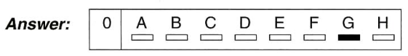
if you want to buy this ticket.

1. If you want to do something special for your child’s birthday, call this number. | 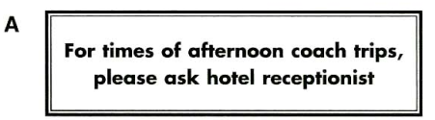
 | 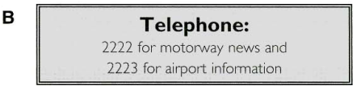
2. This company can take you to catch your plane at any time. | 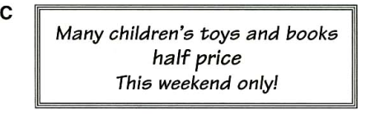
 | 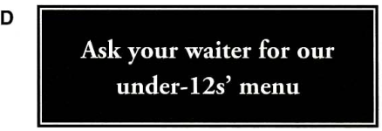
3. If you need to buy something to wear, this may be the cheapest place to look. | 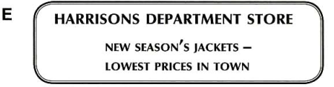
 | 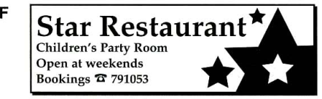
4. This restaurant always has special meals for children. | 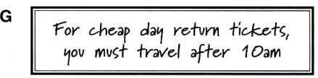
5. If you need to know about the traffic, you can call this number. | 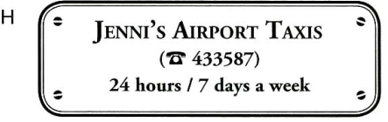

Part 2- Questions 6-15 Choose the best answer A, B, or C. The first one is an example.

- She’s reading…………. in the living room.
- a video | B. some music | C. a magazine | ……C……

- My brother’s………… .He works in a small French restaurant.
A. a waiter | B. a shop assistant | C. a secretary
- Please………..the piano now. The children are asleep.
A. don’t play | B. no play | C. not to play
- Our car isn’t very fast. It’s very ………….. .
A. weak | B. short | C. slow
- My mother likes Mel Gibson, but she ………..Arnold Schwarzenegger.
A. likes | B. don’t like | C. doesn’t like
- We usually watch the football match………..Saturday afternoon.
A. in | B. on | C. at
- The programme starts at ten………….. .
A. o’clock | B. clocks | C. hours
- Where………………?
A. do you work | B. you do work | C. you work
- That’s her over there - ………………a green dress and a hat.
A. she wears | B. she’s wearing | C. she wearing
- People usually eat soup with…………. .
A. a knife | B. a fork | C. a spoon
- The school is in the River Street, next…………….the supermarket.
A. by | B. to | C. at

Part 3 – Questions 16-20
Read the article about energy. Are sentences 16-20 ‘Right’ (A) or ‘Wrong’ (B)? If there is not enough information to answer ‘Right’ (A) or ‘Wrong’ (B), choose ‘Doesn’t say’ (C).
GOOD SOURCE OF ENERGY
People need energy so we can turn on our lights, use our computers, cook our food and lots more. Some ways of getting the energy we need for our electricity are better than others. There isn’t enough coal and oil to last us forever, and taking them out of the ground is bad for the environment.
The best sources of energy don’t hurt the environment and won’t run out. In places where it is often sunny, we can use energy from the sun. We can also use water power from rivers and from waves in the sea. In windy places we can use wind power. These sources of energy don’t cause pollution.
We always have to be careful of the environment when we get our energy. For example, we shouldn’t put wind machines where we know lots of birds will be flying, because they might fly into the machines. But if we choose the right kind of energy in the right place, we will have good, clean energy for the future.
Example: 0. Lights and computers use energy.
A. Right | B. Wrong | C. Doesn’t say | 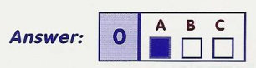

- Coal and oil are the best sources of energy.
A. Right | B. Wrong | C. Doesn’t say
- We can use the sun energy for electricity.
A. Right | B. Wrong | C. Doesn’t say
- We can use water power from lakes.
A. Right | B. Wrong | C. Doesn’t say
- Using sun, water and wind for energy pollutes the environment.
A. Right | B. Wrong | C. Doesn’t say
- It’s important to think about the environment when planning where to get energy.
A. Right | B. Wrong | C. Doesn’t say

Part 4 – Questions 21-25
Read the article about camping. Choose the best word (A, B or C) for each space.
For questions 21-25, mark A, B or C.
Camping is a (0)…. way to spend a holiday. You can spend time (21)……..and enjoying nature. If you go camping far from the city, you (22)……….remember to bring everything you need with you.
First, you need a tent and a sleeping bag. You should bring all (23)………..food too, unless you are planning to fish or find food. Be very carefully if you are eating wild berries or plants. Don’t eat (24)………if you don’t know what it is.
There are many fun things to do when you are camping. You can go for a (25)……., look for birds and animals or take photographs. Always remember to clean up after yourself and don’t leave any rubbish behind.

Example:
0. A. great | B. better | C. best | 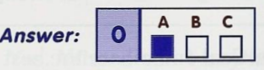

21. A. relaxed | B. relaxing | C. relaxes
22. A. must | B. do | C. have
23. A. its | B. his | C. your
24. A. anything | B. everything | C. nothing
25. A. flight | B. walk | C. kick

PART B – Writing (20 pts)

Part 1 – Questions 1-5
Put the words in the correct order to make sentences.
- window/ beside/ is/ standing/ dad/ my/ the.
_____________________________________________.
- I/ wearing/ glasses/ am.
_____________________________________________.
- laptops/ are/ expensive/ more/ mobile phones/ than.
_____________________________________________.
- the theater/ how to/ get to/ me/ can you tell/ please?
_____________________________________________.
- Classrooms/ the/ students/ aren’t/ in/ their.
_____________________________________________.

Part 2:
Write about your own favourite gadget. Write 25-30 words. Use these questions to help you.
- What is your favourite gadget?
- What colour is it?
- What size is it?
- Why do you like it?
- What do you do with it?
- Where do you like using it?

…………………………………………………………………………………………………………………………………………………………………………………………………………………………………………………………………………………………………………………………………………………………………………………………………………………………………………………………………………………………………………….…………………………………………………………………………………………………………………………………………………………………………………………………………………………………………………………………………………………………………………………………………………………………………………………………………………………………………………………………………………………………………….………………………………………………………………………………………………………………………………………………………………………………………………………………………………………………………………………………………………………

