**Problem Statement**

**Home Depot Pro Software (HDPS)**

**HDPS - 1.0 Introduction**

The HDPS shall be a software application which shall be used for querying Pro customer information based on request. The HDPS shall give the Home Depot employees the ability to access and modify Pro customer details as needed by their skillsets and availability. The software application shall be divided into 2 major components which include Server Data and Store App.

**HDPS - 2.0** **Pro Management**

The Pro management component shall allow the employee to manage data and the various aspects related to it, such as searching and scheduling.

* The Pro data shall be encrypted in order to ensure that data remains protected in a database.
* The employee shall be able to view and print data as needed.

**HDPS - 2.1 Server Data**

Each Pro customer shall receive a unique account in which data will be stored for their basic information which will include the following:

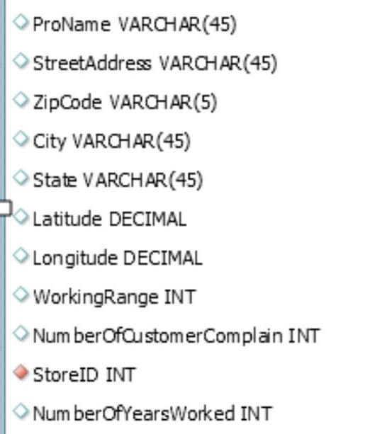

**HDPS - 2.2 Store Web App**

Employees, based on their granted permissions, shall be able to perform the following functions pertaining to patients:

* Be able to query from skill sets
* Be able to query for zipcode
* Be able to query for available time
* Accessing and printing data
* Schdeluing an appointment
* Data update
* Personalized note detailing unique findings or concerns