Matriculation No: 200009834. IS5103 Web Technologies

# Assignment Report

Table of Content

Assignment Report 1

1. PRIOR PLANNING AND RESEARCH 3

1.1 Prior planning 3

1.2 Research 4

2. AIMS AND AUDIENCE 5

2.1 Aims of website 5

2.2 Target Audience 5

3. DESIGN AND CONTENT 7

3.1 Web design 7

3.2 Web content 15

4. ACCSEEIBILITY 16

4.1 Google Chrome 16

4.2 Firefox 16

4.3 IE 17

4.4 Edge 17

5. TESTING 18

5.1 Code legality testing 18

5.2 Scaling test 20

6. APPENDICES 21

6.1 Reflection 21

6.2 REFERENCES 22

## PRIOR PLANNING AND RESEARCH

### Prior planning

In the beginning, I first chose one of the seven topics, which was relatively simple, because I didn't have a deep understanding of web production. Finally decided the theme is ‘A beginner’s guide to CSS’.

There are several reasons for choosing this theme. First, I have a great interest in web design. Second, it also involves the application of aesthetics. I can learn a lot of useful design methods with this project. Third, through this project, you can have a deeper understanding of the front-end design.

After deciding on the theme, I was thinking about how to design six pages. My initial idea was the homepage, introduction page, recommended book and useful URL page, CSS page, CSS3 page, help page (some knowledge that might be helpful).

After determining the idea, I drew a draft of the homepage (Picture 1). Provide links to visit other web pages.

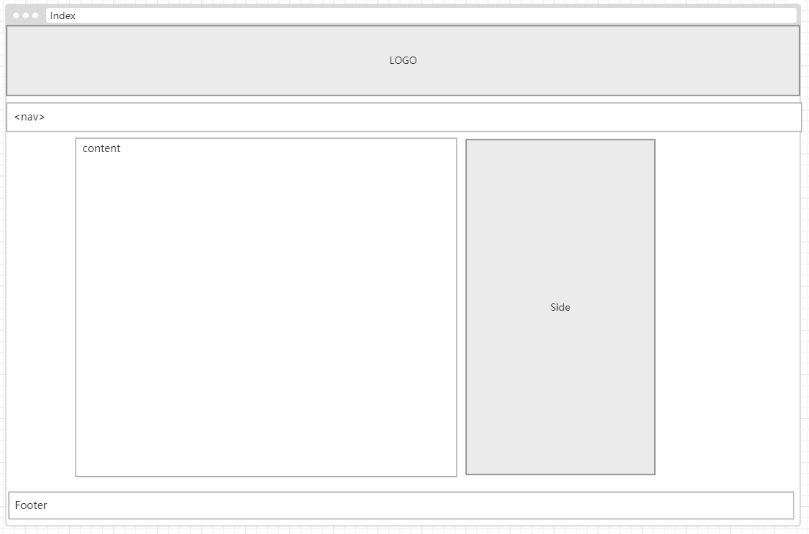

Picture1

### Research

During the investigation phase, I referred to Hexo's personal blog webpage[1] and learned how to make the webpage concise and easy to understand. Then learn top web design from Awwwards[2].

After looking at these designs, I understand that designing a webpage must first have a clear theme. The entire website revolves around this theme, before the web design, it is necessary to clarify what the purpose of the website and what it is used for. All pages are made around this content. Clear content has a very important role in ranking. Second, you need to understand the customers in your website's industry and which category your page belongs to.

## AIMS AND AUDIENCE

### Aims of website

The main purpose of my web page is to introduce CSS and give new web designer an opportunity to learn about CSS. Make it easier for new designer to learn CSS later.

If developer want to learn web design, you must first understand the basics of web design. Web design must understand layout, color matching, image processing, and html5 code. This website is to provide some useful books to help developers learn to master various layout layouts, design styles, html, CSS styles, web page production methods, learn custom production methods, master practical skills, and understand each through web design concepts, the appearance structure, functional layout and layout rules of the webpage. Understand and master the picture design and form design, so that the picture layout can be reasonable and not dull, do not make users disgusted, the page element specification is simple, the font style is unified, the visual effect is unified, and the effect meets the user's habits.

### Target Audience

The audience of this page is mainly for designers who are just starting to learn Html or are interested in html and CSS and want to learn more. Because the content of the website is very simple, it is mainly about the general theory of CSS. If users want to learn more professionally and systematically, they can study in w3schools, other websites and read related books, which will be more helpful to designers.

## DESIGN AND CONTENT

This chapter is mainly the embodiment of the design process.

### Web design

In order to make the web page more beautiful I used bulma framework[3] and font-awesome. Code as follow in Picture2:



Picture2

The first step is to build the navigation bar and title, the implementation code snippet is as follows Picture3 and Picture4:

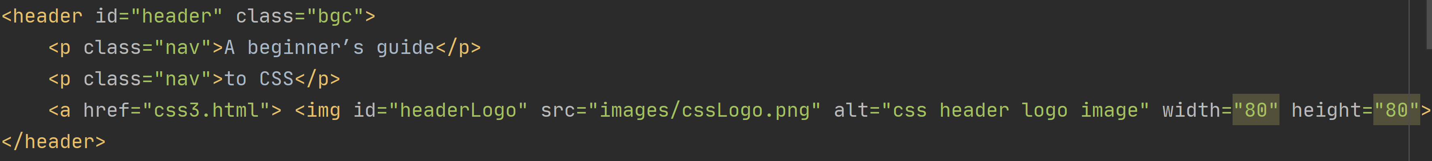

Picture3

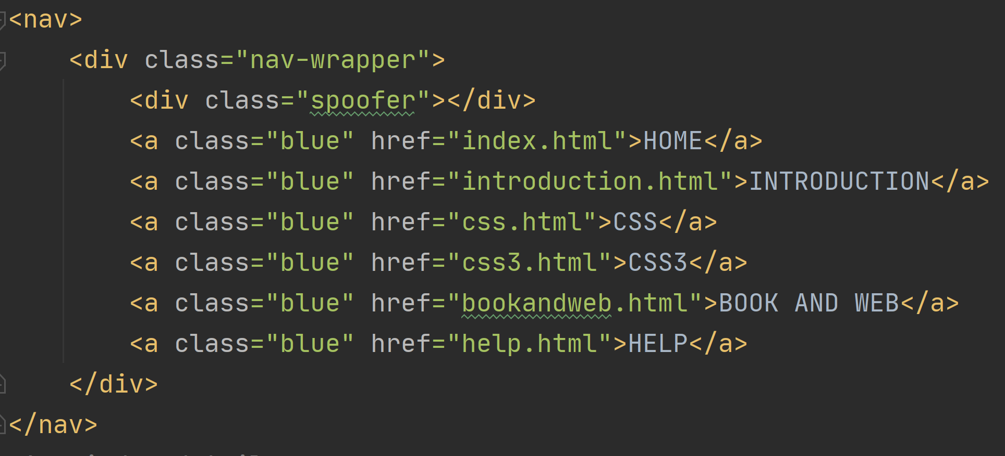

Picture4

The actual effect is as follows picture5:



Picture5

The source code of the footer is as follows(Picture6):

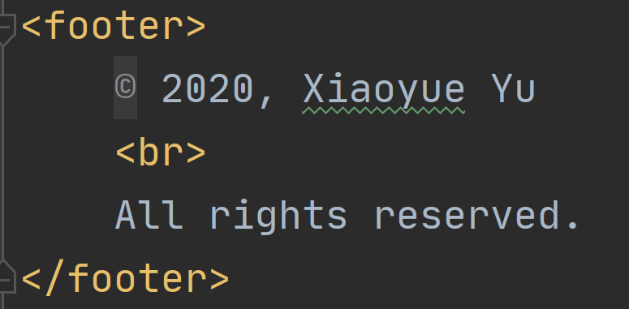

Picture6

The footer is designed as shown in the figure below in Picture7:



Picture7

The above is a template for handling webpages. All webpages are developed based on this template. Simple pages and careful color selection are conducive to improving the user’s perception.

Next is the detailed part of each page. I divided the page into seven pages (the 404 page has not been added yet). The structure of the project is shown in the following figure(Picture8):

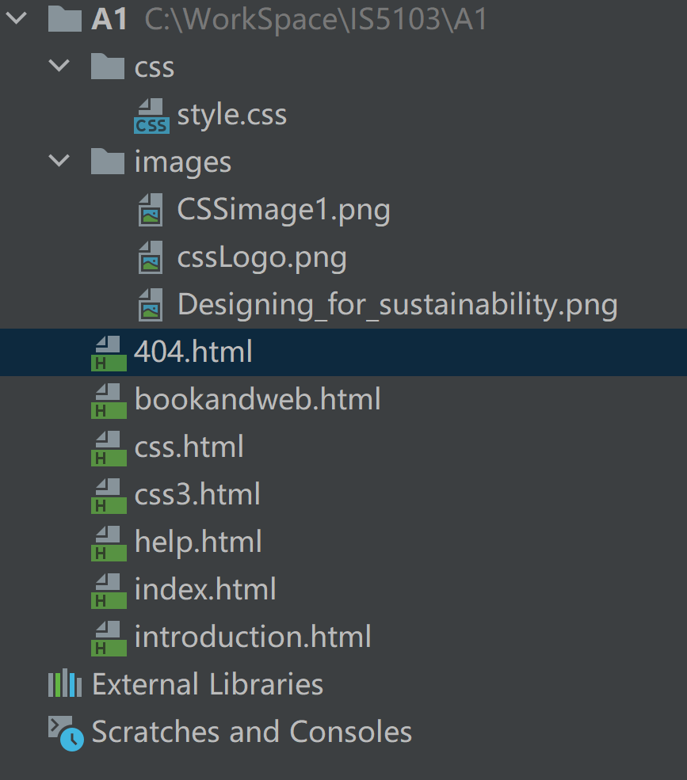

Picture8

Code abbreviation for homepage in Picture9:

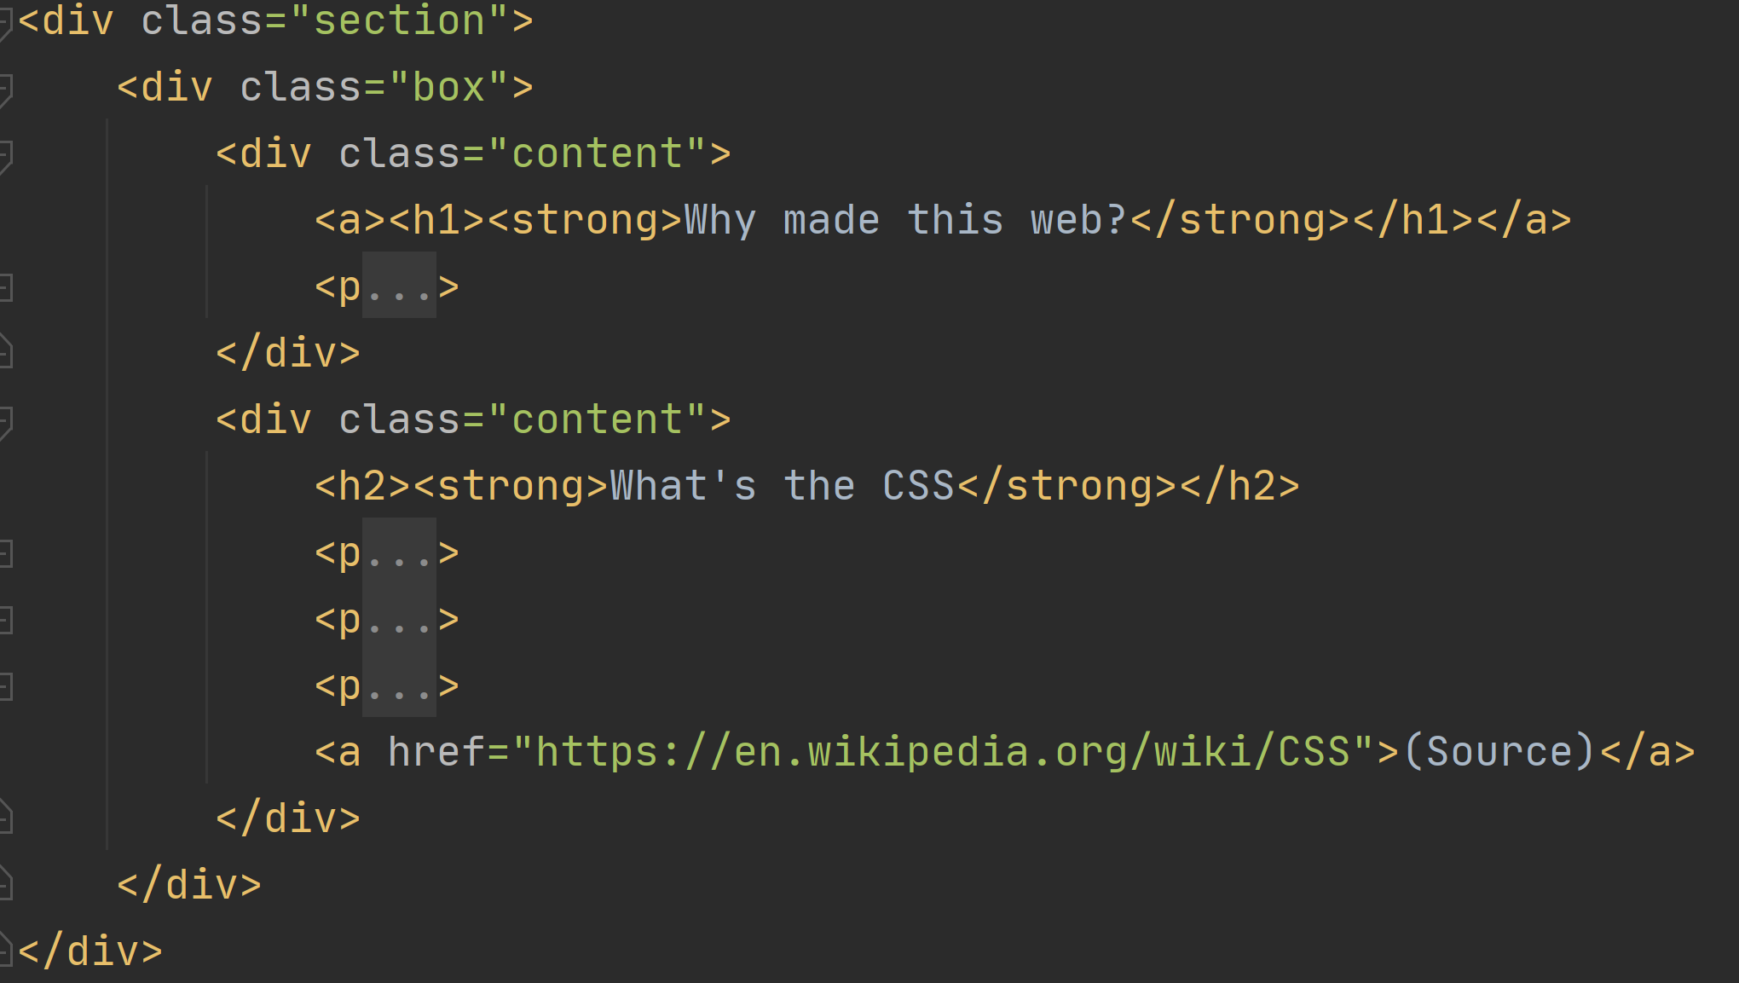

Picture9

The display effect is as follows(Picture10):

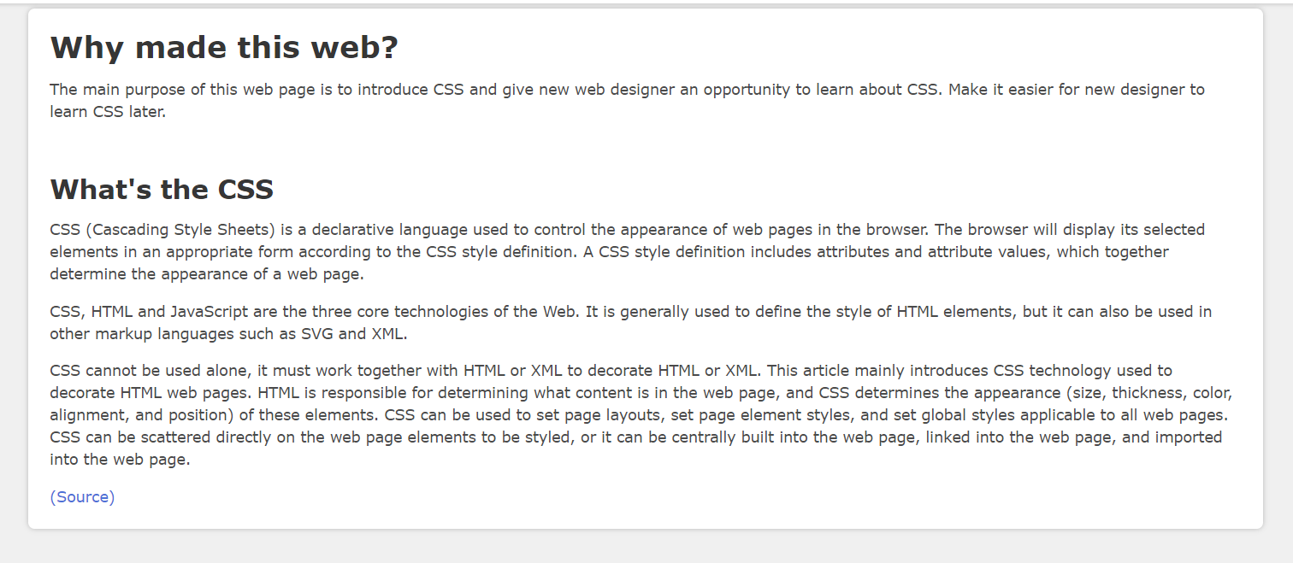

Picture10

Code abbreviation for introduction in Picture11:

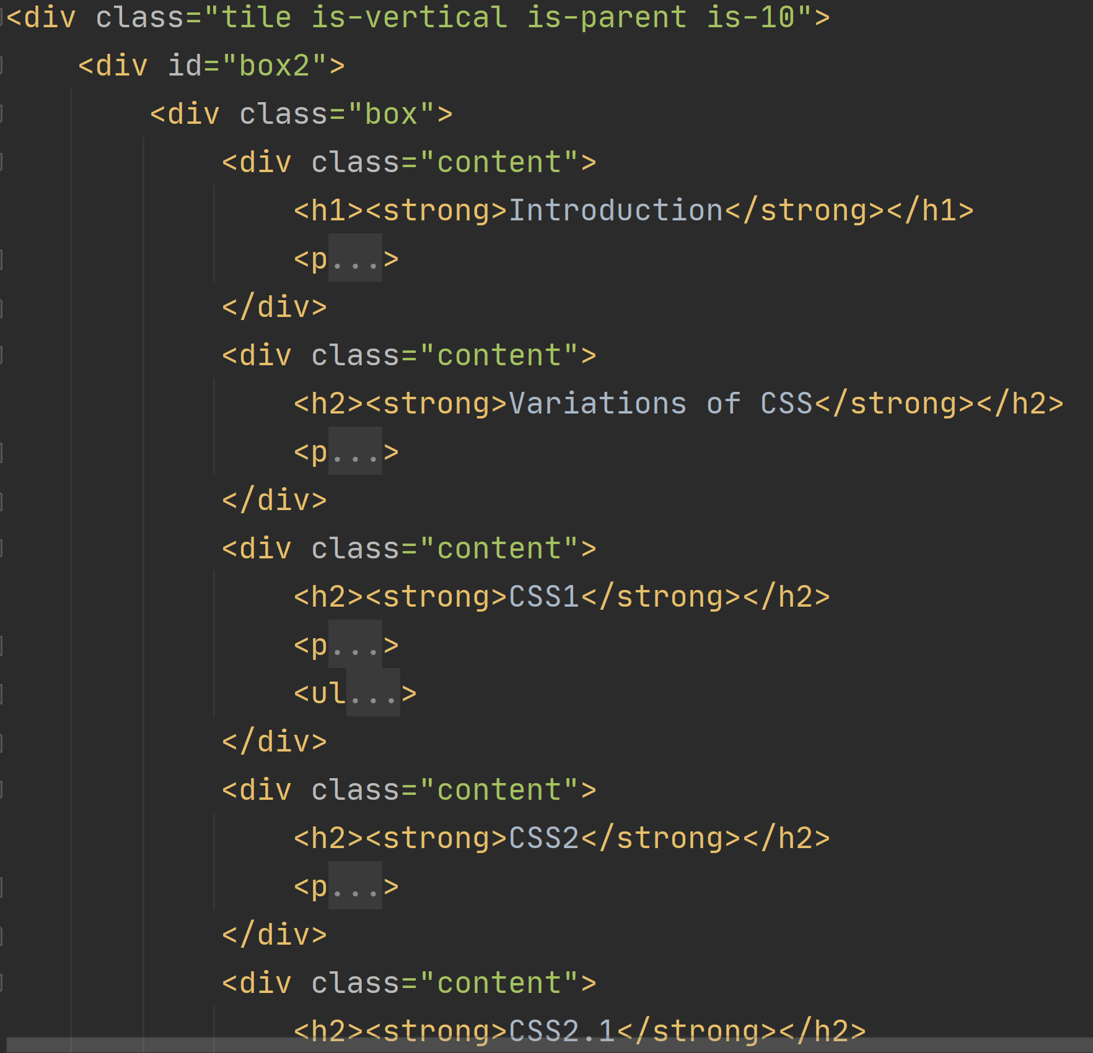

Picture11

The display effect is as follows(Picture12):

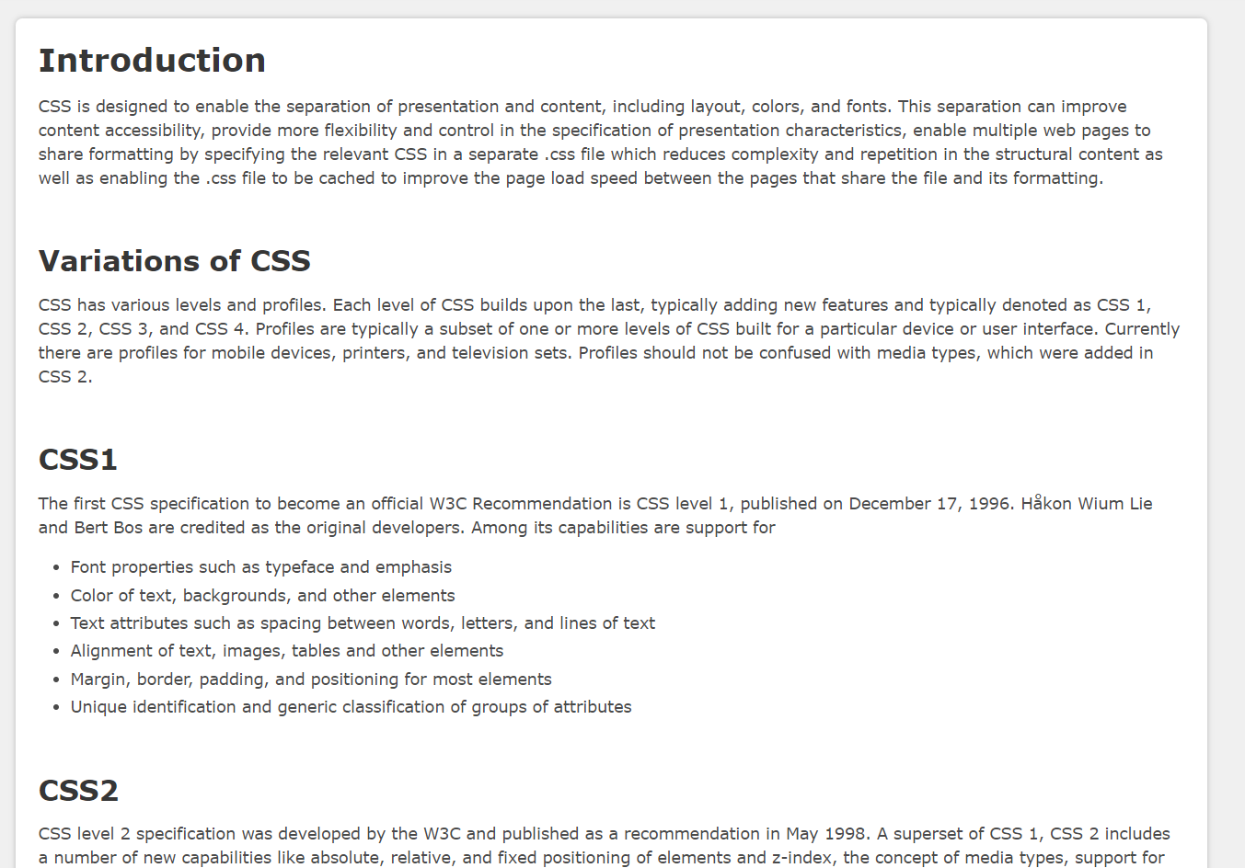

Picture12

Code abbreviation for CSS page in Picture13:

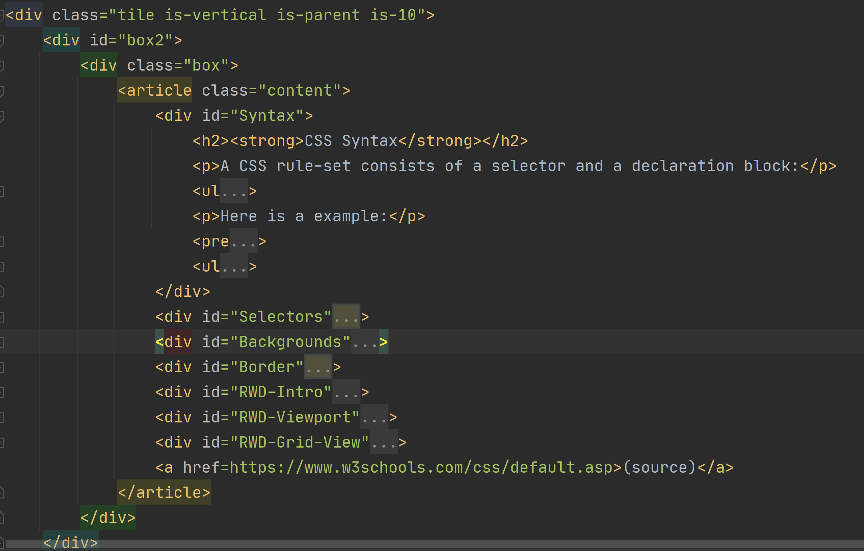

Picture13

The display effect is as follows(Picture14):

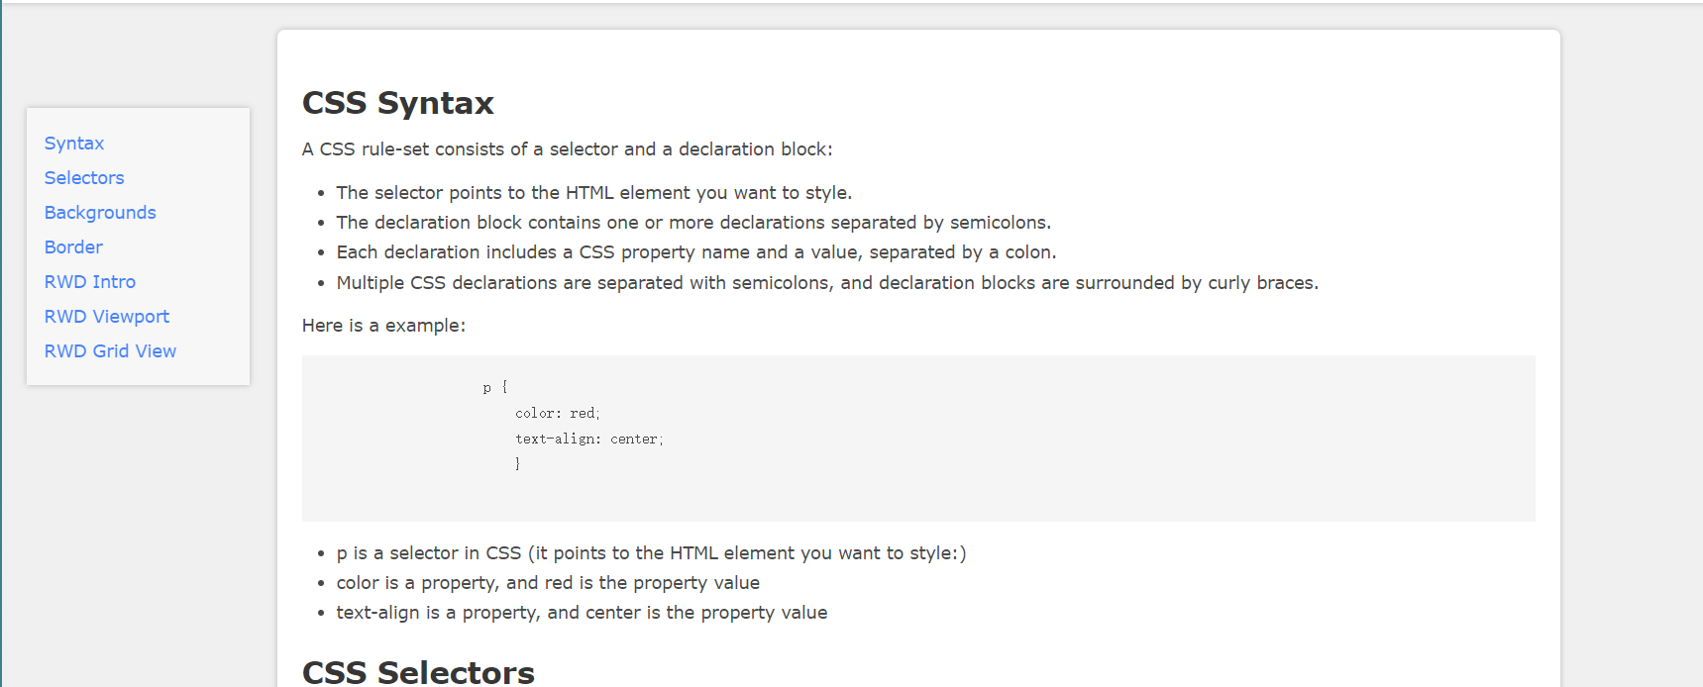

Picture14

Code abbreviation for CSS3 page in Picture15:

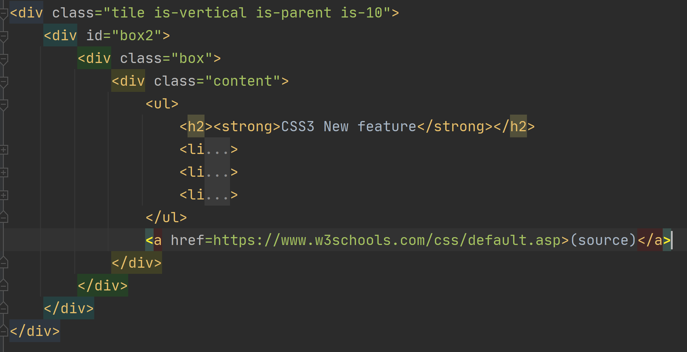

Picture15

The display effect is as follows(Picture16):

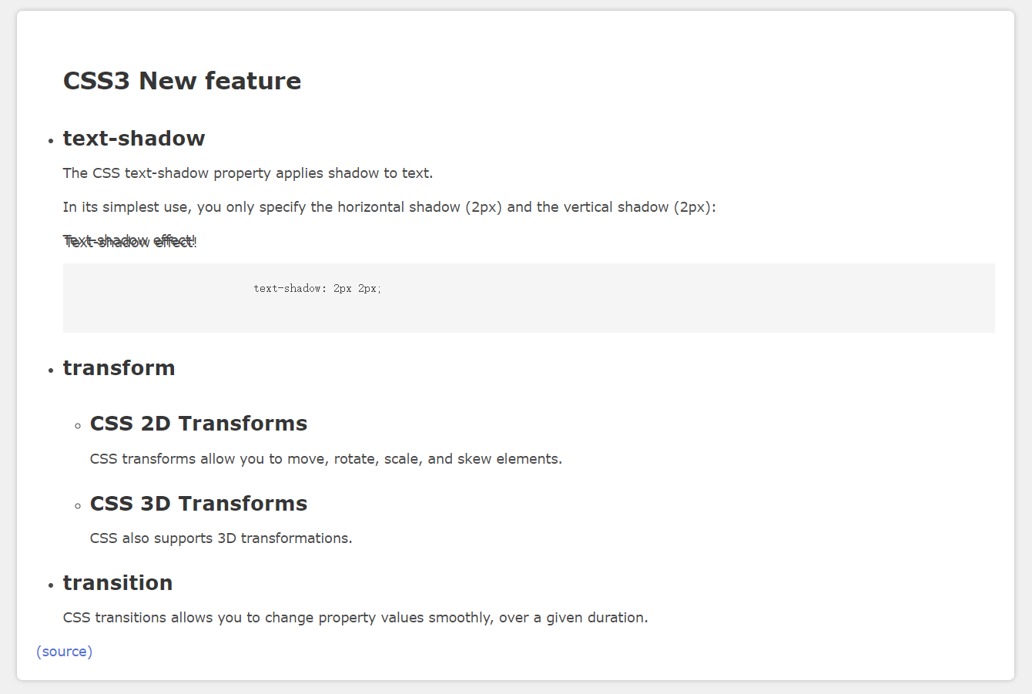

Picture16

Code abbreviation for Book and web page in Picture17:

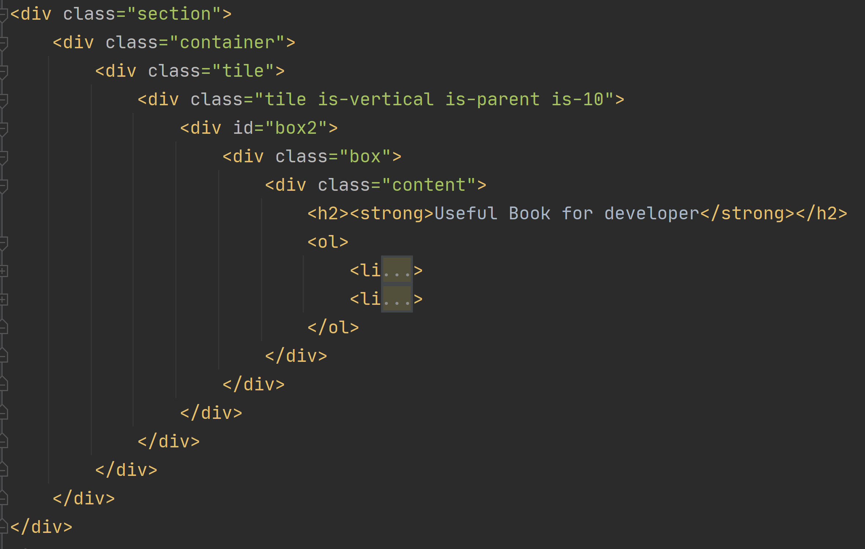

Picture17

The display effect is as follows(Picture18):

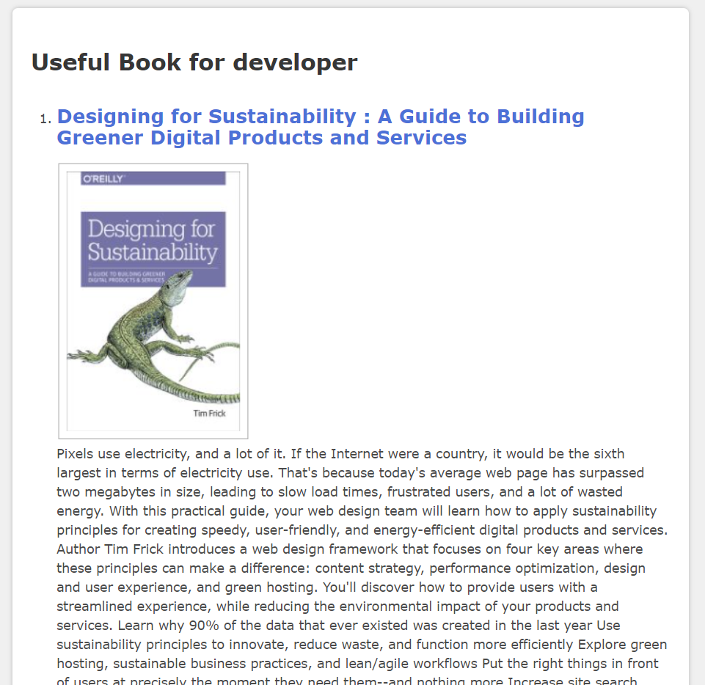

Picture18

Code abbreviation for help page in Picture19:

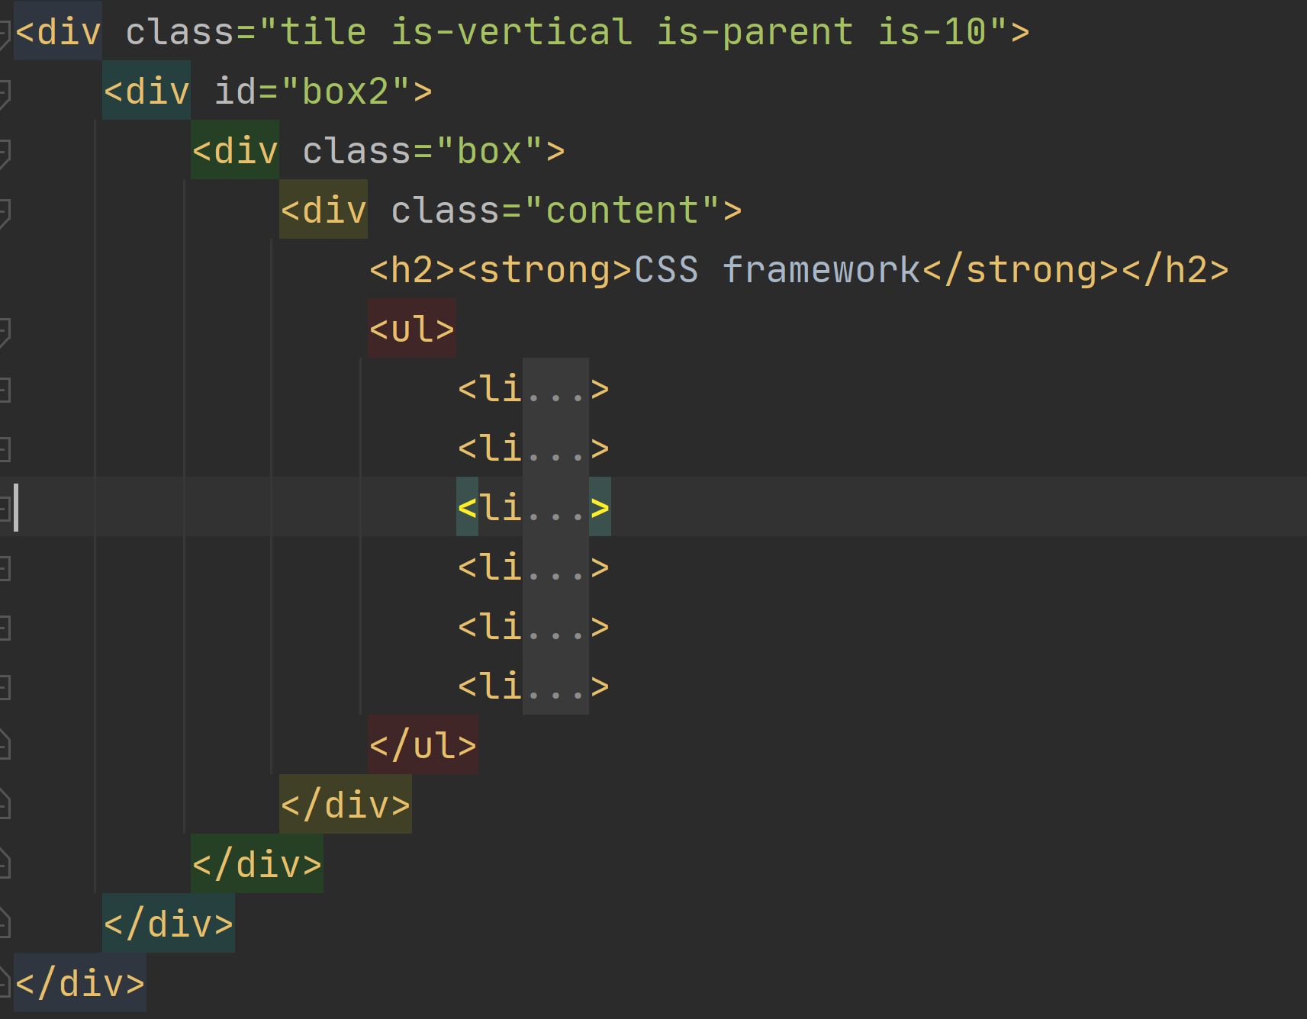

Picture19

The display effect is as follows(Picture20):

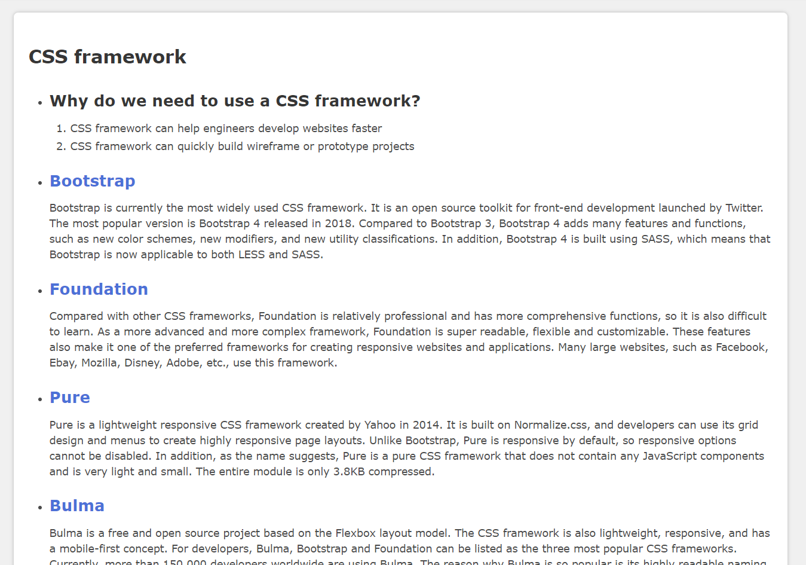

Picture20

### Web content

The main content of the page is quoted from Wiki[4] and w3school[5]. Mainly look for some more useful knowledge and information for beginners.

## ACCSEEIBILITY

### Google Chrome

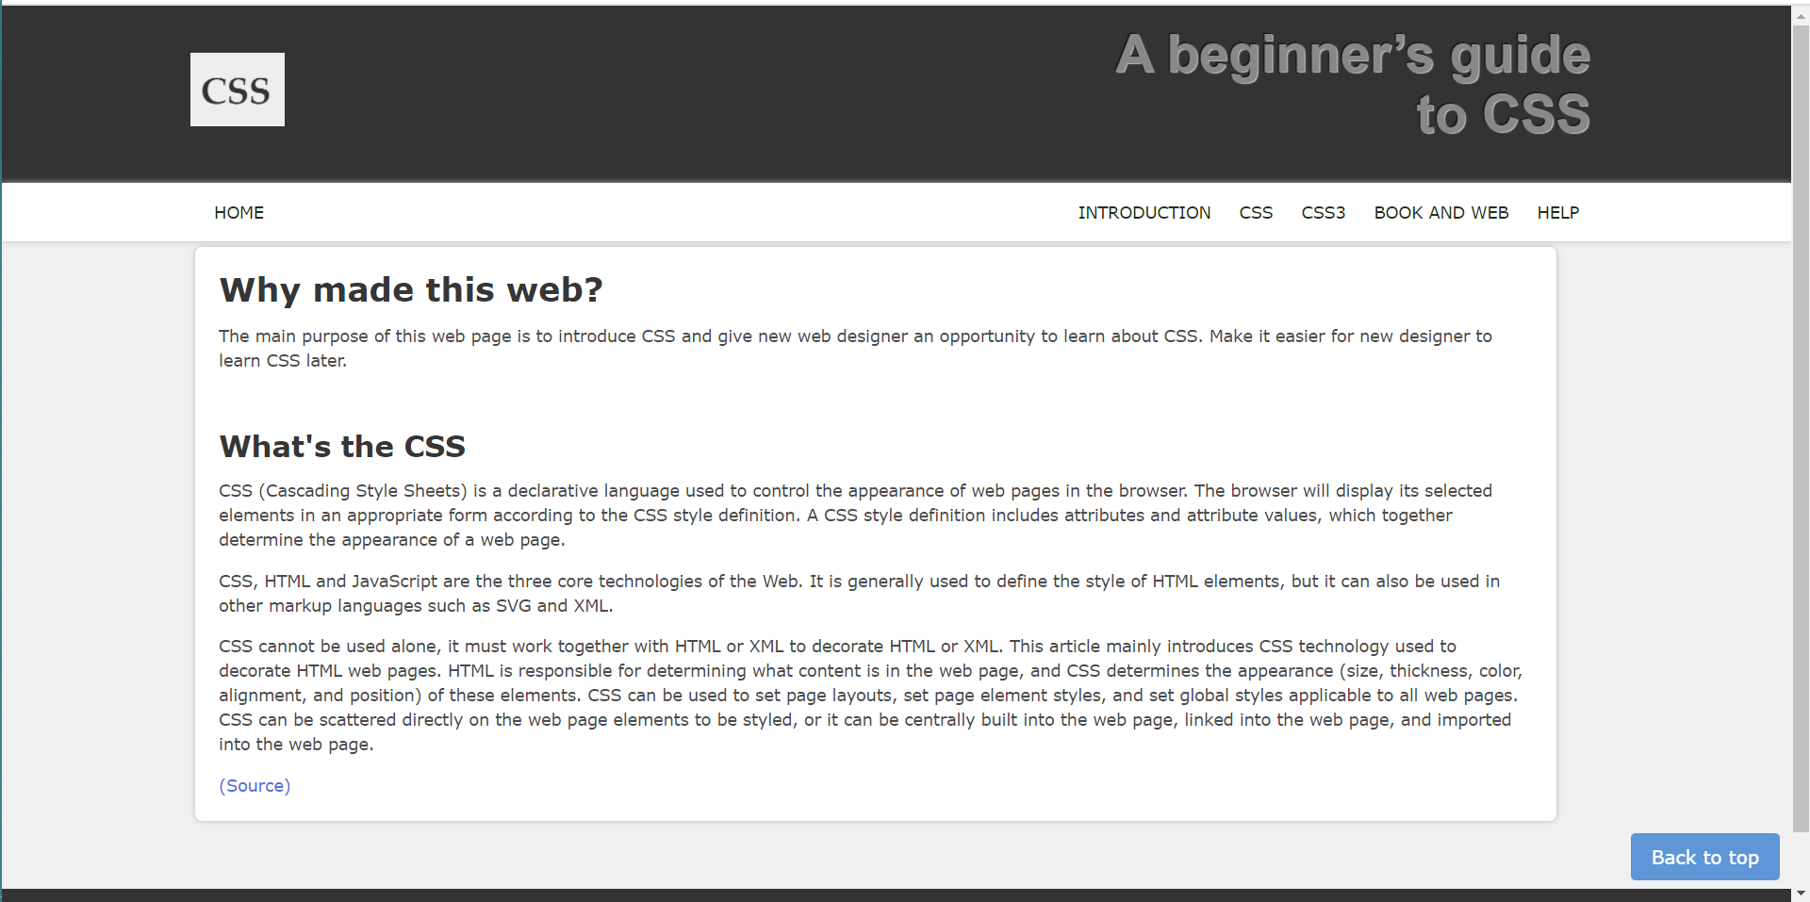

Picture21

### Firefox

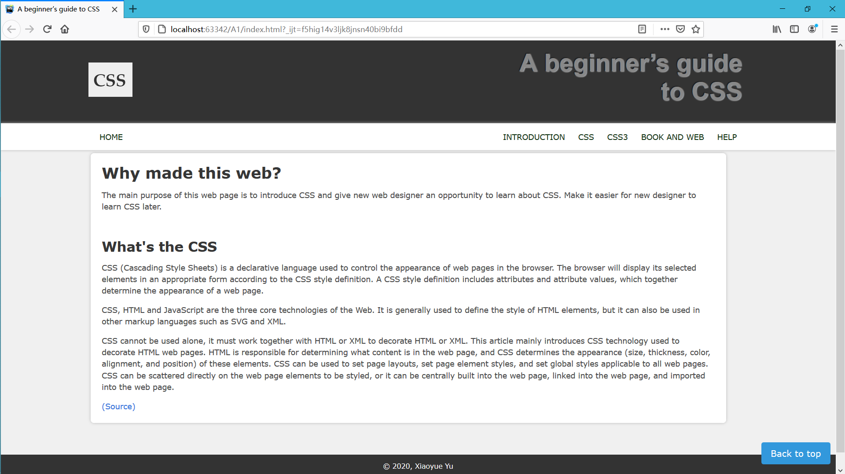

Picture22

### IE

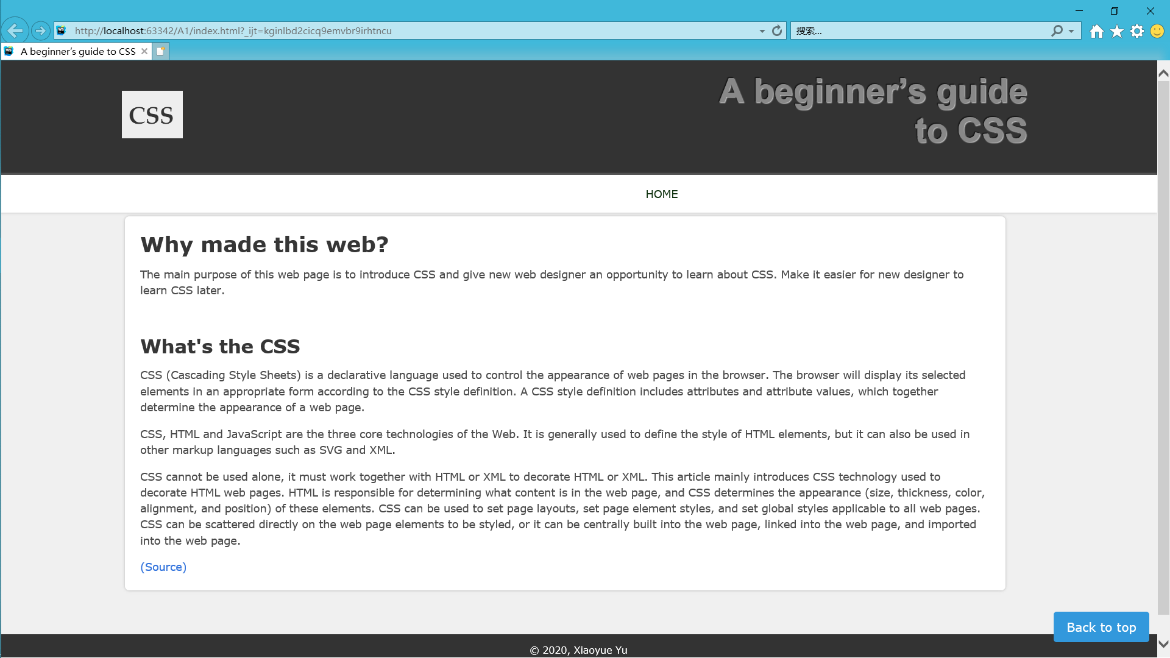

Picture23

### Edge

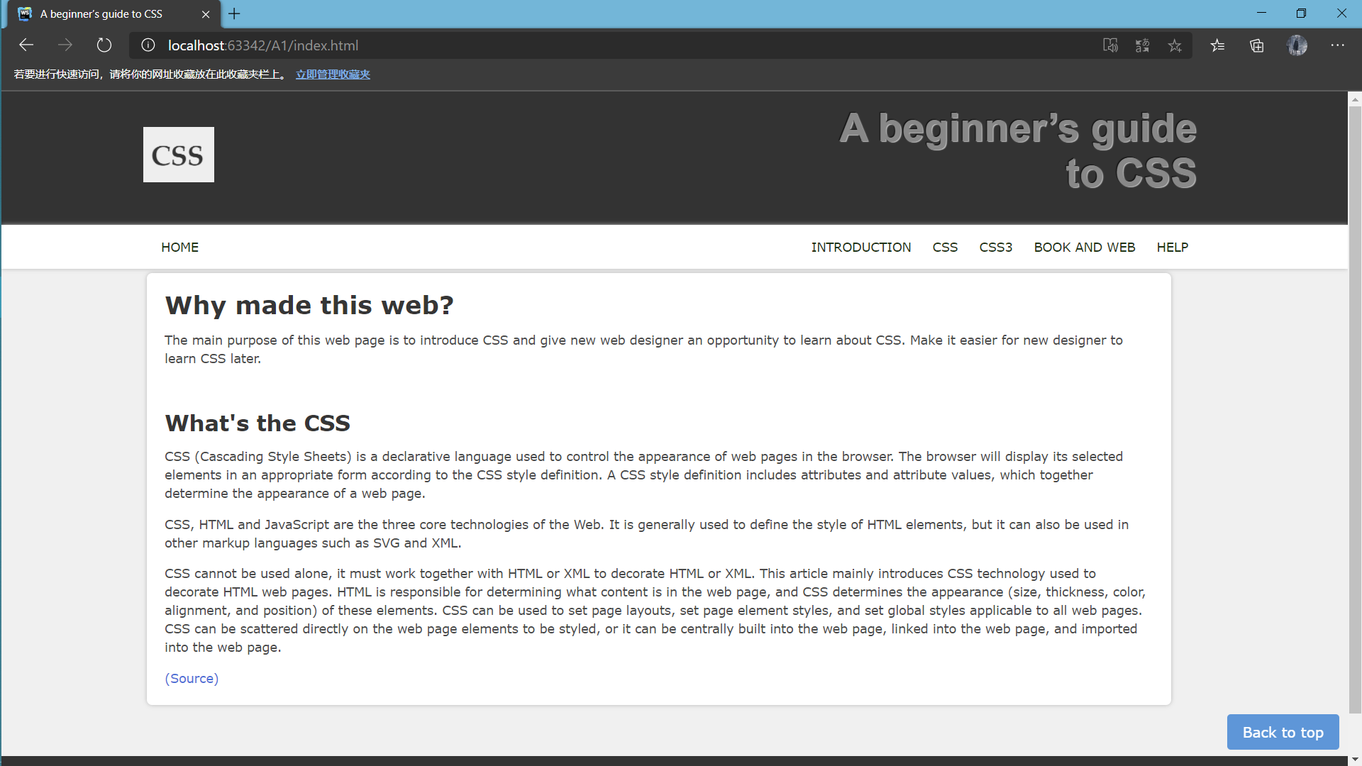

Picture24

## TESTING

### 5.1 Code legality testing

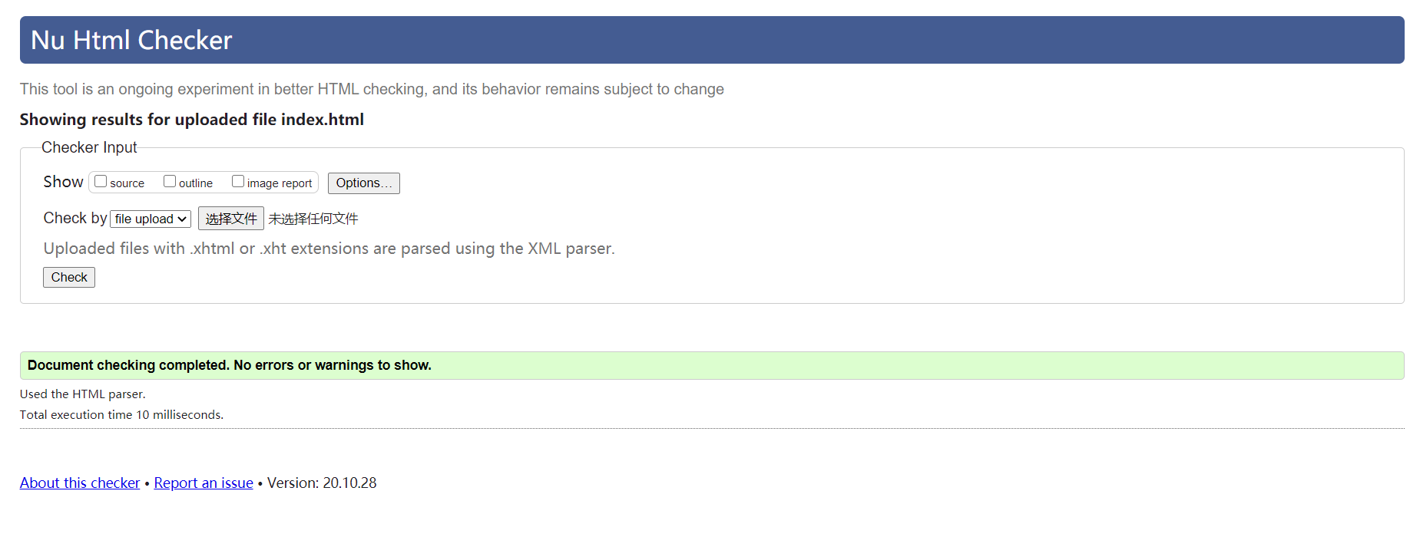

Picture25

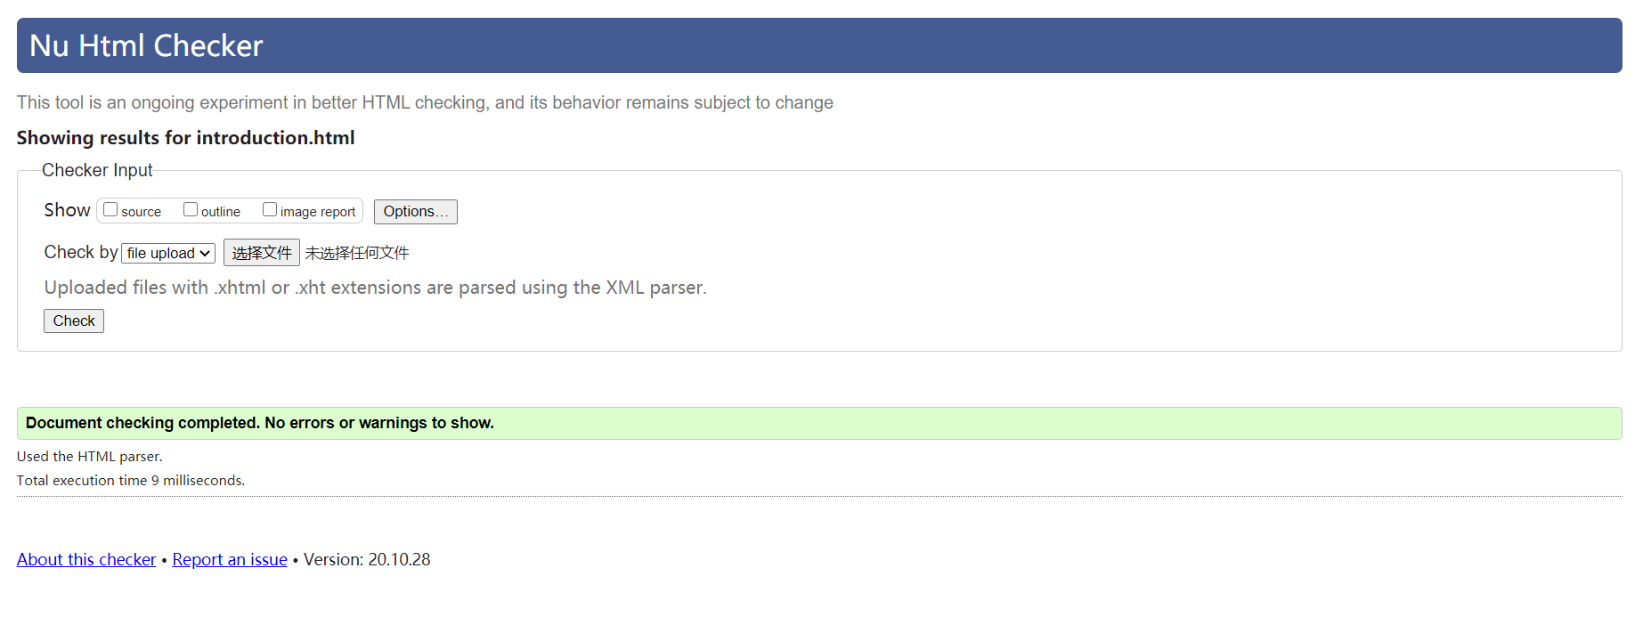

Picture26

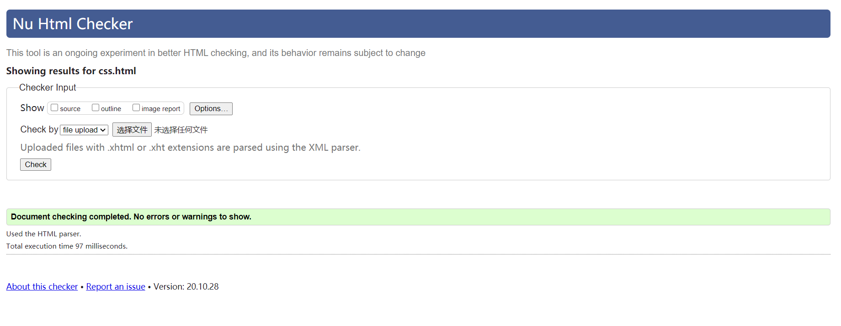

Picture27

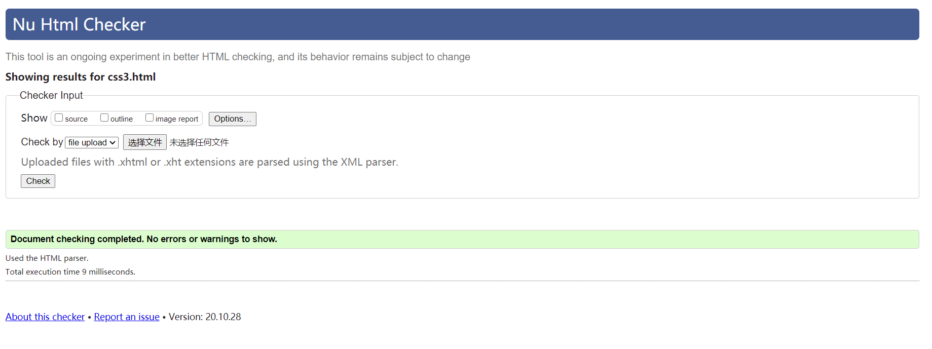

Picture28

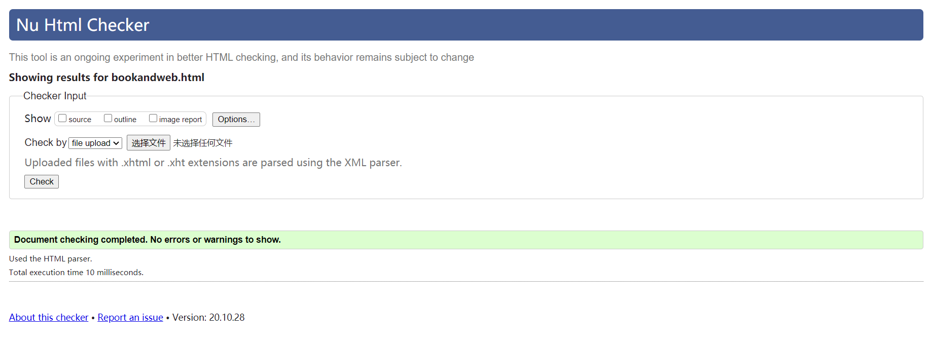

Picture29

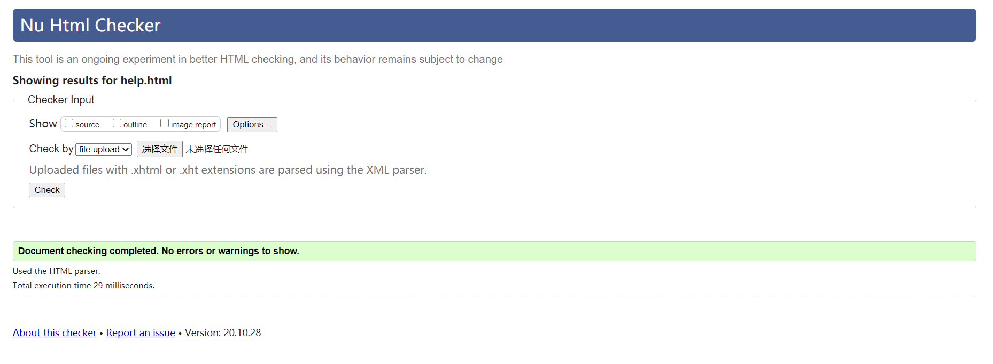

Picture30

### 5.2 Scaling test

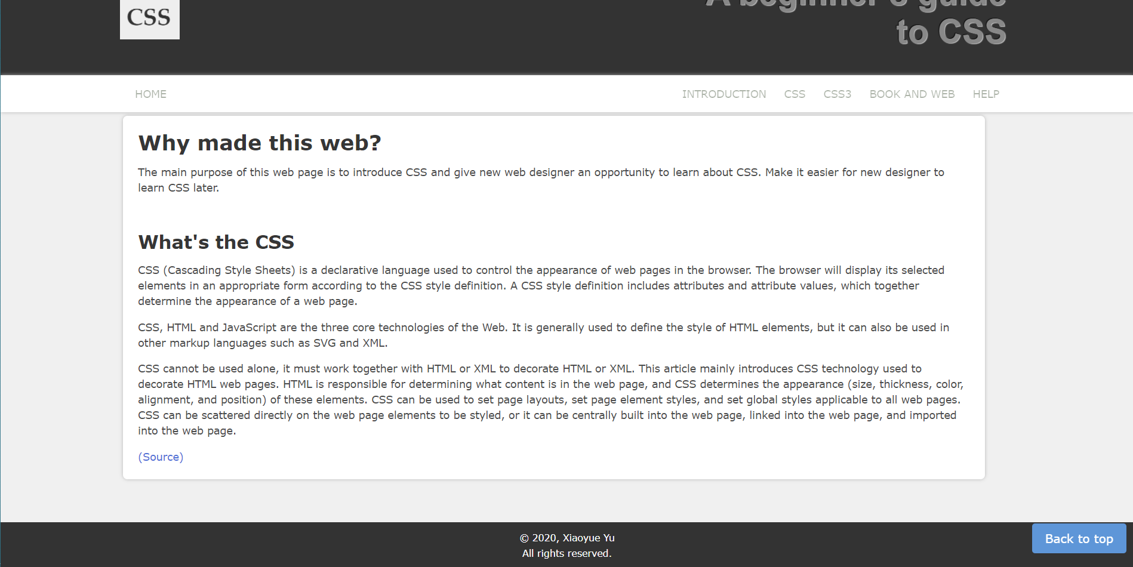

Picture31

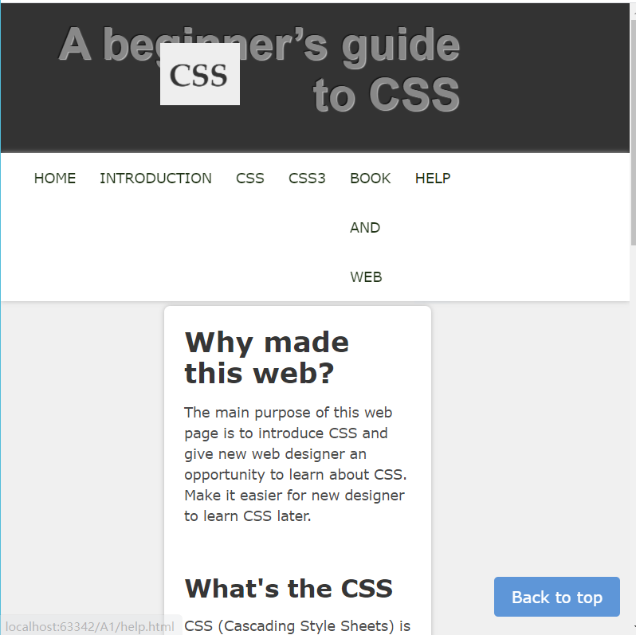

Picture32

## APPENDICES

### Reflection

I learned a lot of knowledge through this project. The next step is to make specific content by hand, select the theme, select the frame, and then start to fill in the content on the homepage.

If it is a personal homepage, capable people can create all the content on their own. Most people's method is: collect relevant information from newspapers, magazines, CD-ROMs and other media, plus some editing. Another good method is to collect it from the Internet. You can find a lot of information as long as you search for the corresponding keywords on the search engine. When preparing materials, we can use some small animations and dynamic pictures. Flash provides full-featured drawing and editing graphics tools. You can draw directly in the editing area, and the editing and modification is very flexible. Its other major feature is its strong "interactivity". During animation playback, you can use the mouse or keyboard to control the animation playback, and the effect can be reflected intuitively. Then began to make the homepage formally.

Generally speaking, the learning of web design through this project has yielded and regretted. However, I have already stepped into the door of web design. As long as I study hard and learn more about making web pages in my spare time in the future to improve my own skills, I firmly believe that the web pages I design will be even better in the future. Professional, more gorgeous, making it a skill of its own.

### REFERENCES

[1]hexo [Internet].[cited 2020 10 28]. Available from: <https://hexo.io/>

[2]Awwwards [Internet].[ cited 2020 10 28]. Available from: <https://www.awwwards.com/>

[3] Bulma [Internet].[ cited 2020 10 28]. Available from: <https://bulma.io>

[4]Wiki [Internet].[ cited 2020 10 28]. Available from: <https://en.wikipedia.org/wiki/CSS>

[5]w3school[Internet].[ cited 2020 10 28]. Available from: <https://www.w3schools.com/css/default.asp>