TACTILE ENTERTAINMENT — COOKIE CATS A/B TEST PROJECT

PHASE 2 REPORT — EDA & DATA QUALITY ASSESSMENT
Exploratory Data Analysis & Data Quality Assessment
Project | Cookie Cats — Mobile Game A/B Testing (moving the progression gate 30 → 40)
Phase | Phase 2 — Data Understanding & Data Quality (CRISP-DM)
Author | Xuân Quang — Data Analyst
Analysis date | 06-07/08/2026
Data source | Kaggle — Mobile Games A/B Testing: Cookie Cats (~90,000 users)
Dataset MD5 | 99b48ea3d4a552fa6b27aac60a8cfddf
Status | Completed — ready to proceed to Phase 3 (Data Preparation)

1. Executive summary
Phase 2 performs the entire data understanding and data quality assessment for the Cookie Cats A/B test dataset before entering formal statistical analysis. The goal is to ensure the data is clean, the randomization is valid, and every anomaly is recorded with a clear handling policy. Result: the data meets the standard to proceed with hypothesis testing in Phase 4.
Four main conclusions:
- Good data quality: 90,189 records, no nulls, no duplicate userids, a clean version column (only gate_30 / gate_40), no negative values.
- Valid randomization: The SRM check (chi-square) gives p = 0.009, higher than the strict agreed threshold p < 0.001 → no Sample Ratio Mismatch. Additional checks on 6 segments all pass.
- Engagement is strongly right-skewed and highly concentrated: sum_gamerounds median is only 16 rounds but the top 20% of users account for 74.1% of all rounds; ~4.4% of users install but play no rounds (zero-play).
- Preliminary signals (not yet tested): gate_40 has D1 retention 0.59 pp lower and D7 0.82 pp lower than gate_30; the negative direction of the difference is consistent across most engagement buckets. This is descriptive and will be tested in Phase 4.
One important policy decision: exclude exactly 1 extreme user (49,854 rounds in 14 days ≈ 89 hours of play/day — suspected bot/emulator), keeping 90,188 users for the analysis. The impact on the retention rate is negligible.

2. Context & scope of Phase 2
Cookie Cats is a match-3 puzzle game by Tactile Entertainment. The dataset records a real A/B test: the control group (gate_30) places the progression gate at level 30, the treatment group (gate_40) moves the gate to level 40. The core business question: does moving the gate improve player retention (D1, D7) and engagement?
Per the CRISP-DM process, Phase 2 does not make a Go/No-Go conclusion — its task is to confirm the data foundation is solid enough for later-phase conclusions to be trustworthy. Phase 2 is split into four work groups, all merged into this report:
- Group 1 — Data Integrity: nulls, duplicates, value validity, sanity & logic consistency.
- Group 2 — SRM Check: randomization test via chi-square goodness-of-fit, overall and by segment.
- Group 3 — Distribution Analysis: percentiles, skewness/kurtosis, histogram, Pareto, zero-inflation, retention by engagement bucket.
- Group 4 — Outlier & Anomaly: profiling extreme users, filter thresholds, boxplot, sensitivity check and finalizing the outlier handling policy.

3. Group 1 — Data Integrity check
The data is loaded with explicitly declared dtypes so the schema is deterministic across mirrors of the dataset. The file is pinned by MD5 hash to ensure reproducibility.
Check item | Result | Conclusion
Total records | 90,189 | Matches baseline
Duplicate userids | 0 | No duplicates
Null values (all columns) | 0 (0.0000%) | Clean
version column values | gate_30 / gate_40 | Clean, no whitespace/case errors
Negative sum_gamerounds | 0 | Valid
Users with 0 rounds (zero-play) | 3,994 (4.43%) | Normal for a mobile game

3.1. Deduplication policy
Although the dataset currently has no duplicate records, the policy is still documented for reuse and in case the pipeline is rebuilt: if a userid is duplicated, keep the record with the highest sum_gamerounds (assuming the higher record is more recent data — the user played more rounds). The deduplication code is written to be idempotent, with an assertion checking userid uniqueness after processing.

3.2. Logic consistency check
Two logic anomalies are recorded and handled as working assumptions rather than removed:
- 87 users with 0 rounds but retention_1 = True (and 29 users with retention_7 = True). Theoretically a contradiction — how can you 'return' without playing any rounds. An acceptable interpretation: the retention system most likely tracks app opens rather than rounds played. This assumption must be carried forward and disclosed in later reports.
- 3,599 users (≈4%) with retention_7 = True but retention_1 = False. Logically entirely valid (the user skips D1 then returns on D7). The median sum_gamerounds of this group is only 45 → mostly 'just checking it out', not an abnormal signal.

4. Group 2 — Sample Ratio Mismatch (SRM) test
The SRM check answers a foundational question: were the two A/B arms split at the designed ratio (50/50)? If the ratio deviates abnormally, then randomization is broken and the entire A/B test loses its value. The project uses the strict threshold **p < 0.001** instead of the usual 0.05, because the cost of analyzing a contaminated experiment is very high.

4.1. Chi-square goodness-of-fit — overall
Metric | Value
Observed (gate_30 / gate_40) | 44,700 / 45,489
Expected (50/50) | 45,094 / 45,094
Difference | −394 / +394
Actual split ratio | 49.56% / 50.44%
Chi-square statistic | 6.902
P-value | 0.009
SRM threshold | 0.001
Conclusion | Fail to reject H0 → randomization PASS

The p-value of 0.009 is larger than the 0.001 threshold, so H0 is not rejected: the distribution between the two groups is considered even. Note this p-value is still smaller than 0.05 — using the usual threshold it would report a 'mismatch', showing the importance of choosing a threshold appropriate to the error cost of a large A/B test context.

4.2. SRM by segment
An additional check to detect hidden imbalance in important sub-groups. All segments PASS:
Segment | N | gate_30 | gate_40 | % g30 | p-value | Conclusion
All users | 90,189 | 44,700 | 45,489 | 49.56 | 0.0086 | PASS
Only 0 rounds | 3,994 | 1,937 | 2,057 | 48.50 | 0.0576 | PASS
0 rounds & R1=True | 87 | 41 | 46 | 47.13 | 0.5919 | PASS
0 rounds & R7=True | 29 | 16 | 13 | 55.17 | 0.5775 | PASS
≥ 30 rounds (past gate_30) | 33,269 | 16,656 | 16,613 | 50.06 | 0.8136 | PASS
≥ 40 rounds (past gate_40) | 27,393 | 13,566 | 13,827 | 49.52 | 0.1148 | PASS

4.3. Retention & engagement by group (descriptive, not yet tested)
The table below is descriptive to shape expectations, NOT test results — significance will be assessed in Phase 4.
Group | N users | Retention D1 | Retention D7 | Mean rounds | Median rounds
gate_30 (control) | 44,700 | 44.82% | 19.02% | 52.46 | 17
gate_40 (treatment) | 45,489 | 44.23% | 18.20% | 51.30 | 16
Difference (g40 − g30) | — | −0.59 pp | −0.82 pp | −1.16 | −1

Both retention metrics of gate_40 are lower than gate_30, consistent with the directional expectation that an early gate (level 30) builds a better comeback habit. The difference is small but the direction is consistent — worth a formal test.

5. Group 3 — Distribution Analysis

5.1. Percentile table of sum_gamerounds
Percentile | All | gate_30 | gate_40
p1 | 0 | 0 | 0
p5 | 1 | 1 | 1
p10 | 1 | 1 | 1
p25 | 5 | 5 | 5
p50 (median) | 16 | 17 | 16
p75 | 51 | 50 | 52
p90 | 134 | 135 | 134
p95 | 221 | 222 | 220
p99 | 493 | 493 | 492
p99.9 | 1,074 | 1,053 | 1,086
Mean | 51.87 | 52.46 | 51.30

The median (16) is much lower than the mean (51.87) — a classic sign of a strongly right-skewed distribution: most users play very little, while a minority who play a great deal pull the mean up. The two groups gate_30 and gate_40 are nearly identical at every percentile, reinforcing the good-randomization conclusion.

5.2. Skewness & Kurtosis
Group | Skewness | Kurtosis (excess) | Interpretation
gate_30 | 163.70 | 31,684.84 | Extremely right-skewed, extremely heavy tail
gate_40 | 5.97 | 63.10 | Strongly right-skewed, heavy tail

The abnormally large skewness and kurtosis of gate_30 are due to exactly one user with 49,854 rounds in this group. After removing the outlier in Group 4, gate_30’s figures will fall to a level comparable to gate_40. An important implication for Phase 4: the data is NOT normal → non-parametric tests (Mann-Whitney U) and bootstrap must be used instead of a t-test.

5.3. Distribution histogram
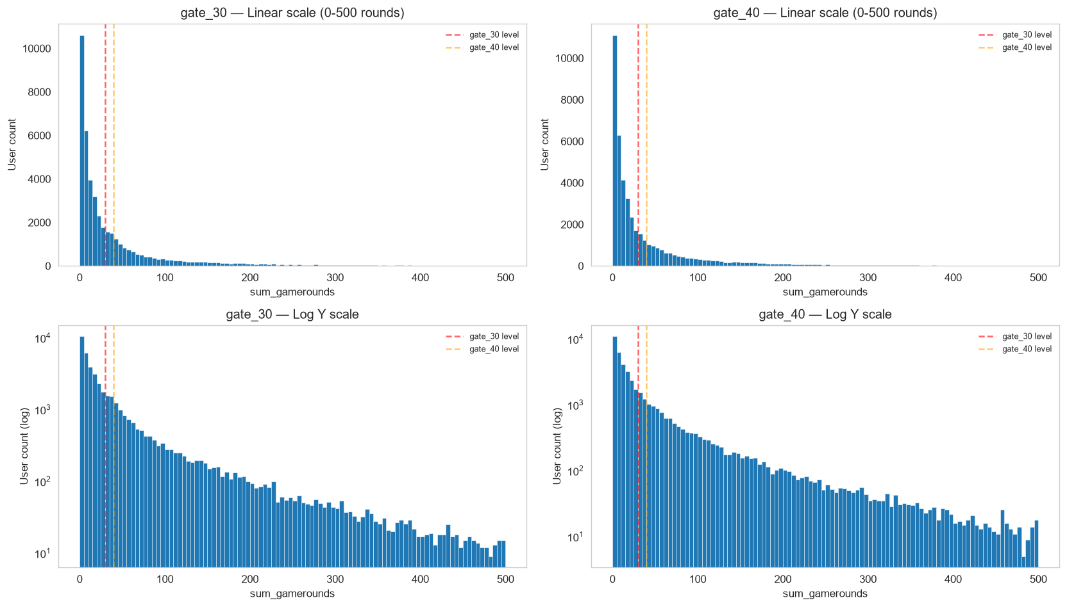
Figure 1. Histogram of sum_gamerounds by group (linear scale top row, log scale bottom row). The dashed lines mark the positions of gate levels 30 and 40.
The mass of players is densely concentrated in the low-rounds region and dissipates quickly toward the tail. The log scale (bottom row) shows the tail extending evenly out to 500+ rounds in both groups — the distribution shapes of gate_30 and gate_40 are nearly identical.

5.4. Pareto analysis — engagement concentration
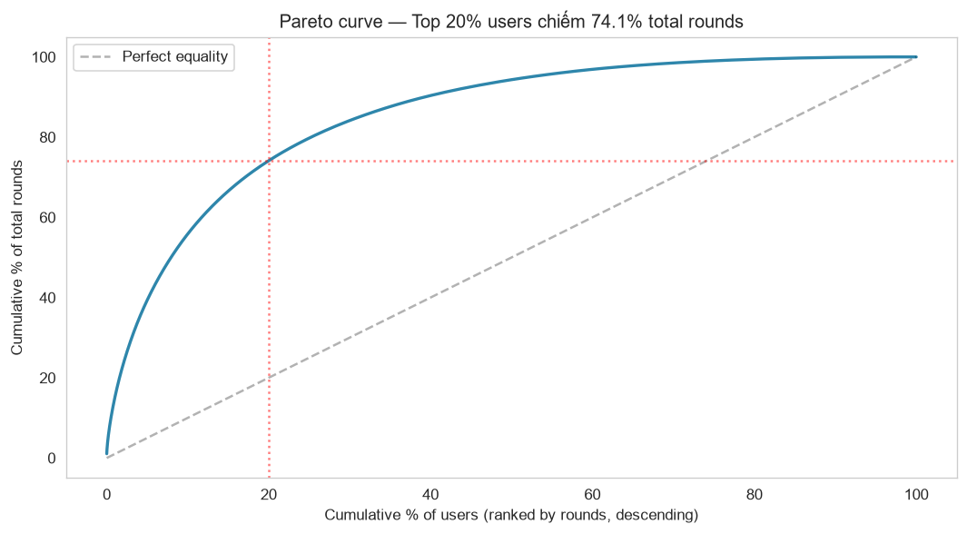
Figure 2. Pareto curve — cumulative percentage of total rounds by percentage of users (sorted descending by play level).
User group (top) | % of total rounds contributed
Top 1% | 15.0%
Top 5% | 39.4%
Top 10% | 55.8%
Top 20% | 74.1%

Engagement is highly concentrated: the top 20% of users generate 74.1% of all rounds — close to the Pareto 80/20 principle. In business terms, a small group of heavy users dominates most of the activity; the game’s retention/monetization depends heavily on keeping this group.

5.5. Zero-inflation — users who install but do not play
Group | Total users | Users with 0 rounds | % zero-play | Of which R1=True | R7=True
gate_30 | 44,700 | 1,937 | 4.33% | 41 (2.12%) | 16 (0.83%)
gate_40 | 45,489 | 2,057 | 4.52% | 46 (2.24%) | 13 (0.63%)

The zero-play rate of ~4.3-4.5% in both groups is below the usual 5-15% for mobile games — good traffic/onboarding quality. The 0-rounds-but-'retained' group is exactly the 87 anomalous users noted in Group 1, reinforcing the assumption that retention tracks app opens.

5.6. Retention by engagement bucket
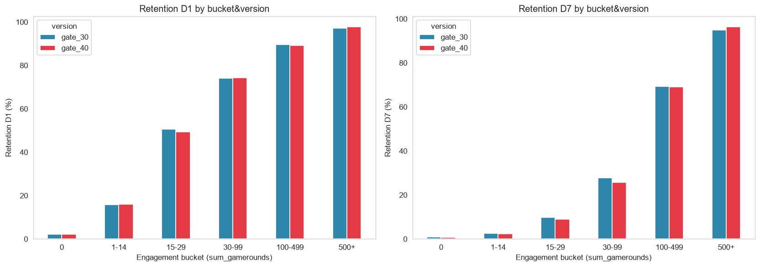
Figure 3. Retention D1 (left) and D7 (right) by sum_gamerounds bucket and version group.
The relationship is very clear and monotonic: the more a user plays, the higher the retention — from ~2% (0 rounds) up to ~97% D1 and ~95% D7 in the 500+ rounds group. This is strong evidence for the segment-analysis direction in later phases: the difference between the two gates (if any) is likely in specific buckets rather than uniform across the whole set.
For D7 retention, gate_30 edges out gate_40 in almost every intermediate bucket (15-29, 30-99, 100-499), consistent with the overall −0.82 pp difference. This is the most notable descriptive signal of Phase 2.

6. Group 4 — Outlier / Anomaly detection & handling

6.1. Profiling the extreme user
The user with the largest sum_gamerounds: 49,854 rounds in 14 days, equivalent to ~3,561 rounds/day ≈ 89 hours of play each day — impossible for a real person. Record: userid 6390605, gate_30 group, retention_1 = False, retention_7 = True. Combined with the evidence of an absurd play volume → strongly suspected to be a bot/emulator/QA account.

6.2. User counts by threshold
Threshold | Total exceeding threshold | gate_30 | gate_40
> p99.9 (~493 rounds) | 91 | 41 | 50
> 1,000 rounds (~71/day) | 116 | 53 | 63
> 3,000 rounds (~214/day) | 1 | 1 | 0
> 10,000 rounds | 1 | 1 | 0

The threshold table shows the 49,854-rounds user is completely separated: it is the only user exceeding both the 3,000 and 10,000 rounds marks, a full order of magnitude away from the rest of the outlier cluster. The 1,000-3,000 rounds users are ambiguous — they could be hidden bots or real heavy users, with no distinguishing evidence.

6.3. Boxplot
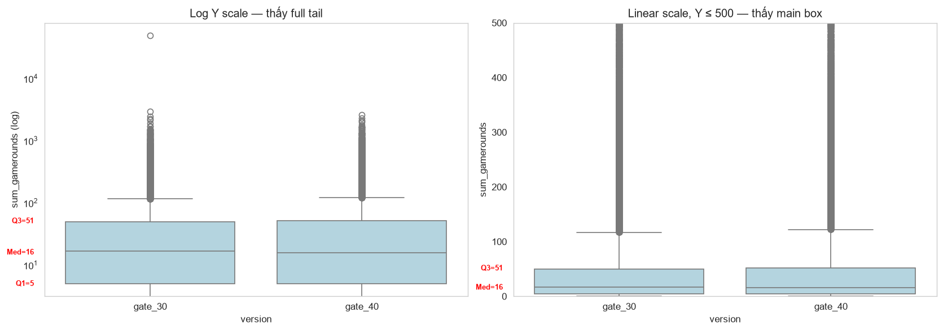
Figure 4. Boxplot of sum_gamerounds by group — the log scale (left) displays the full Q1/Median/Q3, the linear scale limited to Y≤500 (right) to show the main box.
The boxplot visually confirms: the main box (Q1=5, Median≈16, Q3≈51) is very small compared to the tail range, and the extreme user sits well apart from the rest of the outlier crowd.

6.4. Sensitivity check — the outlier’s impact on the main metrics
Comparing metrics between the full dataset and the outlier-removed versions to quantify the level of influence:
Dataset | Group | Retention D1 | Retention D7 | Mean rounds | Median
Full | gate_30 | 44.82% | 19.02% | 52.46 | 17
Full | gate_40 | 44.23% | 18.20% | 51.30 | 16
Remove >3,000 | gate_30 | 44.82% | 19.02% | 51.34 | 17
Remove >3,000 | gate_40 | 44.23% | 18.20% | 51.30 | 16
Remove >1,000 | gate_30 | 44.76% | 18.92% | 49.83 | 17
Remove >1,000 | gate_40 | 44.16% | 18.09% | 49.53 | 16

The retention rate is nearly unchanged when removing the outlier (changing at the second-decimal level of a percentage point). The mean rounds is more sensitive — removing exactly 1 user with 49,854 rounds pulls gate_30’s mean from 52.46 down to 51.34. Because retention is a binary variable, a single user affects the retention rate by only ~0.002 pp.

6.5. Finalizing the outlier handling policy
Decision: exclude exactly 1 most-extreme user (threshold sum_gamerounds > 10,000), keep all 90,188 remaining users (removing 0.0011% of the dataset).
Reasons:
- Only the 49,854-rounds user has strong bot evidence (89 hours of play/day, separated by an order of magnitude, the only user exceeding 10,000 rounds).
- The 1,000-3,000 rounds outliers are ambiguous, with no evidence to distinguish a bot from a real heavy user → default to trusting the data.
- Because retention is a binary variable, keeping/removing the 500-3,000 rounds users hardly changes the conclusion (the sensitivity check confirmed this).
- Minimum data removal = less audit risk, only needing to protect exactly 1 user.
Accepted trade-off: there may still be hidden bots below the 10,000 rounds threshold that cannot be filtered out, but the impact on the retention rate is negligible.

7. Conclusions & assumptions carried to later phases
Phase 2 fully completes the four work groups. The Cookie Cats data meets the quality standard for analysis: clean, valid randomization, every anomaly recorded with a written handling policy. No validation gate FAILED, so the project is permitted to proceed to Phase 3.
Three mandatory assumptions/notes to carry forward and disclose in later reports:
- Retention tracks app opens, not rounds played — inferred from the 87 users with 0-rounds-but-retained. Affects how the retention metric is interpreted.
- The data is strongly right-skewed, not normal — Phase 4 must use Mann-Whitney U and bootstrap, not a t-test; consider a Bonferroni correction (α = 0.0167) for the 3 simultaneous tests.
- 1 outlier removed (userid 6390605) — every Phase 3+ analysis runs on 90,188 users; SRM must be re-checked after removal.
Descriptive signal (not yet tested): gate_40 has D1 retention 0.59 pp lower and D7 0.82 pp lower, with a consistent negative direction of difference. If confirmed statistically significant in Phase 4, this will be the basis for a No-Go recommendation on moving the gate.

Next step — Phase 3 (Data Preparation)
Build mart_ab_test_base on SQL Server: apply the deduplication and outlier removal policies, create engagement_bucket (light ≤ p33 < medium ≤ p67 < heavy) and log_sum_gamerounds = LOG(sum_gamerounds + 1), then run the validation query set (VAL-1 → VAL-8) before moving to Phase 4.

Appendix — Source of results & charts
All the figures and charts in this report are generated from the Python notebooks (the notebooks/ folder) and saved in the reports/ folder:
- phase2_01_data_integrity_check.ipynb — Group 1
- phase2_02_srm_check.ipynb — Group 2
- phase2_03_distribution_analysis.ipynb — Group 3 (Figures 1, 2, 3)
- phase2_04_outlier_anomaly.ipynb — Group 4 (Figure 4)
- PNG charts: phase2_histogram_gamerounds.png, phase2_pareto.png, phase2_retention_by_bucket.png, phase2_boxplot_minor_ticks.png

