PHASE 3 REPORT — DATA PREPARATION
A/B Test analysis project — Cookie Cats

Author: Xuân Quang | Role: Senior Data Analyst | Date: 07/08/2026 | Status: Completed

1. Summary
The data preparation stage (Phase 3) is complete and has passed all 8 data quality gates. The Cookie Cats dataset has been cleaned, deduplicated, cleared of anomalous data, and augmented with the necessary analytical columns, ready for the formal statistical testing stage (Phase 4). No issues were found that would block the project from continuing.
The final analytical data table cookie_cats.mart_ab_test_base contains 90,188 unique users (from 90,189 raw rows, excluding 1 bot account). The integrity of the A/B test is confirmed via the Sample Ratio Mismatch (SRM) test: the two groups gate_30 and gate_40 remain balanced as designed (χ² = 6.92; p ≈ 0.009; passes the α = 0.001 threshold).

2. Stage objectives
The objective of Phase 3 is to turn raw data into a reliable, reproducible, and fully documented analysis-ready dataset. Four main work groups:
- Register data provenance — store the MD5 hash and row count of the source file to verify integrity and reproducibility.
- Deduplication — keep exactly one row per userid following the MAX(sum_gamerounds) rule.
- Outlier removal — exclude 1 account with 49,854 rounds (suspected bot/emulator), keep all remaining users.
- Feature engineering — create the columns log_sum_gamerounds and engagement_bucket (light/medium/heavy by tertile).

3. Data processing pipeline
The entire pipeline is written in idempotent SQL (re-running yields the same result) and each transformation step is logged into the audit log cookie_cats.meta_transformation_log. The chart below reconciles the row count through each step — the difference is exactly 1 (the excluded outlier account).
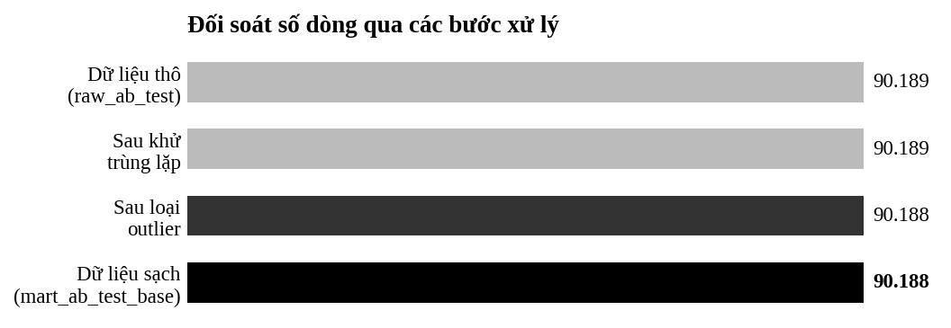
Figure 1. Row count reconciliation: 90,189 (raw) → 90,188 (clean).

4. Data quality results
The data must pass 8 validation gates before it is allowed to proceed to Phase 4. Hard rule: if just 1 gate fails, the project stops to fix it. All 8 gates passed.
Code | Check | Result | Assessment
VAL-1 | Row count reconciliation (raw → mart) | 90,188 = 90,189 − 1 | Pass
VAL-2 | No duplicate userids | 0 duplicates | Pass
VAL-3 | Outlier account excluded | 0 rows = 49,854 | Pass
VAL-4 | No NULL values | 0 NULLs | Pass
VAL-5 | SRM chi-square (50/50) | χ² = 6.92; p ≈ 0.009 | Pass
VAL-6 | Engagement bucket distribution | ≈ 33% / 34% / 33% | Pass
VAL-7 | sum_gamerounds stats vs Phase 2 | Matches EDA | Pass
VAL-8 | Baseline retention rates | D1 ~44% · D7 ~18% | Pass

4.1. Experiment integrity check (SRM)
SRM checks whether the split ratio of the two groups deviates abnormally from the design. The observed ratio of 49.56% / 50.44% gives χ² = 6.92 (p ≈ 0.009), passing the strict threshold α = 0.001 → the two groups are balanced and the experiment is valid for further analysis.
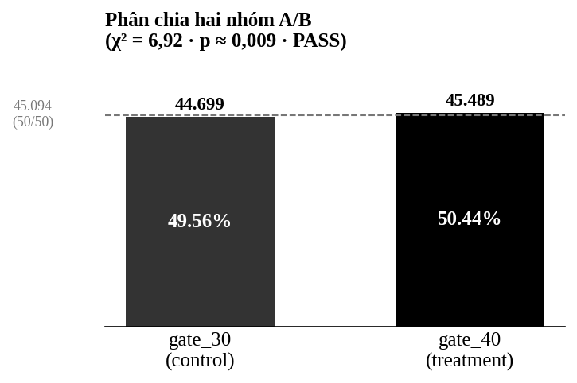
Figure 2. The A/B split of the two groups versus the ideal 50/50 level.

4.2. Engagement distribution
Users are split into three engagement groups by tertile of sum_gamerounds, computed on the whole population (both groups combined) to ensure the same measuring stick for cross-group comparison. The distribution is approximately 33/34/33 as expected.
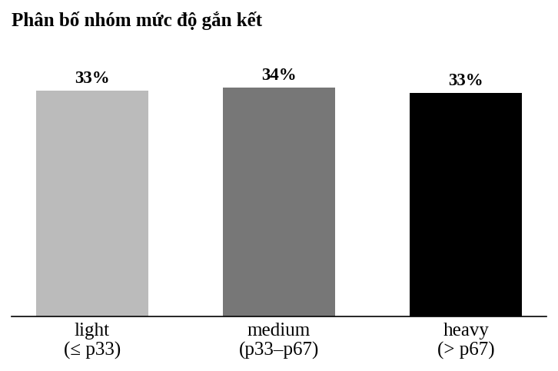
Figure 3. Distribution of the three engagement groups (light / medium / heavy).

4.3. Return (retention) rates — preview
These are reference figures before the formal analysis. Important note: the retention metric in this data measures app reopens, not necessarily playing the game (there are 87 users who opened the app but played 0 rounds). It must be interpreted correctly as "app retention" when reading the final results.
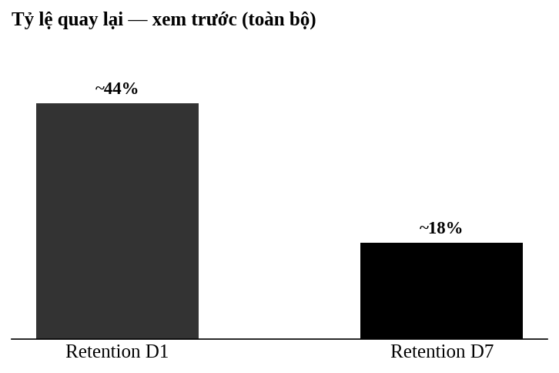
Figure 4. D1 and D7 return rates (preview, whole population).

5. Data processing decisions

Code | Issue | Decision
POL-1 | Deduplication | Keep MAX(sum_gamerounds) per userid
POL-3 | Outlier with 49,854 rounds | Exclude (suspected bot); keep every other user
POL-2 | 87 users with 0 rounds but retained | Keep; retention measures app opens
POL-6/7 | Engagement bucket | Tertile p33/p67 on the whole population
DEC-01 | SRM threshold | α = 0.001 (strict, avoids false alarms at large n)

6. Handover deliverables
- cookie_cats.mart_ab_test_base — the analytical data table, 90,188 rows, 1 row/user.
- The SQL scripts — 01_metadata_setup, 02_build_mart_ab_test_base, 03_validation_queries (idempotent).
- Documentation — data_dictionary.md, decision_log.md, preprocessing_checklist.md.
- Notebook — phase3_report.ipynb, reproducing the results and charts from live data.
- Audit log — meta_dataset_version and meta_transformation_log in the database.

7. Limitations & next steps

Limitations to keep in mind
- The data only covers the first 14 days — no long-term impact can be concluded.
- No revenue data — the money impact is not directly measured.
- Retention measures app opens, not gameplay — interpret with caution.

Next step: Phase 4 — Analysis
The next stage tests the 3 formal hypotheses: the difference in D1 retention, D7 retention (2×2 chi-square), and the difference in median sum_gamerounds (Mann-Whitney U + bootstrap), with a Bonferroni correction (α = 0.0167) and effect size. The results will come with a Go/No-Go recommendation for the product team, with a quantified impact estimate.
— End of the Phase 3 report —

