PHASE 4 REPORT — ANALYSIS (HYPOTHESIS TESTING)
A/B Test analysis project — Cookie Cats
Author: Xuân Quang | Role: Senior Data Analyst | Date: 08/08/2026 | Status: Completed

1. Summary
Phase 4 formally tests the three hypotheses of the Cookie Cats A/B experiment on the cleaned dataset of 90,188 users (the mart cookie_cats.mart_ab_test_base). Overall conclusion: recommend NO-GO — keep the gate at level 30, do not roll out gate 40.
The basis for the recommendation rests on three pillars. First, the gate_40 group’s D7 retention drops 0.82 percentage points (−4.3% relative) versus gate_30, a difference statistically significant beyond even the Bonferroni threshold (p = 0.0016; the 95% confidence interval does not contain 0). Second, engagement (number of rounds played) between the two groups is essentially equal (p = 0.051; bootstrap CI contains 0), meaning gate_40 provides no engagement benefit to trade for. Third, the segment analysis shows the harm falls exactly on the valuable player groups (medium and heavy), while the light group is virtually unaffected.
Business impact estimate (a proxy with transparent assumptions since the data contains no revenue): for every 100,000 new installs per month, rolling out gate_40 corresponds to about 818 D7 users lost per month; this figure scales linearly with traffic.

2. Objective and hypotheses
The objective of Phase 4 is to answer the core business question: does moving the gate from level 30 to level 40 improve retention and engagement, with clear statistical confidence, in order to make a Go/No-Go recommendation for the Product team.
The three null hypotheses (H0) tested:
- H0₁: Retention_D1(gate_30) = Retention_D1(gate_40).
- H0₂: Retention_D7(gate_30) = Retention_D7(gate_40).
- H0₃: Median(sum_gamerounds | gate_30) = Median(sum_gamerounds | gate_40).
The original significance threshold is α = 0.05. Since three hypotheses are tested simultaneously, a Bonferroni correction is applied: adjusted α = 0.05 / 3 = 0.0167. Every "significant" conclusion is read under this 0.0167 threshold.

3. Methodology
The guiding principle: at a large sample size, the p-value is almost always small, so every conclusion separates statistical significance from practical significance — always accompanied by an effect size and a confidence interval, read by the rule "if the CI contains 0, there is no practical difference".
- Retention D1/D7 (binary variables): the Chi-square test (independence, Yates correction for the 2×2 table), effect size Cohen's h, and the 95% confidence interval of the difference in proportions.
- Engagement (continuous, skewed variable): the Mann-Whitney U test (non-parametric, suited to a right-skewed distribution), effect size rank-biserial, and a 10,000-iteration bootstrap (seed = 42) to obtain the CI for the median difference.
- Segment analysis (HTE): chi-square on D7 retention within each light/medium/heavy group, read by pattern (direction and magnitude) rather than hard claims per cell.
- Business impact: convert the D7 difference into a number of users and money via an LTV proxy, leaving ARPU as a parameter and running a sensitivity table.

3.1. SRM (Sample Ratio Mismatch) guardrail check
Before the analysis, the split ratio of the two groups is checked to ensure randomization is not broken. Observed: gate_30 = 44,699 (49.56%) and gate_40 = 45,489 (50.44%); SRM chi-square = 6.92; p = 0.0085. Against the guardrail’s own threshold α = 0.001 (deliberately strict to avoid false alarms at a large sample size), p = 0.0085 ≥ 0.001 so the SRM PASSES — the experiment is valid and further analysis is permitted. Note: at the usual 0.05 threshold, this difference would be deemed significant; this is why the project uses α = 0.001 for SRM and handles the large sample size with effect size rather than lowering the threshold.

4. Test results

4.1. Retention D1 (H0₁)
D1 rates: gate_30 = 44.82% versus gate_40 = 44.23%, a difference of −0.59 percentage points (−1.32% relative). Chi-square = 3.17; p = 0.0750; Cohen's h = −0.012 (very small); 95% confidence interval of the difference = [−1.24; +0.06] percentage points — contains 0. Conclusion: do NOT reject H0₁. Insufficient evidence for a difference in D1 retention between the two groups.

4.2. Retention D7 (H0₂)
D7 rates: gate_30 = 19.02% versus gate_40 = 18.20%, a difference of −0.82 percentage points (−4.3% relative). Chi-square = 9.92; p = 0.0016; Cohen's h = −0.021; 95% confidence interval = [−1.33; −0.31] percentage points — does not contain 0. Conclusion: REJECT H0₂. Gate_40 reduces D7 retention in a statistically significant way, beyond even the Bonferroni threshold. The effect size is small in absolute terms, but at a large traffic scale the operational impact is significant (see section 5).
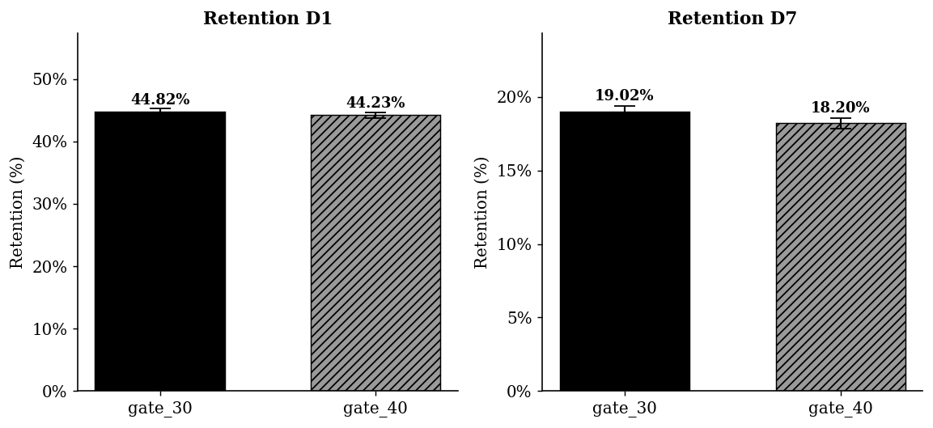
Figure 1. D1 and D7 retention by group (error bars = 95% confidence interval).

4.3. Engagement — sum_gamerounds (H0₃)
The number of rounds is strongly right-skewed (median ~16–17 but mean ~51 due to the long tail), so the median and a non-parametric test are used. Median: gate_30 = 17 versus gate_40 = 16. Mann-Whitney U ≈ 1.024×10⁹; p = 0.0509; rank-biserial r = −0.0075 (extremely small). Bootstrap of the median difference (gate_40 − gate_30): mean ≈ −0.93; 95% confidence interval = [−1.00; 0.00] — contains 0. Conclusion: do NOT reject H0₃. The engagement of the two groups is essentially equal. With the CI containing 0 and an effect size ~0, the safe conclusion is that there is no practical difference.
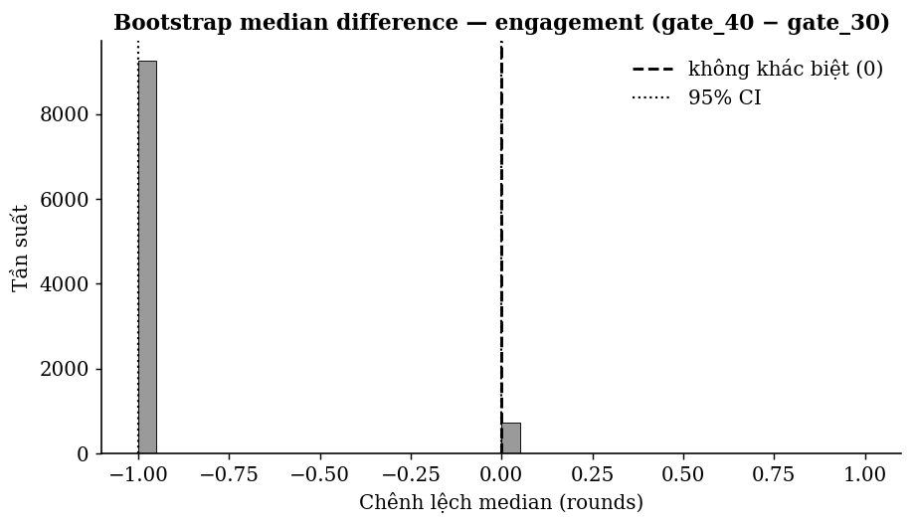
Figure 2. Bootstrap distribution of the engagement median difference; the 95% confidence interval contains the 0 mark.

4.4. Segment analysis — heterogeneous effect (H0₂ in detail)
The −4.3% figure at D7 is the average effect; analysis by engagement group shows the impact is distributed unevenly. The light group is virtually unchanged (+0.11 percentage points; p = 0.44); the medium group drops −0.63 percentage points (p = 0.043); the heavy group drops the most, −1.27 percentage points (p = 0.029). This monotonic pattern by engagement level matches the mechanism: light players mostly leave the game before even level 30 so they do not "hit" the gate, while medium/heavy players are the ones truly affected by moving the gate — losing the comeback habit in exactly the most valuable group.
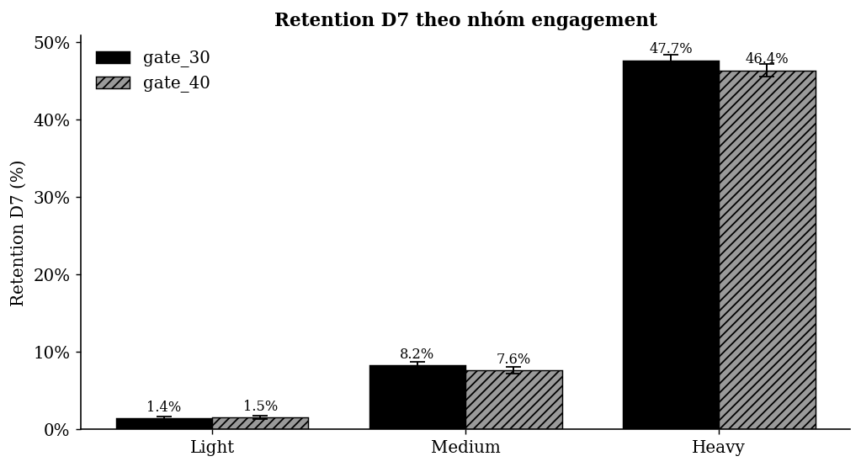
Figure 3. D7 retention by engagement group; the harm concentrates in medium and heavy.
Group | gate_30 | gate_40 | Difference (pp) | p
Light | 1.42% | 1.54% | +0.11 | 0.444
Medium | 8.25% | 7.61% | −0.63 | 0.043
Heavy | 47.66% | 46.38% | −1.27 | 0.029

5. Business impact estimate
Because the dataset contains no revenue (out of scope), this section is a proxy estimate with transparent assumptions, not directly measured revenue. The core figure: the D7 retention difference = −0.82 absolute percentage points. Number of D7 users lost per month = (new installs) × 0.0082. The table below presents a range of scenarios; ARPU is left as a parameter — plug in the team’s real numbers to get a concrete money value.
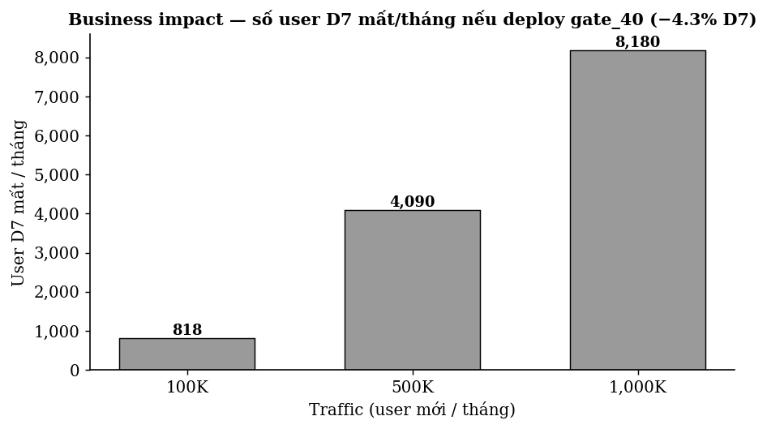
Figure 4. Number of D7 users lost per month by traffic scale (if gate_40 is rolled out).
Traffic/month | D7 users lost | ARPU $0.20 | ARPU $0.50 | ARPU $1.00
100,000 | 818 | $164 | $409 | $818
500,000 | 4,092 | $818 | $2,046 | $4,092
1,000,000 | 8,183 | $1,637 | $4,092 | $8,183
Note: "loss/month" = number of D7 users lost × ARPU. D7 retention is used as a proxy for stickiness/LTV, not a full LTV model (the data only has D1/D7, no long-term retention curve).

6. Summary of the three hypotheses
Hypothesis | Effect | p-value | Conclusion
H0₁ — Retention D1 | −1.32% relative | 0.0750 | Do not reject (tie)
H0₂ — Retention D7 | −4.30% relative | 0.0016 | Reject — gate_40 is worse
H0₃ — Engagement | −1 round (median) | 0.0509 | Do not reject (equal)

7. Conclusion and recommendation
Recommendation: NO-GO — keep the gate at level 30, do not roll out gate 40, with confidence > 95%.
Three findings reinforce the recommendation: (1) D7 retention drops significantly and beyond Bonferroni; (2) engagement does not improve to compensate; (3) the harm falls exactly on the core-user group (medium/heavy). No benefit was recorded to trade for the lost D7 retention.
Suggested next step: if you still want to optimize the gate placement, design a new A/B test trying intermediate gate positions (e.g. level 35) or a soft gate, and add revenue measurement to directly assess the monetization impact instead of a proxy.

8. Limitations and interpretation notes
- Nature of retention: the retention metric in the dataset measures app opens, not necessarily gameplay (a working assumption from Phase 3) — this must be stated clearly when presenting.
- Time scope: the data only covers the first 14 days; no long-term impact (D14+) can be concluded.
- Revenue: no revenue data; every money figure is a parameterized proxy, not directly measured.
- SRM: SRM passes at the project threshold (α = 0.001) but not at 0.05; the large sample size was handled with effect size, and monitoring the split is recommended for future tests.

— End of the Phase 4 report —

