PHASE 6 REPORT -INSIGHTS & RECOMMENDATION
A/B Test analysis project -Cookie Cats (moving the progression gate 30 → 40)
Author: Xuân Quang | Role: Senior Data Analyst | Date: 08/08/2026 | Status: Completed

1. Executive summary
Recommendation: NO-GO -keep the gate at level 30, do not roll out gate 40, with confidence > 95%.
The A/B experiment on 90,188 cleaned users shows that moving the gate delivers no benefit whatsoever, while harming exactly the most valuable player group. Three pieces of evidence were found as follows: (1) gate_40’s D7 retention drops 0.82 percentage points (−4.3% relative), statistically significant beyond even the Bonferroni threshold (p = 0.0016); (2) engagement between the two groups is essentially equal (p = 0.051; bootstrap CI contains 0) -no benefit to trade for; (3) the harm concentrates in the medium and heavy groups, while the light group is virtually unchanged.
Core figures
• Retention D7: 19.02% (gate_30) versus 18.20% (gate_40) → −0.82pp, p = 0.0016 → REJECT H0
• Retention D1: 44.82% versus 44.23% → −0.59pp, p = 0.075 → no difference
• Engagement (median rounds): 17 versus 16 → p = 0.051, CI contains 0 → no difference
• Business impact (proxy, ARPDAU $0.10): ~818 D7 users lost/month per 100K installs ≈ $2,454/month ≈ $29,448/year (linear with traffic)

2. Context & business question
Cookie Cats is a mobile puzzle game (match-3) by Tactile Entertainment. The gate is a progress-blocking mechanic, forcing players to wait / invite friends / pay -the main tool for creating controlled friction. The A/B experiment compares two gate positions: gate_30 (control, blocking at level 30) and gate_40 (treatment, moved to level 40).
The question to answer: does moving the gate 30 → 40 improve retention (D1, D7) and engagement, in order to make a Go/No-Go recommendation for the Product team? This report synthesizes and interprets the test results (Phase 4) into insights and an actionable recommendation; the methodology and testing details are in the Phase 2–4 reports.
3. Summary of the three-hypothesis results
Principle for reading the results: at a sample size of ~90K, the p-value is almost always small, so every conclusion separates statistical significance from practical significance. Thresholds: α = 0.05, Bonferroni-corrected α = 0.0167 for the 3 simultaneous tests.
Hypothesis | Difference | p-value | 95% Confidence interval | Conclusion
Retention D1 | −0.59pp (−1.3%) | 0.075 | [−1.24; +0.06] contains 0 | Do not reject H0
Retention D7 | −0.82pp (−4.3%) | 0.0016 | [−1.33; −0.31] does not contain 0 | REJECT H0
Engagement (median) | 17 → 16 rounds | 0.051 | [−1.00; 0.00] contains 0 | Do not reject H0

=> moving the gate does NOT increase engagement, nor does it improve day-1 retention - but it REDUCES D7 retention.
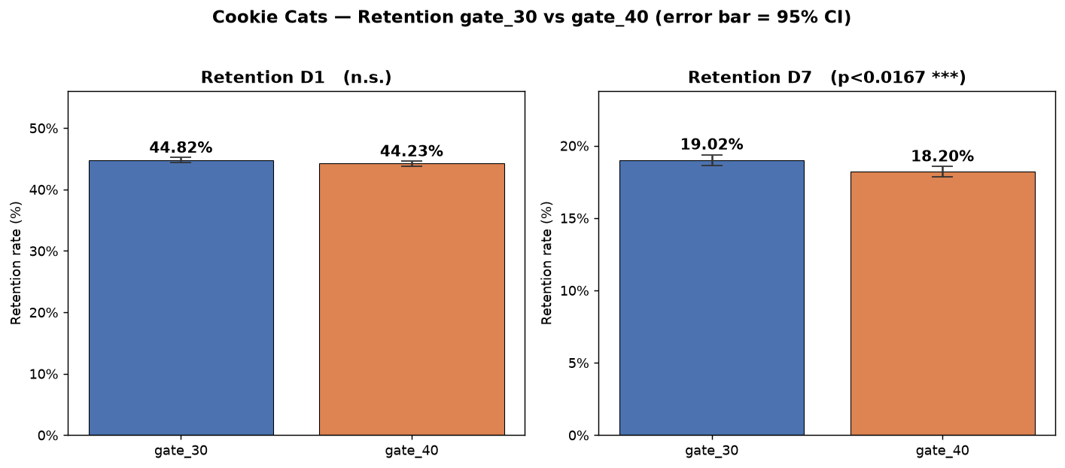
Figure 1. D1 and D7 retention by group (error bars = 95% confidence interval). The D7 difference is clear and non-overlapping.
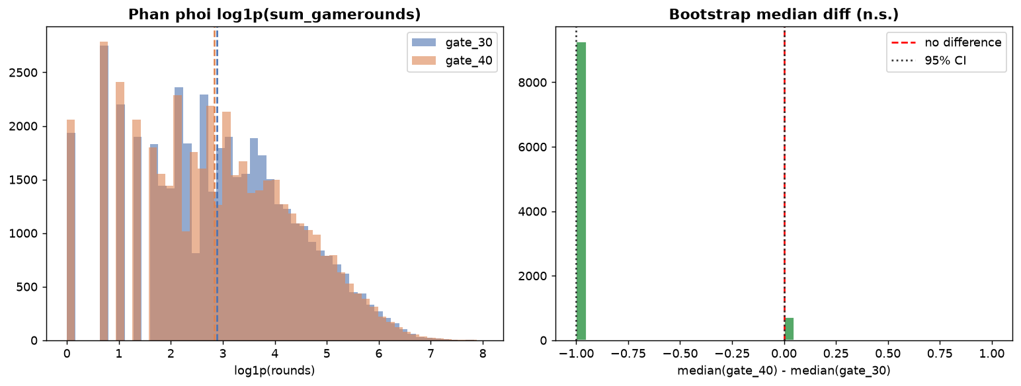
Figure 2. Bootstrap distribution of the engagement median difference; the 95% confidence interval contains the 0 mark → no practical difference.
4. Deep insight -the harm falls exactly on the valuable group
The −0.82pp figure at D7 is the average effect; analysis by engagement group shows the impact is distributed unevenly -this is the most important insight for the Game Designer:
- Light group: +0.11pp (p = 0.44) -virtually unchanged.
- Medium group: −0.63pp (p = 0.043) -starting to feel the impact.
- Heavy group: −1.27pp (p = 0.029) -the largest drop.
This monotonic pattern by engagement level matches the game mechanism: light players mostly leave before even level 30 so they do not "hit" the gate; medium/heavy players are the ones who truly reach the gate point -and moving the gate breaks the comeback habit in exactly the most valuable group. In other words, gate_40 does not harm those about to leave, but harms those who are staying.
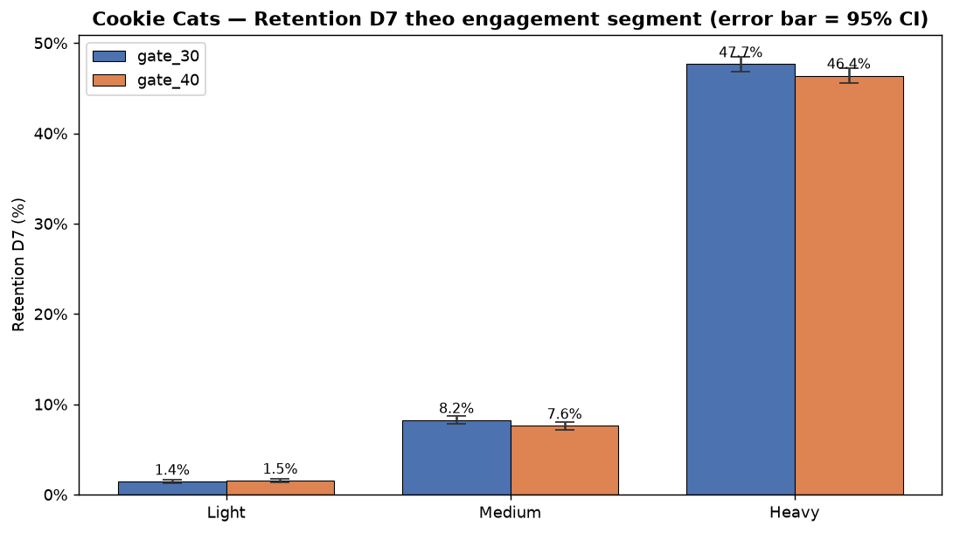
Figure 3. D7 retention by engagement group; the harm concentrates in medium and heavy.
5. Business impact estimate
The dataset contains no revenue data, so this section is a proxy estimate with transparent assumptions, not directly measured revenue. D7 retention is used as a proxy for stickiness/LTV.
Assumptions (casual puzzle industry benchmark):
- ARPDAU ≈ $0.10 (average revenue per active user per day).
- LTV proxy per user ≈ ARPDAU × ~30 estimated active days = $3.00.
- Illustrative scale: 100,000 new installs per month.
Formula: D7 users lost/month = Installs × |ΔD7| = 100,000 × 0.00818 ≈ 818 users. Proxy revenue lost = 818 × $3.00 ≈ $2,454/month ≈ $29,448/year -and it scales linearly with traffic.
New installs/month | D7 users lost/month | Loss/month ($) | Loss/year ($)
100,000 | 818 | $2,454 | $29,448
500,000 | 4,092 | $12,276 | $147,312
1,000,000 | 8,183 | $24,549 | $294,588

Note: this is a benchmark-based proxy, not a full LTV model (the data only has D1/D7, no long-term retention curve).
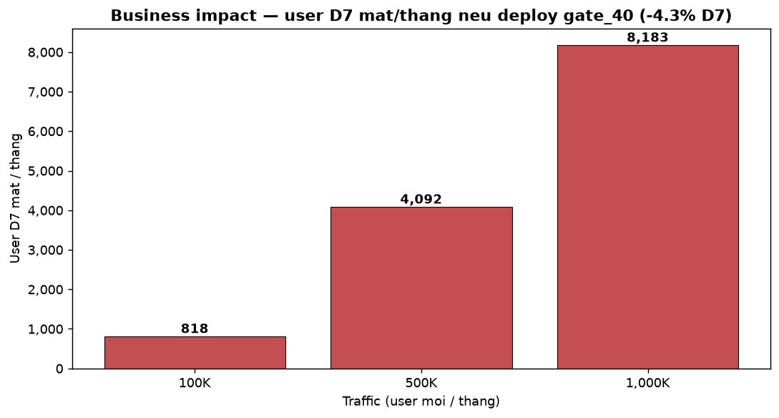
Figure 4. Number of D7 users lost per month by traffic scale (if gate_40 is rolled out).
6. Recommendation & next steps
Recommendation: NO-GO -keep the gate at level 30, do not roll out gate 40.
Three findings reinforce the recommendation: (1) D7 retention drops significantly and beyond Bonferroni; (2) engagement does not improve to compensate; (3) the harm falls exactly on the core-user group (medium/heavy). No benefit was recorded to trade for the lost D7 retention.
Suggested next steps:
- If you still want to optimize the gate placement: design a new A/B test trying an intermediate position (e.g. level 35) or a soft gate instead of a hard gate.
- Add revenue measurement in a future test to directly assess the monetization impact, instead of a proxy.
- Monitor the split ratio (SRM) more strictly in the next test -this time SRM passes at the project threshold (α = 0.001) but would "fail" at α = 0.05.
7. Messaging by stakeholder
Stakeholder | Core message
Product Manager | NO-GO, no deploy schedule needed. The main risk if deployed: losing ~4.3% D7 retention in the core group.
Game Designer | Gate_40 breaks the comeback habit of medium/heavy players; the light group is unaffected. Consider a soft gate / level 35.
Marketing Lead | The D7 retention drop pulls the LTV proxy down to ~$2,454/month per 100K installs (ARPDAU $0.10) -it affects CAC efficiency.
CEO / Leadership | Keep the status quo. No upside; this change loses money at scale with traffic.

8. Limitations & interpretation notes
- Nature of retention: the metric measures app opens, not necessarily gameplay (a working assumption from Phase 3).
- Time scope: the data only covers the first 14 days; no long-term impact (D14+) can be concluded.
- Revenue: no revenue data; every money figure is a benchmark-based proxy, not directly measured.
- SRM: passes at the project threshold (α = 0.001) but not at 0.05; the large sample size was handled with effect size.

-End of the Phase 6 report —

