Introduction: 2
Customer requirements: 2
Page designing: 3

Introduction:

The Project is to be developed where the user is allowed to register their mobile number on the site and they will be allowed to send the message to any mobile. There is certain validation for the user to send the message like it should not exceed more than 120 characters. Only 5 messages are allowed to send free to any single mobile number. Once the message is send then the appropriated message must be prompted. Even user can also edit the profile by adding personal, professional details. Once the profile is created the user can be allowed to add the other registered users by sending the request. Once the request is accepted then his/her mobile number will be added in the friend list of the profile and sending message to the friend mobile number will be free unlimited through out the day. There will be contact page open for the user where they can enter the mobile number with the name of the person for sending the message. It also provide option for activating the service for the joke, current affairs, sports, news in your mobile, this would be paid service where user has to pay through credit card.

Customer requirements:

This is an Online SMS site where the user first registers them with their personal details and registering their mobile number. Only one account can be created for one mobile number.
If the user tries to create the account with mobile number which had been already registered then the message must be displayed to the end user that
“THIS MOBILE NUMER had been registered already”

Website must contain following features:
Home Page: Here the information about the website must be placed in the center and in the right corner or left corner depending on the choice the registration section must be added. In the top right corner login details of the registered user must be asked.
A sample Page is shown below:
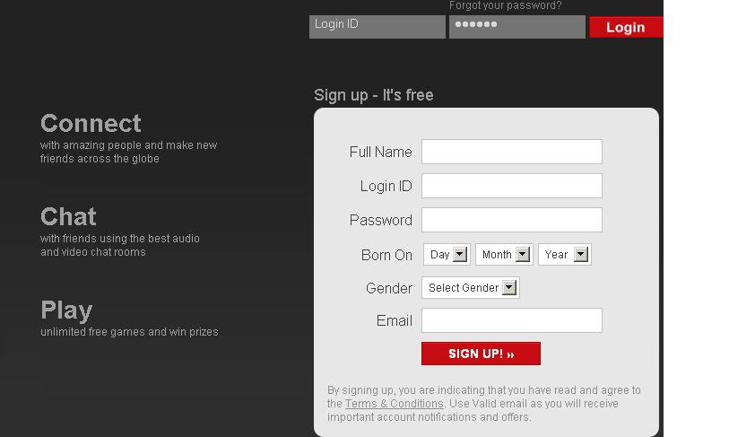

While registering the account it should ask following data
- Username (must check whether available or not)
- Validate Username
- Password
- Confirm Password
- Email ID
- Enter 10 digit mobile number
- Validate (Message must be prompted whether the number is available or not)
- Verification code (Here code must be appeared)
- Entering the verification code in the text field
- Submit

Page designing:

Once the user creates the account then he/she edits their profile details:
Edit Profile:
Personal Details like

    - *Name
    - *Gender
    - *DOB
    - *Address
    - Marital Status
    - *Email address
    - Hobbies
    - Likes
    - Dislikes
    - Cuisines
    - Sports
    - Image (Profile Photo)

Professional Details

    - Qualification
    - School
    - College
    - Work status (Employed, not Employed, Student)
    - Organization( If employed then name of the Organisation)
    - Designation

Add Contacts: Here the list of the contacts can be added. It should contain following detail

    - First Name
    - Last Name
    - Contact number

Message: Here the Page will be displayed with two sections :
- Sending message to friends
    - Name
    - Message in the text area( with validation of the size)
    - Send( Button) (appropriate message must be generated when the message is send.)
- Sending message to non – friends
    - Contact number (there should be an button for adding the number from contact details
    - Message in the text area
    - Send (Button) (appropriate message must be generated when the message is send.)

Friends: here the friends can be added in your account
- Friend Request : here the user has to accept or reject the request received
- Send Request: here you can send the request by entering the email ID
- Friends: can view all the friends available.

Activation of the services:
Here the list of service should come in the check List and user is allowed to checked the required services which he/she wishes to activate.
Once the required services are selected then user should click on the next link at the bottom of the page. There the user should pay the charges as per the number of services are activated and must pay through the credit card.

