Xuan(James) Zhai

CS3339 Lab

April 30th, 2021

CS 3339 - Lab 9 - Lab Report

1: Start a scan

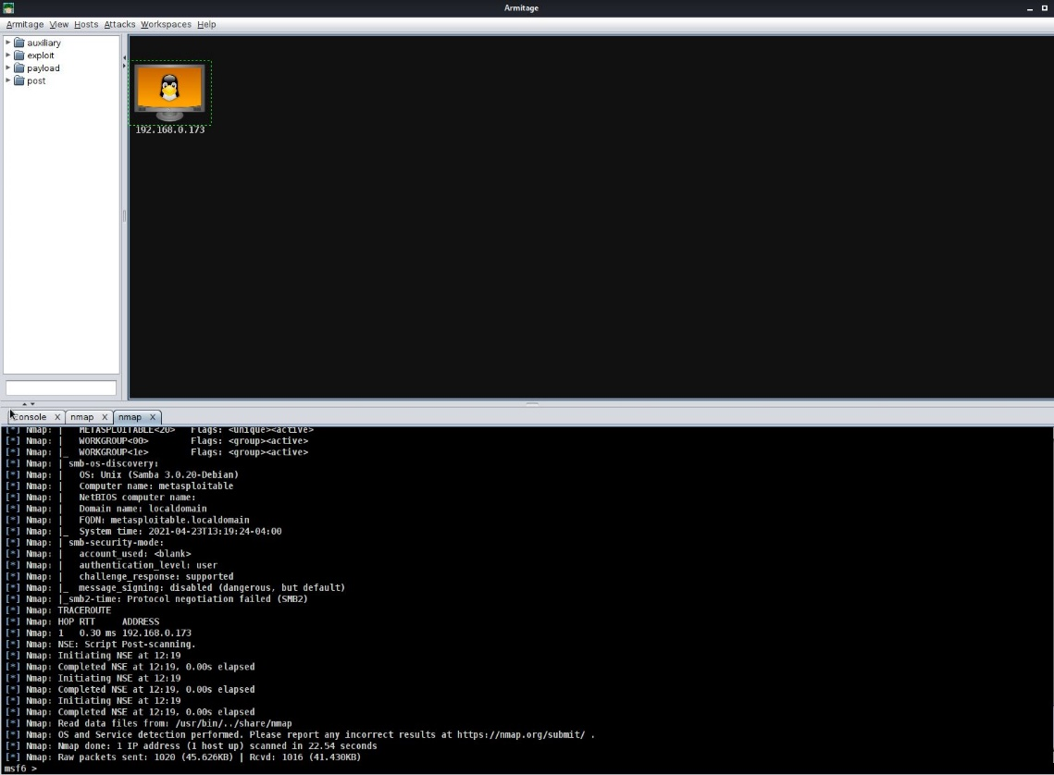

2: Find all the attacks

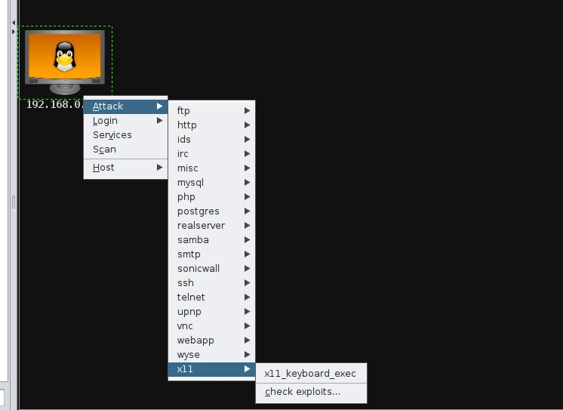

3: Get the shell access

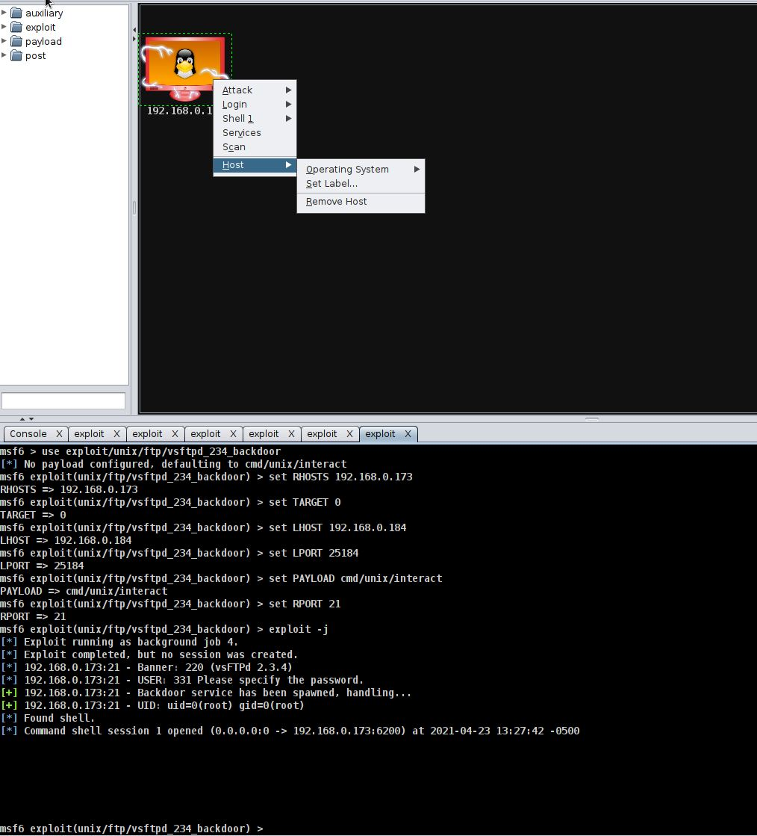

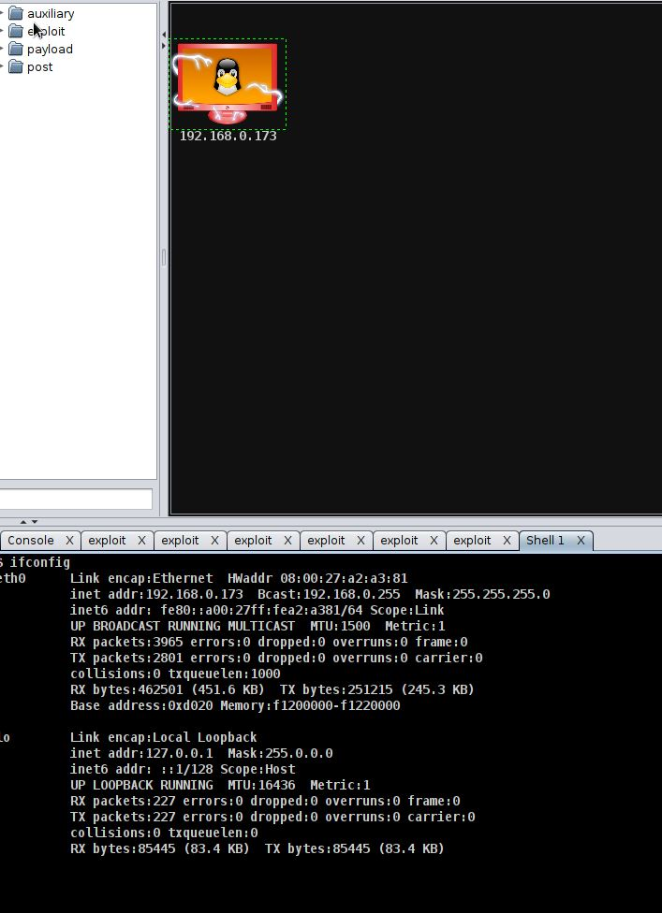

4: Get the user accounts

