Xuan(James) Zhai

Dr. Corey Clark

CS 3353

Oct 16th, 2019

CS 3353- Lab 2 Report

In this lab, we are going to use 6 different algorithms to find the Returned Path, Number of nodes in returned path, Total Cost of path, Total distance of path, Number of nodes explored in path, Execution time to find path. Since there is a bad-alloc() failure when running the 100 files or sometimes even the 50 files with DFS/BFS iterative, I could only use the sample graph to do the analysis.

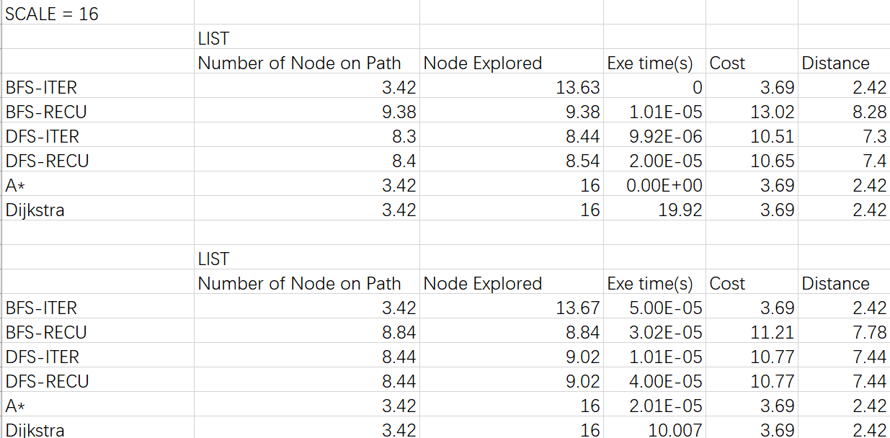

From the chart we could find out that A\* and Dijkstra will always return the lowest cost (lowest distance) path even they have longer execution time. That may be caused by the number of paths it found. For those two algorithms, they need to find nearly all the paths to find the shortes.

For DFS and BFS, their data are relatively similar, but iterative more close to the path with shortest node.

Works Cited

AuthorLastName, FirstName. *Title of the Book Being Referenced*. City Name: Name of Publisher, Year. Type of Medium (e.g. Print).

LastName, First, Middle. "Article Title." *Journal Title* (Year): Pages From - To. Print.

University of Georgia. "Continued destruction of Earth's plant life places humans in jeopardy." ScienceDaily. ScienceDaily, 14 July 2015. <www.sciencedaily.com/releases/2015/07/150714160923.htm>.