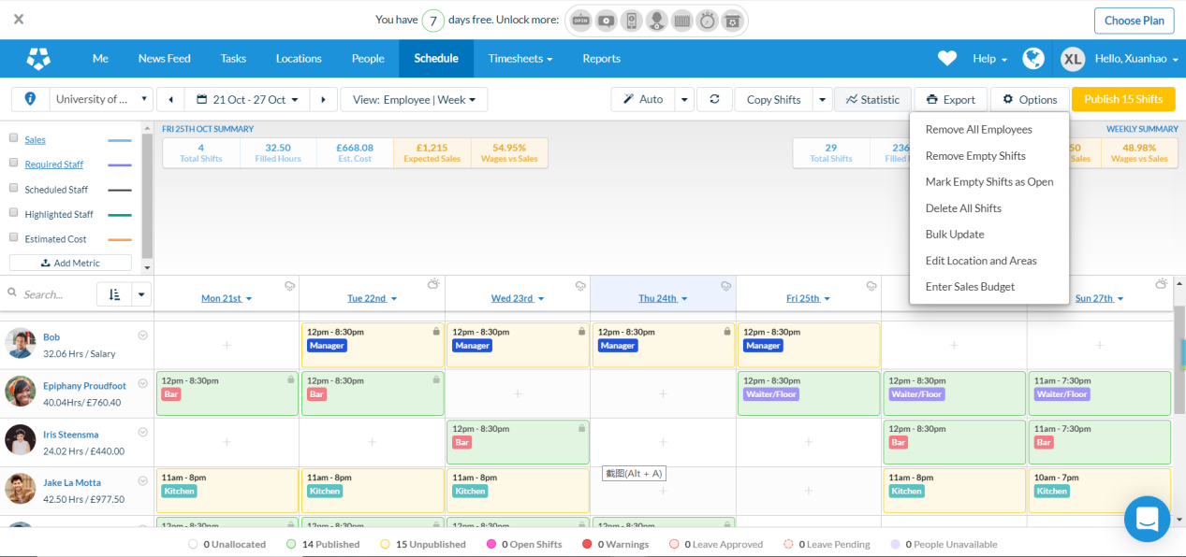

This screenshot was selected from deputy, the schedule is of great reference value for our object.

-- On the left side of the page there is a row of employees that can be placed into the table, in this part we can add and delete engineers’ information, which is quite to our plan. So, we can do this part in their way and add some of our elements, like drag and drop. We can add search function here to help operators find employees faster.

-- The time and the way to arrange work. compared with our plan, his schedule is more detailed in terms of time.

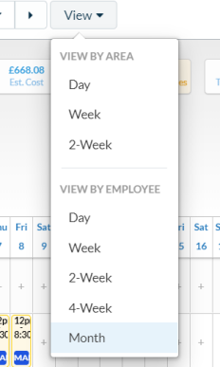 **VIEW BY AREA** ()

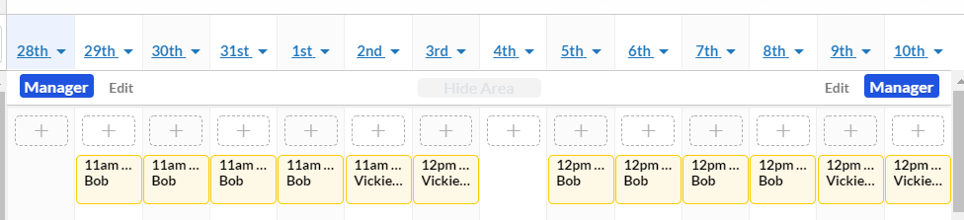

**VIEW BY EMPLOYEE**()

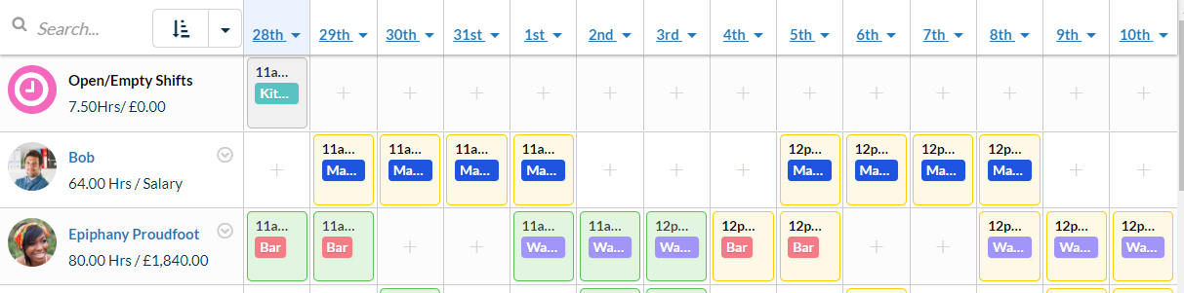

-- In the specific work and time, input is relatively free, easy to arrange staff operations. In this schedule, click the corresponding personnel and time grid, we can add or delete the work. In addition, some forms can be locked and require more advanced authority to make changes.

For example, after we click a grid.

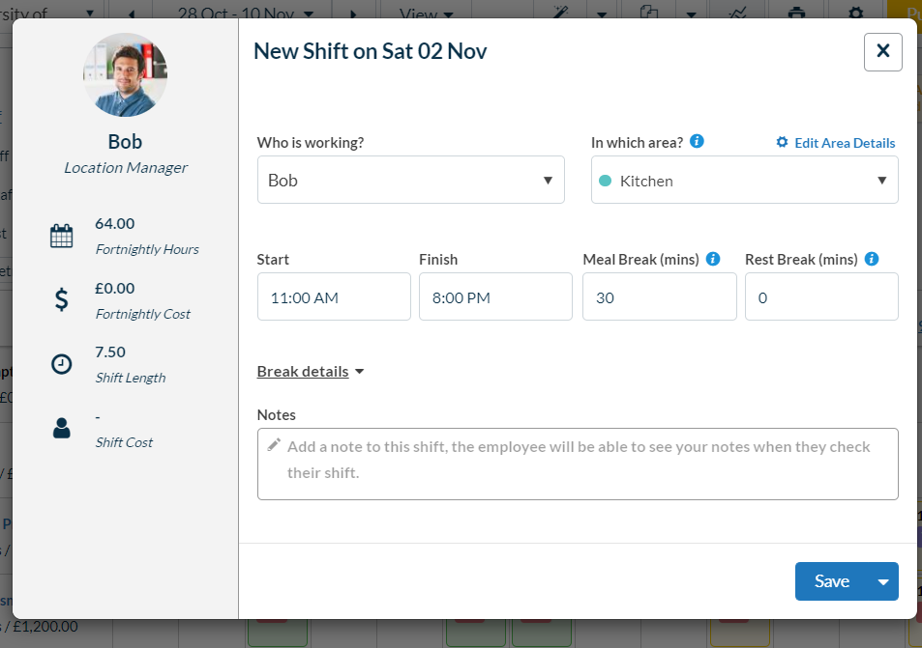



--Similarly, there are different colors corresponding to different situations at the bottom of the table, which is correspond to the situation of the employee in the table.

--Some shortcuts can be provided based on different permissions. So people can print，download or do some other option.

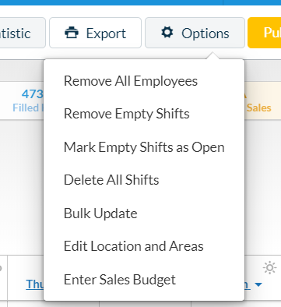

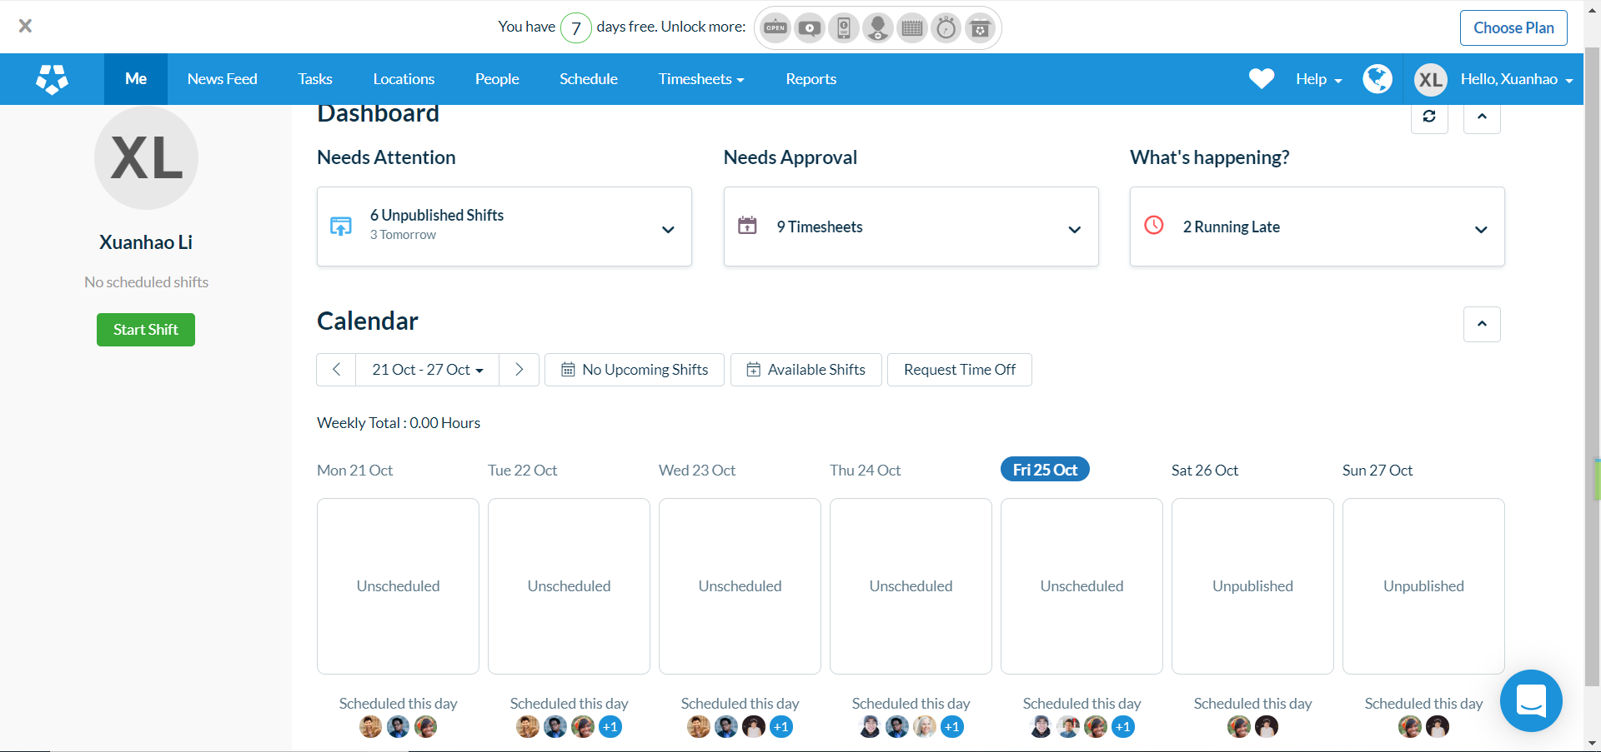

In our plan, this is similar to an employee website for employees self-checking.

First, the site must be able to display the individual's work schedule smoothly, and second, it can add other people's work schedules if needed, like the little head picture in the screenshot. In addition, users can be reminded of the deadline of some tasks. Some personal matters are subject to change.

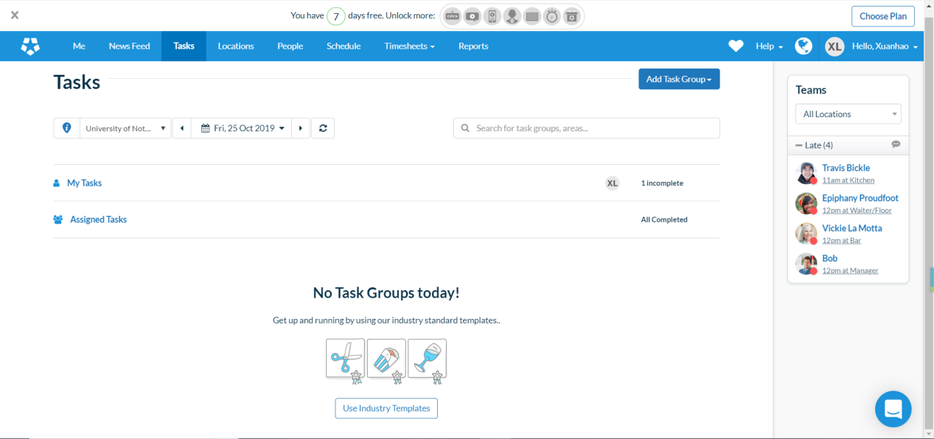

If there is an individual's work, the corresponding employee can see his specific project here.If there is group collaboration, information about the group members and their current situation will also be provided.