Chapter18:Oscillations
Key points:
1,Period周期（T）: the time taken for one complete oscillation. T=2π/ω unit:s
2,Frequency频率（f）: the number of oscillations per unit time, f=1/T unit:HZ
3,Angular frequency角频率（角速度）: the rate of change of angular displacement ω=2π/T=2πf Unit:rad/s：
4, displacement( x) : a distance from the equilibrium position. Unit:m
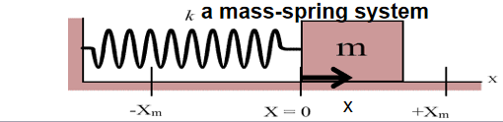
5,Amplitude振幅（A）: The maximum displacement from the equilibrium position. Unit:m
6,Phase相位θ: the point that an oscillator has reached in a complete cycle. Unit:rad/º
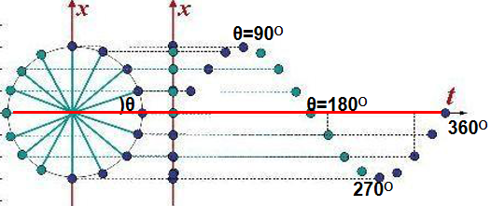
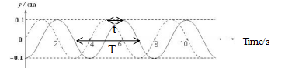
7,Phase difference相位差: can be measured as a fraction of a cycle in degrees, or in radians.Phase difference=(t/T)2π

Worked example 1:
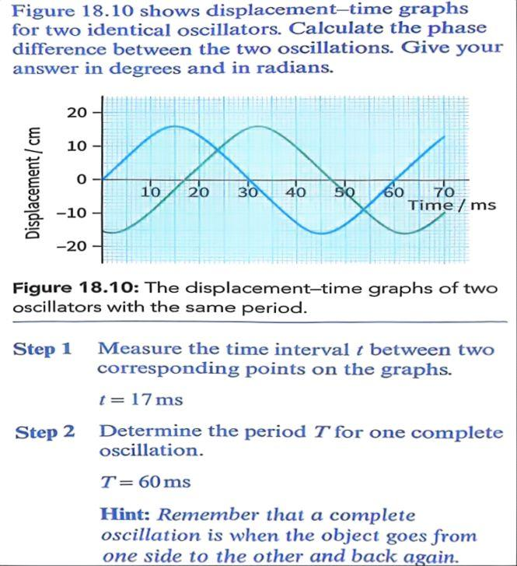
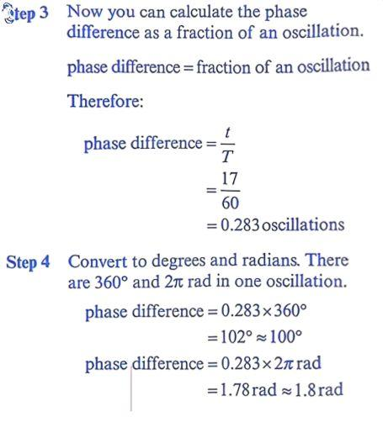

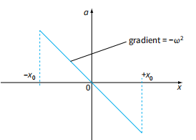
8,Simple Harmonic Motion（简谐振动）: An oscillation in which the acceleration is always directly proportional to displacement x, and in opposite direction to the displacement from equilibrium position;
a =－ω²x (Defining equation of S.H.M)
Here ω is constant Angular frequency, independent of Amplitude.
- direction of displacement x is away from the equilibrium position.
direction of acceleration is directed toward the equilibrium position.
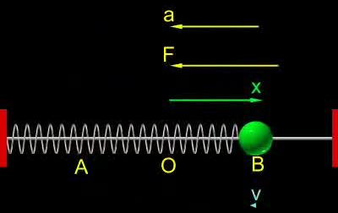

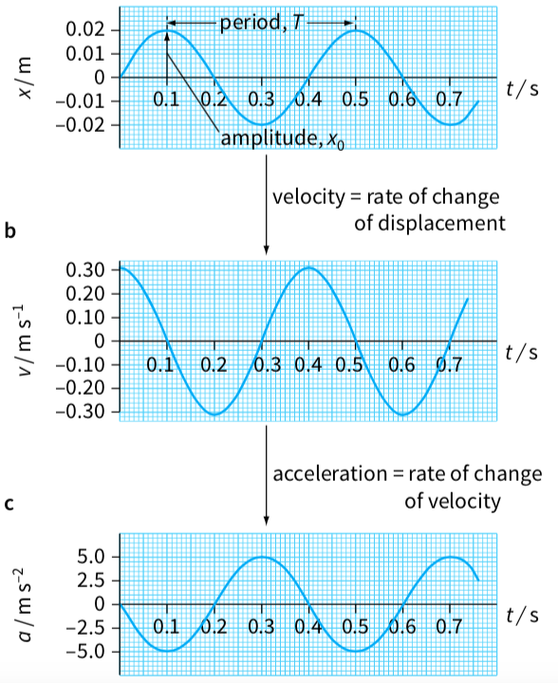
9, In S.H.M， displacement x and velocity v can be represented as functions of time t by equations of the form:
- If t=0 , a particle in S.H.M starting at equilibrium position of the oscillation with x=0
x = x_{o} sin(ωt) ; x_{o} is Amplitude
then v=v_{o}cos(ωt) (max v_{o}=ωx_{o})
- If t=0 , a particle in S.H.M starting at one end of the oscillation with x=Amplitude x_{o}
x = x_{o} cos (ωt); then v=v_{o}sin(ωt)

Worked example 2:

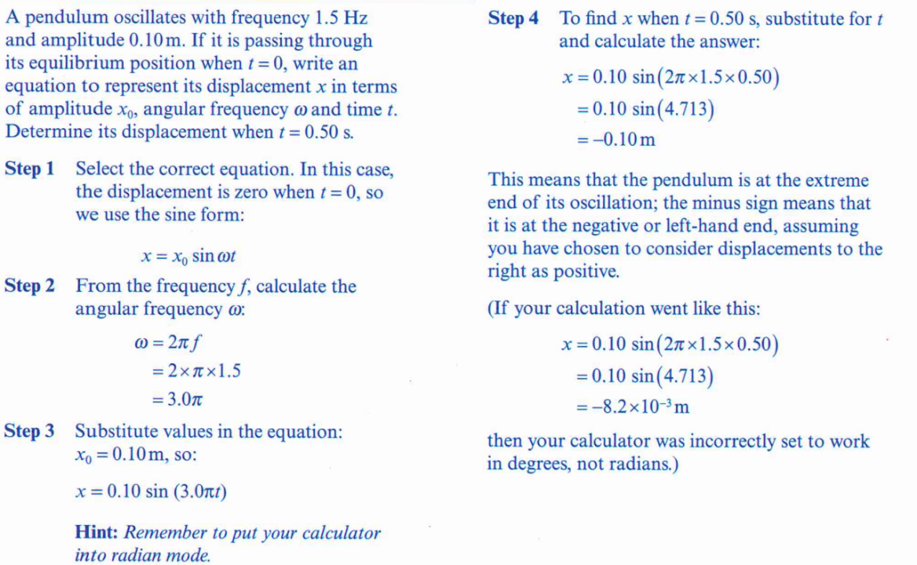

10.The relationship between v and x: at any position with displacement x the velocity is
v=±ω$\sqrt{x_{o}^{2}−x^{2}}$ when x=0(equilibrium position) v_{max}=ωx_{o}
when x=x_{o}(amplitude) v=0
Worked example 3
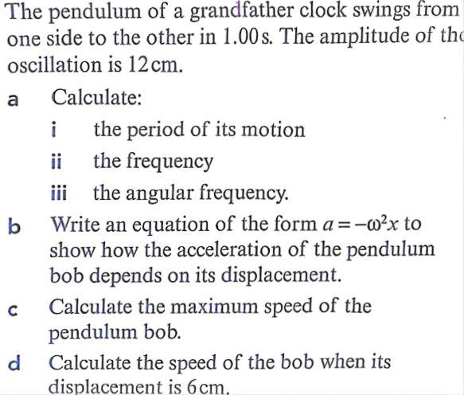
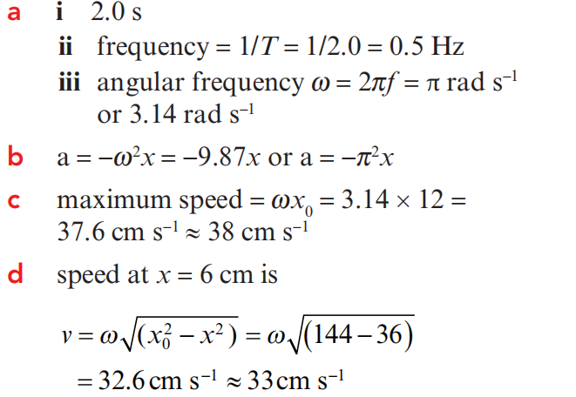

11.Energy in S.H.M at any point : total Energy=K.E(kinetic energy)+PE(potential energy)
The energy changes from potential to kinetic and back to potential in every half-cycle interval. At the equilibrium position x=0, maximum KE=½mv²_{max}= ½mω²x_{o}², PE=0
At either end position x=amplitude x_{o}where the speed is 0, KE= 0, PE maximum=½kx_{o}²
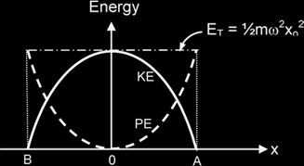
Xo=Amplitude
V=0
)e

势能PE=½ kx²
动能KE=½ mv²

v_{max}=ωx_{o}o_{o}
)e

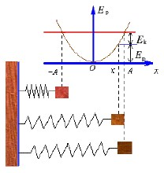

total energy = KE + PE=maximum KE +0=0+ maximum PE

= ½ mω²x_{o}² (x_{o} is Amplitude)
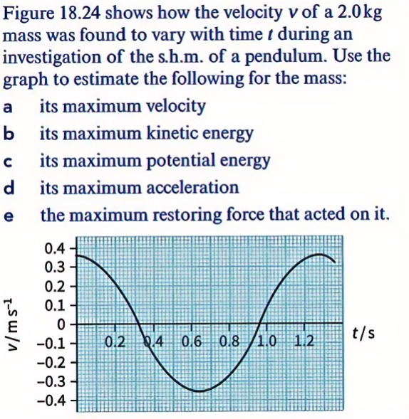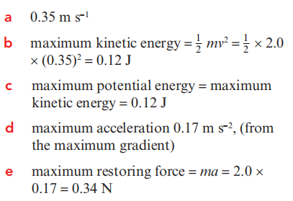
Worked example 4:

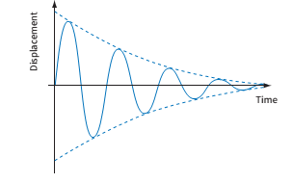
12.Damping阻尼: amplitude reduce to 0 refers to the loss of energy from an oscillating system to the environment due to resistive forces. The Amplitude decreases with time exponentially. but Frequency(period) cannot be affected by damping.

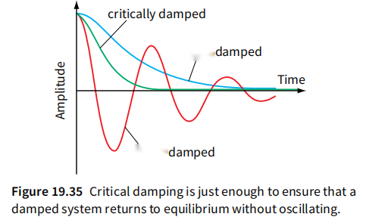
Critical damping is the minimum amount of
light
heavy
damping required to return an oscillator to
its equilibrium position without oscillating.
It could avoid unwanted oscillation.

13.Free Oscillation自由振动: an oscillation is at its own natural frequency 固有频率that is independent of amplitude。there is no external driving force acting on the amplitude remains constant.

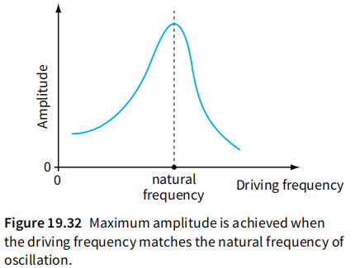
14.Forced Oscillation受迫振动: an oscillation caused by an external periodic driving force驱动力. The frequency of the forced oscillation will be at the frequency of the driving force {called the driving frequency} no longer at its own natural frequency amplitude changes with driving frequency..

15.Resonance共振: A phenomenon whereby the system undergoing forced oscillations its amplitude increases to a maximum when the driving frequency is equal to the natural frequency of the system.the system absorbs the greatest possible energy from the driver.

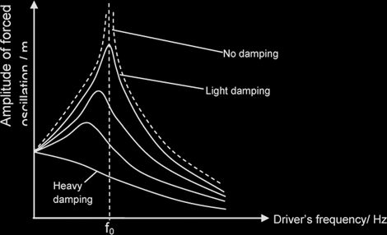
16. effect of Damping on Resonance:Damping is thus useful if we want to reduce the
damaging effects of resonance.
- Resonant frequency decreases
- Sharpness of resonant peak decreases
- Amplitude of forced oscillation decreases
NOTE: when there is no damping, the amplitude is infinite in theory.

17.Using resonance
Useful example, many musical instruments played rely on resonance. Microwave cooking： The microwaves used have a frequency that matches a natural frequency of vibration of water molecules (the microwave is the ‘driver’and the molecule is the resonating system’)
The water molecules in the food are forced to vibrate and they absorb the energy of the microwave radiation. The water gets hotter and the absorbed energy spreads through the food and cooks or heats it.
Magnetic resonance imaging (MRI) is increasingly used in medicine to produce images
A radio or television also depends on resonance for its tuning circuitry

Damaging:During earthquakes, buildings are forced to oscillate by the vibrations of the Earth. Resonance can occur, resulting in serious damage .. In regions of the world where earthquakes happen regularly, buildings may be built on foundations that absorb the energy of the shock
waves. In this way, the vibrations are damped,so that the amplitude of the oscillations cannot reach dangerous levels.

点评：这章的重难点是S.H.M简谐振动的定义，应用牛顿运动定律分析某振动系统得到加速度a和位移x的关系满足S.H.M的定义式a = -ω² x，就证明是简谐振动，否则，就不是。注意频率（周期）是一个固定常量（natural frequency），只由振动系统本身因素决定，与振动发生时的振幅A没有任何关系。每一个振动系统都有自身的一个固有频率（natural frequency）。简谐振动的图像是正弦或余弦函数图像（取决于初始状态）
Worked examples: Q1:
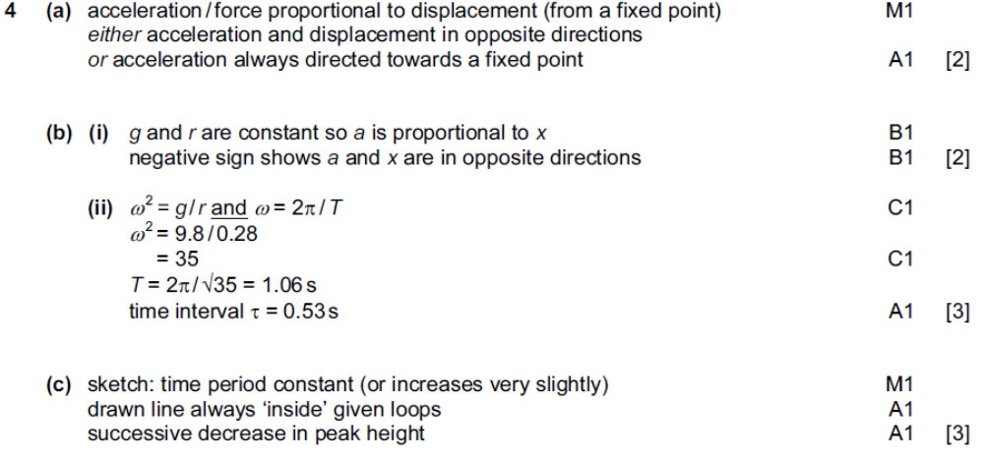
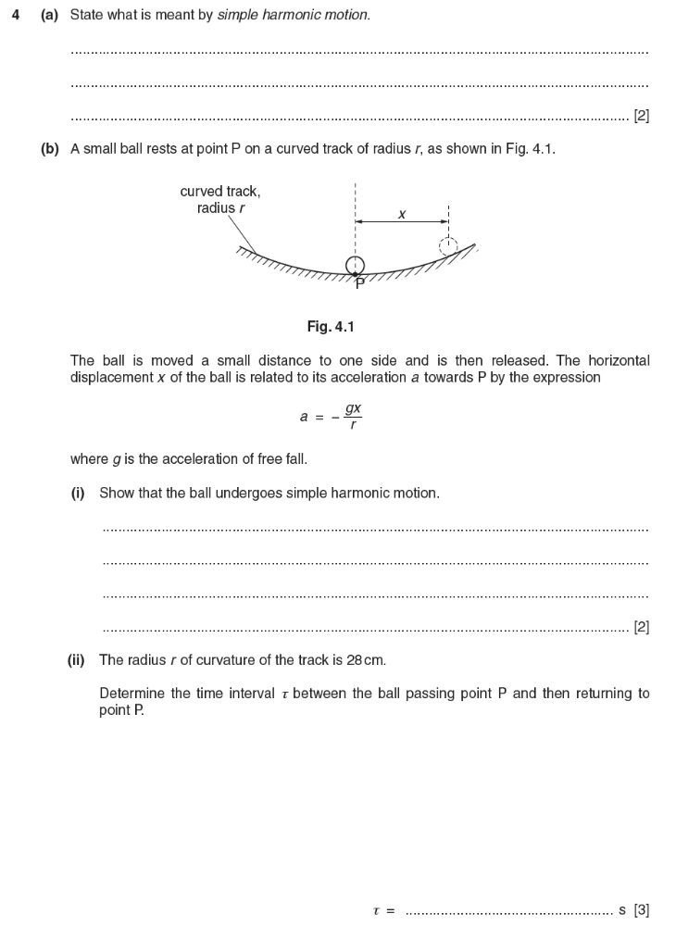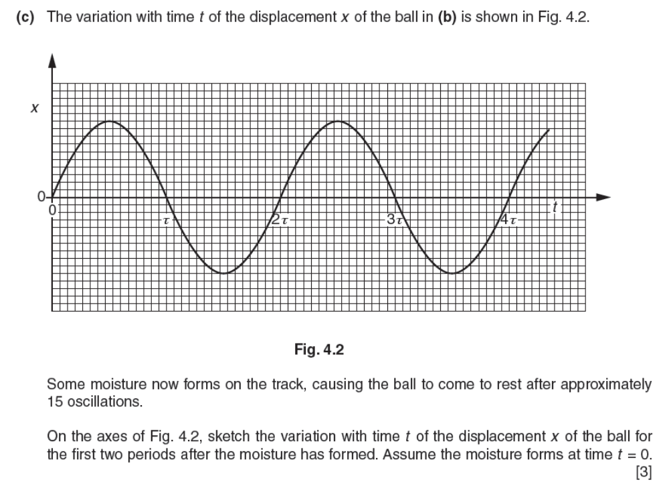
here the given expression a= -gx/r obeys the definition of S.H.M . g/r =ω² ,a is directly proportional to x.- show us the direction of a is opposite to x.
the acceleration is always directly proportional to displacement x, and in opposite direction to the displacement from equilibrium position;

in the given expression a= -gx/r ,g/r =ω² ,the time interval between the ball passing point P and then returning to point P is half period. Period=2π/ω
Moistures will cause damping. amplitude decreases ,period keeps the same.

Q2.a
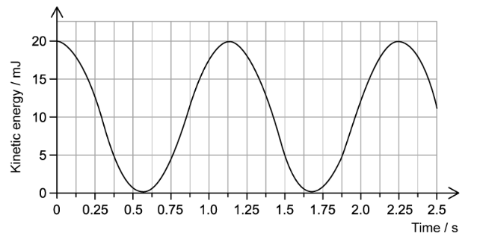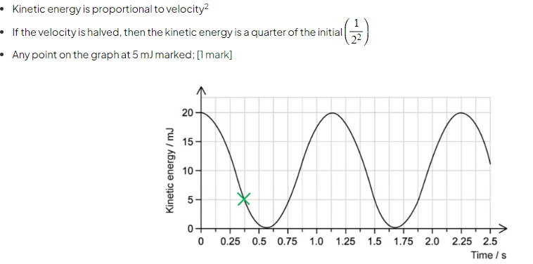
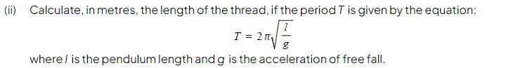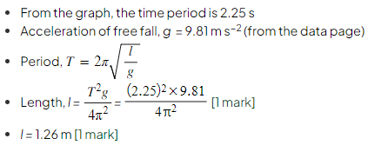
Q2.b
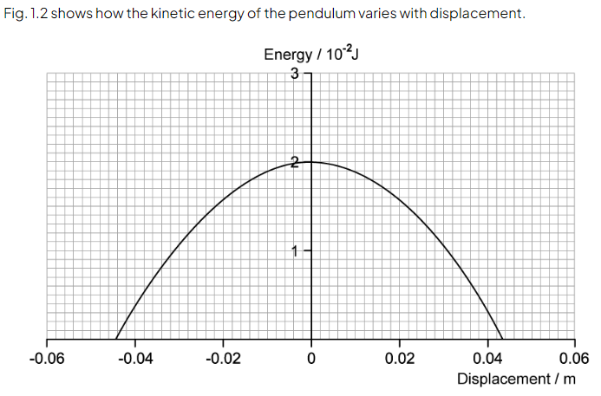
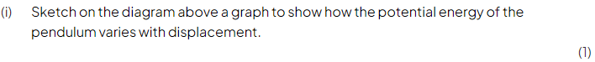
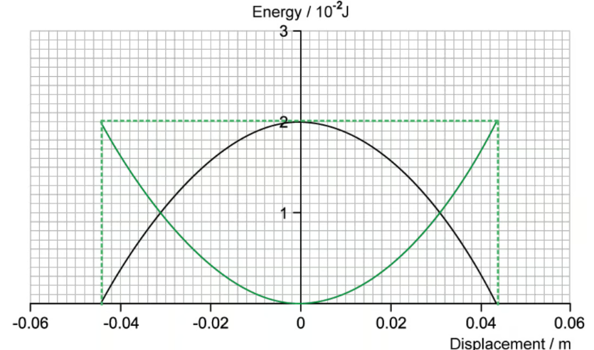
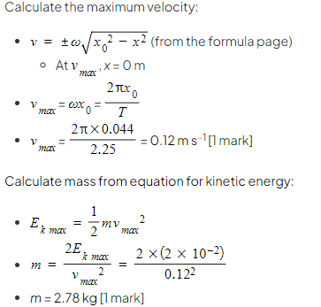
Q2.c
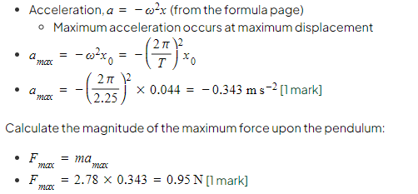

Q3.a
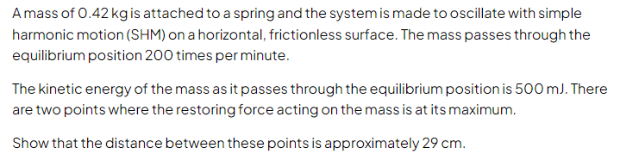
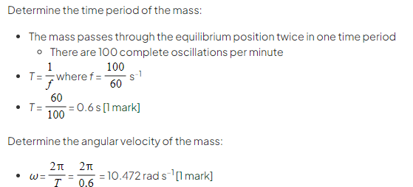
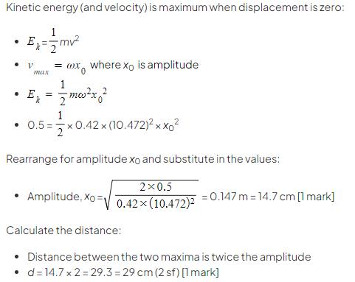
Q3.b
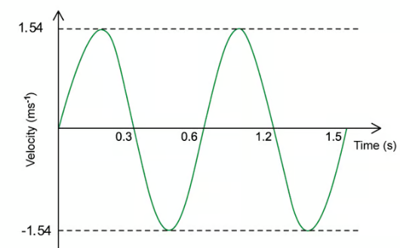
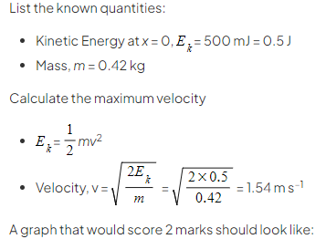
Q3.c
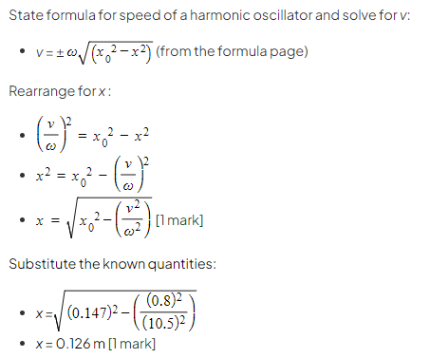

Q4.a
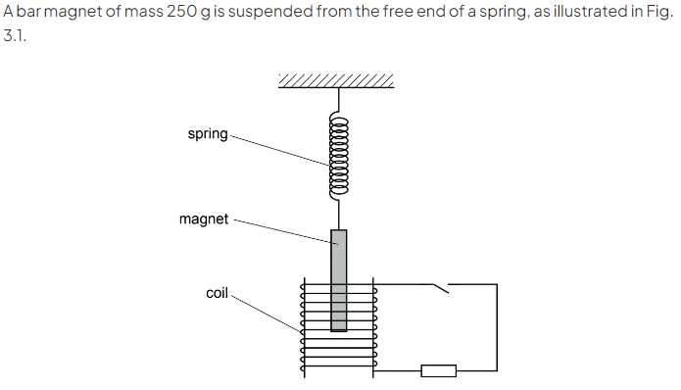
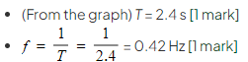
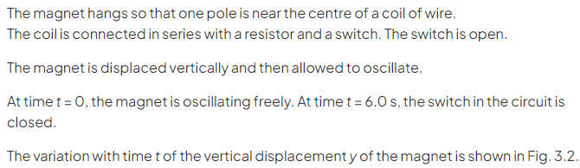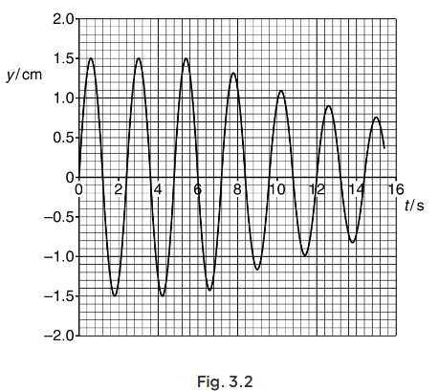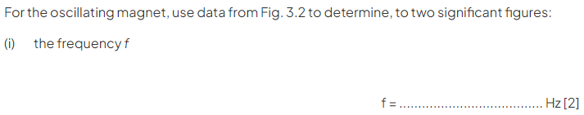
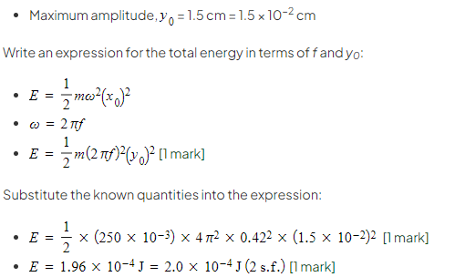
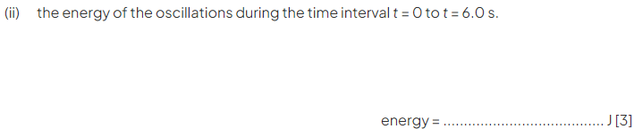

Q4.b
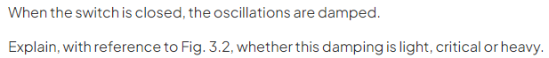


Q5 2022 sample question
