SENG3030 – INTERNET OF THINGS

Assignment 4
Multi-Device IoT Prototype over MQTT
Architecture and Communications Report
TEAM
Name | Username | Device
Juan Jose Bejarano | jbejaranoherrer7056 | A
Carlos Gomez Guerrero | cgomezguerrero5580 | B
Deyi Zou | dzou1734 | C
Alexia Tu | atu8211 | D
Conestoga College · School of Engineering & Technology
November 5, 2026

1. Introduction
Our team of four built a multi-device IoT prototype in which three M5StickC Plus devices [1] and one web page exchange data only through the course MQTT broker [2]. The four components are:
- A · Data acquisition device: reads all lab sensors (SHT30, QMP6988, IMU, battery, microphone) and publishes the data.
- B · Data display device: shows the data from A on its screen, one sensor per page, and plays audio clips from A.
- C · Control device: changes the page on B, turns all data from A on or off, and asks A for an audio clip.
- D · Client UI: a web page that shows all data, the state of each device and the audio clips.

2. Architecture
Figure 1 shows the overall communications. The broker (EMQX) lets each account publish only under SENG3030/Wednesday/<own username>/, but subscribe to any topic under SENG3030/ [3]. Each device therefore logs in with a different team member's account and publishes in its own namespace; a device receives commands by subscribing to the sender's namespace. The devices connect with MQTT over TLS on port 8883 using PubSubClient [4]. A browser cannot open a raw TCP connection, so D uses MQTT over secure WebSocket on port 8084 [5] [6].
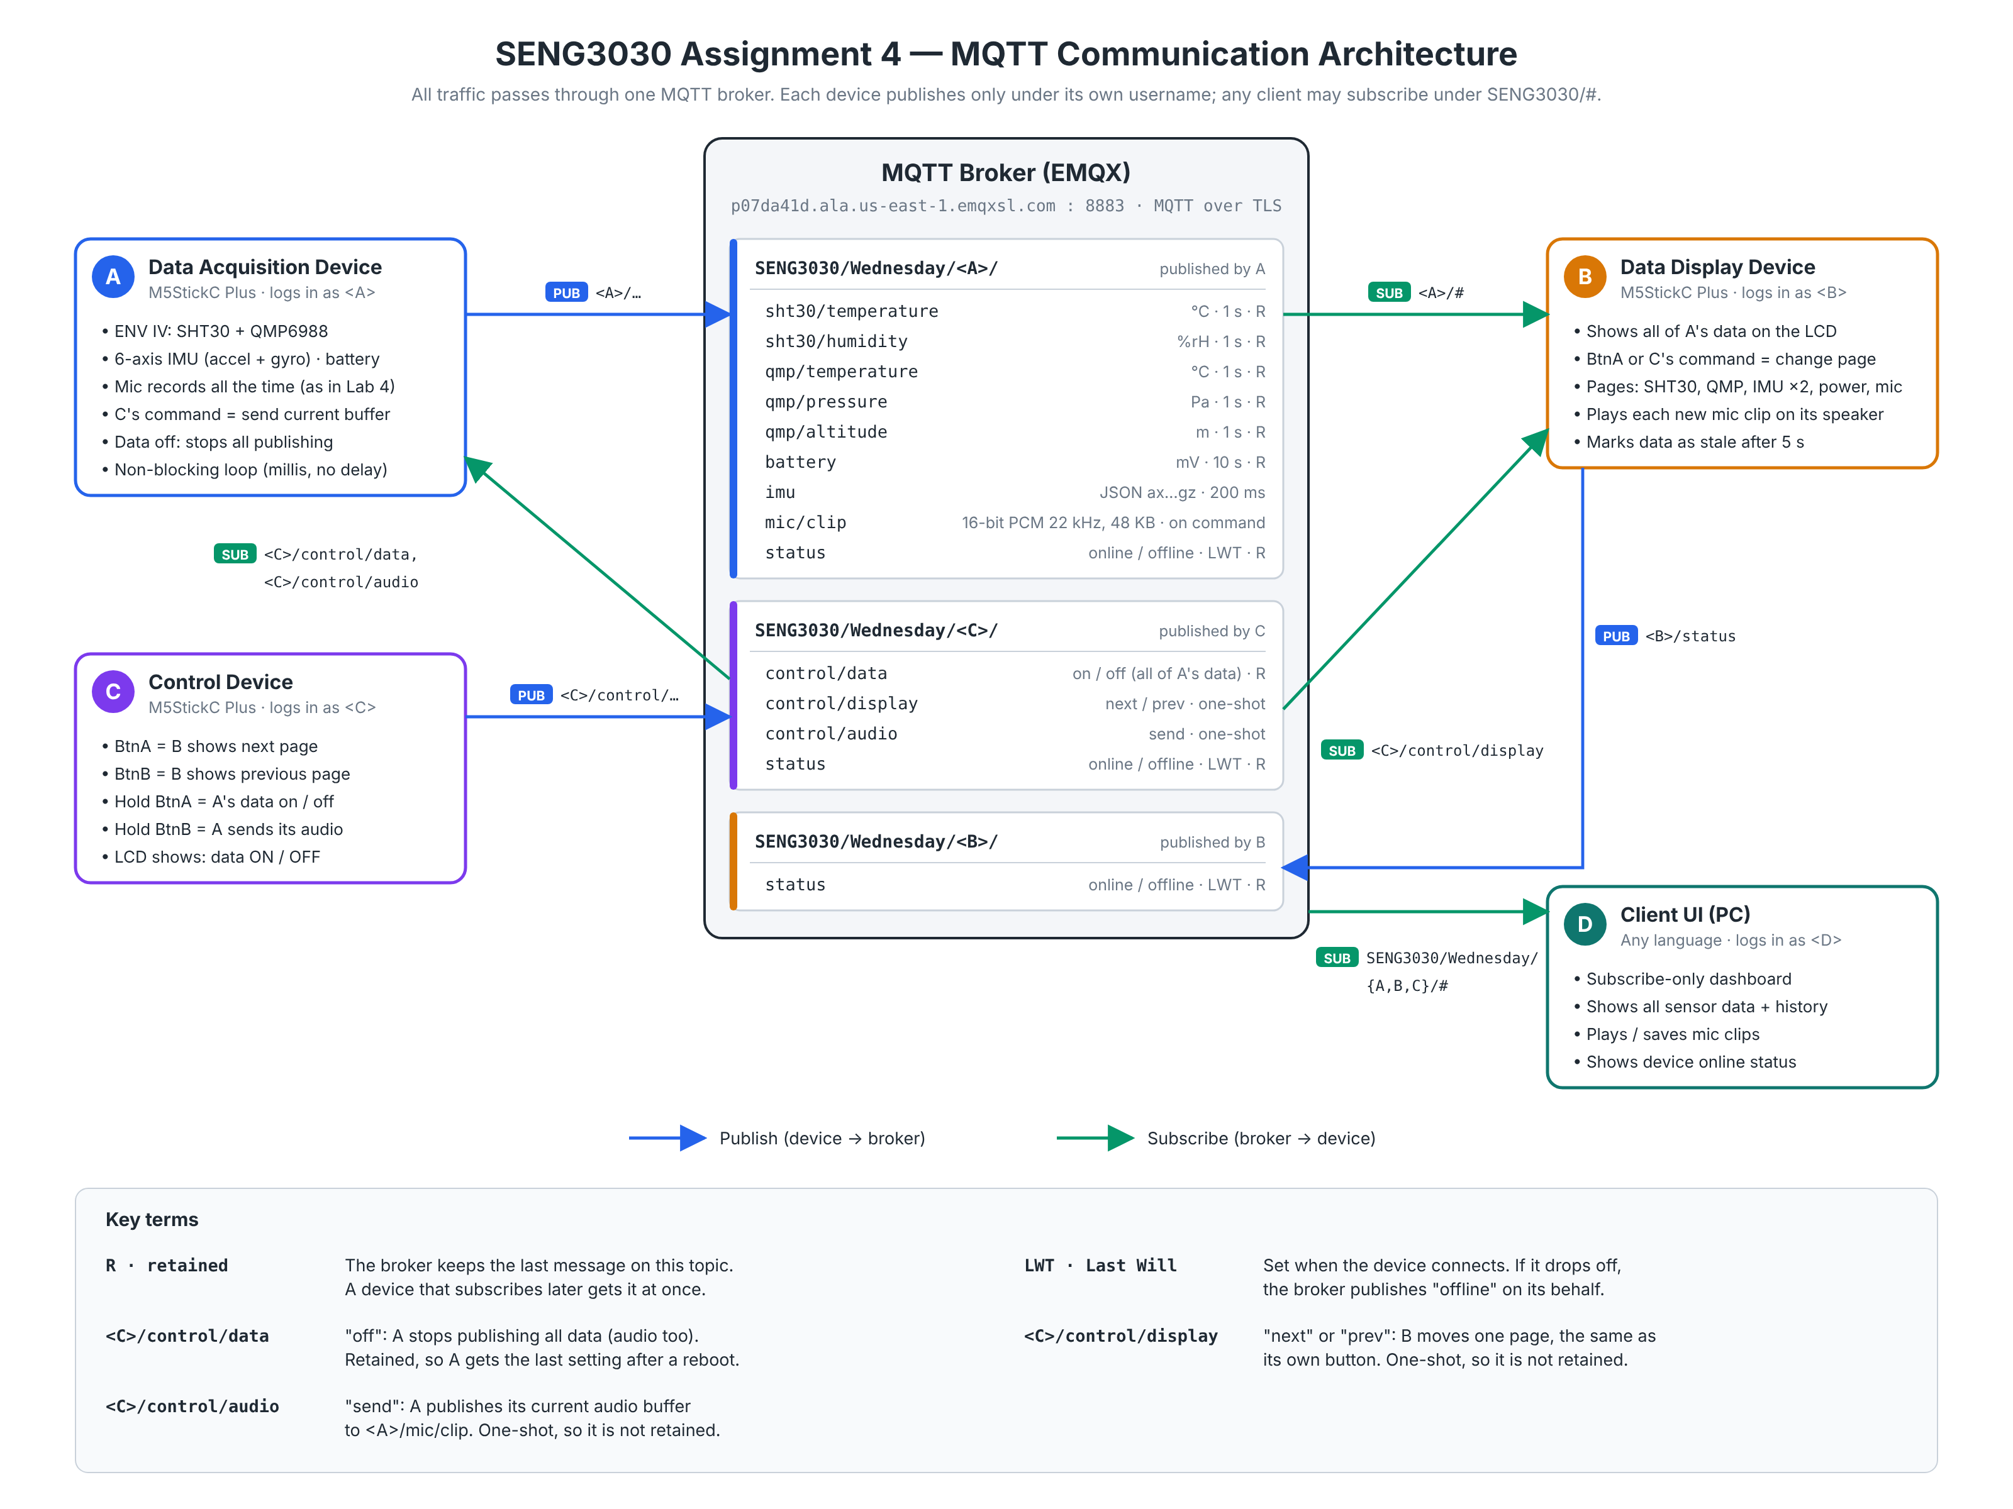
Figure 1: Block diagram of the overall communications
Table 1: Components and MQTT accounts
Component | MQTT account | Publishes | Subscribes to
A · Data acquisition | jbejaranoherrer7056 | sensor data, mic/clip, status | <C>/control/data, <C>/control/audio
B · Data display | cgomezguerrero5580 | status | <A>/#, <C>/control/display
C · Control | dzou1734 | control/data, control/display, control/audio, status | (none)
D · Client UI (browser) | atu8211 | (none) | <A>/#, <B>/#, <C>/#
<A>, <B>, <C> = SENG3030/Wednesday/<username of A, B or C>/

3. Messages
All messages use QoS 0. Numbers are sent as text. Retained means the broker keeps the last value and gives it to a new subscriber at once [2]. Each device sets status = offline as its Last Will, so the broker publishes it if the device drops off [2].
Table 2: Messages published by A (prefix <A>/), received by B and D
Topic | Payload (example) | Unit | Rate | Retained
sht30/temperature | 23.45 | °C | 1 s | Yes
sht30/humidity | 41.20 | %RH | 1 s | Yes
qmp/temperature | 23.80 | °C | 1 s | Yes
qmp/pressure | 101325.00 | Pa | 1 s | Yes
qmp/altitude | 312.40 | m | 1 s | Yes
battery | 4012 | mV | 10 s | Yes
imu | {"ax":0.012,"ay":-0.981,"az":0.105, "gx":1.25,"gy":0.30,"gz":-0.48} | g; °/s | 200 ms | No
mic/clip | 48 000 bytes: 16-bit PCM, mono, 22 050 Hz, about 1.1 s | – | When C asks | No
status | online / offline | – | Connect / drop | Yes

Table 3: Messages published by C (prefix <C>/)
Topic | Payload | Button on C | Receiver: effect | Retained
control/display | next / prev | Click BtnA / BtnB | B: next / previous page | No
control/data | on / off | Hold BtnA | A: start / stop all publishing | Yes
control/audio | send | Hold BtnB | A: publish its audio buffer on mic/clip | No
status | online / offline | – | D: device status | Yes

Table 4: Message published by B (prefix <B>/)
Topic | Payload | Receiver | Retained
status | online / offline | D: device status | Yes

4. Components
A reads each sensor on its own millis() timer and never calls delay(). WiFi and MQTT reconnect automatically. As in Lab 4 [7], the microphone records all the time into a ring buffer; on send A publishes the buffer. The clip uses 22 050 Hz instead of 44 100 Hz because PubSubClient cannot handle a message of 64 KB or more [4].
B has six pages: SHT30, QMP6988, accelerometer, gyroscope, battery and microphone. The front button or a command from C changes the page. A value turns red (STALE) when it has not been updated for 5 s (25 s for the battery). New audio clips play on the speaker.
C sends one command per button action (Table 3). A beep confirms that the command was sent, and the screen shows whether A's data is ON or OFF.
D is one HTML file that uses MQTT.js [8] and Chart.js [9]. It shows the online state of A, B and C, every value from A with its age, live charts, the audio clips (play or save as .wav) and the latest MQTT messages.

References
[1] M5Stack, "M5StickC PLUS," M5Stack Docs. [Online]. Available: https://docs.m5stack.com/en/core/m5stickc_plus
[2] OASIS, "MQTT Version 3.1.1," OASIS Standard, Oct. 2014. [Online]. Available: http://docs.oasis-open.org/mqtt/mqtt/v3.1.1/os/mqtt-v3.1.1-os.html
[3] Conestoga College, "SENG3030 Lab 3 – Sensors and Such," course handout, 2026.
[4] N. O'Leary, "Arduino Client for MQTT (PubSubClient)," GitHub. [Online]. Available: https://github.com/knolleary/pubsubclient
[5] EMQ Technologies, "Create a Serverless Deployment," EMQX Cloud Docs. [Online]. Available: https://docs.emqx.com/en/cloud/latest/create/serverless.html
[6] EMQ Technologies, "How to Use MQTT over WebSocket: A Beginner's Guide," EMQX Blog. [Online]. Available: https://www.emqx.com/en/blog/connect-to-mqtt-broker-with-websocket
[7] Conestoga College, "SENG3030 Lab 4 – Microphone and Speaker," course handout, 2026.
[8] MQTT.js contributors, "MQTT.js," GitHub. [Online]. Available: https://github.com/mqttjs/MQTT.js
[9] Chart.js contributors, "Chart.js Documentation." [Online]. Available: https://www.chartjs.org/docs/latest/

Evaluation Form
All evaluation criteria are judged on a scale from zero to five.
Document |  | Self Evaluation | Score
 | Completeness, Format, Content | / 5 | / 5
Demonstration |  | Self Evaluation | Score
 | Demonstration and Readiness | / 5 | / 5
Functionality |  | Self Evaluation | Score
 | Data Acquisition | / 5 | / 5
 | Data Display | / 5 | / 5
Groups of 3 | Remote Control | / 5 | / 5
Groups of 4 | Client Display | / 5 | / 5
 | Weighted Functionality Grade (scaled to 10) | / 10 | / 10
Assignment Total |  |  | / 20

