Analysis of Impact of the Impossible Whopper

Monthly Sales:

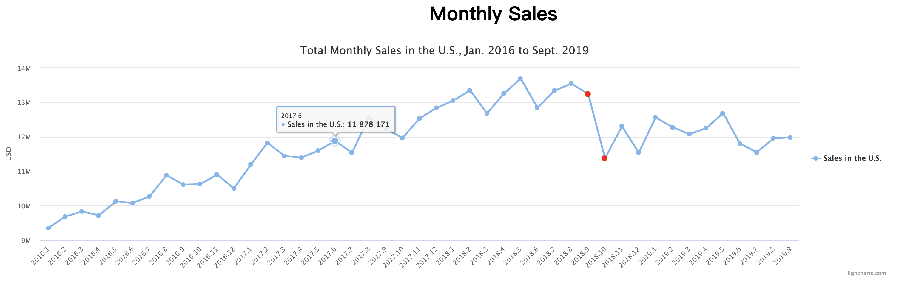

To investigate the impact of Impossible Whopper introduced by Burger King, I analyzed the monthly sales data from Jan. 2016 to Sept. 2019, during which Burger King introduced these Veggie burgers in October 2018. It can be seen from the monthly sales of burgers that there was a drastic drop in last October. Besides the abnormal sales data for this single month, we could also notice that the trend of sales changed before and after last October. Before the advent of Impossible Whopper, the sales were increasing steadily. However, after October, sales of our company stopped increasing. Before we move on and draw any conclusions, let us take a look at the sales data of different products and regions.

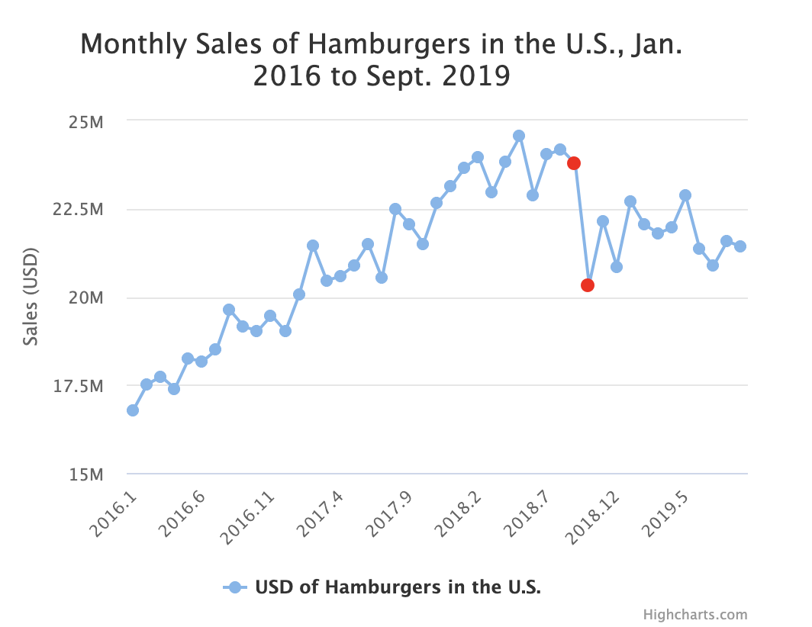 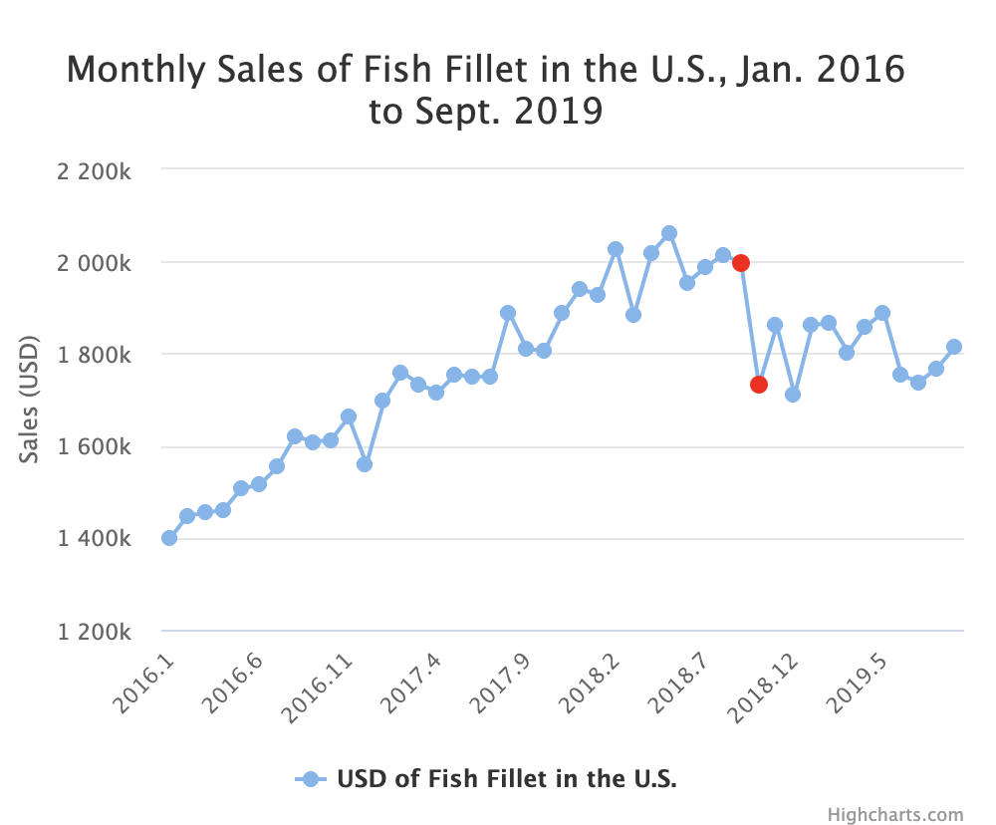 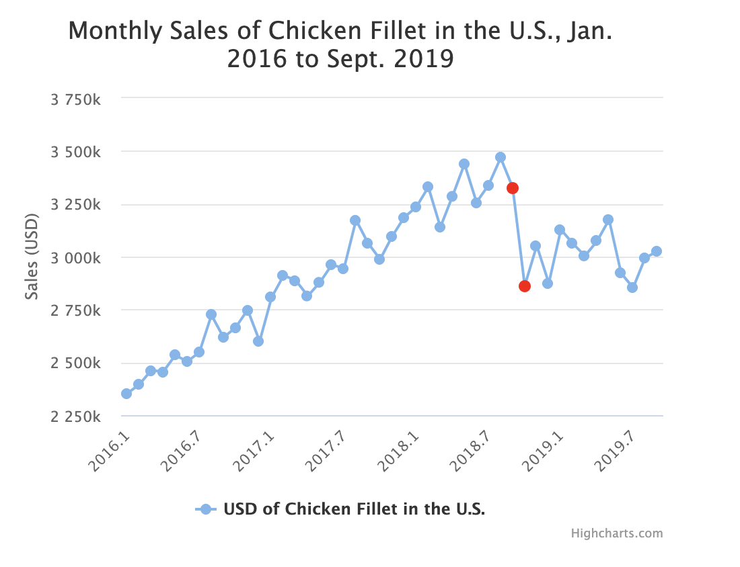

The monthly sales of three differnt products tell us that the sudden drop of sales in October is not caused by a single product but three products simultaneously. So our customers are not attracted by Burger King’s hamburgers or fish or chicken burgers but a totally different product.

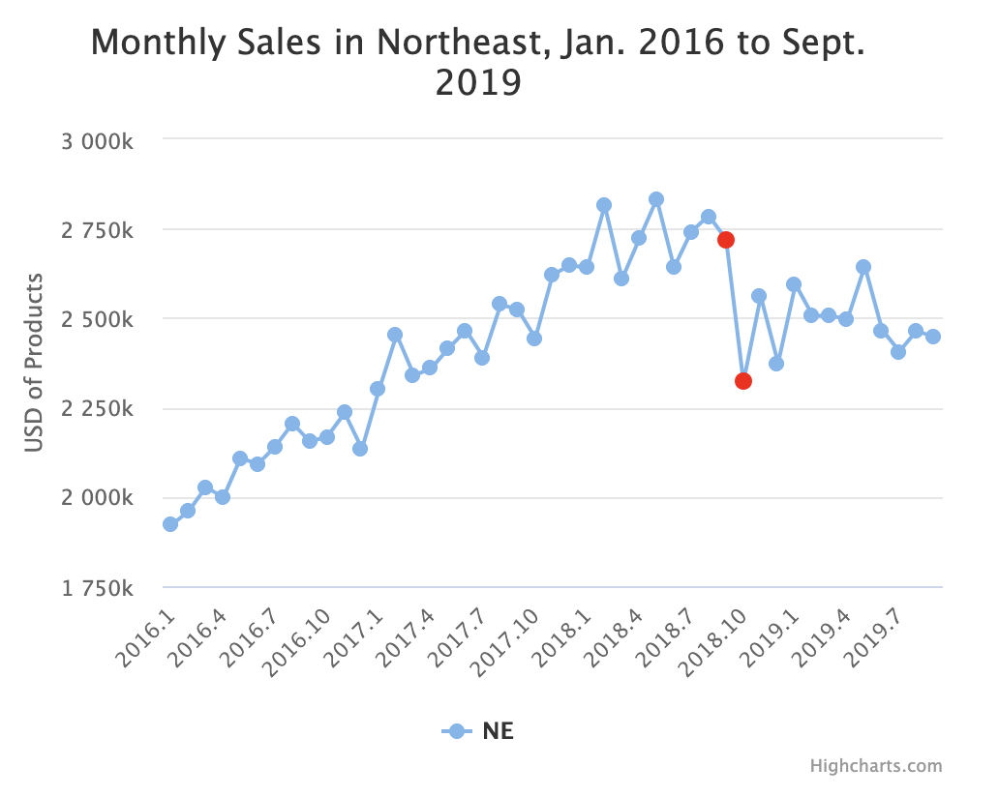 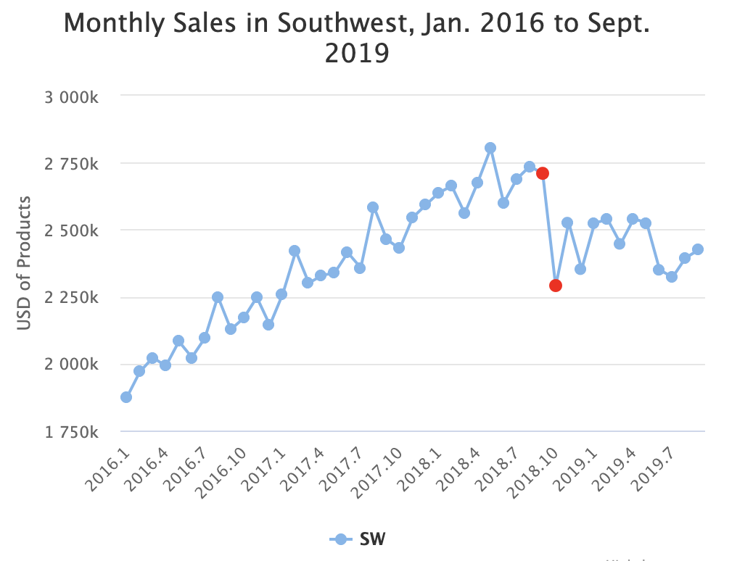 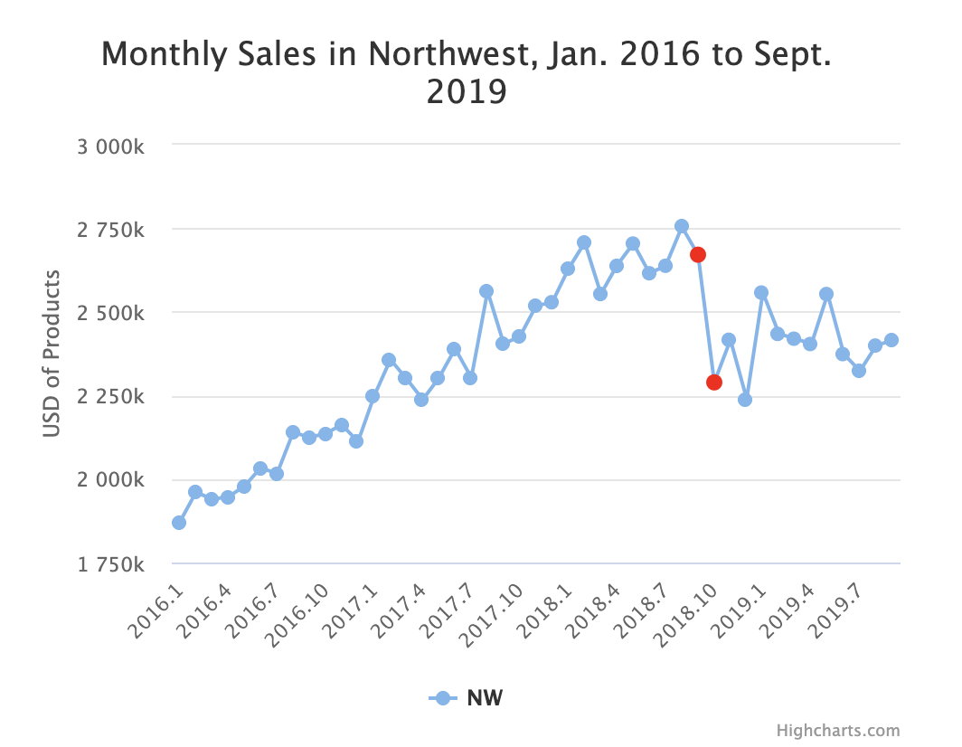 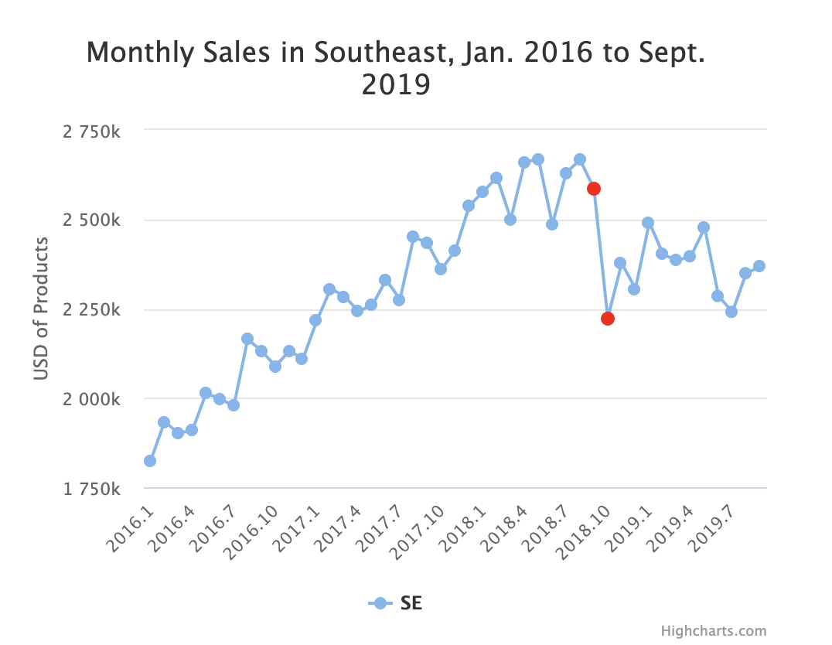 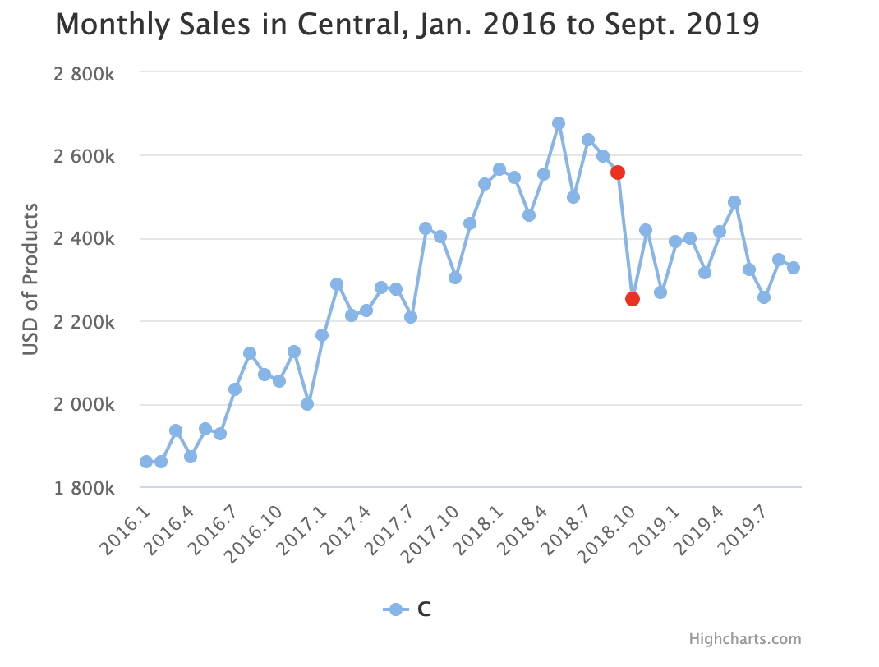

The pattern of monthly sales in different regions are also almost identical. Therefore, the impact is national rather than regional. It is less likely that customers are affected by some regional event than affected by a large-scale product.

Thus, I believe some customers went to try the new product of Burger King on last October, the reason why our sales suddenly dropped. Moreover, some customers continued to buy these Veggie burgers months following the initial release. As a result, the sales stopped their steadily increasing trend.

Therefore, we need to find a way to get those customers back. Since those customers are mainly attracted by the Veggie burgers, McDonald’s should also introduce some kind of Veggie burger as a competitor to the Impossible Whopper. In this way, customers who love Veggie burgers may return and enjoy Veggie burgers made by McDonald’s.

Daily Sales:

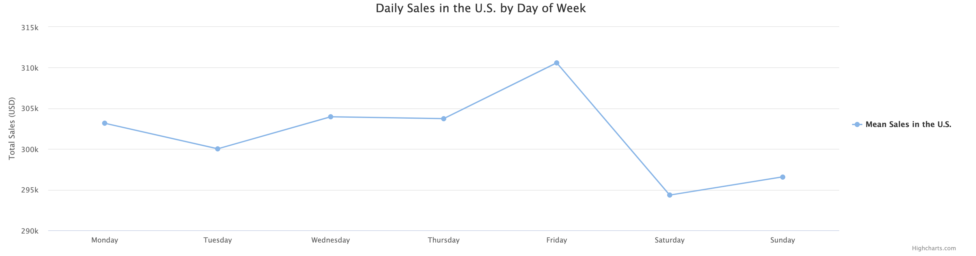

To discover some micro-trends in the way customers interact with us, I looked at the daily sales data in January 2016. The first aspect that I investigate is day of week. Combining all regions and products and group data by day of week, we can see that there are less sales on weekends than on weekdays. Therefore, people tend to visit McDonald’s more on weekdays instead of on weekends. It’s probably because people are going to finer restaurants on weekends when they have more time while visiting McDonald’s on workdays when they have less time.

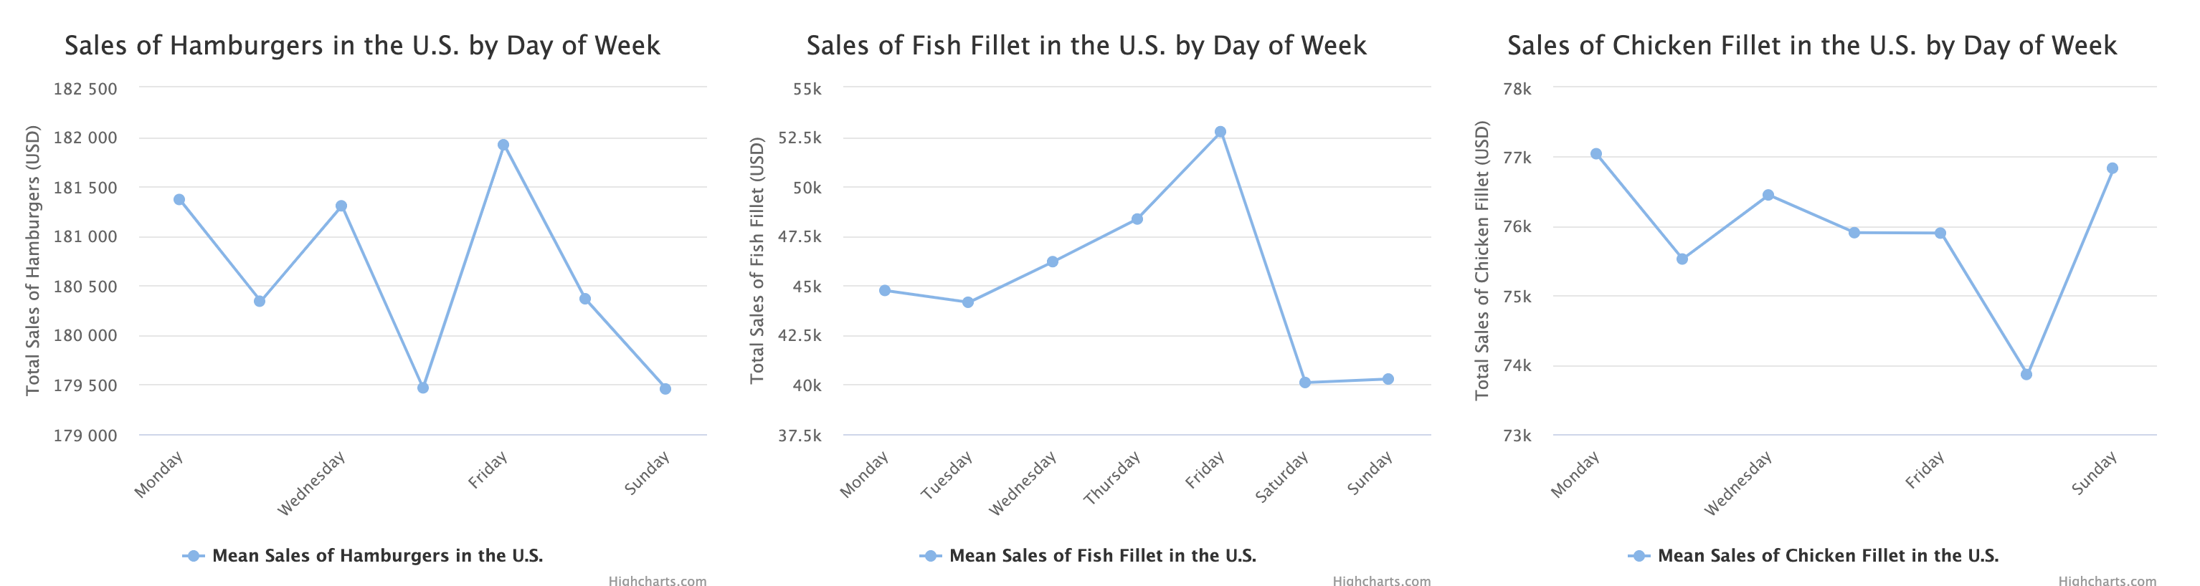

If we look at different products separately, we can see that products are indeed generally sold less on weekends. Specifically, less fish fillet is sold on both Saturday and Sunday; fewer people buy hamburgers on Saturdays; and chicken fillet are not sold well on Saturdays. Therefore, to boost the company’s revenue, we need to find a way to make these products more attractive on unpopular weekends. 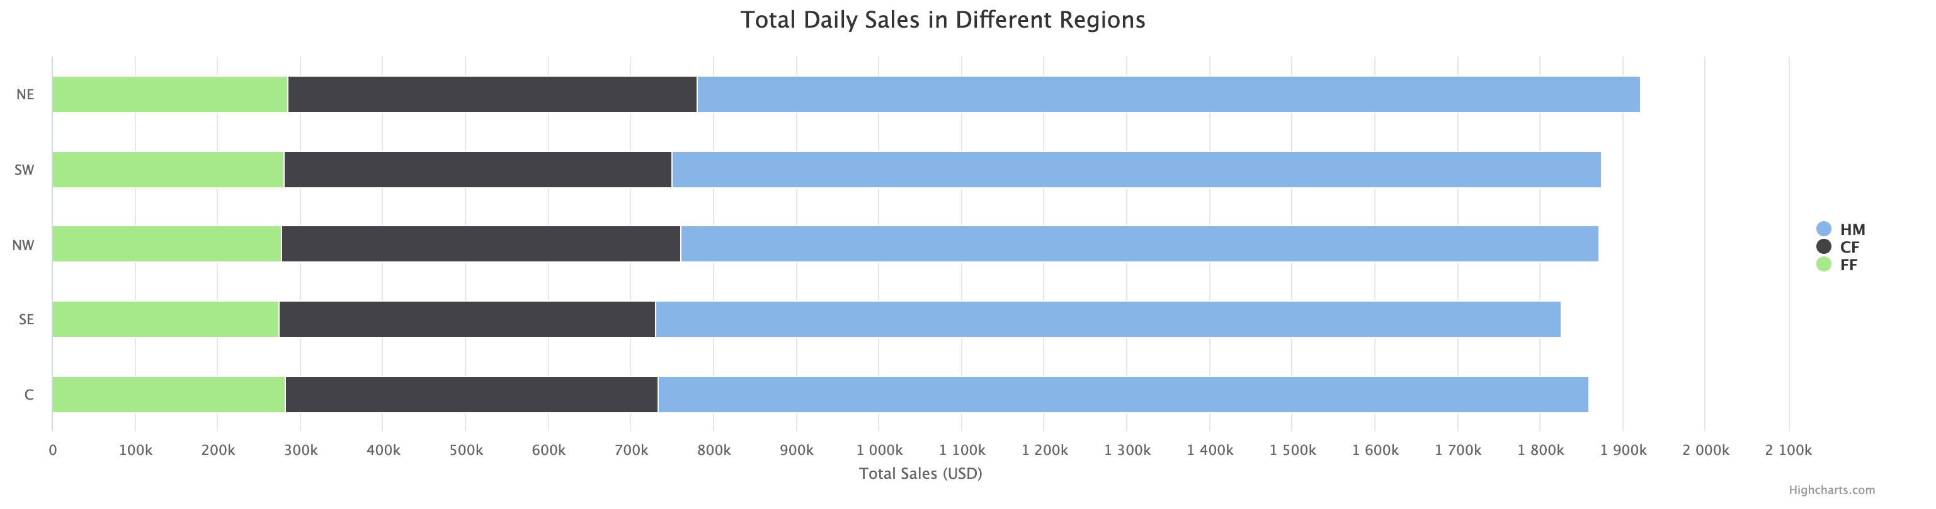

If we pay attention to daily sales in different regions, we may find that the makeup of sales in different regions are quite similar. Therefore, there is no much difference between people’s preferences across the country. If we can find a way to boost the sales in one region, it is reasonable to expect the sales in other regions to increase as well.

To address the problem of low sales on weekends, McDonald’s should make itself an alternative to those who want to have something nicer than just burgers. I believe McDonald’s should introduce more expensive luxury meal plans only offered on weekends. Different from ordinary weekday meals, luxury meals offer special burgers that have the best patties, fries of different tastes, a drink, and a dessert. In this way, those who want to have nice food would also consider visiting McDonald’s and sales would increase.