Project 2 Part 2

# Answer each of the following questions in BLUE colored font. Include all the required images and clearly label everything.

## Project:

* 1. Include name of the team members.

Alan Xu, Jai Bansal

* 1. Who is responsible for what? 1-2 sentences against each team member.

At this stage of the project, we are each responsible for working together on designing our schema, tables, and overall database and code layout.   
  
Individually, we are both responsible for setting up our local development environments so that all of the data, tables, and code is the same (with version control via Git). The front-end setup will also be completed together (pair programming).

* 1. How are you sharing codebase? 1-2 sentences.

After setting up local development environments to be the same (same ports, package versions, IDE, configurations, etc.), we will use GitHub to share code between one another. For raw data, due to the size and perhaps sensitivity of the files, we will each download those locally instead of sharing on GitHub.

## Database:

* 1. By this assignment submission date, you should have your raw data set imported in MySQL server in a megatable. You should also have started working on decomposition.

Include screenshots of CREATE TABLE statements that you have completed/working on. This includes your megatable (required) and any other tables that you have designed.

CREATE TABLE statement for `atbats` (Screenshot below)  
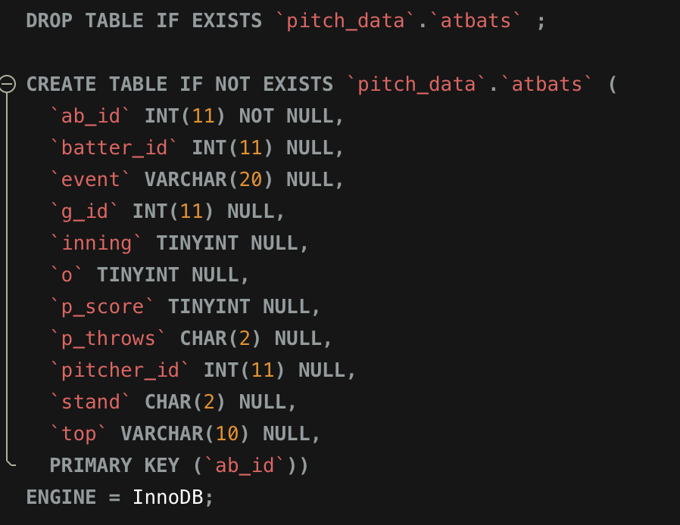

CREATE TABLE statement for `pitches` (2 screenshots below)

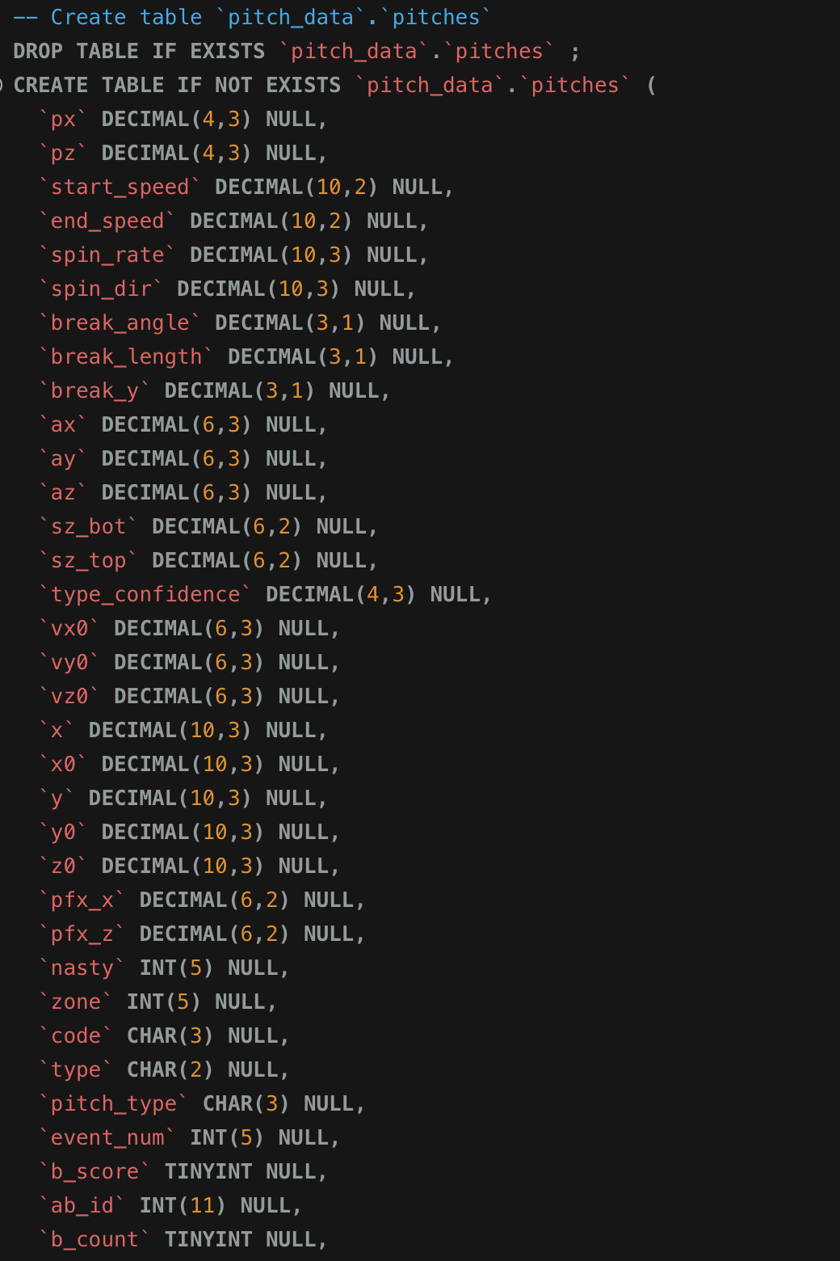

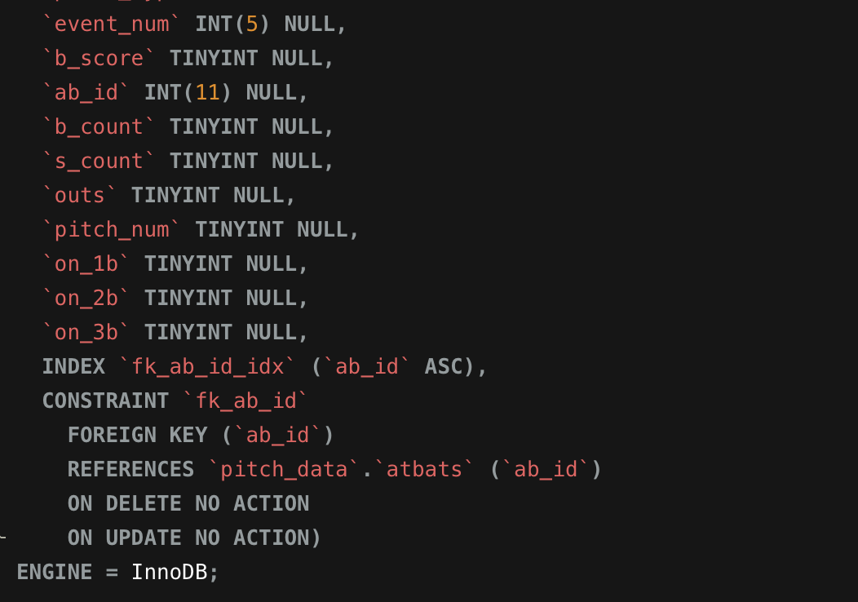

Include screenshot of fetched data from your megatable by running a simple query like following (required):

SELECT * FROM megatable LIMIT 100;

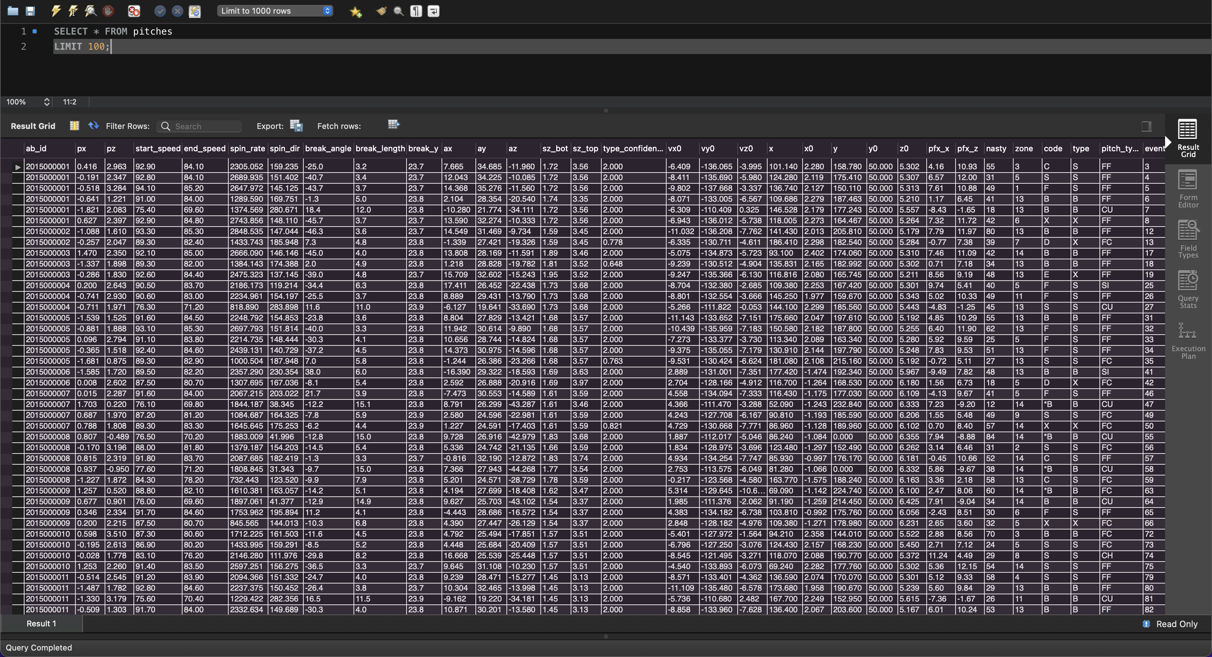

Include screenshot of any other relevant code blocks. Clearly label the screenshots.

LOAD DATA statements to populate the database from .csv files

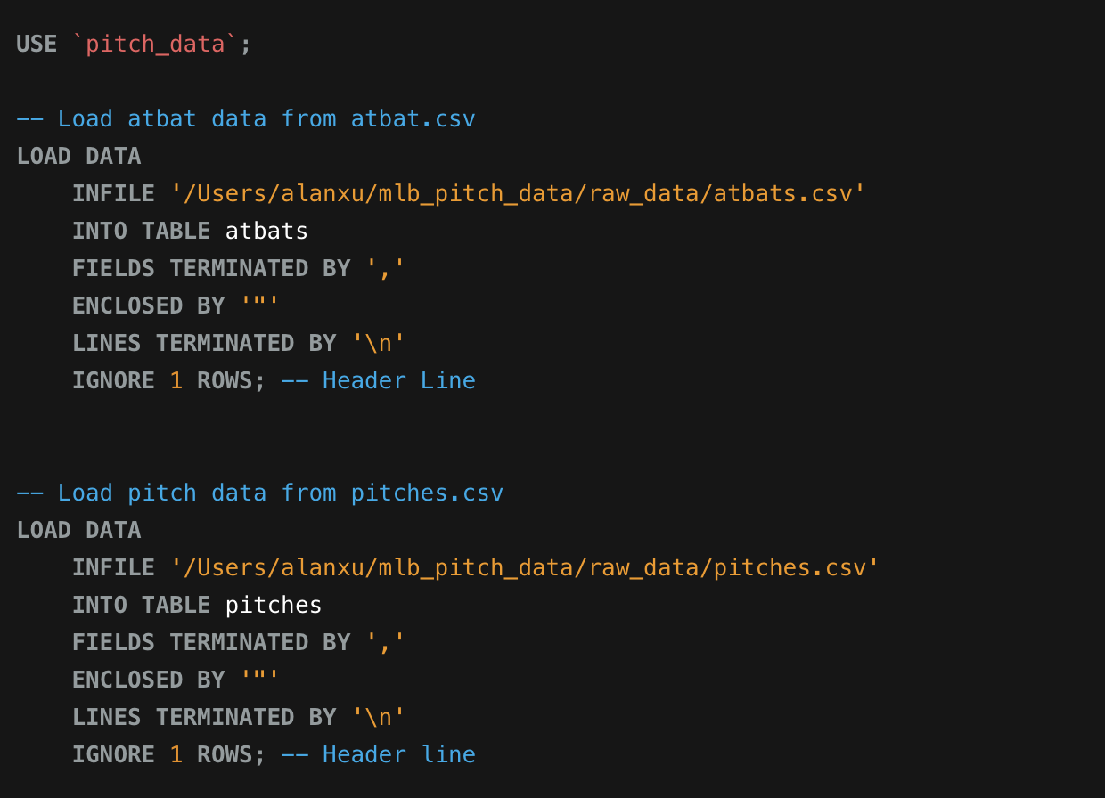

* 1. In terms of percentage how much you think you have completed on database side of the project? Describe the completed work in 2-3 sentences. Describe roadblocks, if any.

Since we did the database modeling portion of the assignment together, I would say I contributed 50% to the database side of the project. This involved designing the schemas, tables (with appropriate data types), writing scripts for populating the tables, decomposing, and verifying that the data is valid. The biggest roadblocks were definitely dealing with inconsistencies in the raw data, which need to be handled during table insertion.

## Front end:

* 1. By this assignment submission date, you should have decided on the front-end application programming language and have a successful connection established between the front end and the project database.   
       
     Attach a screenshot of the browser showing a successful connection displaying some data from any table of your project (can be megatable). Clearly label the screenshots.
  2. Which front end application programming language are you working with? Has anyone from team has prior knowledge of working with front end? Has anyone from team has prior knowledge of working with the chosen front end application programming language. 2-3 sentences.
  3. What is the status of front-end application? In terms of percentage how much you think you have completed on front-end side of the project?

## Next deliverable

* What are your next steps? By next deliverable (in 10 days) what do you plan to complete? Define clear goals.

# Submission:

Complete this document and save it as pdf. You must submit a PDF file named **p2-part2-lastname1-lastname2.pdf** (For example if I submit this document with John Smith, I would name it p2-part2-singh-smith.pdf). Submit your files on Brightspace.

You must include your name and your partner name in the Brightspace submission text box.

Each member of the team must make the submission of same file.

# Grading:

This Assignment will be graded on the following criteria:

1. Completeness of document.
2. Completeness of required components at this stage of project.
3. Clear evidence of work completed.

*NO grading will be done on file/s sent through email or not uploaded to Brightspace.*